选择性必修二Unit 5 Using Language Share your story about providing first aid

文本简述
本节的主题是分享你的急救故事，通过一个具体的故事来展示急救的重要性，提倡施以援手和提供人道主义救助的必要性，培养学生应对紧急情况的能力。在本节中，要求学生模仿故事，写一篇文章，记录生活中的难忘经历，分享自己和他人使用急救知识救人的故事，以及自己的感受。这项写作任务不仅有助于培养学生的语言表达能力，而且有助于培育学生正确的人生观和价值观。
教学目标
By the end of the class, students will
- analyze the structure of the passage, grasp the writing characteristics of the narrative, and experience the cohesion and transition between paragraphs;
- master the operation steps of Heimlich first aid method, explore the theme of the article, and learn Chen Wei's spiritual quality.
- write their own first aid stories based on the story mountain;
- learn the act of being brave for a just cause and convey the humanitarian spirit.

- 教学设计
Step 1: Lead-in
Show students the picture of an old granny.
Questions:
What happened to the old granny?
What do you think she is suffering from?

Step 2: Pre-reading
- What do you know about Heimlich Manoeuvre?
- Video Time: How to perform Heimlich Manoeuvre?

Step 3: While-reading
Activity 1: Read the whole passage and put A-E in the correct order.
(Try to find the key words in each sentence and the clue in the paragraphs. )
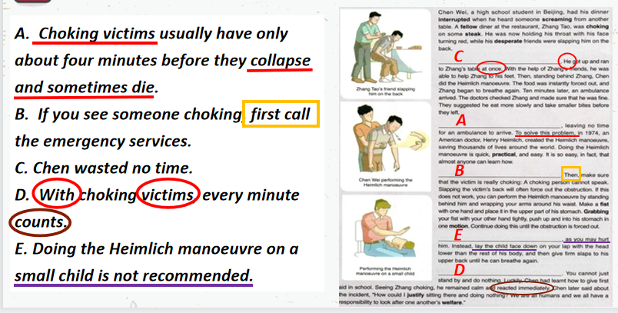

Activity 2 Read for different parts and main idea
- How many parts can this passage be divided into?
- What is your reason?
- Can you summarize the main idea of each part?
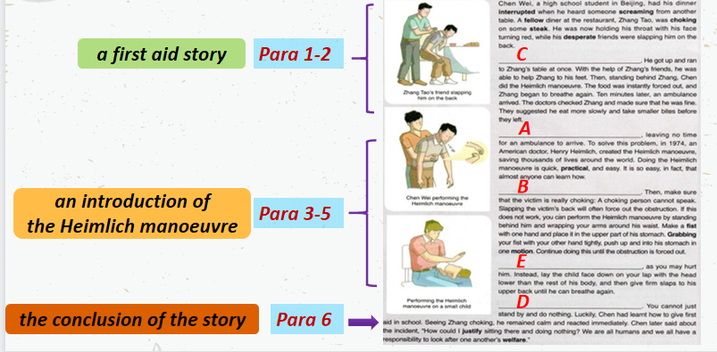

Activity 3: Read for detailed information
- What are the elements mentioned in Para. 1? ( 5W 1H )
Who:
When:
Where:
What:
Why:
How:

- How did Chen help Zhang? What did Chen and Zhang’s friend do in Para. 2?

- Read Para. 3-5
- Read and choose the correct words in the following sentences.
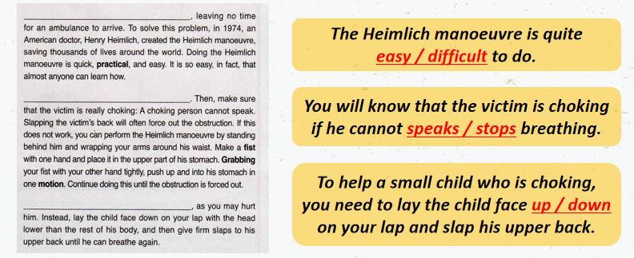

- How to perform the Heimlich manoeuvre on adult?

- How to perform the Heimlich manoeuvre on small child?

- Why did Chen help Zhang in Para. 6?
If you were Chen Wei, would you choose to help Zhang Tao?

Activity 4: Summary --- Story Plot Map
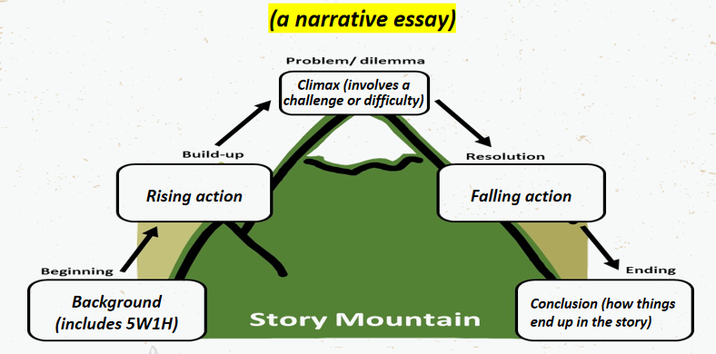

Summarize Chan Wei and Zhang’s story by using the story plot map.

Activity 5: Write a narrative essay
1. Work in pairs. Discuss your experience of giving first aid in an emergency. Or discuss stories you have read or heard about or think up a situation.
2. Write the structure and plot of your story.
3. Think of a good quote to sum things up.

Example
Last Sunday, I went to the park with Tony for a picnic. Unfortunately, Tony's left foot got injured on our way to the park. Luckily,I'd just learmed about first aid in our school. So I dialed 120 immediately and performed first aid before the doctor came.
First, I put his left foot in a more comfortable position. Then I rushed to a shop nearby and fetched bags of ice, and carefully applied the ice to the injury. Fifteen minutes later, the swelling seemed to have gone down a little. And I covered the injury with a clean and dry bandage. Ten minutes later, an ambulance arrived and took Tony to the hospital.
Only then was I aware of what a difference a basic knowledge of first aid could make, especially in such a case.

