**语篇研读**

**Theme：**Football

**What:**The text is adapted from the 4th chapter of *Good English 8 Pass the ball.* Tommy's grandad used to be a famous footballer. Now he embarrasses Tommy by turning up at his matches in his football kit. But one day Grandad is needed and no one is embarrassed.

**How &Why：**Bydescribing theGrandad’sunexpectedly brilliant performance in the school football match, the author inspires the readers to take an objective attitude towards things before making a judgement and cherish the affection and love of family members.

**Target readers:** Freshmen in senior high schools who have a good foundation in English

**Pass the ball - Chapter 4章节阅读-教学设计**

**Teaching aims:**

After the class, students are expected to :

1.master words and expressions related to football, including different positions in a team, people involved in a football match and common football techniques;

2.get a grip on the plot of the story by means of completing the mind map;

3.discover the language features of the story, especially the usage of specific verbs;

4.have a basic understanding of designing plots by taking advantage of the given sentences in continuation writing;

5.get more interested in football and appreciate the value of sportsmanship as well as the ties of kinship.

**Teaching procedures:**

**Lead-in: A quiz about football**

**Task 1: Review the previous chapters**

**Summary of the previous chapters:**

Tommy’s grandad used to be a famous footballer. Now Grandad embarrasses Tommy, the **goalie** of the school football team, by turning up at his matches in his old football kit. But that day, in the match against Forest Hill Juniors, when Tommy’s team **was short of** one player, Grandad offered to play as a **striker**.

**Task 2: Read Chapter 4 and raise questions by yourself**

**Q1: Who are mentioned in the passage?(characters)**

**Q2: What happened in the story?/What were they doing? (event)**

**Q3: When did the story happen?（time)**

**Q4: Where did the story happen? (place)**

**Your questions:**

**Task 3: Read for the details and complete the mind map**

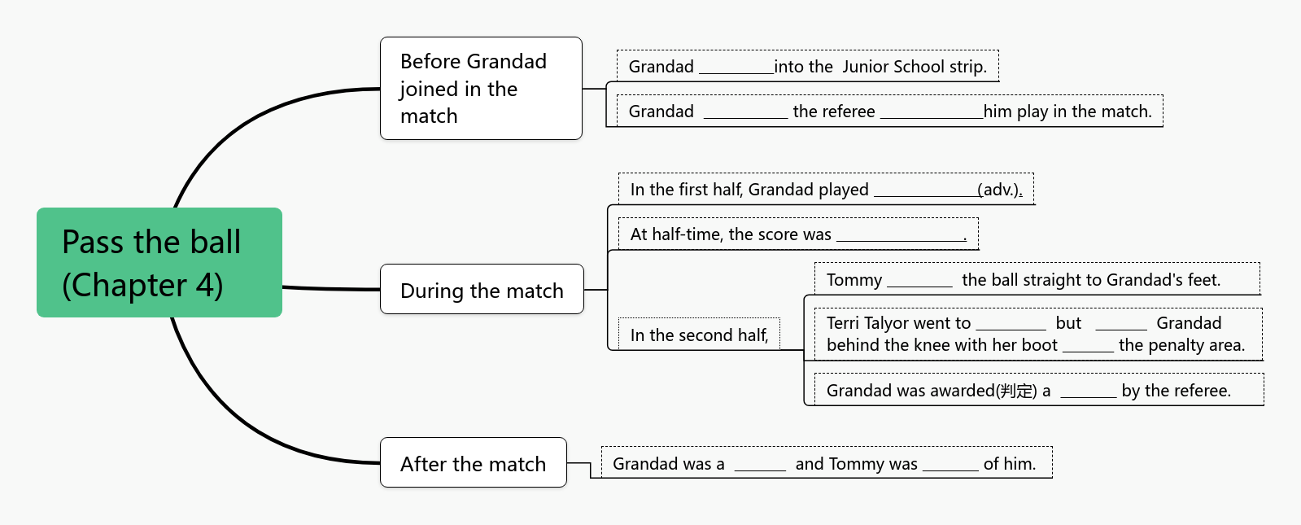

**Task 4: Role play and describe an exciting scene**

Find a partner and role-play commentators(解说员) to describe what was happening in the match.

**For your reference:**

Commentator 1:

Wow, Grandad is **brilliant**. **Ducking** and **diving, dodging** and **weaving**. His **ball control** is still **masterly**. At half-time, the **score** is **one all**. Then Tommy gets the ball. He looks around. He sees Grandad down the field. He **kicks** the ball **straight** to Grandad’s feet. With only a minute to go, Grandad sees his **chance**. But then he comes up against Forest Hill’s **sweeper**. She **towers** over Grandad.

Commentator 2:

Terri ‘Queen of the **Foul**’ Taylor goes to **tackle**. But she doesn’t go for the ball. Instead she **catches** Grandad behind the **knee** with her boot. Oh,no! Grandad is **rolling** on the floor, **holding** his knee. It is **just outside** the **penalty area.**The ref blows his whistle. **Free kick!** Unbelievably, Grandad **leaps** to his feet and places the ball with care. Want to know more? Please **stay tuned**!

**Task 5: Complete the writing**

1.**Design the plot**

***But Grandad leapt to his feet and placed the ball with care.***

|  |  |
| --- | --- |
| Cohesive Sentence  (衔接句1) | To stop the free kick from Grandad, some players of the Forest Hill team . |
| Transitional Sentences  (过渡句) | Grandad and the ball . |
| Cohesive Sentence  (衔接句2) | Tommy’s team won by goals to with Grandad’s last kick. |

***Grandad was a hero.***

**2.Accumulate good expressions**

**How to take a free kick**:

1. **冲**过去，抡起脚**猛踢**球

over to the ball and swing one’s foot to it as hard as sb. can;

1. 用**脚内侧/外侧**（踢），把球一盘(curl)绕过防守人员

curl the ball around defenders using the ;

1. 自动向后**倾斜**以**调整**身体**位置**，并将支撑腿**放在**球后 automatically backward to one’s body and one’s support leg behind the ball;

4. **转动**球，让球无法预料地**凌空穿过**

that ball and make it unpredictably;

**The ball**:

1. **好球**！What a !
2. 球穿过时，**触及**守门员的**指尖**，刚好进了**球网的上方角落**

The ball of the goalkeeper’s as it passed, right into the .

1. 球**绕过**防守人员，直接进了**球门的右下角**

The ball **curved around/swerved over** the defenders, straight into the .

**The audience**:

1.**发出欢呼** a thundering ;

2.**突然爆发出**如雷的**掌声** a thunderous ;

**3.P your writing**

**Task 6: Assignment (Practice)**  **2021深圳一模（改编） (注意：续写词数应为80左右)**

The football season, was almost over. Sally had been playing football all summer. She really enjoyed running around with the other players in her bright orange uniform, chasing the black and white ball across the grassy field. As much as she tried, though, Sally still had not scored one single goal.

Before each game, they had a practice session. The coach showed Sally and her team how to pass the ball to each other and take shots at the goal. Sally was pretty good at passing the ball, but even during practices, she couldn’t kick the ball past the goalkeeper. She wondered if she should quit football and join a different club.

“Don’t give up,” said the coach. But it was half-time, and Sally was feeling frustrated (沮丧). She was trying! Every time she got a chance to kick the ball, it would go in the wrong direction or a player from the other team would take control of it. She sipped at her cola and pouted (撅嘴).

The break was over and the referee blew his whistle to start the game again. The two teams walked back onto the field, both determined to win. Sally bent, tied up her shoelace and heard her mother whisper in her ear. “Stay focused. Keep your eyes on the ball. Look for an opportunity to get the ball. You can do it.”

Sally stood up and took a deep breath. Even if she didn’t get one goal all summer, she knew that she had tried her best. That was something to be proud of. So she smiled at her mother and headed to her position. The whistle blew, and the game continued.

The score was tied with one goal each. The green team was pretty good, but Sally’s orange team was fast. The girls’ ponytails bounced as they ran, with many feet kicking frantically (拼命地) at the ball when it came near them. It was a rather boring game and Sally’s heart was no longer in it.

Sally started daydreaming about joining other school clubs. She could be a member of the hip hop club, which her best friend Tracy kept talking about. She imagined herself dancing on stage of a big auditorium with thousands of people cheering for her. She could also try a different sport, like jogging or cycling. Anyway, football would be her last choice. Just as her mind was wandering, she saw a familiar face in the crowd. It was her mother. “Stay focused. You can do it.”

***Recalling her mother’s words, Sally was woken from her daydream.***

**足球相关词汇补充**

line-up阵容/formation阵型:

1.goalkeeper守门员

2.wing-back边后卫

3.full-back后卫

4.sweeper清道夫

5.center-back中后卫

6.defensive midfielder防守型中场球员（后腰）

7.central midfielder中前卫

8.attacking midfielder攻击型中场球员（前腰）

9.winger边锋

10.forward前锋

11.striker前锋

**其他相关人员：**

1.substitute替补

2.coach/manager教练

3.ref/ referee裁判

4.VAR(video assistant referee视频助理裁判)

5.commentator解说员

6.spectator/crowd观众

7.talent scout星探

8.security guard安保人员

9.journalist记者

10.sponsor赞助商

11.a favorite/favored team呼声很高的热门球队

12.underdog/dark horse黑马

比赛的各个阶段:

1.eliminating rounds/games

淘汰赛

2.group matches小组赛

3.round of 16/octofinal/Top 16

八分之一决赛

4.quarter-finals/Top 8

四分之一决赛

5.semi-finals/Top 4 半决赛

6.final/ the championship match决赛

7.defending champion卫冕球队

评价好球、臭球：

1.What a shot/strike/header!

好球/好一记头球！

2.Couldn’t find the back of the net.进不了球

3.That was an awful play/kick.这脚/球踢得真烂

4.That stunk.这球踢得真臭

加油:

1.Come on!

2.Go, go, go!

3.Do it!

4.Go get them!

场地名称

1.stands看台

2.field / pitch 足球场

3.midfield 中场

4.backfield 后场

5.kickoff circle/center circle中圈

6.halfway line中线

7.touchline / sideline 边线

8.goal line 球门线

9.end line 底线

10.penalty mark（点球）罚球点

11.penalty area 大禁区（罚球区）

12.goal area 小禁区（球门区）

13.crossbar门梁

14.goal post门柱

球队技术

1.corner ball / corner角球

2.bicycle kick倒钩= scissor kick剪刀脚

3.goal kick球门球

4.handball 手球

5.header 头球

6. score an own goal 乌龙球

7.hat-trick 帽子戏法(在一场比赛中某运动员单场比赛连进球三次)

8.pass传球/short pass短传/long pass长传/cross横传

9.take a pass接球

10.dribble 盘球,带球

11.break through突破

12.tackle 拦截，铲球

13.clear the ball解围

14.shoot /take shoots射门

15.attack攻击

16.offend防守

17.score an equalizer打进了扳平比分的进球

18.dive to the ground(守门员)倒地and save sb’s shot化解射门

19.score the winning goal打进了制胜球

20.concede(守门员)失球

21.penalty kick /spot kick点球

22.free kick任意球

23.throw in(掷)界外球

24.take control of the ball控球

25.kick/strike/hit/boot/hammer踢/猛踢

足球战术

1.beat the offside trap

反越位成功

2.foul 犯规/technical foul技术犯规

3.break loose摆脱

4.control the midfield控制中场

5.set/make a wall 筑人墙

6.close-marking defence

盯人防守

7.on the bench坐在替补席

比赛方式

1.coin toss/ toss a coin掷硬币

2.kick off开始

3.half-time interval中场休息/first half上半场/second half下半场

4..go into extra time加时赛

5.injury/stoppage time伤停补时

6.penalty shootout点球大战

7.yellow card黄牌/red card红牌

8.be sent off 被罚下

9.on side在位/off side越位

10.end in a draw/be tied平局

11.knock out淘汰

12.home game 主场

13.away game客场

**《典范英语8》足球运动描写积累**：

1.The game began. Almost at once, City were on the attack. The centre forward(中锋) broke through(突破防守) and rushed towards the goal. He was about to shoot when he saw Hilda running at him. The player was so shocked that he kicked the ball over the bar(球横杠梁) and into the crowd. … Hilda booted(猛踢) the ball up the pitch.…The referee blew the final whistle and the Smalltown team carried Hilda round on their shoulders. They let her collect the cup(领奖杯).(典范英语8-5:P.23-26 ***The big chance***)

2.People still talk about the way Keith played that day. Every touch on the ball was a winner(制胜的进球). The penalty kick was magic. The run past three defenders was stunning. And the goal that hit the top corner stuck so fast, they had to knock it out with the corner flag(角旗).(典范英语8-17:P.49 ***Doughnut Dilemma***)