B2U3 Listening&Talking 教学设计 by 武汉光谷未来学校 尚洁

* **教学目标：**

In this lesson, students will

1. listen to get the **main purpose** and **details** of the conversation about choosing apps;
2. master expressions to show your **predictions/ guesses/ beliefs**;
3. choose suitable apps based on **purposes/ apps’ functions/ expectations**;

recommend suitable apps to others in need.

* **教学重点：**

1. Improve students’ listening skills to better understand **the main purpose and details** of the conversation;
2. Lead students to focus on expressions used to show **predictions/ guesses/ beliefs**.  
   教学难点：
3. Encourage students to **naturally show their predictions/guesses/beliefs** in daily conversations;
4. Lead students to **choose or recommend suitable apps** **logically**.

* **教学过程：**

**Step1: Warming up**

Ask students to look at commonly used apps on the slide, and answer questions below together.

Q1: What apps will you use if you want to *chat online*? Any other apps for *social networking*?

Q2: How about *online shopping*? And *online payment*?

Q3: What if you want to *stream the movies or music*?

Q4: If you want to *ask questions or improve your study*, you may use ________ ?

【设计意图：建立真实情境，引出话题“应用程序”，激发学生学习兴趣；师生一起回忆日常生活中应用程序的使用习惯，引出选择应用程序需要考虑的因素之一——“**个人目的**”。】

**Step2: Listening**

**Activity1**

Set up Listening - Activity1. Ask students to listen to the conversation and find out ***personal purposes*** when choosing apps. Then elicit answers from the class.

*What apps does Xiao Bo/Laura want? Why?*

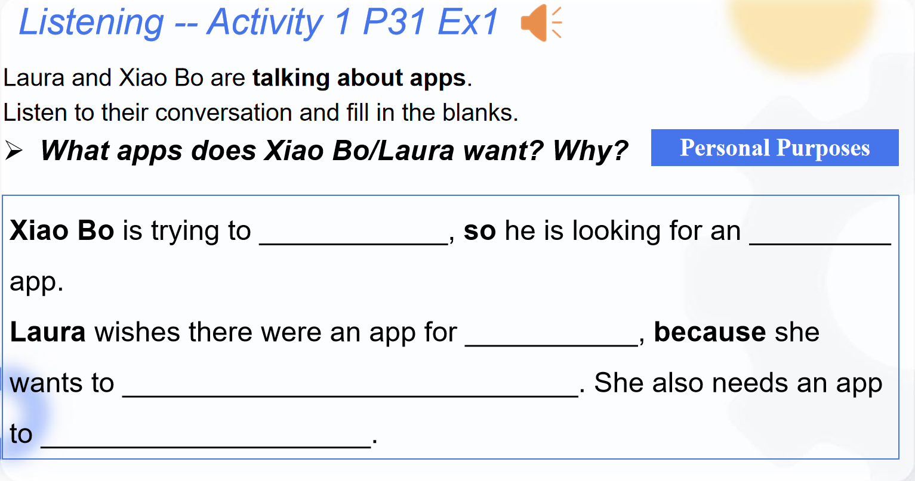

**Activity2**  
Set up Listening - Activity2. Ask students to listen again and focus on ***functions*** of each app mentioned in the conversation. Invite a group of students to share answers.

*What apps are found for Xiao Bo/Laura? What functions do these apps have?*

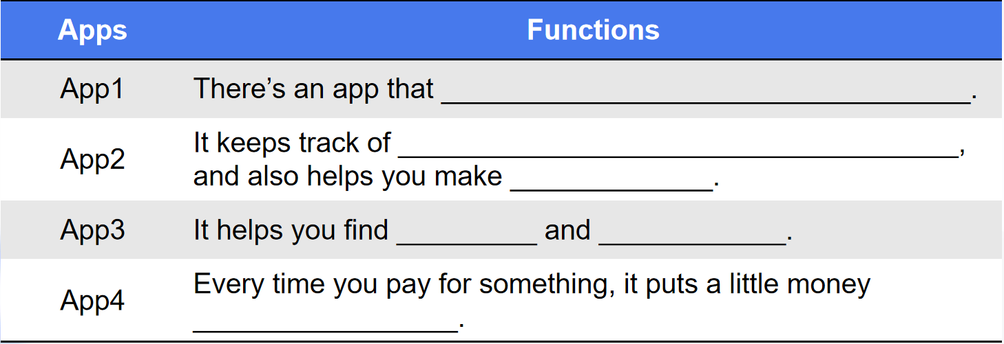

Activity3

1. Show statements about ***predictions/guesses/beliefs*** to students. Ask students to underline key expressions used to express predictions, guesses, and beliefs. Then ask students to read statements together, stressing the underlined parts.

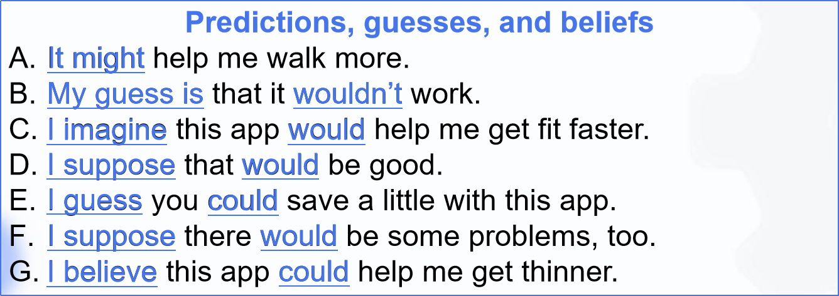

1. Listen once more. Ask students to put the sentence they hear into the form. Find out ***expectations*** of those mentioned apps. Then invite volunteers to share their answers.

*What does Xiao Bo/Laura think of these apps?*

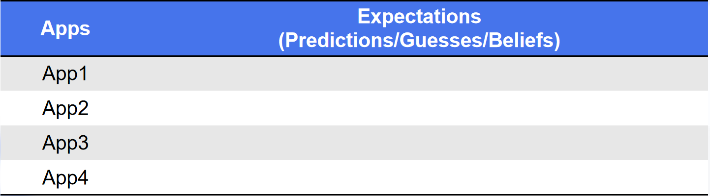

Make a brief summary

After finishing listening tasks, invite students to summarize key factors when choosing apps.

*When choosing apps, we should consider:*

*___________, ______________, and ________________.*

【设计意图：

第一遍听力活动重点训练学生**获取主旨**的能力，同时引导学生关注对话双方选择应用程序时各自的**目的**;

第二遍听力活动重点训练学生**获取细节信息**的能力，同时引导学生关注不同应用程序的**功能**；

第三遍听力活动重点引导学生学习对话中**表示“预测、猜测及相信”的功能意念项目**，同时引导学生关注选择应用程序时个人的**预期**；

最后基于对话内容引领学生小结选择应用程序时应考虑的因素，为后面的对话输出**搭建语言及内容结构支架**。】

**Step3: Talking**

**Activity1**

Ask students to discuss in pairs: *Which app would Xiao Bo/Laura probably choose? Why?*

Give the sentence pattern to students in advance. And remind students to refer to their expectations of those mentioned apps.

***Xiao Bo/Laura*** *would probably choose App_________, because _______________.*

Activity 2

Share a post from Susan with students.

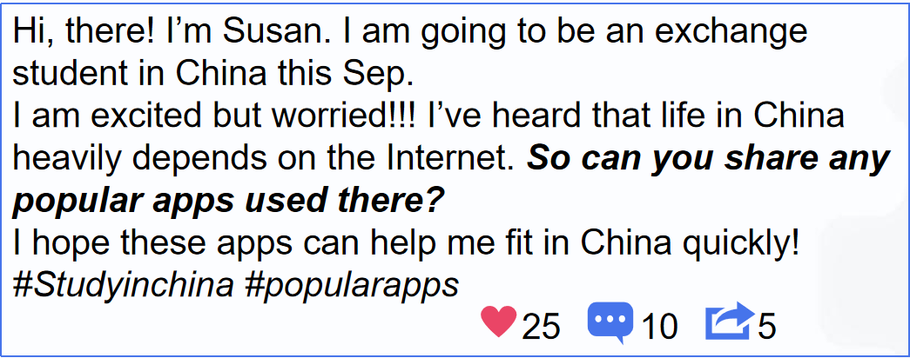

Ask students to discuss in groups：*Which app would you like to recommend to her? Why?*

Remind students to consider ***Susan’s purposes/Apps’ functions/Your expectations***in their discussion. And encourage students to use expressions like ***“I believe .../ I imagine ...”***.

Demonstrate an example first. After the discussion, ask volunteers to share their recommendations with the class.

【设计意图：

输出活动一中学生们需要基于听力对话中“预测、猜测及相信”的细节推断对话主人公最终选择的应用程序，强化了学生们对于**“预测、猜测及相信”功能意念项目**的认知，提升了其**推理判断能力**；

输出活动二中学生们需要向外国交流生推荐好用的应用程序。该活动再次回归**真实情境**，鼓励学生将课堂所学知识进行迁移创新，从**“目的”、“功能”、“个人预期”**三个方面出发，推荐合适的应用程序，并在此过程中**再次强化表示“预测、猜测及相信”的功能意念项目口头训练**。】

**Step4: Homework & Summary**

*Homework:*

1. Write down your recommendations to Susan;
2. Recommend an English learning app to your deskmate;
3. Discussion: Should we control the use of apps? *(Reference: Video Time* in Unit 3)*

*Summary:* Remind students to **choose apps carefully and use them wisely** in the future.