2019.9浙江高三百校联考应用文

上周六下午，你校学生会举行了“绿色校园，我们在行动（Green School, We Are in Action）”为主题的植树活动。假定你是学生会主席李华，受校编辑部委托写一篇活动报道，内容包括：

* 活动的时间、地点；
* 活动的内容；
* 活动的意义。

注意：1.词数80左右 2.可适当增加细节，以使行文连贯

How to write a news report

Step 1 introduce the definition and structure of a news report

1. What is a news report?

A report is a news article or broadcast which gives information about something that has happened.

|  |
| --- |
| * Emphasize that write in a style which is clear, concise, and active. |

1. Parts of a news report.

Show the students a sample from text book-*Heroic teenage receives award (book5unit5)* and make clear of the 4 parts: a headline; a news lead; the body; a conclusion.

|  |
| --- |
| * Clarify the content of each part. * Help the students form a rough idea of the structure and the writing style. |

1. Tips of writing a news report

* Make sure your story conveys information and not an opinion.
* Speak in past tense when writing a news report
* Start a new paragraph whenever there is a new thought
* Always include attributions

Step 2 Present a detailed progress for writing a news report

1. Analyze the structure

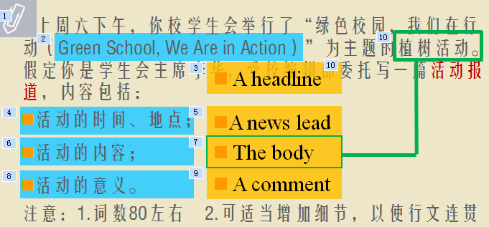

1. begin with a news lead accurately

Summarize the news story with *who, what, when, where and why*

|  |
| --- |
| * Lead the students fill the blanks on their own * Encourage them to combine the filled information into one sentence. * Help them polish the sentence if necessary |

1. Enlarge the content of the body part

Enrich the body part of the passage by describing in details, for example, what did they do? Where did they plant the trees? Or how did they feel? And show them a sample paragraph.

|  |
| --- |
| * Instruct the students to develop the paragraph by asking questions * Fill the question blanks as detailed as possible * Lead them to integrate the details into one paragraph * Present an example of how to polish |

1. Give a comment in the end concisely.

Just stick to the facts and keep the sentences concise.

Show them the students’ works and remind them to stick to the headline.

Step 3 Tips for writing a news report

Display the works of students and make comparisons.

Help the students truly understand the tips of writing a news report.

Step4 Practice

Write a news report using what the students have learned.