**Book1 Unit1**

**Expanding your world**-**Teenage Life around the World**

**Learning Objectives**

1. Understand key information about teenagers from Tanzania, Bangladesh, and Germany.
2. Appreciate different teenage lifestyles across cultures.
3. Reflect on one’s own life and develop empathy, responsibility, and global awareness.

**Teaching Key Points**

* Extract and compare details from the texts.
* Express personal teenage life using learned structures.

**Teaching Difficulties**

* Cultural understanding and comparison.
* Writing a coherent and personal paragraph in English.

**Teaching Procedure**

**Activity1: Lead-in (5 minutes)**

Ask students:  
What is your school life like?

How do you feel?

**What is your hobby?**

I like/enjoy _____ because_________.

**What do you want to do in the future?**

I want to _________ because ______________.

Activity2: Raise questions

What do you want to learn from the text?

Raise questions start with“wh-”

Activity3: Deep explaraion

What kind of person do you think Asha is?

Try to find out which aspects(方面）are mentioned when introducing Samika and Frieder?

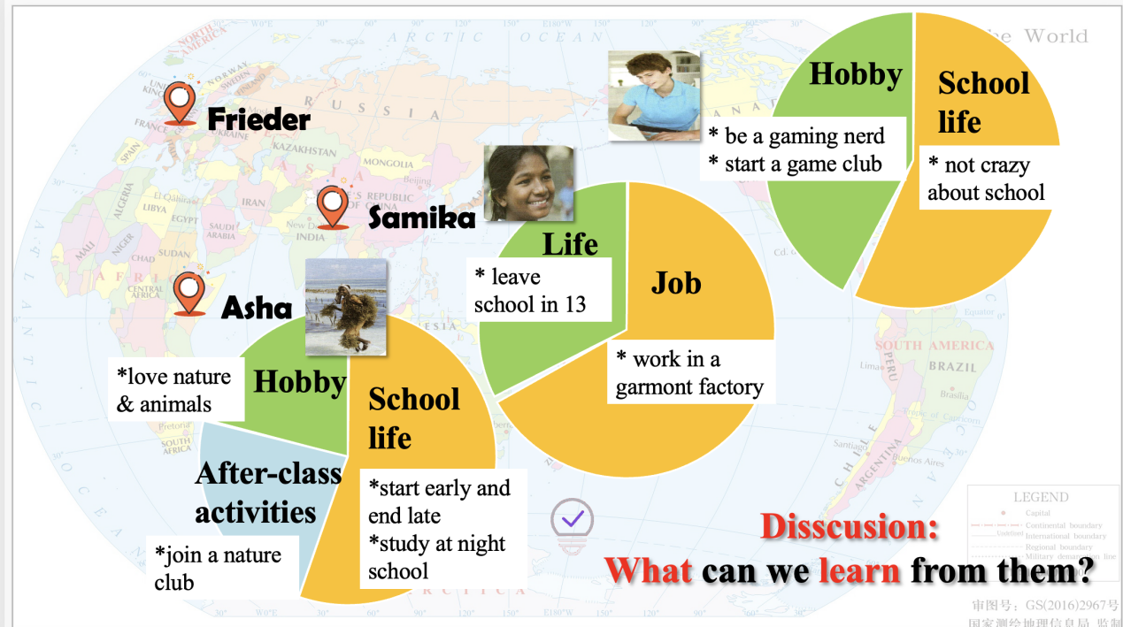

**Discussion：What can we learn from them?**

care for nature

cherish（珍惜） school life

hold a positive attitude to life

know the importance of education

Activity4: Reflecting

What is your ***teenage life*** like?

How do you ***plan your own teenage life*** in the years that follow?

Try to tell teenagers from another country about your teenage life in China. *How do you* ***plan your own teenage life*** *in the years that follow?*

Hi, there! My name is _______ and I’m from China. Like most teenagers, ______________(School life)I love _____________________________. ( Hobby)

_________________________________________________.(After-class activities)

_________________(your goal/plan in the years that follow) because___________

(reasons why you set that goal)

**Sentence pattern for reference**

***1) school life***

* ***Like most teenagers, I start my day...and end it ...***
* ***I study... to prepare for the university entrance exam.***

***2) hobby***

* ***When I have time off, I prefer to...***
* ***I love... so much that...***

***3)after-class activities***

* ***I volunteer to... and I’m a member...***

***4)attitude***

* ***Although ..., we still find time to play and laugh together.***
* ***At times like these, the world feels like a wonderful place.***
* ***It's very difficult for ...to do...***