Continuation Writing-How to show sentences（Review a classic film-Titanic）

Teaching aims:

By the end of the class, students will

1. tell the difference between “telling” and “showing”.

2.appreciate “to show ”sentences

3. polish ordinary writings with “to show” sentences.

Teaching procedure

Step 1: Lead-in

Enjoy a classic clip from Titanic

Ask the students to notice the change of Jack’s emotion while they are enjoying it.

When Jack saw Rose walking towards him, a great sense of excitement took hold of him.

Leading to this class’ learning aims and the standard of a good continuation writing,then tell the students the focus of this class(linguistic（语言） description )

Step 2: Tell the difference between “telling” and “showing” and appreciate “to show ”sentences through “Titanic”(from four moments)

Compare two versions and find out the useful structures

Scene Ⅰ—Beginning: when they met

Scene Ⅱ—Development: when they loved

Scene Ⅲ—Climax: when they were trapped

Scene Ⅳ—Ending: when they said goodbye

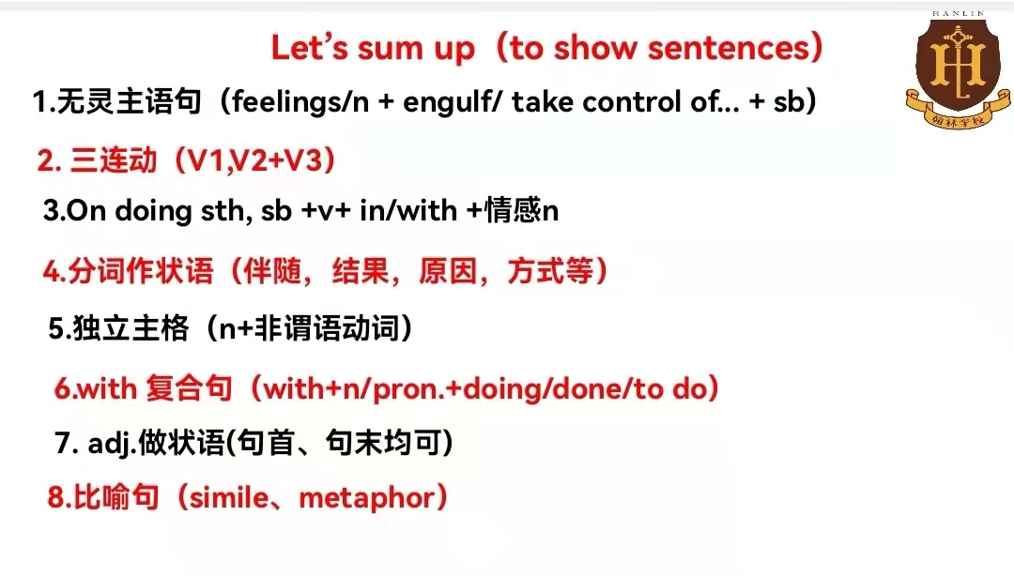

Step 3:Application: polish ordinary writings with “to show” sentences.

Give students some simple writings from previous tests and ask then to polish them with the structures they learned just now.

When I entered the classroom with only shabby tables and chairs, I was shocked.(第三期报纸)

My father picked up the money and gave it to the man.（十月月考）

As soon as the children received their gifts ,they were very moved.(十月月考)

When I reached the vet’s office, I scooped(抱起) the dog and urged（催促） the vet to examine Shep.（期中考试）

I was very relieved and happy, so I hugged the dog gently. (期中考试)

Step4.summary again

Step 5 Homework