溯恩英语 语法填空满分计划系列课程-1 导学案
高考真题析考情, 正本清源规则清
Ⅰ.请完成2020年1月浙江英语卷-语法填空的答题和语篇分析。
Something significant is happening to the world population - it is aging. The median (中位数的）age of an American in 1950 56 (be) 30 - today it is 41 and is expected 57 (increase) to 42 by 2050. For Japan, the 58 (number) are more striking - 22 in 1950， 46 today and 53 in 2050. In 2015, one in 12 people around the world were over 65; by 2050, it will be one in six.
This aging of the population is driven 59 two factors. The first is declining birth rates, which means old generations are large 60 (compare) to younger generations, and so, on average, the population becomes 61 (old) than before. This is 62 (particular) true in the US. The second reason is that people are living longer. A child born in the US today has 63 very realistic chance of living beyond 100 and needs to plan accordingly.
People tend to focus on the first factor. However, greater attention should 64 (place) on longevity (长寿）. It isn’t just that people are, on average, living longer. It’s also that they are on average healthier 65 more productive for longer. Therefore, they can work for longer, consume more and in general be a boost to the economy.
- 请书写你的答案在指定答题区域内

56. 57. 58.
59. 60. 61.
62. 63. 64.
65.

- 请快速分析文章的文体，结构以及行文逻辑。

Ⅱ.纵向分析：浙江新高考 7次语法填空考点分布
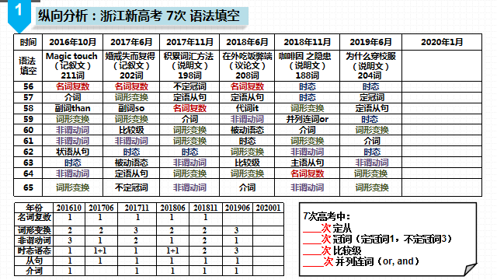
Ⅲ.从语法到语境语篇
1.把握语境，重视语篇的理解。
培养语篇意识和语篇驾驭能力，在语篇中敏感性地感受和运用语法。微观语篇还涵盖能有效判断并确认语篇所使用的交际功能、能正确识别 ，包含语篇逻辑符号和语篇之间的逻辑 以及保持语篇意义连接的逻辑 等。
2.关注语篇的层次和主题。
语法填空不是 ，要把所填词放在 去综合考虑，尤其是 的填空。“空在句中，题在文中”。
3.抓住语篇的文脉。
明晰语篇中“词汇+语法”是如何 的，了解作者的预先设定和布局谋篇的思想。
Ⅳ.从拼写到书写
- 检查你的答题书写是否规范？是否在书写上失分？
- 无论你习惯哪种字体，请按规范书写重新书写下列字母。
①大写字母都应一样高，占上面两格，但不顶第一线。
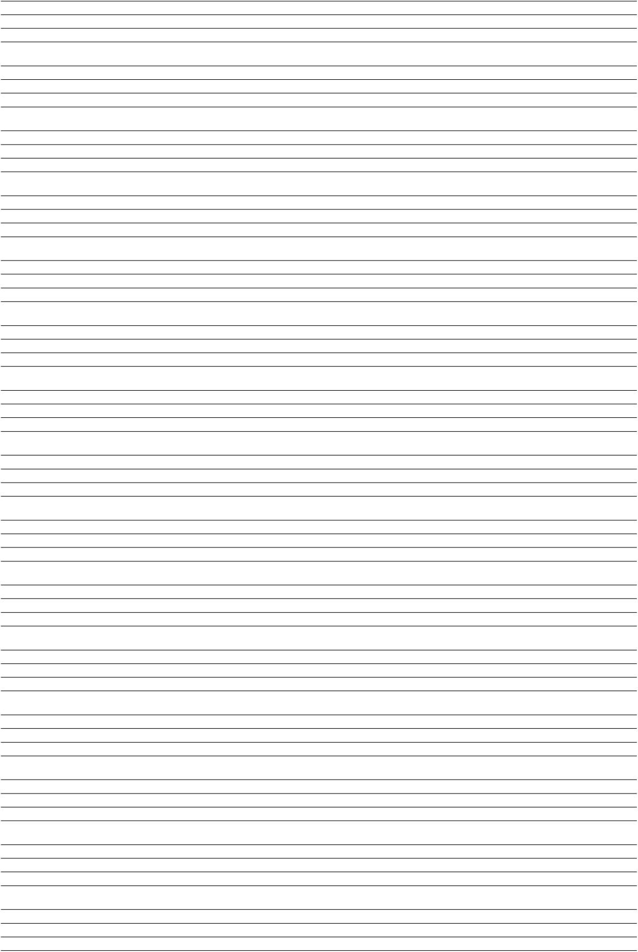
②小写字母a，c，e，m，n，o，r，s，u，v，w，x，z写在中间的一格里，上下抵线，但都不出格。
③小写字母b，d，h，k，l的上端顶第一线，占上面两格。上端不要写过长。
小写字母i和j的点、f和t的上端都在第一格中间，f和t的第二笔紧贴在第二线下。
小写字母f g j p q y的下端抵第四线。
Ⅴ.从规则到意识
1.请你写出语法填空的题目要求。
“第二节（共10小题；每小题1.5分，满分15分）
阅读下面材料，在 或 。”
2. 做下面的题目，感受语法填空的要求。
①Larger amounts of caffeine can cause a problem 62 (call) caffeinism.（2018年11月浙江卷 ）
②Pahlsson and her husband now think the ring probably got 63 (sweep) into a pile of kitchen rubbish and was spread over the garden, 64 it remained until the carrot's leafy top accidentally sprouted (生长) through it.（2017年6月浙江卷 ）
- 研究语法填空的规则要求，析备考重点，知“有所为有所不为”。

Ⅵ.语法填空解题思维导图
1.无提示词题，即没有提示词的纯空格题。
一般是 个小题，
近年来，考查了 、 、 和 等类词。
2.有提示词题，即用括号中所给词的正确形式填空。
一般是 个小题，
近年来，考查了 、 、 、 等四种情况。
3.解题思维导图
