教学设计

——应用文之新闻报道

1. 设计理念：

倒金字塔策略在应用文新闻写作中的使用

二．教学目标：

1. 知识与技能：了解应用文写作中新闻报道的含义、基本结构和语言特点——

* 含义：新闻报道是指对新近发生的事实的报道。
* 结构：一般包括标题、导语、主体和结语四部分。篇章结构一般为：

Para.1 点题：活动简要概括（时间,地点,人物,事件等）+活动目的（如果有）

Para.2 活动主要内容

Para.3 意义：对活动的评价

新闻报道的标题简短，能反映新闻的内容，又能吸引读者阅读该报道；新闻报道的首段包含新闻的重要信息，如时间人物事件的要素。新闻报道的第2段是对首段的补充。

* 语言特点：客观、清晰、简洁、规范、准确。

1. 过程与方法：通过审题思考与语言分析提取有用信息、删除累赘信息； 并熟悉新闻报道的篇章结构及掌握相关话题词汇。
2. 情感态度与价值观：引导学生走近大自然，了解植物的特征、习性等方面知识；激发学

生对珍贵植物的爱惜与保护之情。

1. 教学方法：指导法、展示法、练习法。
2. 教学过程：

Step 1: Review the background information (激活学生背景知识)

Q: What is a news report?

A news report is a fact-based story, on a particular event or incident happening /happened. News report gives all the information about incidents that already happened or currently taking place along with covering answers of 5Ws and 1H i.e. What, Where, When, Who, Why, and How.

Step2: Elaborate the strategy---the inverted pyramid (阐述写作策略)

An inverted pyramid

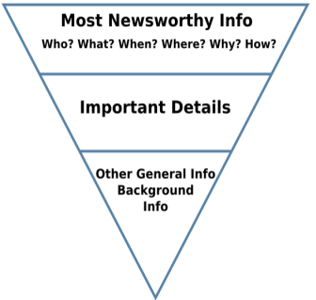

Step3: Apply the strategy (应用写作策略)

* Elements--structure &content

Q: What should be covered according to given information?

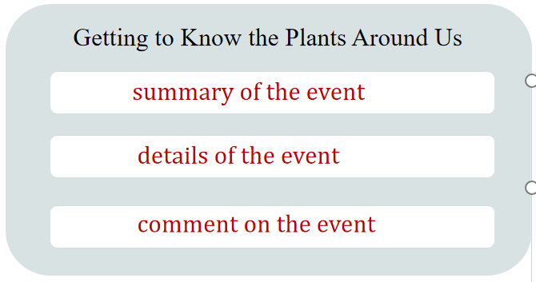

|  |  |  |
| --- | --- | --- |
|  | structure& content | |
| **Para.1** | what, who, when, | 活动概况 |
| **Para.2** | where, what, how | 活动过程 |
| **Para.3** | How, what | 活动收获与感想 |

* Element--language

Q: What are the language features of a news report?

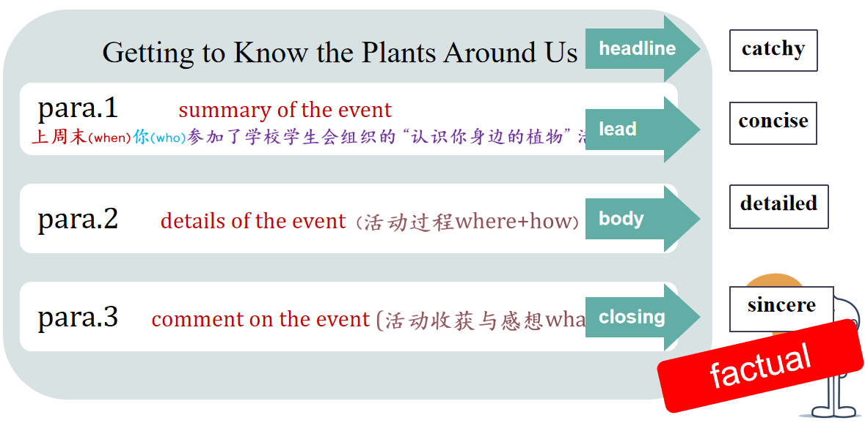

Brainstorm topic-related expressions

para.1 活动概况：

* v 举办 vt. launch/hold/host
* v 参加 (短语)

participate in/join in /take part in/be involved in/enter for/sign up for/be engaged in

para.2 活动过程:

* observe /share/discuss
* label plants
* take photos by camera
* identify different plants
* explore outdoors
* think about plant-related idioms
* collect seeds and leaves of trees
* sort out /name plants
* document observations
* write a report on...
* join in a competition related to..

...

para.3 收获与感想：

总体评价

* It was a hit.
* It is an enjoyable and educational experience.
* We had fun and more than fun.
* meaningful/unforgettable/well-received/beneficial
* speak highly of
* sing high praise for
* ...

认知方面

* deepen one’s insight into...
* deepen one’s understanding of...
* raise one’s awareness of...
* catch a glimpse of
* broaden one’s horizons
* expand one’s scope of knowledge
* cast light on sth
* ...

情感方面

* immerse sb in the charm of...
* arouse/boost one’s enthusiasm
* fuel/ignite one’s passion
* enrich one’s school life
* bring color to...
* stimulate one’s interest
* evoke (/ɪ’vəʊk/勾起) our love for
* ...

Step 4: Practice & share