**2024年3月浙江温州二模应用文 讲评学案**

**PART 1 审题分析与评价**

【题目呈现】

假定你是李华，暑期想在家乡（杭州）寻找外国友人结伴“城市漫步”，请通过社交媒体发布一篇帖子，内容包括：

1.相关介绍

2.旅伴要求

注意：

1.写作词数应为 80 左右；

2.请按如下格式在答题卡的相应位置作答。

**Join Me in a City Walk**

______________________________________________________________________________________________________________________________________________________________

【基本信息把握】

|  |  |  |  |  |
| --- | --- | --- | --- | --- |
| 文体体裁 |  | | | |
| 写作人 |  | | | |
| 目标读者 |  | | | |
| 写作背景 |  | | | |
| 写作目的 |  | | | |
| 人称时态 |  |  |  |  |

①首段吸引网友兴趣

结合帖子的特殊写作情境，要用生动有趣的开场白或提问等方式,抓住读者眼球,激发他们的兴趣和好奇心。因为网络信息比较冗杂，需要设计一些比较attractive的开头段，该部分写作空间比较大。

②次段陈述主体

第二段是整篇帖子的核心部分，也就是所说的“主体”（body），在这段中，必须紧密围绕题干给出的要点进行写作，即围绕“相关介绍”“旅伴要求”两大维度，添加细节丰富内容；字数控制在四句话左右，可各自分配两句话，该部分对语言精炼要求较高。

③尾段表示期待

根据题目要求，作为帖子，可以增加交互性的语言，比如“Interested? Please…………”随即给出联系方式，让感兴趣的旅伴联系自己，期待与外国友人分享和交流的心情。

**PART 2 分段建构与语料**

**【首段】**

Q:首段如何结合帖子特点，吸引人来关注？

___________________________________________________________________________

**Skill 1: __________________**

Do you know there's a different way to experience Hangzhou - beyond the famous West Lake? Are you willing to experience a soulful and impressive journey under the guide of a local this summer break?

**Skill 2: __________________**

Hey This Li hua, a local of Hangzhou. I am looking for some foreign friends to join me in exploring the fascinating city of Hangzhou this summer!

**Skill 3: __________________**

Saunter around Hangzhou, one step at a time! Are you an adventurous soul seeking to explore a city rich in history and culture? Join me, Li Hua, an native, on an unforgettable "city walk" through the charming streets of my beloved hometown this summer.

**共同点:**

____________________________________________________________________________________________________________________________________________________________________________

**【次段】**

Q2:结合题干，相关介绍这个要点的核心是什么？

______________________________________________________________________________

**Option①**：不确定性——从city walk本身特征出发

Our "city walk" won't follow a ______ route. Instead, we'll _________ at our own pace, letting curiosity and personal interests guide our steps.

我们的 "城市漫步 "不会遵循死板的路线。相反，我们将按照自己的节奏在杭城漫步，让好奇心和个人兴趣引导我们的脚步。

It'll be a great opportunity to experience the rich culture, history, and cuisine that Hangzhou has to offer.

Q3:结合题干（杭州），暗示了什么？

______________________________________________________________________________

**Option②**：半确定性——介绍本次城市漫步的景点特色

More than just sightseeing, this is an opportunity to ___________ yourself in the true essence of Hangzhou – its vibrant culture, warm ________________, and enduring legacy.

Along the way, one moment, we might find ourselves admiring the West Lake（行程1）; the next, we may be witnessing a traditional handicraft demonstration in the alleys of the city（行程2）

这不仅是一次观光之旅，更是一次沉浸于杭州真正精髓的机会--它充满活力的文化、热情好客的待客之道和经久不衰的传统。一路上，前一刻，我们可能会欣赏西湖美景；下一刻，我们可能就会在城市小巷目睹传统手工艺品的展示了。

Q4:在表达“要求”这个要点时，用什么句式相对比较好？

______________________________________________________________________________

**①** The ability to communicate comfortably in English is crucial for sharing insights throughout our adventures.

**②**While our pace will be leisurely, some level of physical fitness may be required as we'll be exploring the city on foot.

**③**If you're eager to delve into Chinese culture, open to embracing new perspectives and social interactions, I can't wait to await your contact!

**Choose one: ___________________ Reason:________________________________**

Q5:在表达这个要点时，可以从什么角度出发？

√Open-mindedness and cultural curiosity

√Sense of adventure and flexibility

√Ability to communicate in English

√Respect for local culture

√Enthusiasm for social interactions

**【尾段】**

帖子的结尾还是比较形式化的，主要目的是再次发出寻找搭子的期望，希望对方联系自己。篇幅可以较短，可以放在旅伴要求的后面，可以不单成一段。

①To express your interest or ask any questions, feel free to reach out to me via email or send private messages to me . I'm excited to connect with fellow explorers and craft an authentic, one-of-a-kind experience together.

②Interested? Email me at lihua111223@email.com to secure your spot on this unforgettable journey.

③Let's create unforgettable memories together while soaking up the essence of this captivating city.

**PART 3 例文评价与提升**

**【官方范文】**

Hey everyone! This is Li Hua , a travel enthusiast from Hangzhou, I'm on the lookout for some foreign friends to join me in exploring the fascinating city of Hangzhou this summer.

Our city walk will take us into the heart of Hangzhou, where we'll wander through bustling streets and unfrequented alleys, sample must-try local cuisine,and even try our hand at time-honoured handicrafts, If you're a native English speaker with an appetite for adventure, join me and we'll see a blend of tradition, modernity and endless discoveries.

I can assure you that exploring a city with a local will be the last decision you'll come to regret, If interested, send me a message and let's together hit the road!

你觉得本文的得分是_________

理由与可取之处：______________________________________________________________________________________________________________________________________________________________

**【学生习作】**

Hi, everyone！I’m Li Hua from Hangzhou. Eager to explore the hidden gems awaiting discovery, I’m earnestly expecting to take a city walk here with an foreign friend this summer.

Hangzhou, hailed as the paradise on earth, boasts a galaxy of historically reputed sites, ranging from the bracing West Lake to the antiquely serene LingYin Temple, where you could fully immerse in its timeless charm of beauty and faith behind. Apart from that,I would like to acquaint you with the inclusive local culture through savoring tasty indigenous cuisine, sharing some intriguing stories or legends amidst the hustle and bustle of urban street life.

If you are fluent in English, retain enthusiastic in discovering new places and open-minded for cultural exchange, please feel free to leave a comment or message me. Let’s create unforgettable memories together!

你觉得本文的得分是_________

理由与可取之处：______________________________________________________________________________________________________________________________________________________________

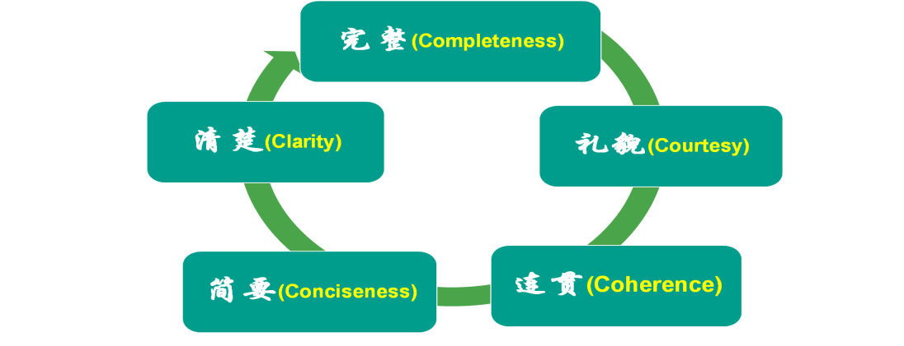

**PART 4 语篇对比与迁移**

**【类似题材：Z20 联考(二）】**

假定你是李华，上周末你参加了学校组织的市科技馆研学活动。请你在校英文论坛发表一篇帖子，分享此次经历，内容包括：

1.活动过程；

2.个人感悟；

3.期待评论。

注意：

1.写作词数应为 80 左右；

2.请按如下格式在答题卡的相应位置作答。

**An Unforgettable Tech Exploration Tour**

_______________________________________________________________________________

_______________________________________________________________________________

_______________________________________________________________________________

**【参考范文】**

Last weekend I participated in a fabulous tech exploration tour in the city science museum organized by our school.

It kicked off with an exhibition of the history of Chinese science, unfolding the awe-striking wisdom behind. What followed was a hands-on experience, which uncovered the secrets of science. With a lecture on the prospect of science, the tour was brought to an end. Not only did the tour instill me with a sense of pride in our scientific advances, but it also planted in my heart a seed of scientific exploration.

Anybody who shares the same feeling? Anticipating your comments!

**【类似话题：2023.12强基联盟】**

假定你是李华，你的外国朋友Daniel正在你的城市旅游。请写封邮件邀请他与你一起进行一次城市漫步（city walk），内容包括：

1.发出邀请；

2.介绍行程。

注意：

1.写作词数应为80左右；

2.请按如下格式在答题卡的相应位置作答。

**Dear Daniel,**

_______________________________________________________________________________

_______________________________________________________________________________

_______________________________________________________________________________

_______________________________________________________________________________

_______________________________________________________________________________

_______________________________________________________________________________

_______________________________________________________________________________

_______________________________________________________________________________

**Yours，**

**Li Hua**

**【参考范文】**

Dear Daniel,

I hope you’re having a wonderful time touring our city. You told me earlier that you are free this Sunday, so maybe we can do a city walk to explore some lesser-known sites and experience the authentic lifestyle here.

Here is my plan. We’ll meet at 9:00 am, at the old pagoda near my school to admire the beautiful architecture and soak in its cultural grandeur. Then, we can head to the ruins of the city wall built around 2,000 years ago, and feel first-hand the weight of history. Our next stop will be an ordinary bridge decorated with delicately carved stone lions, whose distinct facial features and vivid expressions will blow you away! After that, we can hitthe snack street to sample some street food and browse the unique handicrafts, some of which can make perfect souvenirs!

This city walk will make your trip truly complete. I really want to spend this Sunday with you and discover these hidden gems together. So, are you in?

Yours sincerely,

Li Hua