**教学设计：**

考试说明中评分标准有一项，与所给短文和段首句的衔接程度来评分，特别强调与所给句的衔接。针对学生续写中不充分解读所给句，所写句子不连贯，尤其是第二段所给句衔接涉及上一段最后一句和接下去的那一句设计了本堂课。

**第一部分**导入用生活中相亲的一段对话，让学生体会句子之间没衔接好会导致什么样的后果，希望活跃气氛和引出了课堂主题。

**第二部分**是第二段所给句和第一段最后一句的衔接，通过四句话，两组不同句子之间的写作和比较，让学生自主分析归纳什么时候需要衔接什么时候不需要，着重引导学生抓住代笔(衔接的指代)和where we are (衔接中的词汇指代)这种具有明显指向性的指代，并清楚如果不指代会让读者无法读懂这样的后果。**尤其重要的一点是要让学生讨论能不能从时间长短上去判断是否需要衔接，并给出2018年6月续写的那个段首句来总结归纳（A few minutes later, the other cyclists arrived）。**

**第三部分**是后一句与第二段所给句的指代。首先通过例子中三个写作版本来比较哪个版本衔接比较顺利，让学生通过自己的判断大致对怎么样衔接顺利有个概念。然后让学生写另外三句话，并指出所给句的关键词，自己是怎么写的，是怎么样来达到衔接的。接着通过学生习作来进行总结归纳。1. 这些习作中作者是如何来衔接的？归纳出1和2句是代词，3和4句是具体描写，并追问作者为什么要这样来衔接？从而归纳出一般原则: 判断所给句比较specific还是general，一般specific是用了动词之类的描写动作，general是形容词名词这种描写。

**第四部分**是总结23两部分内容和当堂用所学知识去判断和写。

课堂最后教师也指出，这个规则是对所写续写的归纳总结，学生在实际应用中要带着批判的思维去运用。总之，总而言之本堂课希望通过教师设置的问题引导学生运用分析，比较，归纳，批判等高阶思维对写作进行思考，发展思维品质。虽然重点关注第二段首句的衔接问题，但句子间的衔接是相通的，希望学生对句子衔接有一定的认识，可以应用到整篇续写中

**教学设问：**

1. Last week, I went to a blind dating and had dinner with a girl, hoping to fall in love with someone. But after a short conversation, she said “You’re the last one I want to chat with in the world.” I was heartbroken and confused. Can you help me figure out what’s wrong with our conversation? (no connection)

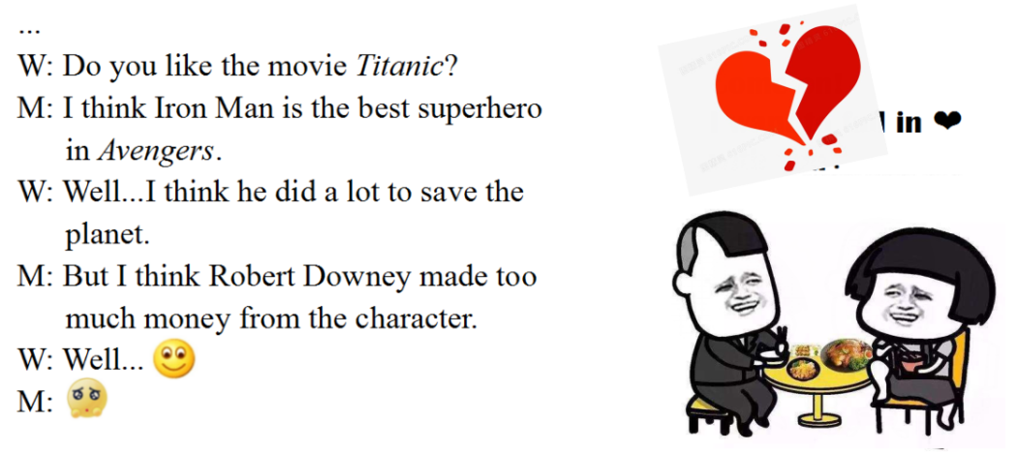

1. This is the same with our story completion. We’re asked to complete the story according to two given sentences and our writing is partially judged by the connection between the given sentences and our sentences. Today we’re going to solve two problems: (见PPT)

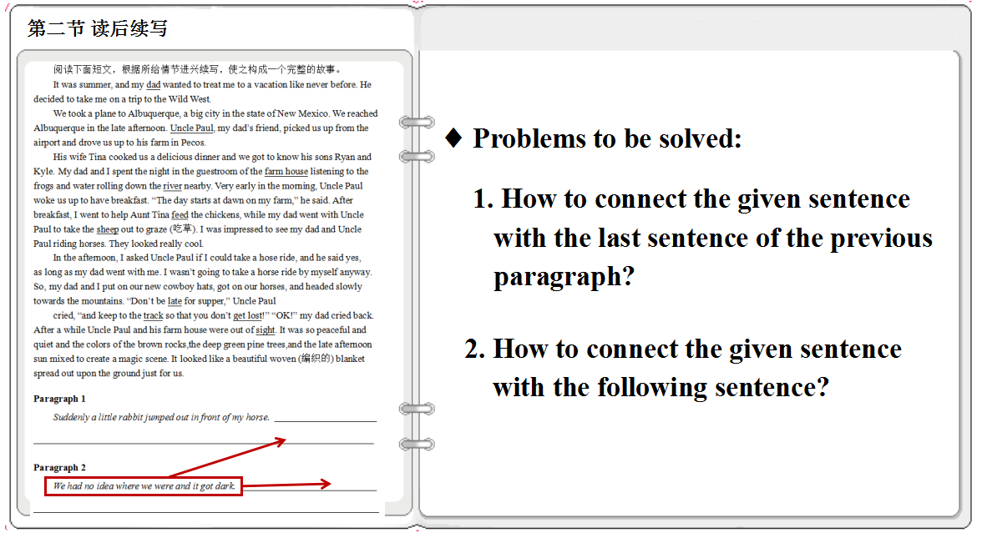

1. According to the four given sentences, think about two questions: Do we have to connect the given sentence with the last sentence of the previous paragragh? If so, how?

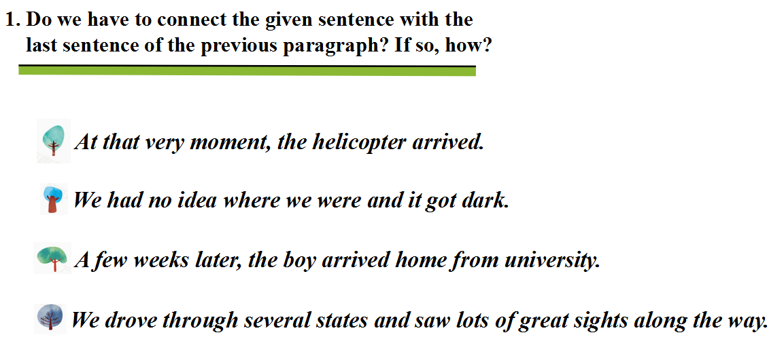

1. Why do we need a connection for sentence 1 and 2, and no connection for sentence 3 and 4?

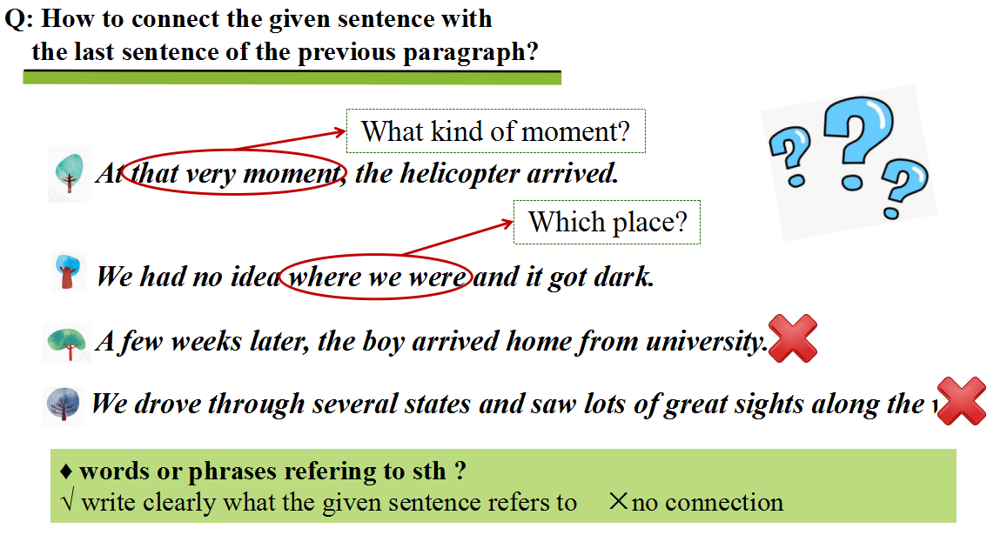

1. According to your understanding, which version is better connected?

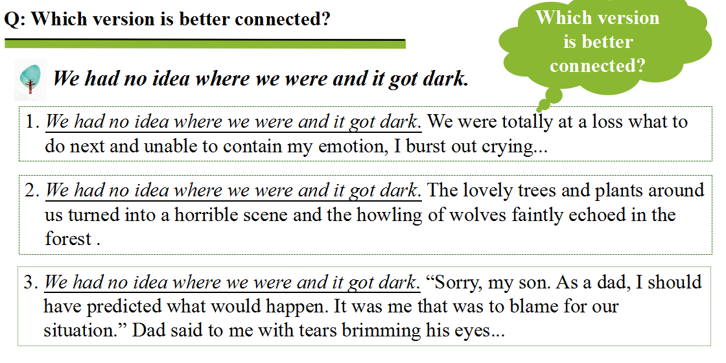

1. How will you connect the following sentence with the given sentence?

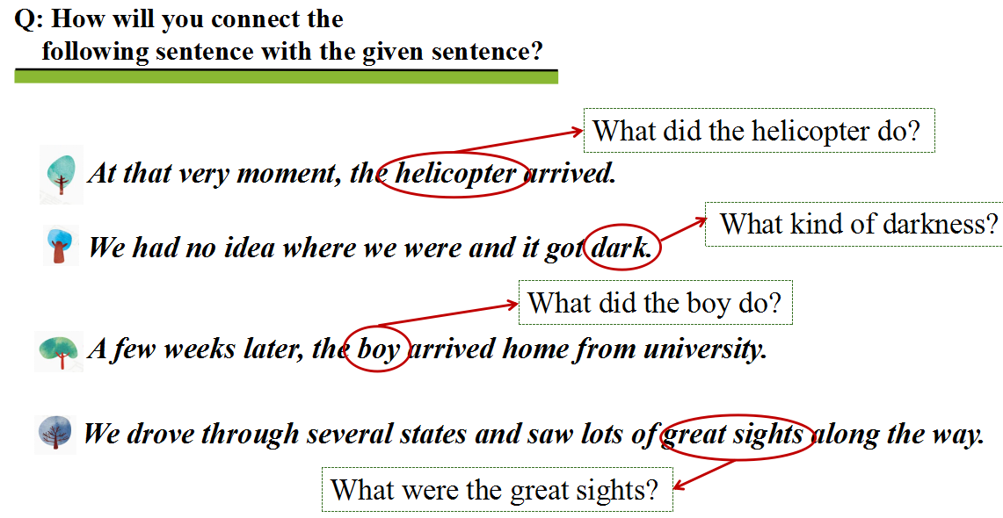

1. (1)How does the following sentences connect with the given sentences?

(2)Why do we connect them this way? That’s for sentence 1 and 2 using pronouns, but for sentence 3 and 4, using specific descriptions.

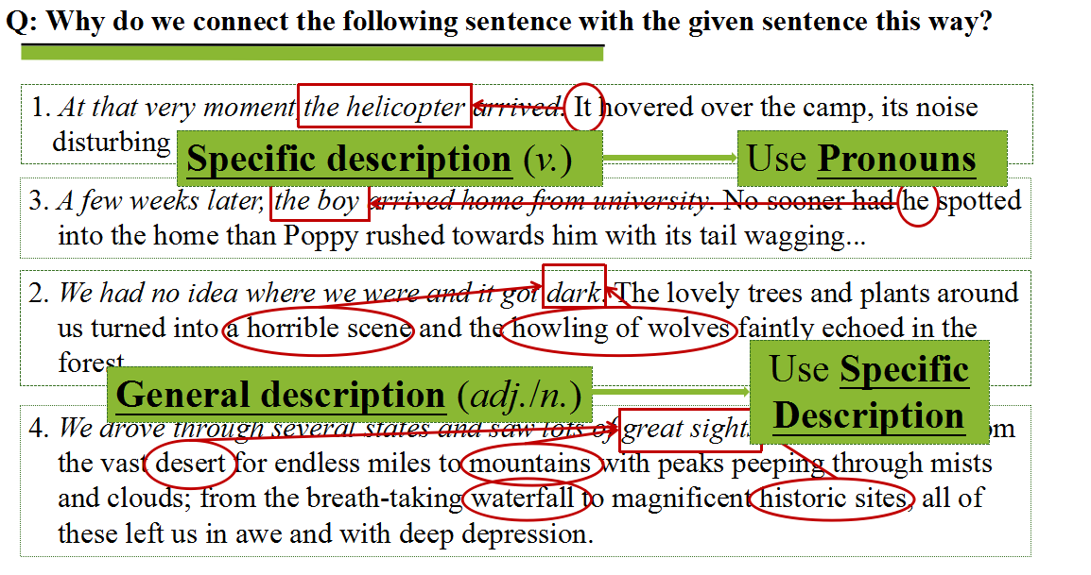

1. Draw a conclusion.

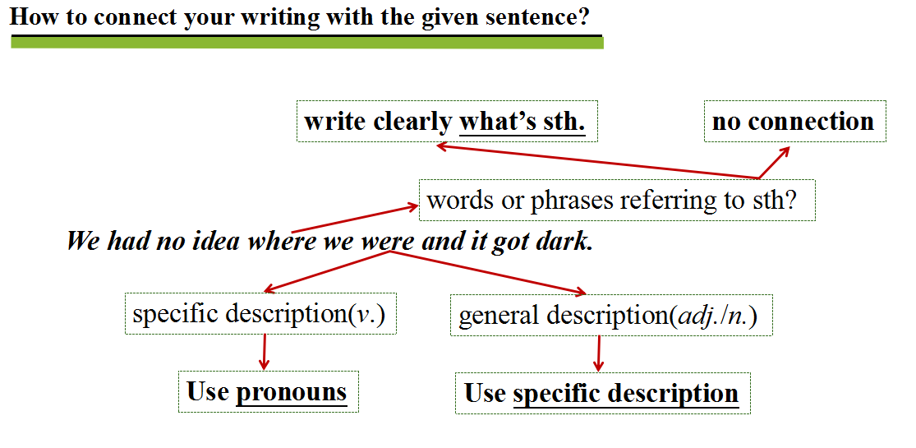

1. Practice based on what you’ve learned.

