**Welcome Unit-Reading and Thinking**

**教学目标**

1. Understand Han Jing’s mood and experience.
2. Know how to use some words and sentences to express their feelings on the first day of senior high.

**教学环节**

**Step 1 Leading–in**

Watch a video ：Lost On the First Day of High School.

What did the girl experience on the first day? What was her feeling?

Choose an emoji to describe their feelings on the first day of senior high school, and why? *I felt excited/happy/nervous... because/for the reason that…*

**Step 2 Skimming and scanning**

1. Skim the text and predict the topic by reading the title and looking at the pictures.

It’s about Han Jing’s first day at senior high school, her experience and her feelings.

1. Can you guess where the text is taken from?Social networking website!
2. Skim the text and decide which order Han Jing follows to talk about her first day. Time order or place order? Time order
3. Fast-reading: Scan the passage to find out time，place and underline or summarize Han Jing’s feelings.

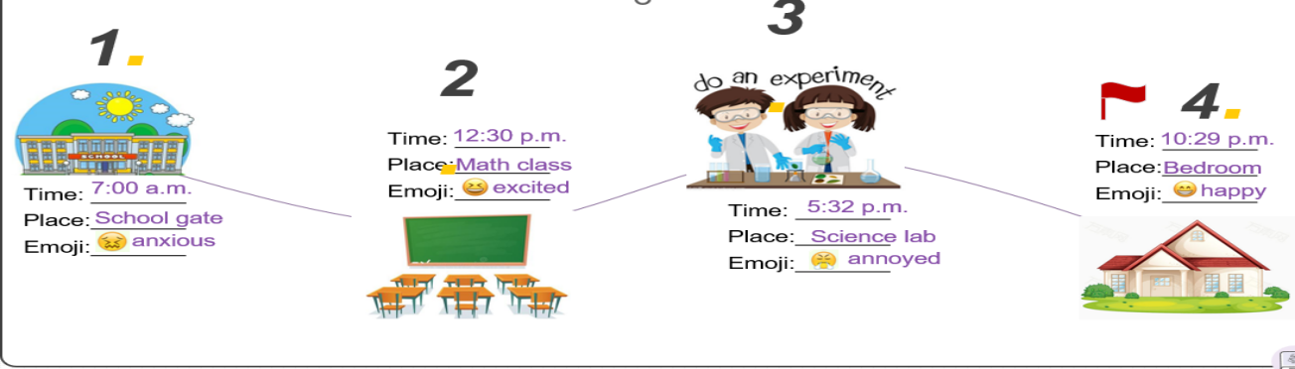

**Step3. Detailed reading**

Para1: Why did Han Jing feel anxious before school? Because she was a new senior high student and she was not outgoing. What was more, she was worried about whether she can make friends.

Para2: How was her first math class? It was difficult but the teacher was kind and friendly.

Para3: What happened in the chemistry class? What would you do if this happened to you?A guy next to Han Jing tried to talk with her and she couldn’t concentrate on the experiment. ;If I were Han Jing, I would tell him to keep quiet and leave me alone.

Para4: 1)What did Han Jing learn from her first day in senior high school? She learned that she would make new friends in her new class and there was a lot to explore in the new school.

2) Do you think Han Jing will lead a wonderful senior high school life? Why?

**Step4: Post-reading** What would you say to Han Jing?

**Step5: Summary and retell**

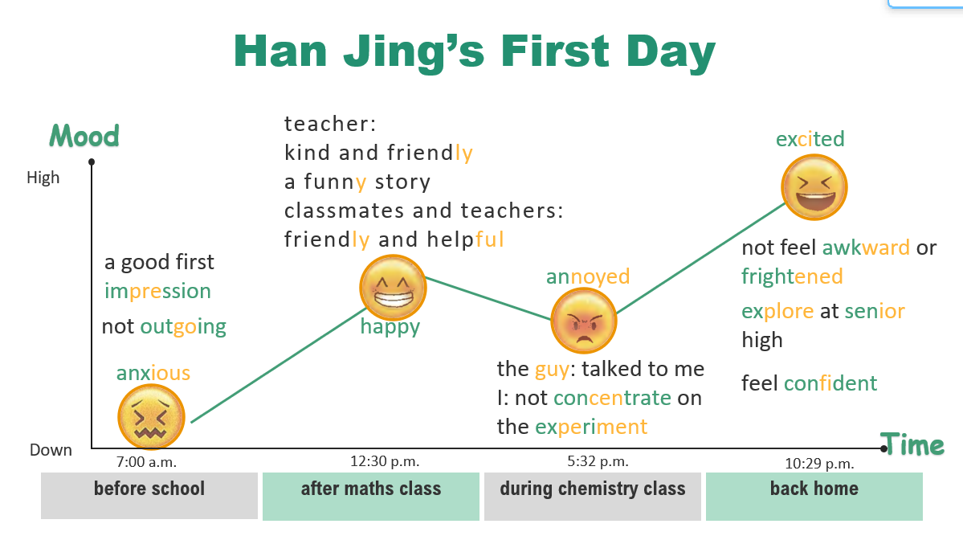

**Step6: Critical Thinking**

According to the writer, the high school life is full of challenges and difficulties. Work in groups, and share your opinions about what kind of attitudes we should have towards the future life?

Life if full of challenges and difficulties ,at the same time it is so mysterious that it is worthwhile for us to explore and face it with hope and confidence, especially for our teenagers ,who are energetic and positive.