A lesson Plan of M5U4 Reading and Thinking
龙泉一中 兰建珍
教师姓名 | 学校 | 上课学校与年级 | 课题名称
兰建珍 | 龙泉一中 | 龙泉一中，高二（5）班 | M5U4 Seeing the True North
课型 | Reading and Thinking
Aims | By the end of this lesson, students will be able to:  - master some relative new words and phrases: bay, arise, massive, literally,bound,awesome,peak,highlight,goat,drill, freeze, anticipate,  bunch, thunder, frost, take sb.’s breath away, grizzly bear, freezing  Cold by learning and practice；  2. learn and pay attention to some important writing tips（like logic (G-S,at a distance/at a close distance); picture; discourse markers, etc）by appreciating specific paragraph；  3. Write a paragraph about their sightseeing using beautiful language  (word—phrase—sentence) by putting what they learnt into practice.
Focus | 1. learn and pay attention to some important writing tips（like logic (G-S, at a distance/at a close distance); picture; discourse markers, etc）；  2. Write a paragraph about their sightseeing using beautiful language  (word—phrase—sentence).
Difficulty | Write a paragraph about their sightseeing using the tips and language they’ve learnt during this class.
Procedures | Step 1 Before you read  Lead-in by free talk after watching a short video  T: What did you see in the video? How did you feel about the sights?  Ss: Sights.  Ss: Breathtaking/amazing/spectacular/awesome/impressive...  T: It seems that there’re so many spectacular sights in Canada that took our breath away. Do you want to go sightseeing in Canada? Today we’re going to read about a long rail journey across Canada.  Intentions: Use the video to arouse what the students have already known about the topic to pave the way for later learning.  Step 2 While you read  - Two Ss’presentation about their understanding of the passage representing their groups after their self study before this class.  - T lead Ss to go into the details of the text:  Para.1:  T: What’s the main idea of the passage? Could you give me any key word?  Ss: Introduction...Background...  T: There are 3 sentences in this paragraph, Sentence1 offers “4W”, Sentence2 offers “How did they go?” Sentence3 offers “How did they feel?”  Para.2:  ①Find out the time and activities;  ②How is this paragraph organized?—Logic?—Tip 1: logic!（G—S）;  ③What’s the function of the discourse markers?  Para.3:  ＊How do you appreciate this paragraph?  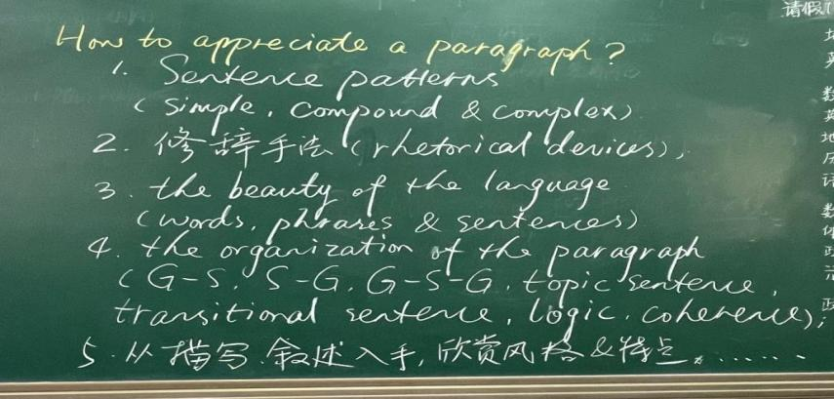  ＊What did they see in this paragraph?  ① the mountains and forests of Canada:  at a distance:  1. Seen from the train window, the mountains and forests of Canada  looked massive.  2. In addition to seeing spectacular mountain peaks and forests,...  at a close distance:  拓展：  1.The peaceful landscape is a true feast for the eyes, with its rolling green hills dotted with goats and deer.  2.Down by the lake, the sound of rippling water and chirp of the seabirds literally make up the music of the bay.  Tip 2: Picture the scenery/imagination and go into details  —— to show not just to tell.  ②the blue water of Lake Louise:  When the train arrived at the station, they took a taxi to Lake Louise where the blue water literally took their breath away with its exceptional beauty.  ③many different creatures：  G: In addition to seeing spectacular mountain peaks and forests, one highlight of their trip was being able to see many different creatures, including deer, mountain goats, and even a grizzly bear and an eagle.  S: As the train thundered on, we found an eagle hovering over the surface of the blue water, which literally took my breath away.  ＊How did they feel? Why?  Looking at the beautiful scenery, they both agreed that it was the most awesome journey they had ever taken.  In addition to seeing spectacular mountain peaks and forests, one highlight of their trip was being able to see many different creatures, including deer, mountain goats, and even a grizzly bear and an eagle.  Para.4:  Q:What do you know about Edmonton after reading this paragraph?  From which 4 aspects is Edmonton introduced in this paragraph?  politics＋natural resources+climate+economics  Para.5:  1.How did they feel? Why?  Amazed——Canada's population is only slightly over thirty-seven million. However, they did not anticipate seeing such an open country.  - What rhetorical devices are used here? —— however—Contrast!  Tip3: Use proper discourse markers to show relationships.  Para.6: their sightseeing from Winnipeg to Toronto  Which sentences impress you most?  The train thundered on, through the rolling hills. The bushes and maple trees outside their windows were red, gold, and orange, and there was frost on the ground, confirming that autumn had arrived in  Step 3 After you read  1.What might be talked about next in the journal?  2. Assignments:  Write a paragraph about the “pictures” of your sightseeing tour of any place you have visited.  Requirements:  1. Put the tips given in class into practice;  Tip 1: logic!（G — S; at a distance/at a close distance）；  Tip 2: Picture the scenery/imagination and go into details；  Tip3: Use proper discourse markers ——coherence.  2.Make your paragraph impressive using beautiful language  (word—phrase—sentence);  3. in order of time or space.
Blackboard Design | 