**The World**（**0901-0915**）材料分析和教学目标：

本次选用的材料：①*The Week*的*The world at a glance*（看世界）、②*The Times*的*Junk food adverts banned before 9pm to take weight off NHS*（英国拟晚9点前禁放垃圾食品广告）、③*BBC Wildlife*的*Tiny satellites detect fire*（微型卫星探测火灾）、④*The Guardian*的*Grid has greenest ever summer as fossil fuel use falls below 20%* （英国电网迎来了有史以来最环保的夏季 ）和⑤BBC的新闻报道。通过语法填空、阅读理解、分析长难句、翻译句子、听力填空和词汇拓展等方式，让学生从多角度提升学习兴趣，提高分析句子、运用词块和听力能力。外媒英语新闻可以让学生体验真实语境下的语言运用，拓展学生的国际视野，了解时事，逐步提升跨文化沟通能力，形成正确的世界观、人生观和价值观。

**教学思路：**

**Part 1: News Report 1 *The Week* (September 6, 2024 P8)**

**The world at a glance 看世界**

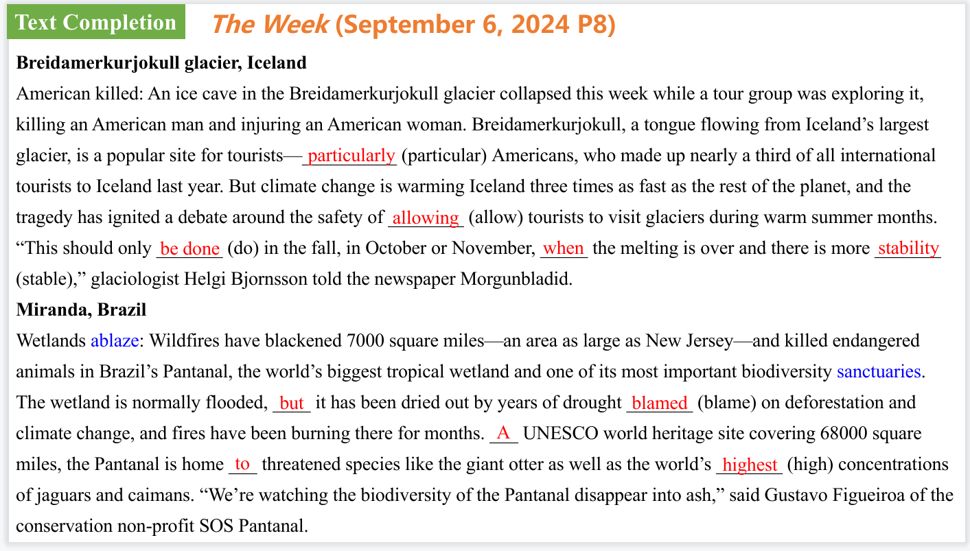

【设计意图】通过语篇填空的形式帮助学生理解新闻的主要内容，同时训练语言语法的运用能力：在语篇的视角下如何正确使用所给词汇，根据语法规则确定词汇的正确形式，使得文章通顺，激活学生的思维和语言。该新闻主题语境是关于“人与社会”中“社会热点问题”这一子主题，通过学习让学生了解两则新闻。

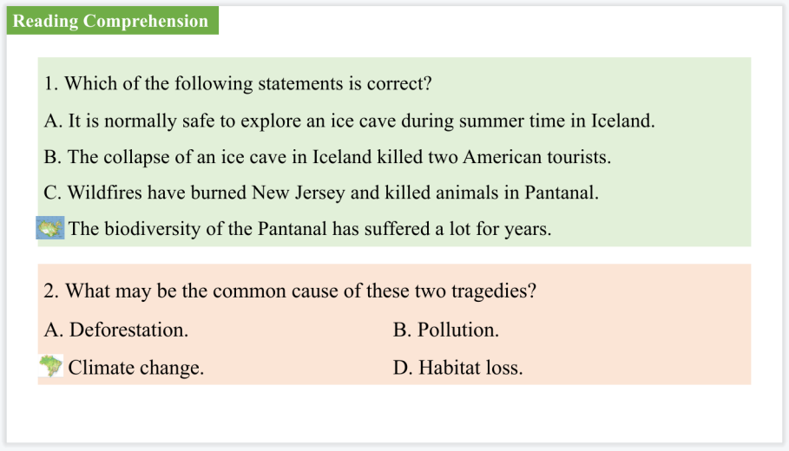

【设计意图】通过阅读理解的形式帮助学生理解新闻的主要内容。

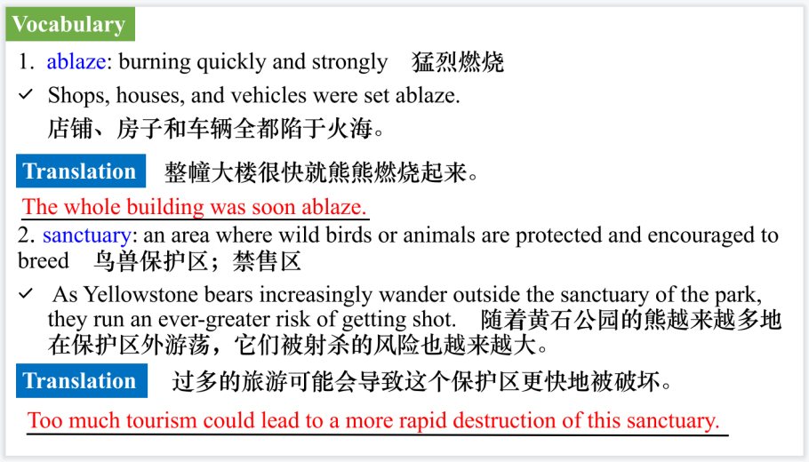

【设计意图】对文本中的词汇进行解读，并通过翻译句子对其进行巩固。

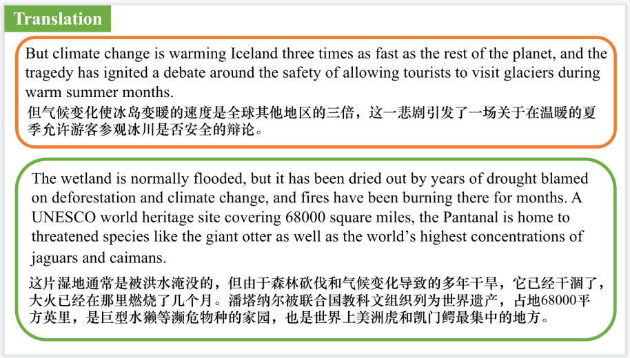

【设计意图】对文中的两个句子进行翻译练习，对其中单词、词组、句法进行巩固并关注句子结构。

**Part 2: News Report 2** ***The Times* (September 13, 2024 P1&6)**

**Junk food adverts banned before 9pm to take weight off NHS**

**英国拟晚9点前禁放垃圾食品广告**

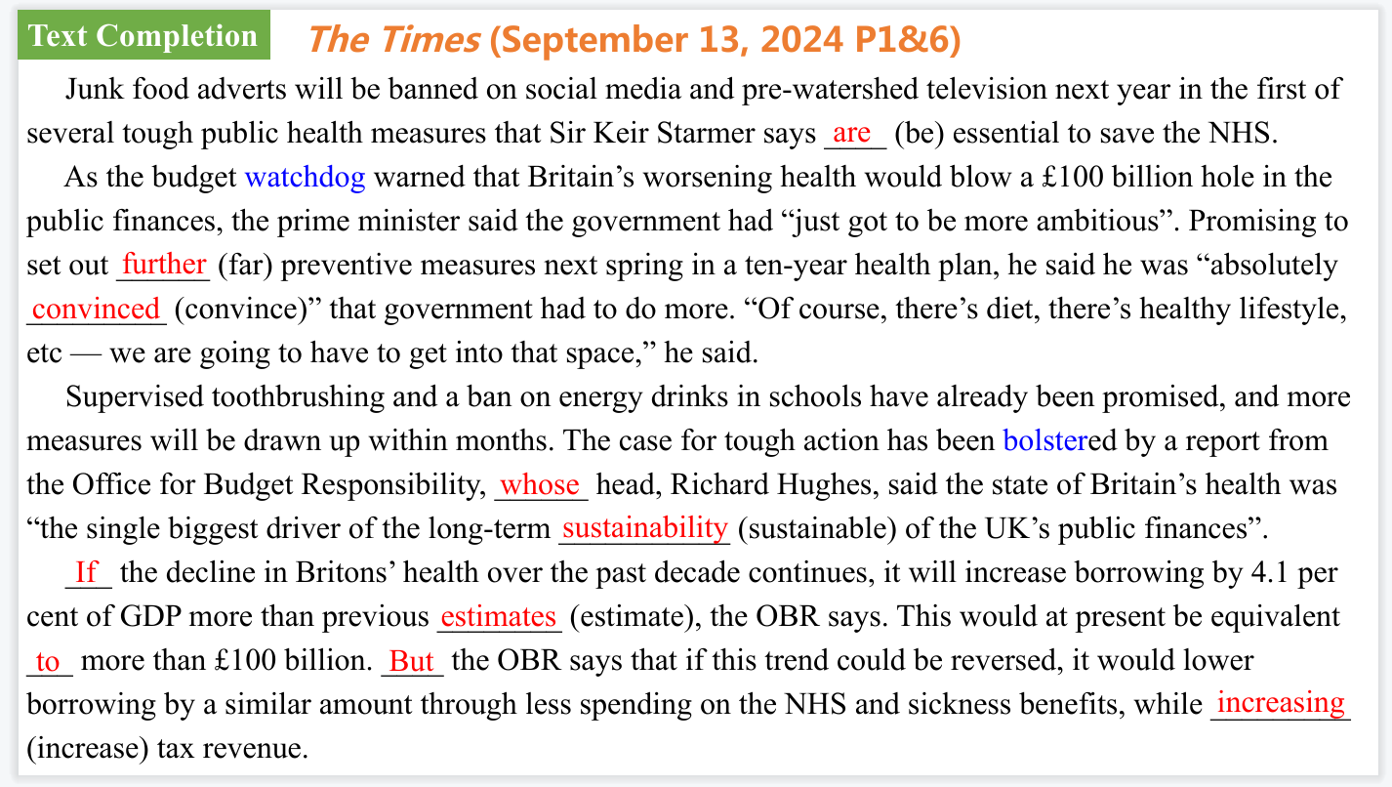

【设计意图】通过语篇填空的形式帮助学生理解新闻的主要内容，同时训练语言语法的运用能力：在语篇的视角下如何正确使用所给词汇，根据语法规则确定词汇的正确形式，使得文章通顺，激活学生的思维和语言。该新闻主题语境是关于“人与社会”中“社会热点问题”这一子主题，通过学习让学生了解关于英国拟晚9点前禁放垃圾食品广告的新闻。

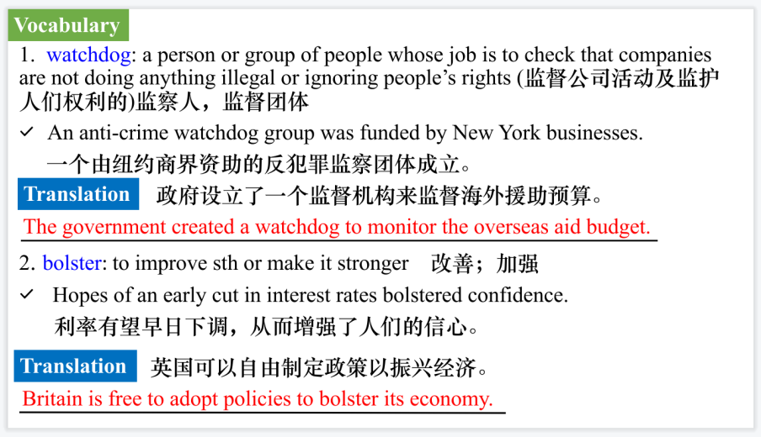

【设计意图】对文本中的词汇进行解读，并通过翻译句子对其进行巩固。

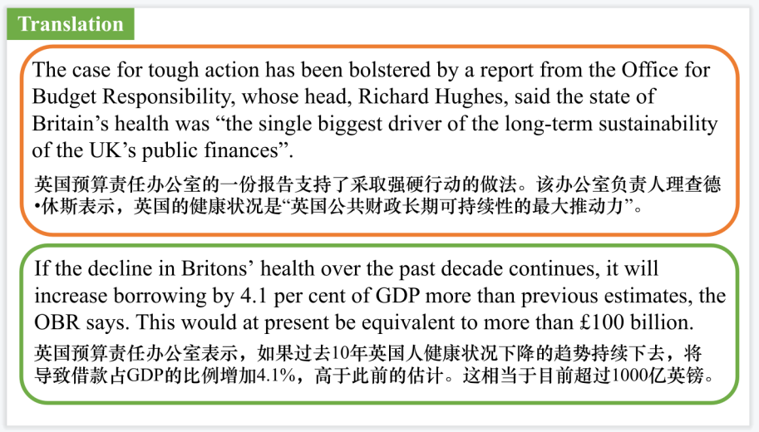

【设计意图】对文中的两个句子进行翻译练习，对其中单词、词组、句法进行巩固并关注句子结构。

**Part 3: News Report 3** ***BBC Wildlife* (June 2024 P14)**

**Tiny satellites detect fire 微型卫星探测火灾**

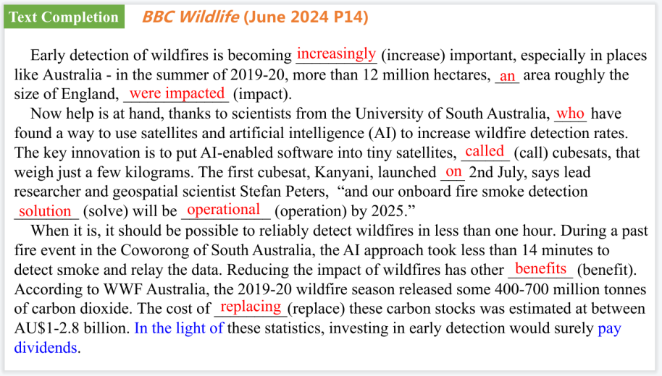

【设计意图】通过语篇填空的形式帮助学生理解新闻的主要内容，同时训练语言语法的运用能力：在语篇的视角下如何正确使用所给词汇，根据语法规则确定词汇的正确形式，使得文章通顺，激活学生的思维和语言。该新闻主题语境是关于“人与社会”中“社会热点问题”这一子主题，通过学习让学生了解微型卫星探测火灾的最新科技。

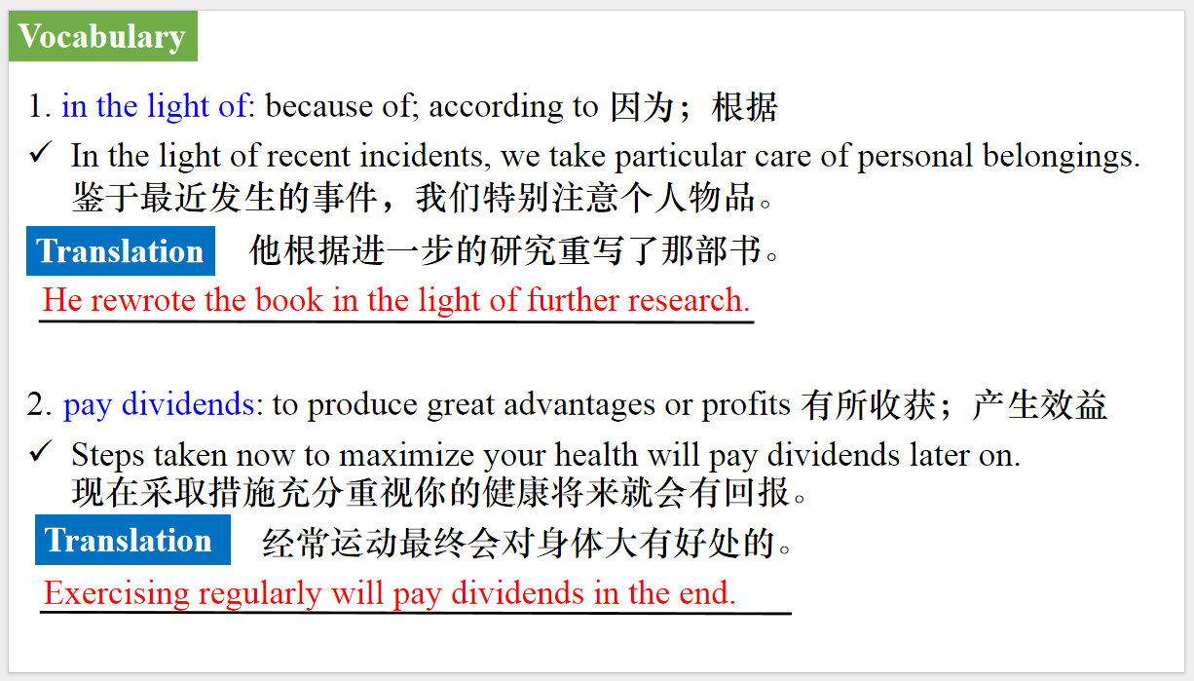

【设计意图】对文本中的词汇进行解读，并通过翻译句子对其进行巩固。

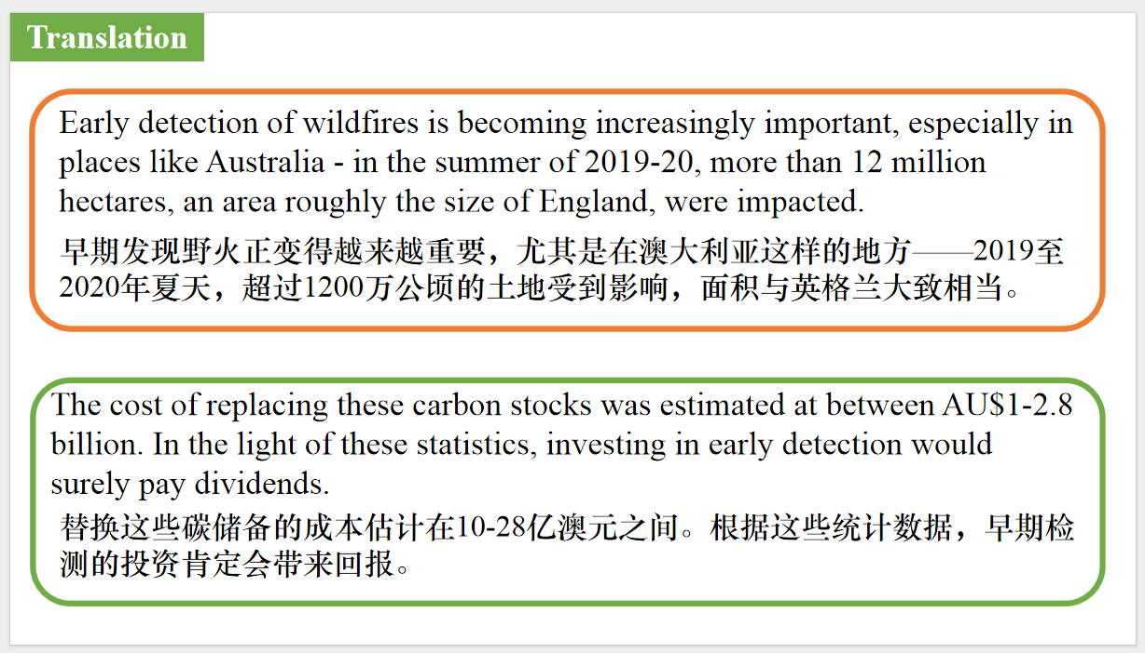

【设计意图】对文中的两个句子进行翻译练习，对其中单词、词组、句法进行巩固并关注句子结构。

**Part 4: News Report 4** ***The Guardian* (7 September 2024 P15)**

**Grid has greenest ever summer as fossil fuel use falls below 20%**

**英国电网迎来了有史以来最环保的夏季**

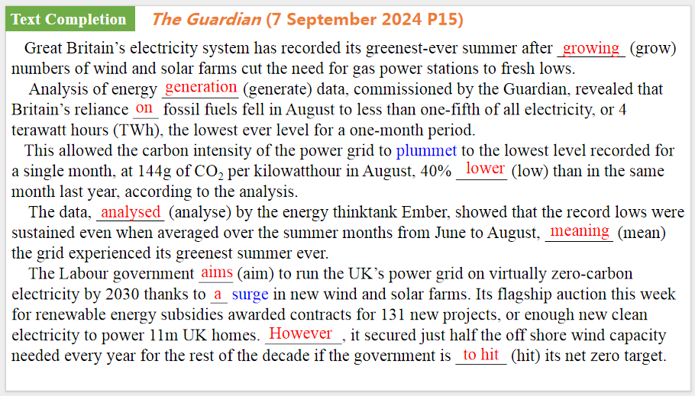

【设计意图】通过语篇填空的形式帮助学生理解新闻的主要内容，同时训练语言语法的运用能力：在语篇的视角下如何正确使用所给词汇，根据语法规则确定词汇的正确形式，使得文章通顺，激活学生的思维和语言。该新闻主题语境是关于“人与社会”中“社会热点问题”这一子主题，通过学习让学生了解英国电网迎来了有史以来最环保的夏季的新闻。

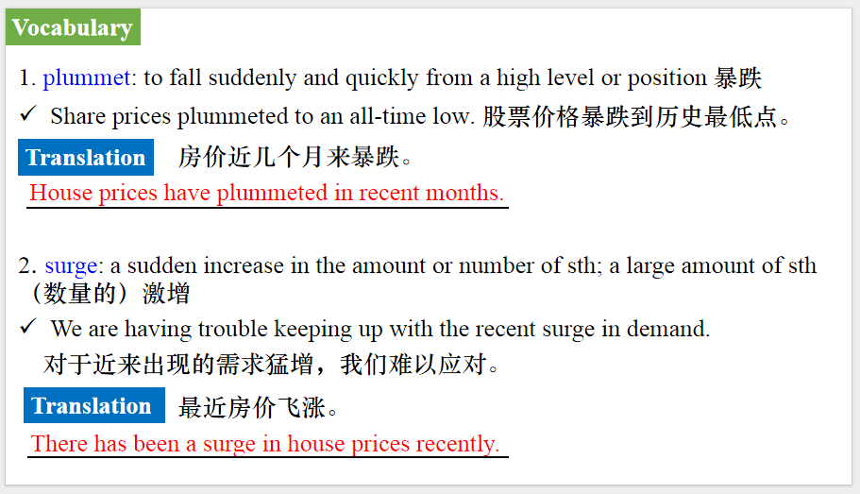

【设计意图】对文本中的词汇进行解读，并通过翻译句子对其进行巩固。

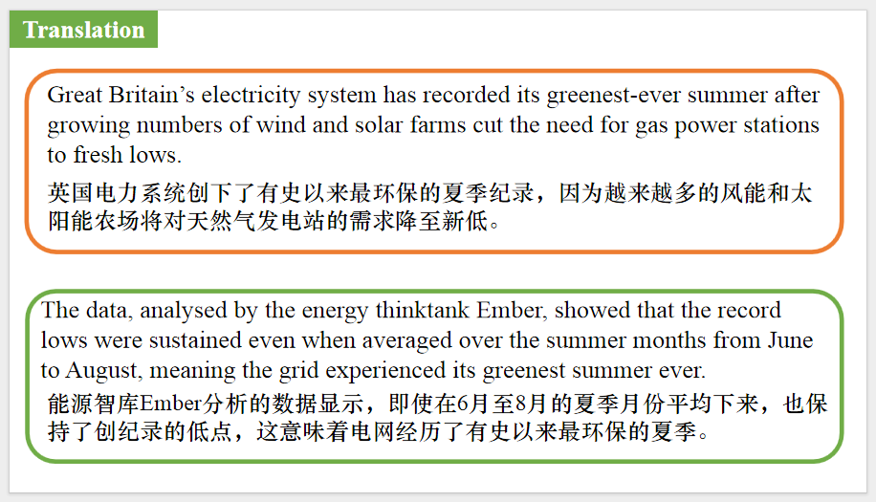

【设计意图】对文中的两个句子进行翻译练习，对其中单词、词组、句法进行巩固并关注句子结构。

**Part 5: BBC News 09/02/2024**

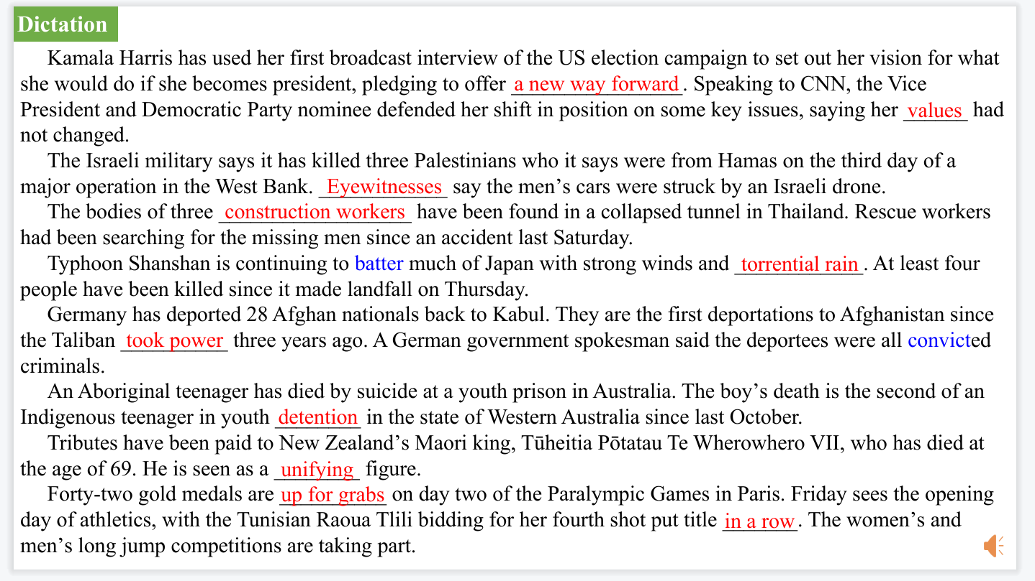

【设计意图】听一则材料，通过听力填空的方式理解文本，考察听力辨识词汇的能力。

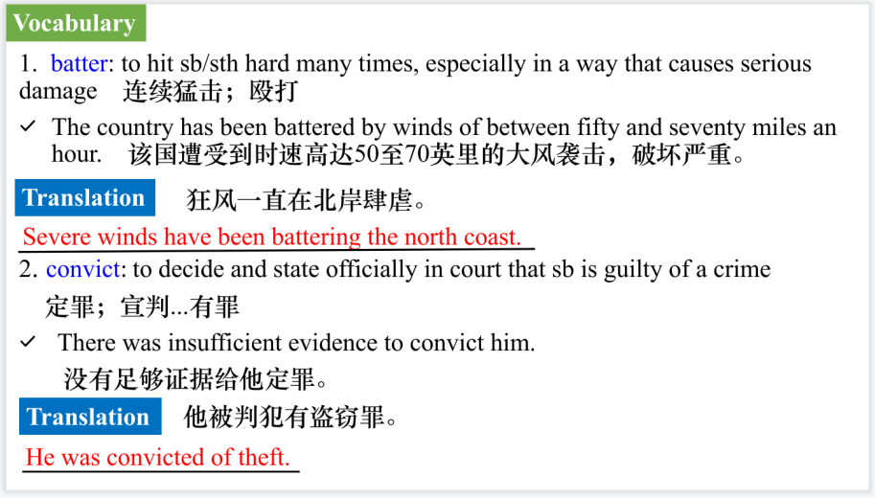

【设计意图】对文本中的词汇进行解读，并通过翻译句子对其进行巩固。

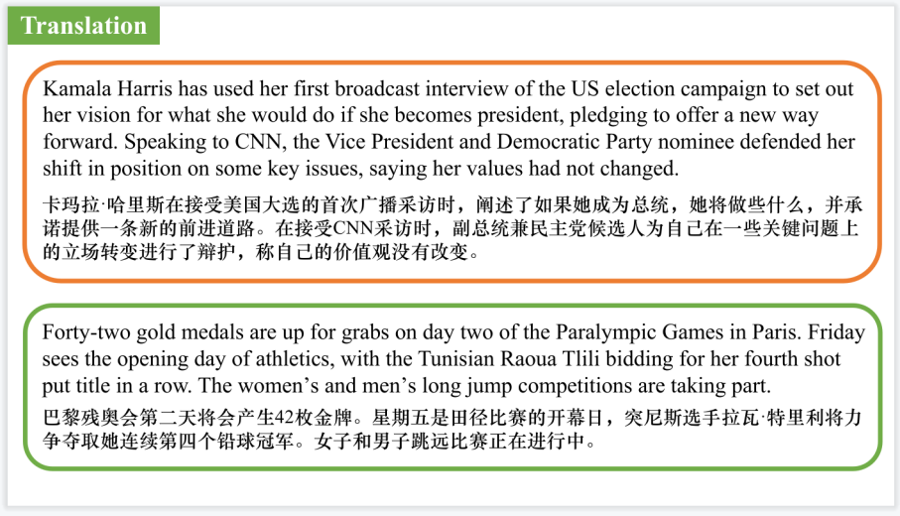

【设计意图】对文中的两个句子进行翻译练习，对其中单词、词组、句法进行巩固并关注句子结构。

附：外刊原文

**Part 1: News Report 1 *The Week* (September 6, 2024 P8)**

**The world at a glance 看世界**

**Breidamerkurjokull glacier, Iceland**

American killed: An ice cave in the Breidamerkurjokull glacier collapsed this week while a tour group was exploring it, killing an American man and injuring an American woman. Breidamerkurjokull, a tongue flowing from Iceland’s largest glacier, is a popular site for tourists—particularly Americans, who made up nearly a third of all international tourists to Iceland last year. But climate change is warming Iceland three times as fast as the rest of the planet, and the tragedy has ignited a debate around the safety of allowing tourists to visit glaciers during warm summer months. “This should only be done in the fall, in October or November, when the melting is over and there is more stability,” glaciologist Helgi Bjornsson told the newspaper Morgunbladid.

**Miranda, Brazil**

Wetlands ablaze: Wildfires have blackened 7000 square miles—an area as large as New Jersey—and killed endangered animals in Brazil’s Pantanal, the world’s biggest tropical wetland and one of its most important biodiversity sanctuaries. The wetland is normally flooded, but it has been dried out by years of drought blamed on deforestation and climate change, and fires have been burning there for months. A UNESCO world heritage site covering 68000 square miles, the Pantanal is home to threatened species like the giant otter as well as the world’s highest concentrations of jaguars and caimans. “We’re watching the biodiversity of the Pantanal disappear into ash,” said Gustavo Figueiroa of the conservation non-profit SOS Pantanal.

**Part 2: News Report 2 *The Times* (September 13, 2024 P1&6)**

**Junk food adverts banned before 9pm to take weight off NHS**

**英国拟晚9点前禁放垃圾食品广告**

Junk food adverts will be banned on social media and pre-watershed television next year in the first of several tough public health measures that Sir Keir Starmer says are essential to save the NHS.

As the budget watchdog warned that Britain’s worsening health would blow a £100 billion hole in the public finances, the prime minister said the government

had “just got to be more ambitious”.

Ministers said that a 9pm TV watershed for promoting foods high in fat, salt and sugar, proposed by Boris Johnson in 2021, would go ahead in October next year after repeated delays. Such ads will be banned online at any time.

Starmer has already signalled that he will ban smoking in pub gardens and other outdoor spaces, and has said he is willing to take on accusations of the “nanny state” to make Britain healthier.

“I know some prevention measures will be controversial, but I’m prepared to be bold, even in the face of loud opposition,” he said.

Promising to set out further preventive measures next spring in a ten-year health plan, he said he was “absolutely convinced” that government had to do more. “Of course, there’s diet, there’s healthy lifestyle, etc — we are going to have to get into that space,” he said.

Supervised toothbrushing and a ban on energy drinks in schools have already been promised, and more measures will be drawn up within months. The case for tough action has been bolstered by a report from the Office for Budget Responsibility, whose head, Richard Hughes, said the state of Britain’s health was “the single biggest driver of the long-term sustainability of the UK’s public finances”.

If the decline in Britons’ health over the past decade continues, it will increase borrowing by 4.1 per cent of GDP more than previous estimates, the OBR says. This would at present be equivalent to more than £100 billion.

But the OBR says that if this trend could be reversed, it would lower borrowing by a similar amount through less spending on the NHS and sickness benefits, while increasing tax revenue.

Andrew Gwynne, the public health minister, said that a third of children were overweight by the time they left primary school and “we want to tackle the problem head on and that includes implementing the restrictions on junk food advertising on TV and online without further delay”.

Katharine Jenner, director of the Obesity Health Alliance, said: “For too long the food industry has consistently pushed back on these incoming restrictions, saying they need to have ‘more time to prepare’. Not any more.”

Although Wes Streeting, the health secretary, says he is reluctant to impose sugar and salt taxes, ministers are beginning to draw up measures to reverse a decline in Britain’s health.

Spending on the NHS is rising twice as fast as economic growth and Hughes said there was “clearly an unsustainable trajectory” there. He said that big improvements in public health could make a key difference to public finances, adding: “You do need to intervene during people’s adult working lives.”

**Part 3: News Report 3 *BBC Wildlife* (June 2024 P14)**

**Tiny satellites detect fire 微型卫星探测火灾**

Early detection of wildfires is becoming increasingly important, especially in places like Australia - in the summer of 2019-20, more than 12 million hectares, an area roughly the size of England, were impacted.

Now help is at hand, thanks to scientists from the University of South Australia, who have found a way to use satellites and artificial intelligence (AI) to increase wildfire detection rates. The key innovation is to put AI-enabled software into tiny satellites, called cubesats, that weigh just a few kilograms. The first cubesat, Kanyani, launched on 2nd July, says lead researcher and geospatial scientist Stefan Peters, “and our onboard fire smoke detection solution will be operational by 2025.”

When it is, it should be possible to reliably detect wildfires in less than one hour. During a past fire event in the Coworong of South Australia, the AI approach took less than 14 minutes to detect smoke and relay the data. Reducing the impact of wildfires has other benefits. According to WWF Australia, the 2019-20 wildfire season released some 400-700 million tonnes of carbon dioxide. The cost of replacing these carbon stocks was estimated at between AU$1-2.8 billion. In the light of these statistics, investing in early detection would surely pay dividends.

**Part 4: News Report 4 *The Guardian* (7 September 2024 P15)**

**Grid has greenest ever summer as fossil fuel use falls below 20%**

**英国电网迎来了有史以来最环保的夏季**

Great Britain’s electricity system has recorded its greenest-ever summer after growing numbers of wind and solar farms cut the need for gas power stations to fresh lows.

Analysis of energy generation data, commissioned by the Guardian, revealed that Britain’s reliance on fossil fuels fell in August to less than one-fifth of all electricity, or 4 terawatt hours (TWh), the lowest ever level for a one-month period.

This allowed the carbon intensity of the power grid to plummet to the lowest level recorded for a single month, at 144g of CO2 per kilowatthour in August, 40% lower than in the same month last year, according to the analysis.

The data, analysed by the energy thinktank Ember, showed that the record lows were sustained even when averaged over the summer months from June to August, meaning the grid experienced its greenest summer ever.

The Labour government aims to run the UK’s power grid on virtually zero-carbon electricity by 2030 thanks to a surge in new wind and solar farms. Its flagship auction this week for renewable energy subsidies awarded contracts for 131 new projects, or enough new clean electricity to power 11m UK homes. However, it secured just half the off shore wind capacity needed every year for the rest of the decade if the government is to hit its net zero target.