Unit 3

FASCINATING PARKS

Discover useful structures  
The -ing form as the subject **教学设计**

**教学目标：**To learn and practise the -ing form used as subject.

**教学过程：**

一、Leading-in

Showing some pictures and make some sentences according to the Chinese reference .

1.Visiting theme parks can bring you into different world.

2. Going to the Cambridge University is my dream.

V-ing form used as the subject

3. Travelling is a good way to relax.

4. Playing basketball makes me happy.

5. Laughing at others is impolite.

6. Being a basketball player like Kobe has been my life goal.

二、While-class

Activity 1:Find more sentences with the –ing form as the subject from the reading passage.

***1.Being in such a beautiful and wild place*** makes me feel blessed to be alive.

2.Even though the sun is brightly shining, ***telling whether it is morning or night***is impossible.

***3.Getting here*** is quite difficult, so apart from the Semi very few people have ever seen Sarek.

4.For hundreds of years, ***looking after reindeer*** was a way of life for the Sami.

**A.Observe and discover 1 .**

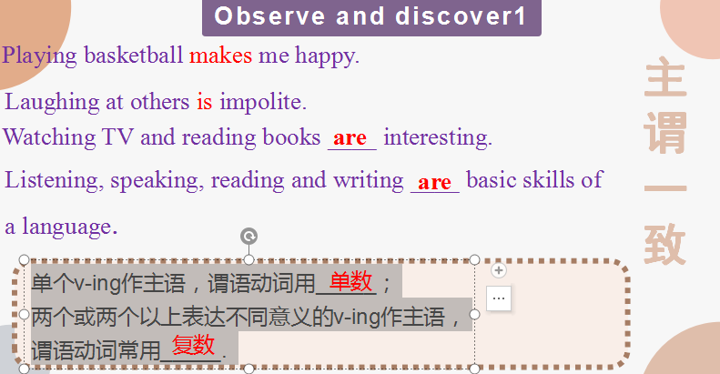

1. **Observe and discover 2 .**

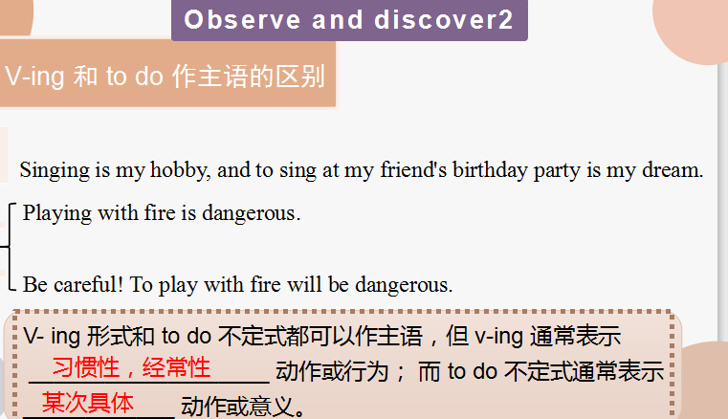

**C. Observe and discover 3 .**

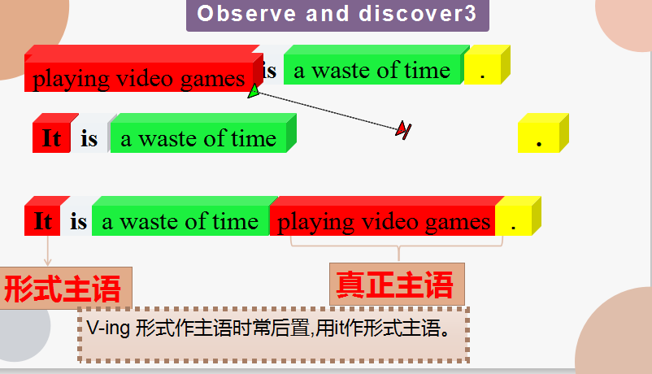

It is a waste of time doing... 做...是浪费时间的

It is / was no good / use doing.. 做... 是没用的

It is /was hardly / scarcely worth doing... 做... 是不值得的

It is worth / worthwihile doing ... 做... 是值得的

**D. Observe and discover 4 .**

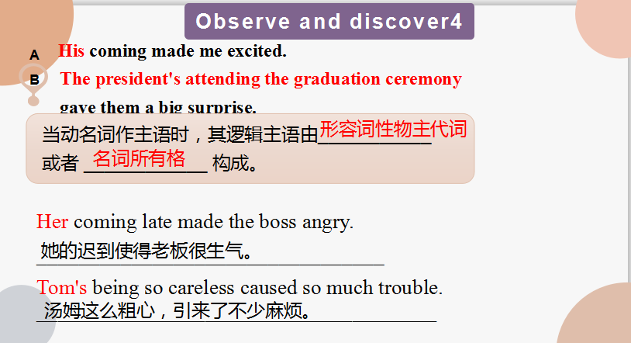

**E. Pactice and Apply**

