Unit 2 Healthy Lifestyle
Period 5 using language(2)：
write a letter to the editor about your lifestyle
Teaching Objectives
1.Know the writing type of the passage
2.Deepen the reading skills, such as summarizing, skimming and scanning.
3.Write a letter about one’s lifestyle
Teahing procedures
Step One：Lead in
What problems do you think you have about your lifestyle?
Suppose you intend to write a letter to the editor about your lifestyle，what contents should be included and in what way？
What should be the contents and logic of your letter?
1. What was the problem?——Problem
2. How did you decide to change that bad habit?——Decision
3. What did you do to change that?——Action
4. What is the result?——Result
What tense should you use for each part?Past tense/present tense
Step Two: Reading
Two letters from students to the editor, who attended the summer camp organized by the magazine Healthy Life
Activity 1:Reading for the main idea
What are the main ideas of the two letters?
The two letters mainly talk about the healthy lifestyle of the two students.
Activity 2:Reading for the structure
Read and analyze the organization of the letter and label the paragraphs using the letters below.
A: identifying problems.
B . considering what to do
C: what he/she has done to change
D: the results
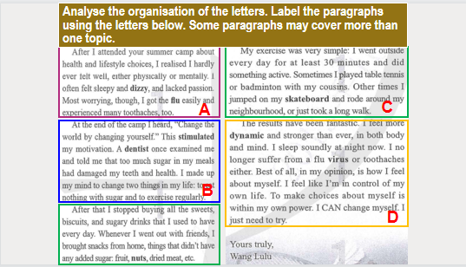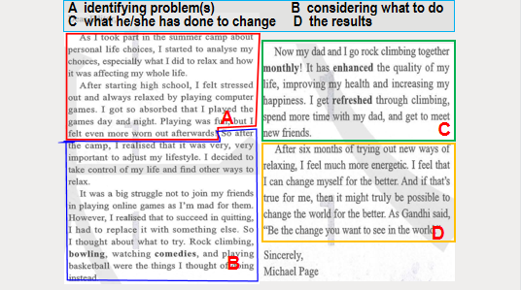
Summary
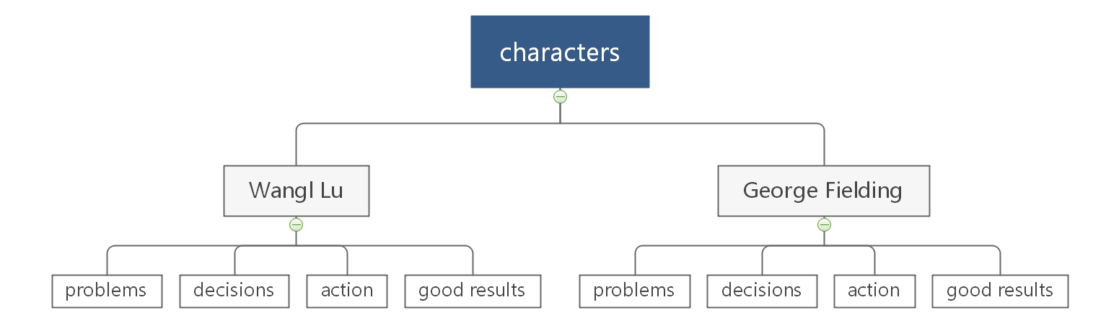
Activity 3:Reading for the details
Student 1 Wang Lu Student 2 George Fielding
 | Wang Lulu | Michael Page
Problem | did not feel well, either physically or mentally  felt sleepy and dizzy, lacked passion  got the flu easily, experienced many toothaches | felt stressed out  felt even more worm out  after playing computer games day and night
Decision | to eat nothing with sugar  to exercise regularly | to adjust his lifestyle; take control of his life and find other ways to relax
Action | stopped buying all the sweets, biscuits and sugary drinks  Exercises every day for at least 30 minutes | goes rock climbing, bowling, watching comedies, and playing basketball.
Result | more dynamic and stronger than ever in both body and mind  sleeps soundly, no longer suffer from a flu virus or toothaches  feels like he is in control of his own life | feels much more energetic  feels he can change himself for the better
Activity 4:Reading for tenses
Filling in the blanks and feel the tenses in the passage
Wang Lu and George Fielding attended the summer camp 1 ____________（organize） by the magazine Healthy Life. At the end of the camp，what Wang Lu heard stimulated her 2____________（motivate）. She made up her mind 3_________ （eat） nothing with sugar and to exercise regularly. Now she sleeps soundly at night and feels 4__________________（dynamic） than ever.
In the meanwhile，George Fielding has changed himself 5_________the better. He used to get so absorbed 6_________he played the games day and night. However，after the camp，he 7_________（take） control of his life though it was 8_________ big struggle not to play online games. Now he and his dad go rock climbing together 9 _________（month）. It has enhanced the quality of his life，10___________ （improve） his health and increasing his happiness.
Step 4 Writing
Writing task: The magazine Healthy Life is organising this year's summer camp. They invite interested teenagers to write to the editor about how they plan to change their bad habits. The campers will be chosen accordingly.
Activity 5: Pre-writing: Brainstorm
What lifestyle habit you would like to change?
Why you want to change?
How you plan to change?
What result you hope to see?
Checklist
Does the letter say what the writer's problem is?
Does the letter explain the decisions the writer made to solve the problem?
Does the letter show the ways to change?
Are the results included in the letter?
Can you see the writer's attitude and determination in the letter?
Is the letter clear and complete?
Sample writing:
Dear editor,
I was walking past a shop window the other day when I saw my reflection. At first, I didn’t realise it was me. When I saw it was me, I felt sad as I am overweight. I didn’t realise how I looked, and I really want to change. I really like eating, but I realise I eat too much, and I don’t eat good things.
I want to change because I want to be able to look at myself and feel happy with how I look. I also want to be healthy.
My plan is to change my diet and exercise routine. I will stop eating sugar, and only eat at mealtimes rather than eating snacks during the day. I will focus on healthy foods. Then I will exercise every day. I will walk to school and back, and on the weekend, I will go swimming. I have only been doing my plan for a week, but I’m already starting to feel better. I haven’t lost a lot of weight yet, but to do anything makes me feel positive. I feel confident I will reach my goal!
Yours sincerely,
A . Smith

