高中英语应用文---约稿信学案

杭州二中树兰高级中学 郭合英

**Teaching goals：**

After learning this lesson, the students will learn:

1. Cultivate the students’ ability to comprehend the question carefully.
2. Learn about the structure.
3. Apply the proper format of the letter.
4. Build up some appropriate expressions
5. Mind your tone in the letter.
6. Make your writing more coherent.
7. Know what a good letter is like.

**Teaching focus：**

1. Cultivate the students’ ability to comprehend the question carefully.
2. Learn about the structure.
3. Apply the proper format of the letter.
4. Build up some appropriate expressions

**Teaching difficulties：**

1. Cultivate the students’ ability to comprehend the question carefully.
2. Build up some appropriate expressions.

**Teaching process：**

**Step 1. Lead in**

Discuss: When do we need to write solicitation letters ?

**Step 2.** Cultivate the students’ ability to comprehend the question carefully.

**应用文审题一般包括六个方面，简称“六步审题法”**

1. 审体裁 ┅ 确保自己不会写错格式。

2. 审关系 ┅ 要不要做自我介绍取决于他们之间的亲疏关系。

3. 审人称 ┅ 避免用错人称。

4. 审时态 ┅ 避免用错时态。

5. 审要点 ┅ 要点齐全不丢分。

6. 审回复 ┅ 结合交际原则看是否需要回复。

应用文

假定你是李华，是你校英语杂志的一名编辑。请给你的英国好友Eric写一封约稿函，请他为“Great Scientists” 栏目写一篇介绍他们国家科学家的稿件，内容包括：

1. 栏目介绍；
2. 约稿要求（内容、稿件长度及交稿日期等）。

注意：

1. 词数80左右；
2. 可以适当增加细节，以使行文连贯。

**六步审题法**

|  |  |  |  |  |  |
| --- | --- | --- | --- | --- | --- |
| 1. 审题裁 | 2. 审关系 | 3. 审人称 | 4. 审时态 | 5. 审要点 | 6. 审回复 |
|  |  |  |  |  |  |

**Step3：Learn about the structure.**

开头段：Para 1: background + purpose

主体段：Para 2: the introduction of the column + requirements for contributions

结尾段：Para 3: express hope + reply to the letter

**Step4：Build up vocabulary**

Ask the students to build up some vocabulary relevant to the letter.

单词部分

1. 杂志 2. 编辑

3. 刊登 4. 栏目

5. 截止日期 6. 要求(n.)

短语部分

1. 稿件要求 2. 交稿

3. 开拓视野 4. 栏目特点

5. 受到┄的欢迎 6. 读者范围

7. 语言风格 8. 有关主题

9. 擅长做某事

翻译：你擅长写作，尤其是有关校园生活的话题。

|  |
| --- |
|  |

**开头段(背景+目的)句子积累**

1.邀请某人做某事

2.为我们栏目“Great Scientists”写一些文章。

3. 为了吸引学生的读书兴趣,拓展他们的视野。

4.我写信想邀请你为我校的栏目写一些文章。

**主体段（栏目介绍+稿件要求）句子积累**

1.关于稿件的一些细节要求

2.名为“Great Scientists”的栏目很受学生的欢迎。

3.我们想刊登一些关于你们国家一些著名的科学家的故事。

4.你能写点关于……的文章吗?

5.你能写一些关于你们国家伟大科学家的文章吗？

6.热烈欢迎关于伟大科学家的稿件

7.请问您愿意写点关于你们国家著名科学家的文章吗？

8.我们会特别喜欢/欢迎有关你们国家有关科学家的文章。

9.如果你能为文章配图那再好不过了。

10.你可写一篇800词的文章，题目自拟。

11. 800 字左右的文章。

12. 我们能在5月28日之前收到你的文章吗？

13.你最好5月28日之前把你的文章发送给我，字数约800就好。

**结尾段句子积累**

1.期待尽快收到您的回复.

2. 我坚信大家都会喜欢你的文章。盼望收到你的回信。

**Step5：set up writing template.**

Ask the students to discuss the key points and summarize several currency writing templates.

**约稿信模板1**

Dear 被约稿人 ，

Knowing that you are proficient in writing, I feel like asking you to write an article for 某媒体 .

What comes first is that the “ 栏目 ” section in our 媒体is very popular among 受欢迎人群. It carries articles that are related to the 话题 . Would you please write something about 这个话题? And we especially welcome articles about A方面 and B方面. You can write anything relevant so long as it’s interesting and informative. Additionally, 稿件字数 words would be fine with a title made up by yourself. Ultimately, could we have your article before/by日期?

Given your prominent/outstanding ability, I firmly hold the belief that everyone will like your articles. Your prompt reply will be highly appreciated.

Yours, 写信人名字

**约稿信模板2**

Dear Peter

Knowing that you shine at writing, I’d like to ask you to write an article for 媒体.

The “某栏目” section provides a terrific platform for 受欢迎人群 where a wide variety of materials available to 这些媒体受众, which not only makes them gain a deeper insight into the话题，but also also broadens their horizons.

Here are some relevant details about the articles.

First and foremost, not only can you write something about A方面 , but also you can focus on B方面. What’s more, your article can have a title made up by yourself with a vocabulary of 字数要求 or so.

In conclusion, in view of your beautiful and artistic writing, your articles are gonna be a hit. you are supposed to submit your articles by某日期. I am looking forward to your reply at your earliest convenience.

Yours,

写信人名字

**One possible version**

Dear Eric,

I’d like to invite you to write an article for our school's English magazine.

The column called “ Great Scientists ” in our English magazine is very popular with us students. Would you please write an article about a great scientist from your country? It would be better if you could attach a picture to the article. In addition, 800 words would be fine for the article. I would be grateful it if you could email your article to me before 5:00 p.m. October 6.

I'm looking forward to hearing from you. Yours sincerely,

Li Hua

**Step6：Comment a student’s composition.**

**回顾那年我们考过的约稿信**

2015年全国英语I卷高考英语作文题目：给彼得写信约稿

假定你是李华，你校英文报“外国文化”栏目拟刊登介绍美国节日风俗和中学生生活的短文。请给美国朋友彼得写信约稿。

要点如下：

1、栏目介绍;

2、稿件内容

3、稿件长度：约400字

4、交稿日期：6月28日前

注意：

1．词数100左右；

2．可以适当增加细节，以使行文连贯。

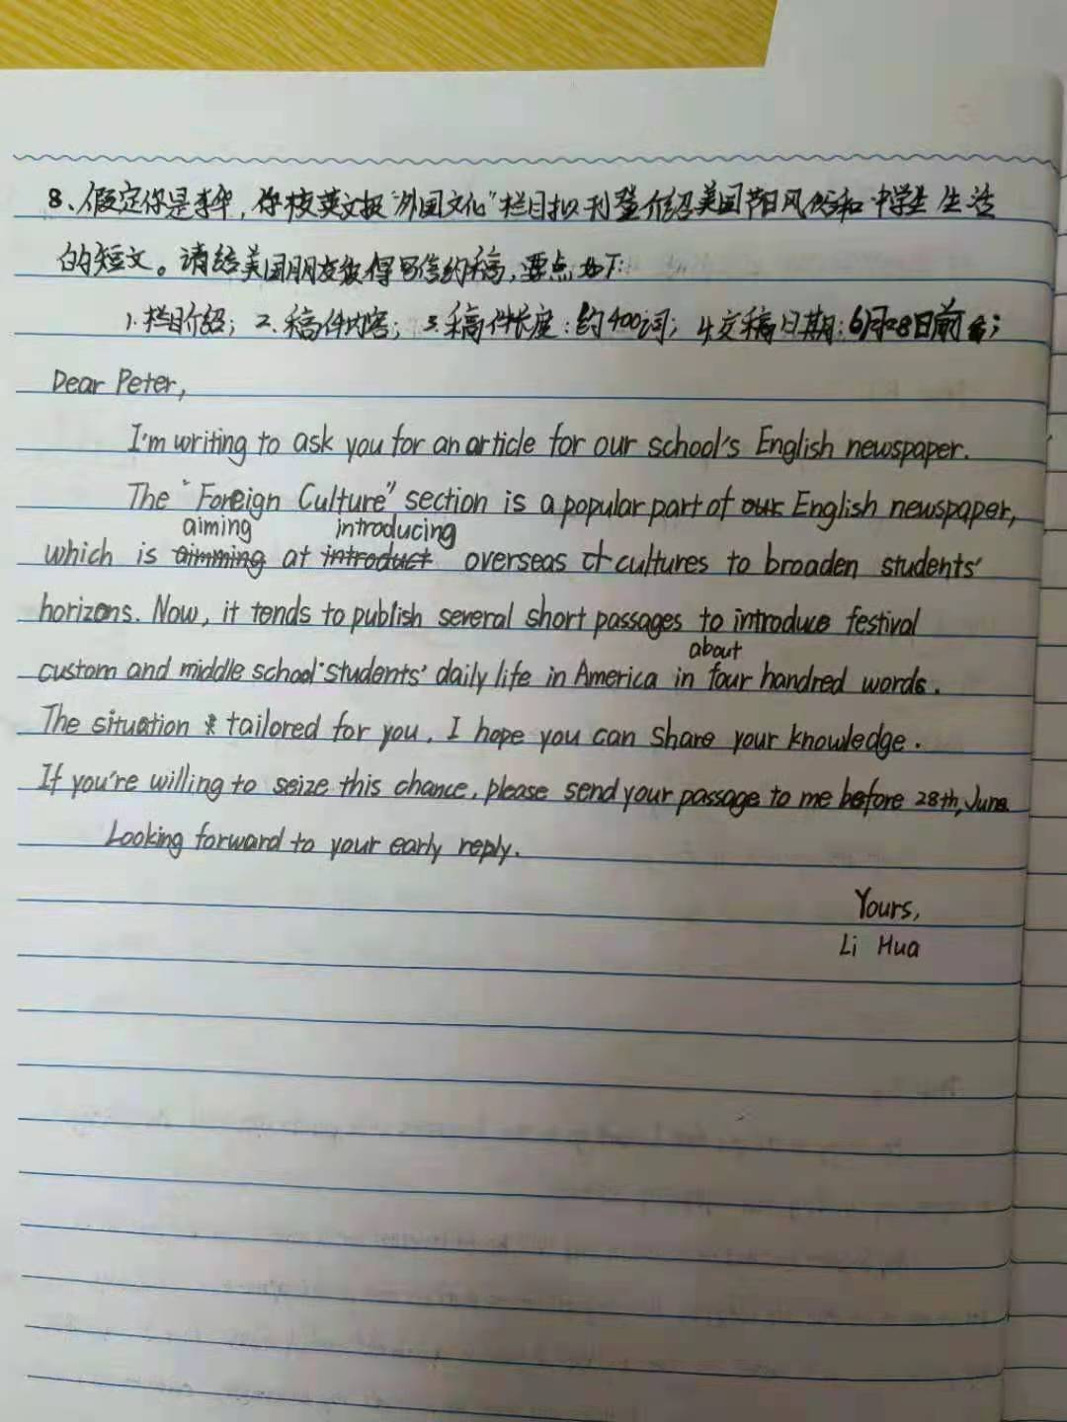

|  |  |  |
| --- | --- | --- |
| 内容 | 靓点 | 需要改进的地方 |
| 语  言 |  |  |
| 内  容 |  |  |
| 结  构 |  |  |

**One possible version 1**

Dear Peter，  
       I’d like to ask you to write an article for our school’s English newspaper.

To start with, the “Foreign Cultures“ section in our newspaper is very popular among the students. It publishes articles written by foreign friends considering the cultures of their countries.Would you please write something with reference to the culture in your country？What’s more, we would especially prefer articles about how Americans spend their holidays and festivals and the life of American high school students. Could you write anything relevant so long as it’s fascinating and informative with a vocabulary of 400 words or so．Could we have your article before June 28?

Your prompt reply will be highly appreciated!

Yours,   
      Li Hua

**One possible version 2**

Dear Peter,

How are you doing? Recently, in order to cultivate our interests, broaden our horizons and enrich our afterschool life, our school newspaper will start a column related to western life and culture. Therefore, I am writing to ask you to write an article on it.

Here are some details about it. To begin with, you may talk about your life in your middle school so that we Chinese students can know more about it. In addition, you can introduce a western festival, such as the Christmas Day or the Thanksgiving Day, which is not only meaningful but also interesting. What’s more, your article should be at least 400 words or so. Eventually, would you be so kind as to send it before June 28 with the purpose that it can be published in time? Hopefully, you could do me the favor. I have the confidence that everyone will like your article. Thanks for reading my letter in such a hot summer. I’m looking forward to your reply and your article.

Yours, Li Hua

**学生反思**

|  |  |
| --- | --- |
| 我的优点  人称/时态  词汇  要点  衔接  审题 | 我需要改进的方面： |