**应用文临门一脚 教学步骤**

**【Part 1应用文误区分析与高分原则】**

**What is Practical Writing ?**

*Judge whether the following statements are correct or not? Why?*

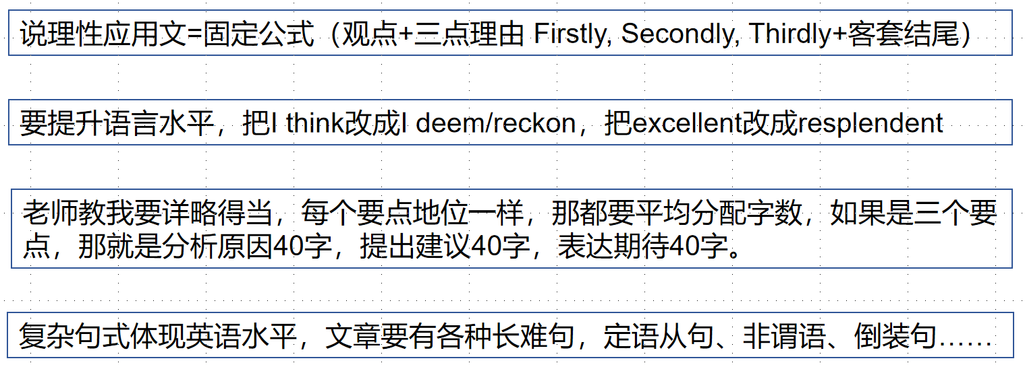

*So, what is the* ***underlying logic*** *of a good example of practical writing?*

**核心原则是_____________.**

高分作文，不仅仅是因为他们的语言好，而是他们想到的东西，他们表达的东西，特别切题（to the point），思维整体和题目的语义场是高度符合的。

深度思维与内容丰富性是应用文得高分的基本逻辑。

拿到一篇应用文后,抛却结构化的框架,最主要呈现在我们脑中的是各种语言表达及他们融合在一起后的语义场。

对于说理性、议论性的应用文,说理、论证的过程需要按照“_____________________”的思维层次进行递进,目的的层次由浅入深。

**【Part 2两大思维训练方法】**

Life is filled with countless choices, and each of your decisions often harbors profound reasons. Here are three sets of images. Make a selection and explain the rationale behind your choice. Think about expressions as many as possible that can help you better clarify your choice.

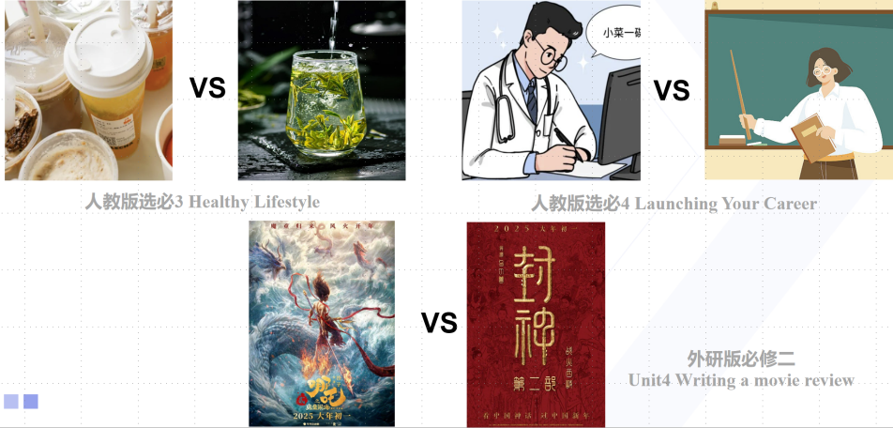

**Brainstorming（Compare Group 1）**

**My version:**

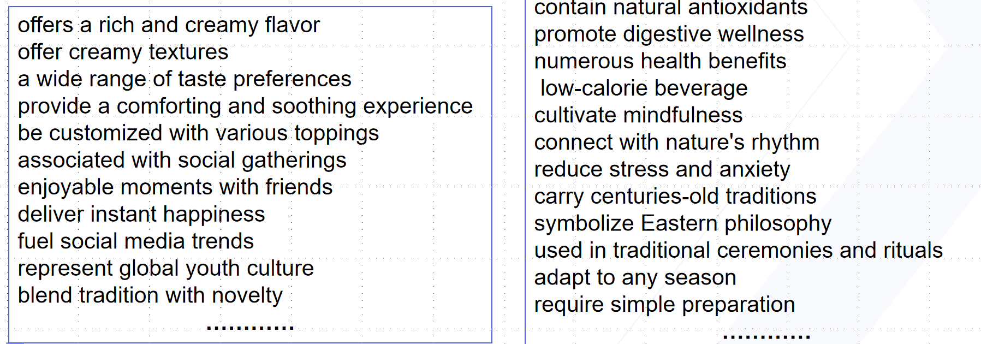

【情境自命题1】 假定你是李华，你的外国好友Jack刚到中国，对中国的饮品文化很感兴趣。请你给他写一封电子邮件，推荐一款茶饮，并说明理由。

【情境自命题2】 假定你是李华，你的外国好友Jack刚到中国，想试试不同的中国饮品，请你给他写一封电子邮件，推荐一款饮品，并说明理由。

**❤思维方法1：**________________________________________________________

**Brainstorming（Compare Group 2）**思维层次化

职业特征

adapt teaching styles

balance strictness and care

be instrumental in imparting knowledge

情感

unlock hidden potentials

build critical thinking

light up dark moments

turn failures into lessons

社会影响

shape civilized citizens

break cycles of ignorance

build a well-educated and informed community

**❤思维方法2：**________________________________________________________

**【Part 3活动类应用文的要点分析】**

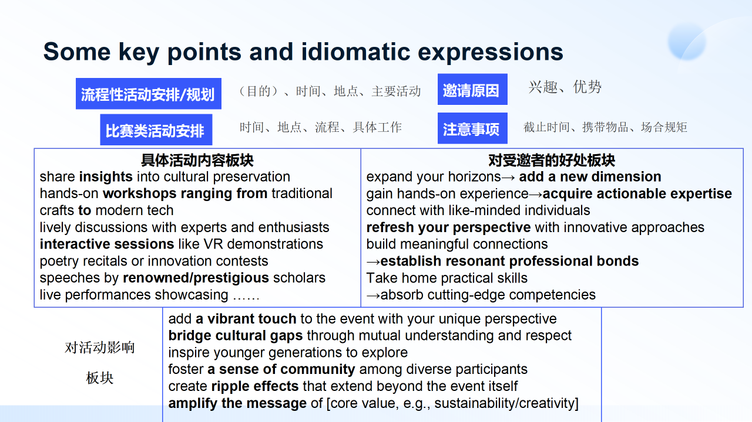

**分析四个常考类型要点指代的内容——需要你建构的内容。**

**分享一个高分的结构模式。**

**引导学生按照这个模式去实践。**

It will kick off with…, closely/subsequently followed by …  /The highlight of the activity, undoubtedly, was a… which … Ulitimately, …will put a perfect ending to…

会议将以著名学者的演讲拉开序幕，随后是专家和爱好者的热烈讨论，交流新的见解。毫无疑问，活动的最高潮是互动VR演示环节，让参与者亲身体验最前沿的技术。

________________________________________________________________________________________________________________________________________________________________________________________

**多任务融合类应用文是什么？**

一种和传统应用文命题单一体裁任务不同的新趋势，笔者将其称为“多任务融合”类应用文，其主要命题特征就是一封信中包含多个任务或需求，用于解决现实生活中的复杂问题。You need to respond to ________________. You can’t immediately tell the ____________.

在“多任务融合”类应用文中，学生需要在一封信中完成多个任务，如请求信息、提出建议、表达感谢等，需要在不同要点中建构合适的衔接部分和自然承接，这也要求学生在有限的篇幅内展示其语言运用和逻辑思维的能力。

假定你是校学生会主席李华，下个月将组织举办一场校园慈善音乐会。请给你校的英国留学生Chris 写一封英语邮件邀请他来参与演出，内容包括:

1.活动介绍;

2.表演形式建议。

Activity introduction → _________________ → Performance suggestions

(e.g. "Given the cultural significance of this event, your performance could...")

Primary purpose: ___________________________________________________

How to transit to the other task: To create make your performance/Given that……，perhaps we could ___________________________ of ….../______________________________/ it is highly recommended that……

假定你是英国留学生Chris ，收到了李华的信件，且有意愿参与本次音乐会，请你给他写一封回信，内容包括:

1. 接受邀请；

2. 询问细节

**立意前分析模式——学生自己问自己：**

**身份分析：写信人与读者在语境中的地位？**

**要点分析：A+B+ 隐含点？(情商体现）**

**任务分析：主任务？次任务？地位一致怎么办？**

思考：征询细节可以从哪些角度出发？如果题干没有提示

Please let me know about the rehearsal dates so that I can adjust my journey.

How long is each performer’s slot? I’d like to plan my piece accordingly.

Will a piano be available? If no, are there restrictions on bringing my own instrument/equipment?

**could you please be so kind as to ?**

**another point I am not certain about is if .**

**I would be more than obliged if .**

**Besides, is there anything that deserves special attention?**