**I. Teaching aims:**

1. To enable students to know the main idea of the story .
2. To enable students to make prediction and form a reasonable ending by analyzing the language, the characters and the plots of the original text.
3. To enable students to understand the theme of the story: Never judge a person by his appearance.

**II. Teaching Important and Difficult points**

1. To help students learn to use the writing tips in their writing.
2. To cultivate students’ logical thinking by analyzing the given information.
3. To encourage students to develop their confidence to overcome all the difficulties.

**III. Teaching Procedures**

**Step1: Greetings and warming up**

Have a free talking with students about some disabled singers at home and abroad.

1.Have you known some disabled singers?Who is your favorite?

2.How do you think of them?

3.Do you admire their courage and confidence?

Intention:

Help the students to focus on the topic “How a disabled girl became a singer”.

**Step2: Reading**

1. Ask students to read the passage to get the main idea of the story.

A girl, Emily, suffered a lot since she was born and got _______________ afterwards. However, she ____________ in the school auditorium. After she failed at the first attempt, she met Mr. Buttler who__________. So she ......

2.  Read the story carefully for its main plot

Para. 1 ---The introduction of Emily

Para. 2&3 --- The introduction of a yearly performance in the town

Para. 4&5 --- Emily’s first attempt to sing

Para. 6&7&8 --- Emily’s second attempt to sing

Para. 9&10---?

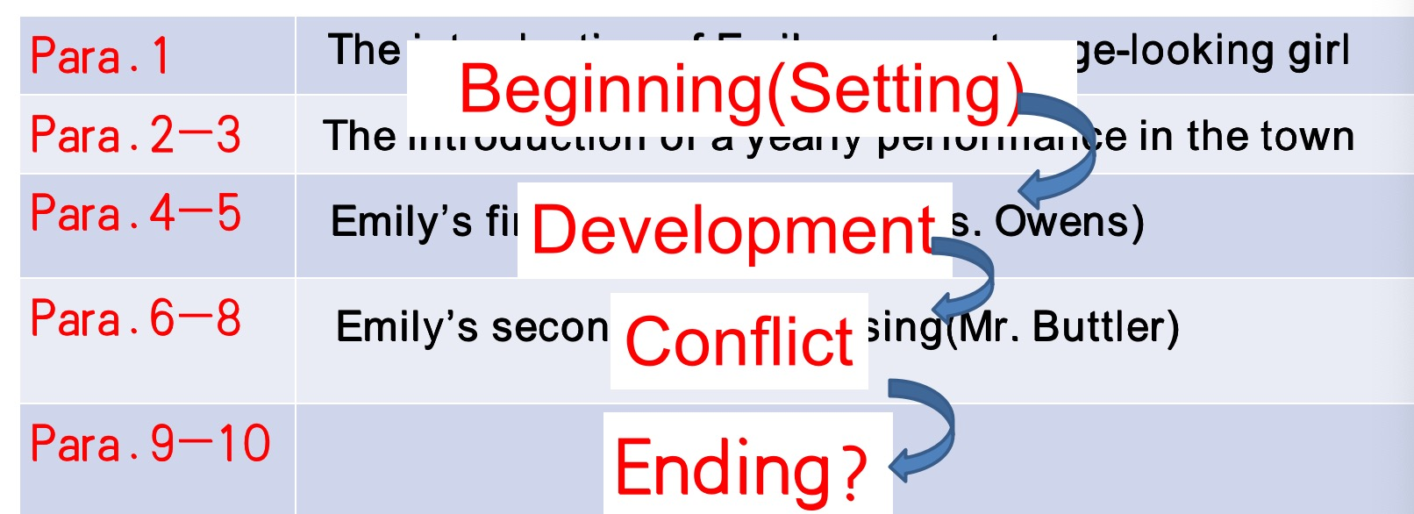

3. Read the story for its characters and Emily’s feelins in different periods.

Main characters:Emily and Mr. Buttler

4. Ask students to read the last two paragraphs and two given sentences to predict the possible plots of the story.

Para.1:

1) How did she find her name posted on the list?

2) What about her reaction to the result?

3) What about Mr. Buttler's reaction?

4) What did they do afterward?

5) ......

Para.2:

1). How about Emily's feelings before performance?

2). What about her performance?

3). What about audience's reaction?

4). The theme?

1. Read and conclude the theme.

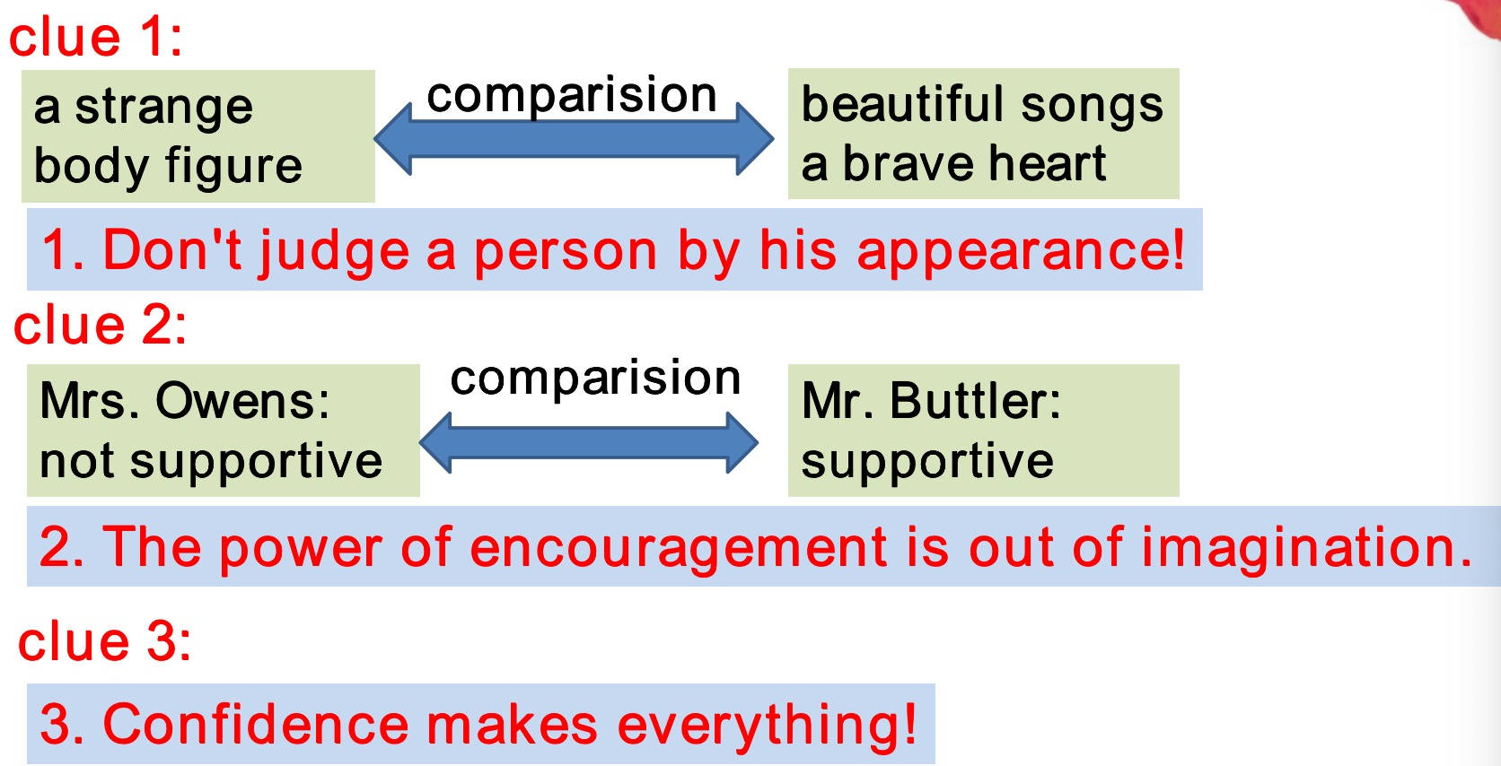

Intention:

Help students learn how to get some reading skills and analyze a passage according to the plots, characters, themes and so on to get some important hints before a continuation writing.

**Step3:Writing**

1. Show students some standards of a good continuation writing.

* 与所给短文融洽度高，与所提供各段落开头语衔接合理。
* ·内容丰富，应用了5个以上短文中标出的关键词语。
* ·所使用语法结构和词汇丰富、准确，可能有些许错误，但完全不影响意义表达。
* ·有效使用了语句间的连接成分，使所续写短文结构紧凑

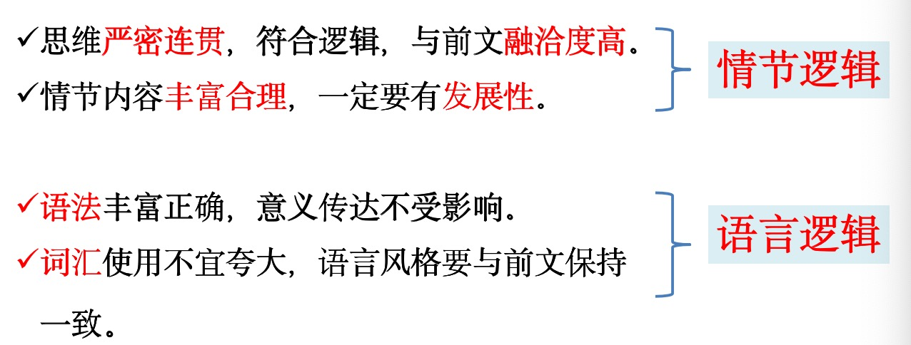

Intention:

Help students to get informed what a good continuation writing should consist of——情节逻辑+语言逻辑

**Step4:Appreciation**

1. Appreciate some samples and analyze some good and bad points.
2. Try to learn some tips in students’ good writings.
3. Learn to make comments by themselves.
4. Learn how to get an appealing ending.

Intention：

Help students to appreciate and analyze the sentences in the samples, how to get an appealing ending and know how to make comments on continuation writings.

宁波市二模 李丹