**Unit 1 Book 1 导案**

1. **teenage [ˈtiːneɪdʒə(r)]a.十几岁的; 青少年的**

**teenager [ˈtiːneɪdʒə(r)] n.青少年，十几岁的少年**

词根词缀：teen(十几)+age(年龄)+er(人)：十几岁的人——青少年

1. **ballet [ˈbæleɪ] n. 芭蕾舞**

破拆法：ball(舞会)+et(小)：小型舞会——芭蕾舞

1. **volunteer [vɔlənˈtɪə(r)] n.志愿者，义工 vi.自愿 voluntary a.自愿的，自发的**

音意互通：我能替 助记：我能替你做志愿者。

Volunteering gives you a chance to change lives, including your own.(2013 北京)

志愿活动给你一个改变生活的机会，包括你自己的生活

Mark volunteered to ride the bus with Susan each morning and evening until she could manage it by herself.(2012 天津) 马克自告奋勇每天早晚和苏珊一起乘公共汽车，直到她自己能自理为止。

Today, over thirty companies regularly donate food and other goods to the cause and volunteers help to deliver them to the homeless.(2012 山东)

如今，有三十多家公司定期为该事业捐赠食品和其他物品，志愿者帮助将这些物品分发给无家可归的人。

1. **prefer [prɪˈfɜː(r)] vt.宁愿，偏爱，更喜欢**

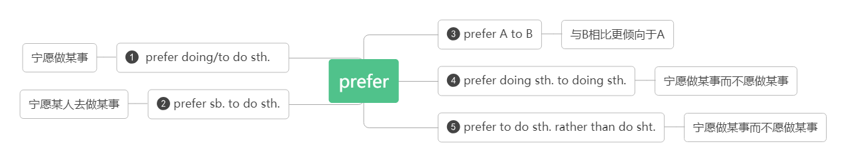

e.g.

Some people prefer to do everything over the internet.

I’d prefer you to start early.

I prefer the red dress to the green one because it fits me better.

I prefer reading books to watching TV.

I prefer to go there by bike rather than by car.

**preference [ˈprefərəns] n. 偏爱，倾向**

Many people expressed a strong preference for the original plan.

**give preference to给….以优惠/优待**

Preference should be given to graduates of this university.

**in preference to 优先于，而不是**

She was chosen in preference to her sister.

1. **content[kənˈtent] a.满足的，满意的 ['kɒntent]n.内容；目录[pl]**

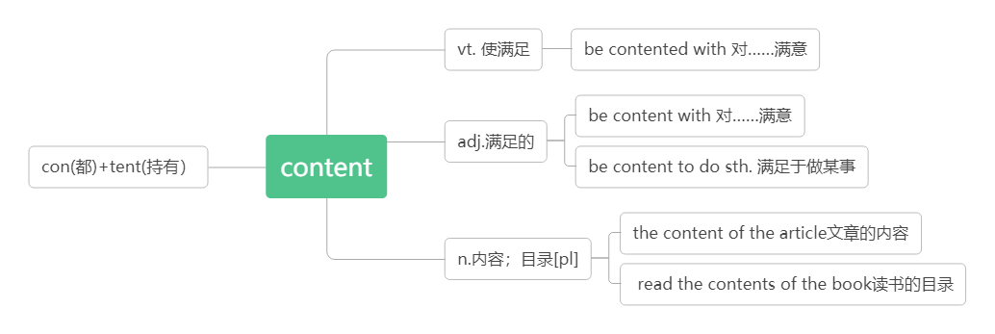

智美例句：

People who are truly content with life are enthusiastic about what they do.

真正对生活满意的人对他们所做之事充满热情。

**6.movement ['mu:vmənt] n*.*动作；移动**

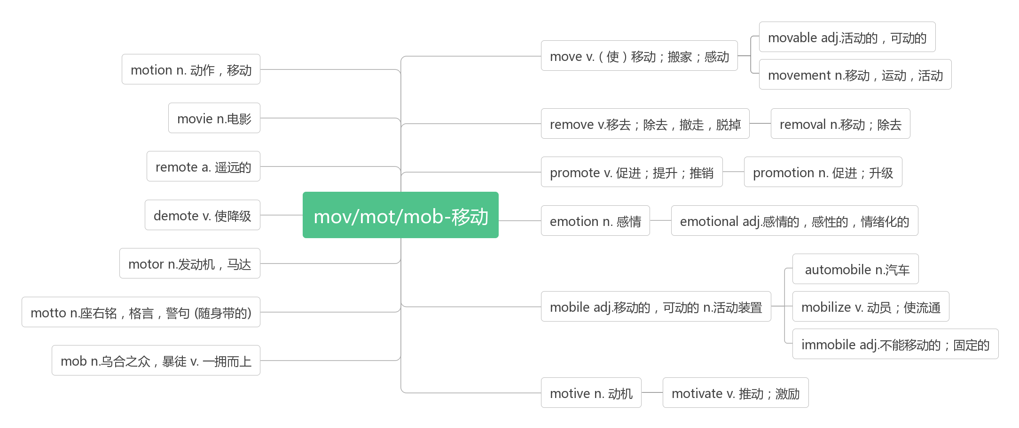

1. **greenhouse ['griːnhaʊs] n*.*温室；暖房**

green(绿色)+house(房子)：绿色植物所在的房子——温室

1. **clean [kliːn] vt. 打扫；弄干净 a. 清洁的，干净的**

智美例句：

A clean hand wants no washing. 身正不怕影子斜。

**clean up打扫/清除干净**

**cleaner n.清洁工,清洁器,清洁剂**

1. **suit [suːt, sjuːt] vt. 适合 n.一套(衣服); 诉讼; 恳求**

**a suit of一套**

a business suit 商务套装

follow suit 学样子; 跟着做

e.g.If we met at 2 o’clock , would that suit you?

The hot weather doesn’t suit me.

Blue suits you. You should wear it more often.

**suitable [ˈsjuːtəb(ə)l] a. 合适的，适宜的**

a suitable place for a picnic 一个适合野餐的地方

**be suitable for 适合于**

suitcase [ˈsjuːtkeɪs] n.(旅行用)小提箱,衣箱

1. **actually [ˈæktʃʊəl] ad.事实上;实际上**

词根词缀：act-(做)+-ual(形容词后缀)+-ly(副词后缀)：已经做出来地——事实上，实际上

actually=in fact=in reality=as a matter of fact 事实上，实际上

1. **challenge [ˈtʃælɪndʒ] n.挑战vt.质疑；向……挑战**

音意相通：才难治 助记：这种有挑战的疾病才难治呢。

face/ take up a challenge 面对/接受挑战

智美例句：

When happy people face a challenge in life, they don’t beat themselves up and fall into a depressive state. Instead, they face up to the challenge and channel their energies toward finding a creative solution.

在生活中遇到挑战的时候，开心的人不会自虐，然后变得很消沉。他们会直面挑战，调动全身力量寻找解决办法。

Everything negative - pressure, challenges - is all an opportunity for me to rise.

压力、挑战，这一切消极的东西都是我能够取得成功的催化剂。(科比)

**challenging  a.具有挑战性的**

a challenging job 一个具有挑战性的工作

1. **title['taitl]n.（书、诗歌等的）名称；标题；称呼；头衔**
2. **topic ['topik]n.话题;主题;论题**

|  |  |
| --- | --- |
| title | "标题,名称",指书，绘画，剧作等创作作品的名称；还可作"头衔，称呼"讲 |
| topic | "话题,主题,论题",可指演讲或整篇作品的主旨,也可指某个章节,段落乃至单句包含的要点 |
| theme | "主题,主旋律",指文学,艺术或建筑等创作所围绕的主题,如诗的思想,乐曲的主旋律或绘画的基调 |
| subject | "题目,主题,科目",在这组词中词义最广,泛指某范围内的主题,涉及面广,概括性强,一般包括若干topic |

It was the book's eye-catching title that helped me make up my mind to buy it.

正是这醒目的书名才使我下决心买下这本书。

The topic of your article is very good, but your spelling and style must be improved.

你文章的主题很好，但拼写及风格必须改进。

I cannot remember in the very long conversation what topic has been touched upon .

我不记得在漫长的谈话中涉及到了那些话题。

The graduates wrote a number of essays whose theme was man's will-power.

研究生们写了以人类的意志力为主题的一系列论文。

He chose "A Reform in Teaching Methods" as the subject of his lecture.

他选择"教学方法的改革"作为讲话的题目。

1. **freshman ['freshmən]n.高一新生；大一新生**

fresh(新鲜的)+man(人): 新人—— 新生

1. **confuse [kənˈfjuːz] v. 使迷惑;使混乱;混淆**

con-(共同,都)+fuse(融合,混合)：都混合在一起了——使迷惑;使混乱;混淆

confusing adj.令人困惑的 (现在分词表示主动内涵，意为“令人……的”)

confused adj.感到困惑的 (过去分词表示被动内涵，意为“感到……的”)

**confuse sth. with sth.把……与……弄混淆**

**be confused at/about对……感到困惑**

**confusion [kən'fju:ʒ(ə)n]n.混乱;混淆**

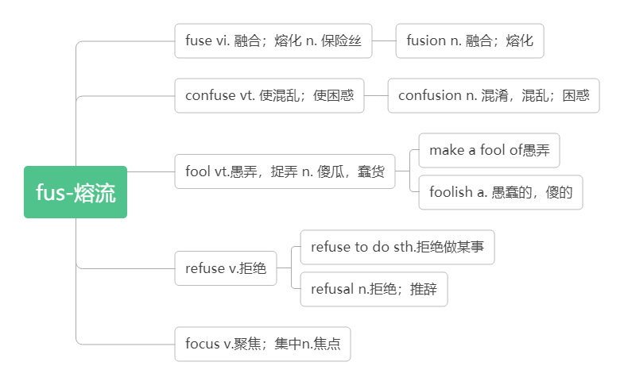

1. **fluent [ˈfluːənt] a. （外语）流利的，流畅的**

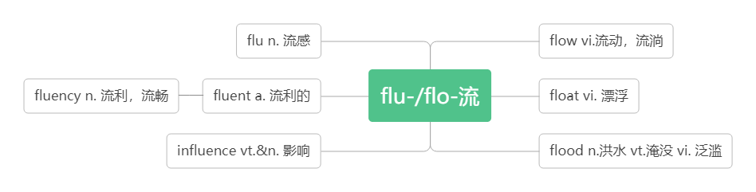

1. **graduate [ˈɡrædjʊət] vi. 毕业 n. 研究生；毕业生adj. 毕业的；研究生的**

grad-(级别)+u+ate(动词后缀)：达到级别——毕业

**graduate from从……毕业**

**graduation [ɡrædjʊˈeɪʃ(ə)n] n. 毕业，毕业典礼**

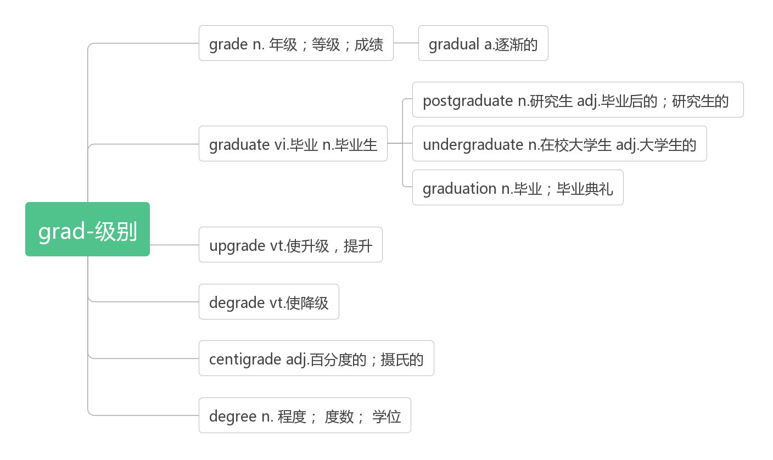

1. **recommend [rekəˈmend] vt. 推荐;建议**

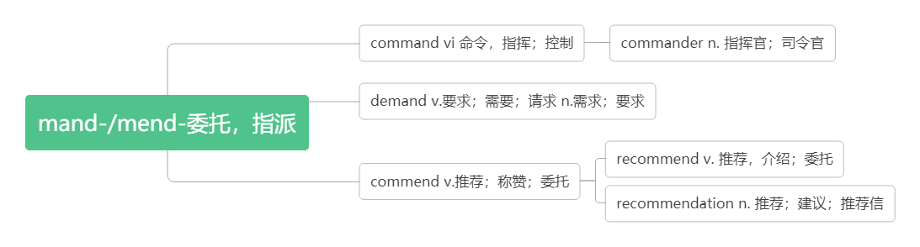

**recommend doing sth.建议做某事**

**recommend sb. to do sth.建议某人做某事**

**recommend that sb. (should) do sth. 建议（+宾语从句）**

Can you recommend a good hotel?你能推荐一个好的旅馆吗?

I recommend he see a lawyer.我建议他去看律师。

We'd recommend you to book your flight early.

He recommended reading the book before seeing the movie.我们建议你早点订机票。

It is strongly recommended that the machines should be checked every year.

强烈建议每年对这些机器进行检查。

1. **sign[saɪn] n. 记号, 符号；手势；迹象；指示牌vi. 签名vt. 签署；示意**

**sign up for 注册，选课；报名参加**

**traffic sign 交通标志**

sign an agreement/contract/treaty etc 签署协议书/合同/条约等

A long tongue is a sign of a short hand. 夸夸其谈，眼高手低。

1. **advance [ədˈvɑːns; (US) ədˈvæns] vt. 推进，促进vi.前进**

**词根词缀：ad-(向前)+-vance(来，走)：（使）向前走——推进，促进；前进**

Confidence and ability usually advance side by side. 信心与能力通常是齐头并进的。

**in advance 提前**

A person’s soul is like the torch made of hay. If taking action ,it must burn itself in advance.

人的心灵好比干草扎成的火把，要发生作用，它必须自身先燃烧。

Those who are content with their present situations will surely make no more advances in life.

满足于现状者止步于当下。

**advanced [ədˈvɑːnsd; (US) ədˈvænsd]*adj.*高级的；高等的；先进的**

1. **literature [ˈlɪtərətʃə(r); (US) ˈlɪtrətʃʊər] n. 文学**

词根词缀：liter-(文字)+-at(在)+-ure(名词后缀)：在文字上的作品——文学。

音意相通：离开猥琐 助记：文学是我们离开猥琐的净土。

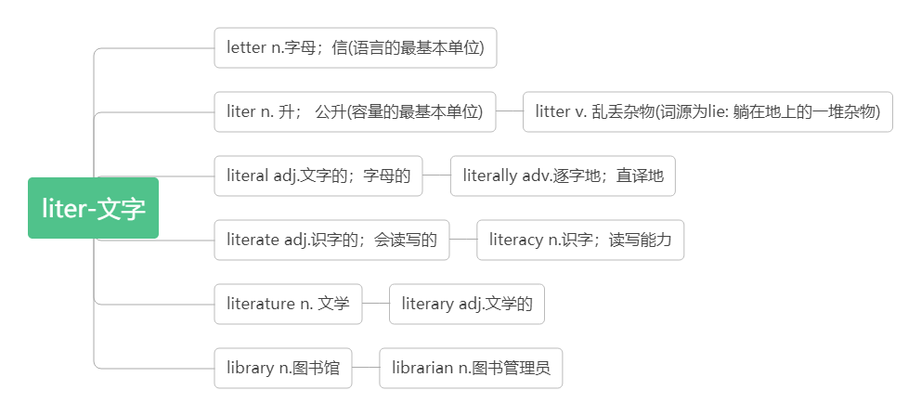

1. **extra-****curricular [ekstrə'kərikjələ] a.课外的**

**extra ['ekstrə] adj*.*额外的；附加的**

**curricular [kə'rɪkjəlɚ]adj.课程的**

词根词缀：cur-(心)+ri-(re-再次，反复)+-cular(形容词后缀)：要反复用心去学习的——课程的

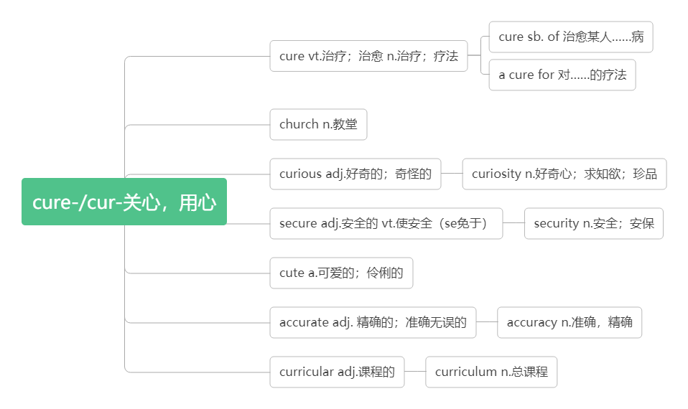

1. **obvious [ˈɔbvɪəs] a. 显然的；明显的**

词根词缀：ob-(对面)+vi-(看)+-ous(形容词后缀)：站在对面就能看到的——明显的

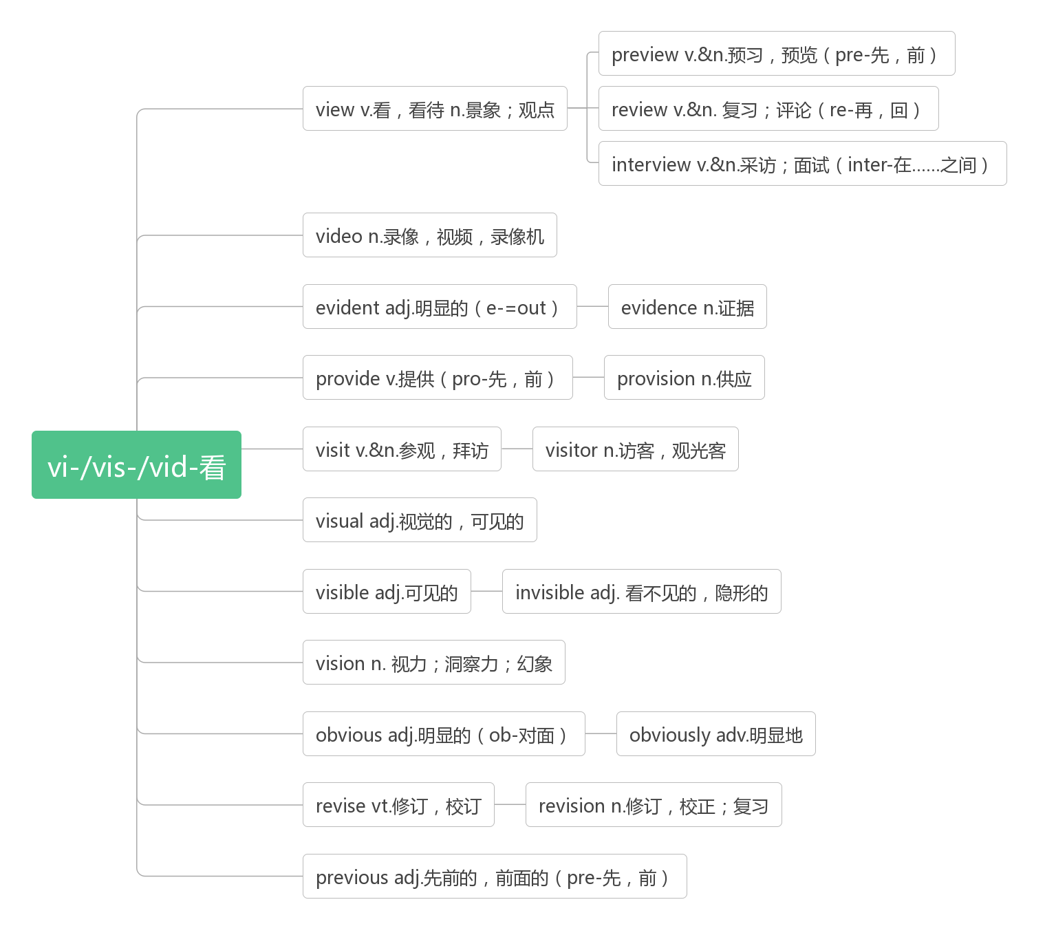

1. **quit [kwit] vi. & vt. (quit, quit)退出；戒掉；离开(职位、学校等)**

Doctors are doing research to find out what happens physically when people quit smoking.

医生们正在做研究，想知道当人们戒烟后身体会发生什么变化。

He said that if he quit the job, he would lose his drive to work and succeed.(2018浙江)

他说如果他辞职了，他就会失去工作和成功的动力。

1. **responsible [rɪˈspɔnsɪbl]adj.负责的；有责任的**

**be responsible for 对……负责**

**responsibility [rɪspɔnsɪˈbɪlɪtɪ] n. 责任，负责**

**have responsibility for**

**对……有责任**

**take responsibility for**

**承担……的责任**

智美例句：

With great power, comes great responsibility.（Spider Man）能力越大，责任越大。

1. **solve [sɔlv]vt. 解决；解答vi.溶解**

solve/settle a problem 解决问题

solve a puzzle/riddle/case 解谜/猜谜/破案

**solution [sə'luʃən]n.解决办法；溶液**

I have tried very hard to find a solution to the problem, but in vain.(2010江苏)

我已经很努力地寻找解决这个问题的办法，但是没有用。

1. **schedule [ˈʃedjuːl; (US) ˈskedʒʊl] n. 工作计划，日程安排v. 安排时间，预定**

音意相通：撕开就 助记：这份工作计划撕开就无效了。

We have scheduled the meeting for Monday.我们把会议安排在星期一。

**on schedule 按计划；按时**

**ahead of schedule 提前**

be scheduled for June/Monday 被安排在六月/周一

scheduled flight/service 定期航班/服务

1. **editor [ˈedɪtə(r)] n. 编辑，编者**

**edition [ɪˈdɪʃ(ə)n]n.（发行物的）版，版本**

1. **plate [pleit] *n.*盘子；碟子**

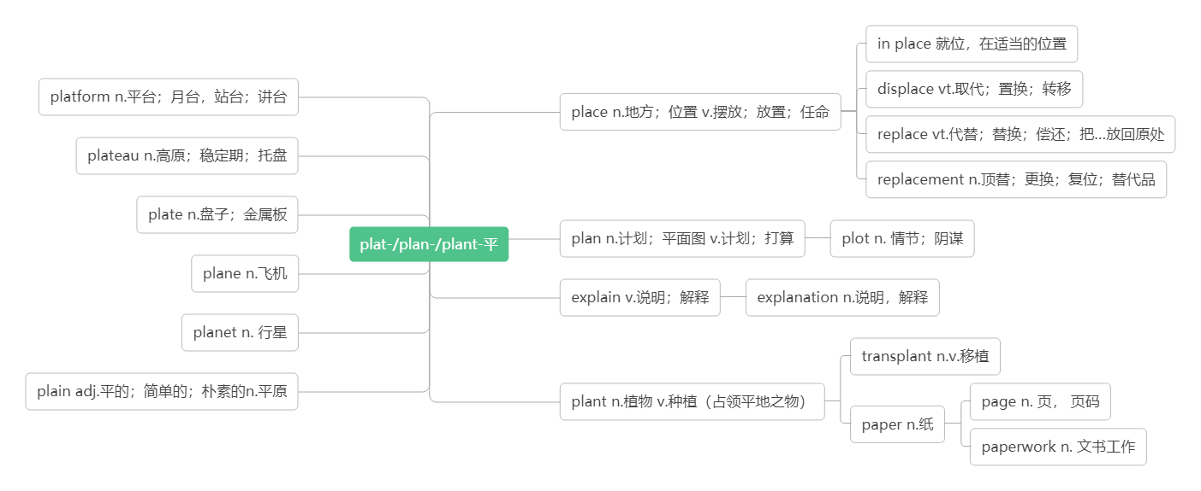

1. **adventure [ədˈventʃə(r)] n. 冒险;奇遇**

词根词缀：ad-(强调)+vent-(来)+-ure(名词后缀)：来到未知的地方——奇遇，冒险。

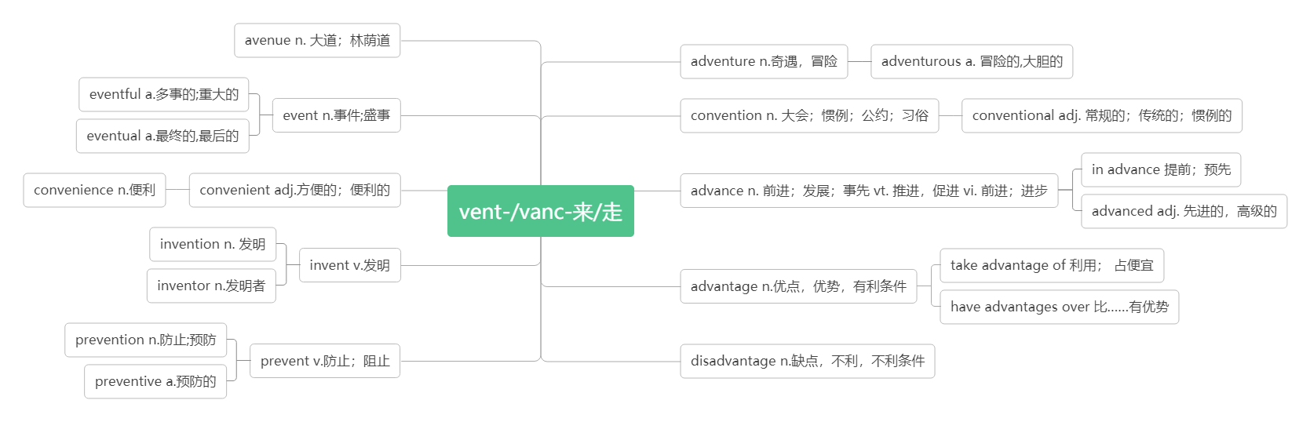

1. **youth [juːθ] n. 青春；青年**

A lazy youth, a lousy(极坏的)age. 少壮不努力，老大徒伤悲。

What sowed in youth, what harvested when old.青年时种下了什么因，老年时就收获什么果。

**young [jʌŋ] a. 年轻的**

Learning keeps us young and dreams keep us alive.学习让我们保持年轻，梦想让我们充满活力。

A plant may produce new flowers; man is young but once. 花有重开日，人无再少年。

He who will not learn when he is young will regret it when he is old. 少壮不努力，老大徒伤悲。

1. **expert [ˈekspɜːt]n.专家，能手adj.内行的，老练的**

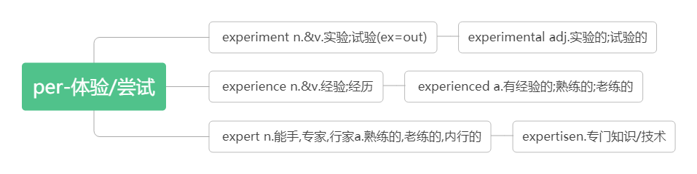

助记：做完实验experiment，就有经验experience，有了经验，就成专家expert。

**be expert at/in 在…… 方面是行家/有经验**

He is expert at playing the piano.他擅长弹钢琴。

智美例句：

Success is doing the same right thing over and over again until you become an expert in your field.

成功就是重复做一件正确的事，直至你成为所在行业的专家。

Every teacher once was a student. Every winner once was a loser. Every expert once was a beginner. But all of them have crossed the bridge called “Learning”.

每个老师都曾是学生。每个胜利者都曾是失败者。每个专家都曾是初学者。但是他们都跨过了一座桥——学习。

1. **behave [bɪˈheɪv] vi.举止;表现**

破拆法：be(存在)+have(有)：有证明存在的行为——举止。

**behave oneself 举止得体，守规矩**

智美例句：

Believe there is a great power silently working all things for good, behave yourself and never mind the rest.

相信举头三尺有神明，谨言慎行，豁达待人。

**behavior[bɪ`heɪvjər ] n. 行为，举止**

智美例句：

A beautiful form is better than a beautiful face; a beautiful behavior than a beautiful form.

美丽的形体胜于漂亮的脸蛋，优雅的举止胜于美丽的形体。——Emerson 爱默生

1. **generation [dʒenəˈreɪʃ(ə)n] n. 世代，一代**

词根词缀：gen(产生)+er(名词后缀,表示人)+ation(名词后缀)：产生的下一代人——世代，一代

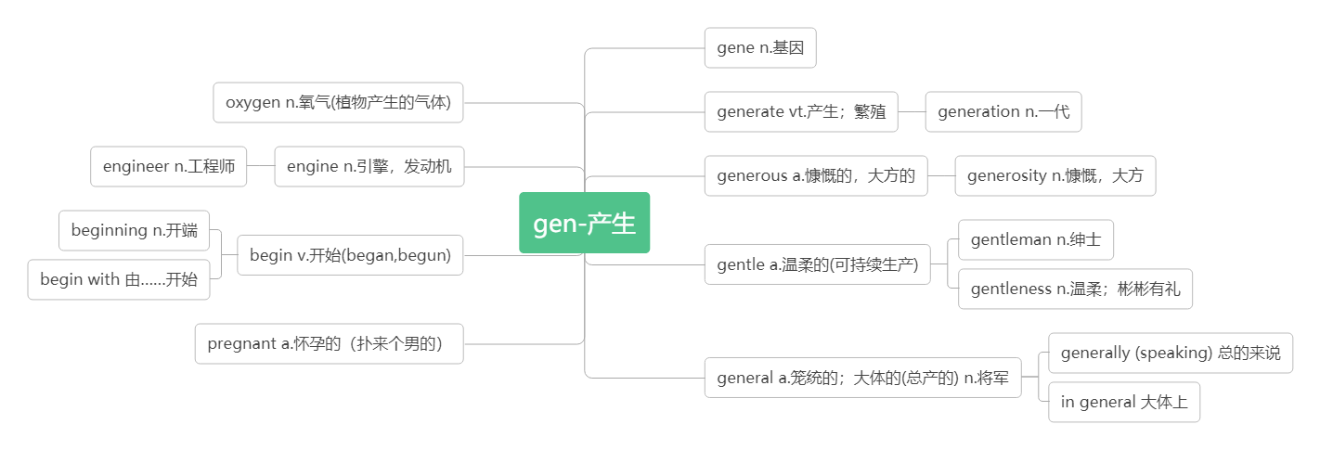

Life is for one generation, a good name is forever.生命只有一代之久,而美名永存于世.

One generation plants the trees in whose shade another generation rests.前人栽树，后人乘凉。

from generation to generation 代代相传

generation gap 代沟

1. **attract [əˈtrækt] vt.吸引**

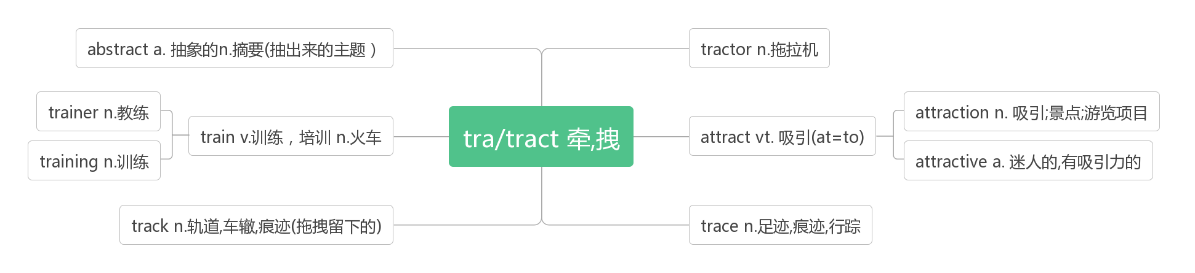

智美例句：

Like attracts like.物以类聚.

The man who attracts luck carries with him the magnet of preparation.（Clifton Fadiman）

吸引好运的人，总是在时刻准备着。

1. **focus [ˈfəʊkəs] vi.&vt.聚焦;集中n.焦点;注意力**

词源：见14 confuse

**focused a.专注的**

**focus on专注于**

智美例句：

The secret of change is to focus all of your energy, not on fighting the old, but on building the new.

做出改变的秘诀不是多么努力地和过去做斗争，而是全力以赴地去打造全新的自己。(Socrates)

Life never stops pushing forward. Stay focused and never slow down with regrets.

生活从来都不会停止向前，保持专注，别因为后悔而放慢脚步。

Control your focus, control your life.

掌控你的注意力，你就能掌控你的生活。

As long as I can focus on enjoying what I’m doing, having fun, I know I’ll play well. (Steffi Graf)

只要我能专注于享受我做的事、得到乐趣，我便知道我将表现不错。——施特菲·葛拉芙 (网球明星)

1. **addicted [əˈdɪktɪd] a. 上瘾的,成瘾的,入迷的**

词根词缀：ad(=to)+dict(说)+ed:总爱去说的——上瘾的,入迷的

**be addicted to 对…上瘾，沉溺于**

Occasionally learning that you are addicted to table tennis, I am writing to sincerely invite you to join the table tennis team in our school aimed at developing our interests and improving our skills.(2017全国Ⅱ) 偶然得知你喜欢乒乓球，我写信诚挚地邀请你加入我们学校的乒乓球队，以培养我们的兴趣，提高我们的技能。

Schoolboys are easier to be addicted than schoolgirls to net. 男生比女生更容易上网成瘾。

**addict [əˈdɪkt]n.成瘾者, 沉迷者vt.使成瘾, 使入迷**

1. **adult [ˈædʌlt] n. 成年人a.成年的**