2023杭一模应用文---推荐信
杭州二中树兰高级中学 郭合英
Teaching goals：
After learning this lesson, the students will learn:
- Cultivate the students’ ability to comprehend the question carefully.
- Learn about the structure.
- Accumulate useful expressions.
- Analyze students’ composition.
Teaching focus：
1. Cultivate the students’ ability to comprehend the question carefully.
2. To combine subject teaching with core literacy.
3. Analyze samples.
Teaching difficulties：
1. Cultivate the students’ ability to comprehend the question carefully.
2. How to combine subject teaching with core literacy?
Teaching process：
Step 1. Lead in
Discuss: How to combine subject teaching with core literacy ?
Step 2. Cultivate the students’ ability to comprehend the question carefully.
应用文微观审题：“六步审题法”
1. 审体裁 ┅ 确保自己不会写错格式。
2. 审关系 ┅ 要不要做自我介绍取决于他们之间的亲疏关系。
3. 审人称 ┅ 避免用错人称。
4. 审时态 ┅ 避免用错时态。
5. 审要点 ┅ 要点齐全不丢分。
6. 审回复 ┅ 结合交际原则看是否需要回复。

应用文宏观审题：学科教学与核心素养的融合
①有意识地介绍爱尔兰文化，如国家背景，文化习俗等让学生理解文化内涵，比较文化异同，汲取文化精髓并运用得体语言进行跨文化交际。
② 有意识地介绍中国传统文化，做中国传统文化的使者和传承人，在中外文化之间搭建一座桥梁，让中国文化走出国门，走向世界，从而坚定文化自信。

杭一模应用文
假定你是李华，为迎接爱尔兰姐妹学校来访，你校英语俱乐部将举行学生活动图片展，现正向全校学生征集照片。你打算参与，请你写一封邮件，说明相关信息，内容包括：
1. 描述照片内容；
2. 选择该照片的理由；
3. 表达入选期望。
注意:
1.写作词数应为 80 个左右;
2.请按如下格式在答题卡的相应位置作答。
六步审题法

1. 审题裁 | 2. 审关系 | 3. 审人称 | 4. 审时态 | 5. 审要点 | 6. 审回复
Step3：Learn about the structure.
开头段：Para 1: Self-introduction + writing purpose
主体段：Para 2: The photo introduction + chosen reasons
结尾段：Para 3:Thanks-expressing + the expection of the photo being selected
Step4：Build up vocabulary
Ask the students to build up some vocabulary relevant to the letter.
1. 爱尔兰 2. 姐妹学校
3. 迎接 4. 参观、访问
5. 举行 6. 图片展
7. 征集照片
开头段(背景+目的)句子积累

- 我是来自高三1班的李华，为了欢迎爱尔兰姐妹学校来访，得知你们正在收集照片，我
非常乐意分享一些珍贵的照片。

- 我是来自高三1班的李华，为了欢迎爱尔兰姐妹学校来访，得知你们正在收集照片，我
非常乐意分享我珍藏的照片。

- 我是来自高三1班的李华，为了欢迎爱尔兰姐妹学校来访，得知你们正在收集照片，我
非常高兴参与这件事。

主体段（栏目介绍+稿件要求）句子积累
1.以爱尔兰为主的照片推荐 （学生5分钟微写作）
Picture-description | Recommended reasons
2.以中国为主的照片推荐 （学生5分钟微写作）
Picture-description | Recommended reasons
3. 以文化交流为主的照片推荐 （学生5分钟微写作）
Picture-description | Recommended reasons

结尾段句子积累

Step5：Anylysize the students’ composition.
Students’ composition 1
Students’ composition | My opinions
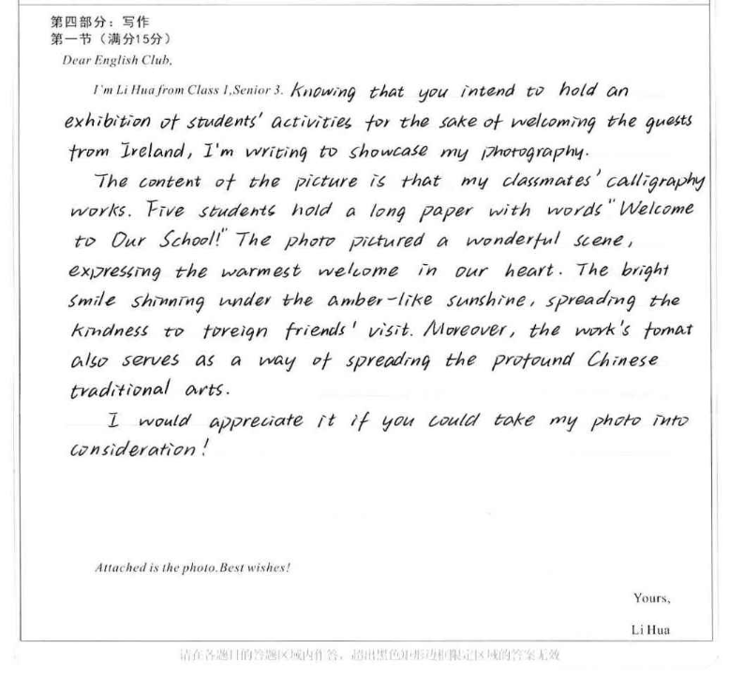 | Advantages:
 | Disadvantages:

Students’ composition 2

Students’ composition | My opinions
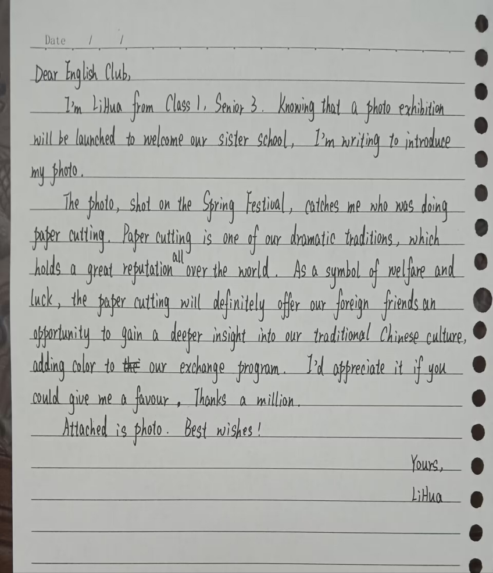 | Advantages:
 | Disadvantages:

Students’ composition 3
Students’ composition | My opinions
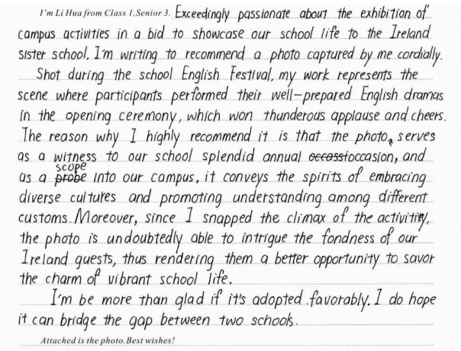 | Advantages:
 | Disadvantages:

Students’ composition 4

Students’ composition | My opinions
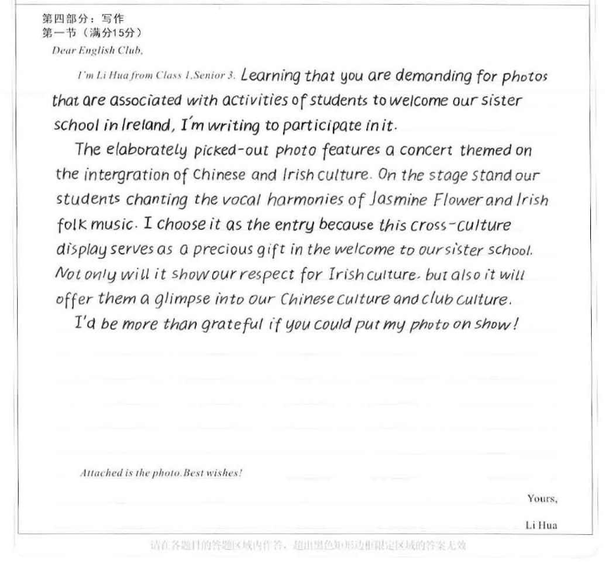 | Advantages:
 | Disadvantages:

A possible reference

I’m Li Hua from Class 1, Senior 3. Thrilled to know that your club is collecting photos with the aim of welcoming the visitors from Ireland sister school, I can hardly wait to share a precious photo with you.
Shot during the summer camp in Ireland, the photo shows a warm scene--- an Irish girl and I were picking up trash when we participated in the Irish cross-country race. The reason why I will choose it is that it shows not only the friendship between transnational countries but also the responsibility of mankind --- to protect our common home --- the earth that is the home of human beings and animals.
It would be appreciative of you if you could make my photo into exhibition. In my opinion, it will be a big hit. Looking forward to your positive reply.
Attached is the photo. Best wishes!
Yours, Li Hua

学生反思
我学到什么 | 我需要改进的方面：

