**链接教材，立足语境**

**2024二轮复习·告知信进阶写作**

**PART 1 寻觅教材溯源**

选择性必修一 Unit 2 Looking into the future

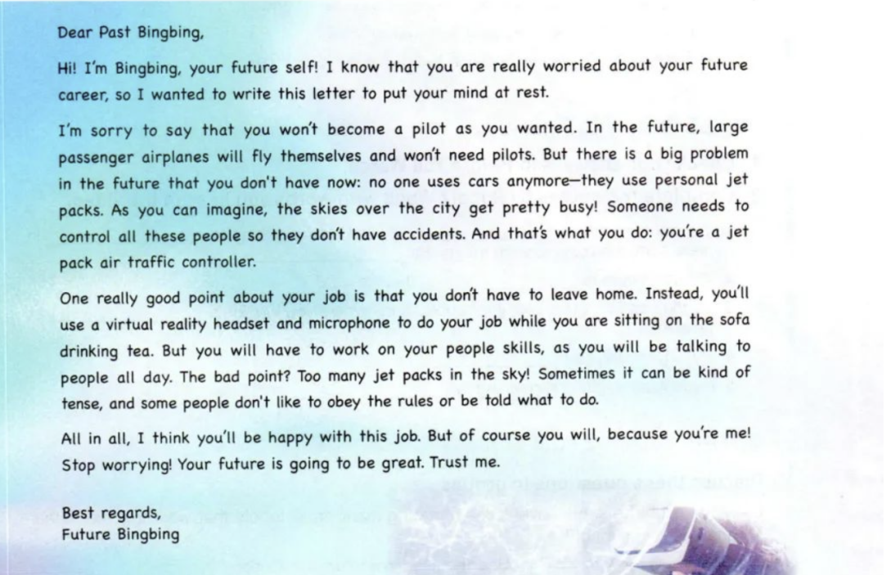

【教材文本分析】

首段交代两大必备要素：

1.____________. 点明写作对象，以及二者之间的关系。

2.____________. 指明写作目的，利用因果逻辑关系自然引出后续的写作。

本篇文本的语境是____________________________

首先用______________________句型表达一种梦想在职业方面未能实现的遗憾。进而告知过去的自己，关于未来的一些畅想。要点段2着力于介绍工作的亮点，运用句型_____________________________以及表示逻辑关系的词，如___________ ___________ ______对全段内容进行了良好链接。

尾段体现写信人和收信人的关系。未来的自己知道更多，因而会安慰过去的自己，整段语言晓畅自然。尽管本语境创设建立在畅想上，仍有颇多值得学习思考。

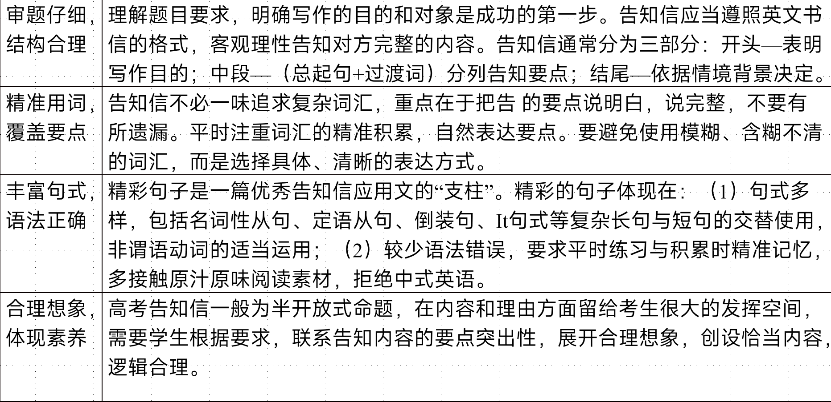

**PART 2 语料输入积累**

应用文写作告知信的写作任务是告知别人某事，主要的选材在于校园生活安排、社会实践等。总体审题难度不大，近些年出现频率升高，更强调告知时语言的得体，内容的完整和表达的精练，对于学生整体语言能力要求高，侧重考察学生如何在有限篇幅内传达清晰明了的讯息。

**【参考句式】**

1. How is everything? I’m so glad that you show great passion for learning Chinese and that your excellent performance won applause in the Chinese speech contest. Now I’m writing to inform you of the details of our next class.

2. Knowing /Having learned that you’re very interested in my recent study trip organized by my school, I am writing/quite willing to share/give some relevant information with/to you.

3. I am more than delighted that you are so interested in the latest developments in the Chinese countryside. Now I’m writing to tell you something about it.

4. I’m very pleased to receive your letter asking about the popularity of American TV dramas among Chinese middle school students. And I’m quite/perfectly willing to share with you some information about that.

**【语境词汇积累】**

|  |  |
| --- | --- |
| ①假定你是校排球队队长李华。请写封邮件告知你的队友Chris球队近期将参加比赛，内容包括：1．比赛信息；2．赛前准备；3．表达期待。  （2019高考真题） | 持续时间：___________ roughly 3 hours  提供能量：provide enough ___________  努力奋斗：with_________ efforts and excellent teamwork  不辜负期望：_____________________________ of our school  努力不会白费：I firmly believe our hard work will ________.  倒装句：  Only with ___________________, excellent teamwork ______ positive attitude can our victory be ___________________.  只有充分的准备、优秀的团队合作和积极的态度，我们的胜利才能保证/实现。 |
| ②假定你是李华，你的英国朋友Alex即将来你校参加国际中学生汉语夏令营，请写一封电子邮件告知其相关信息 | 参加夏令营：___________ the Chinese summer camp  搭建平台：offer a ___________ for foreign students to ___________ an interest in Chinese  活动安排：ranging ___________learning basic Chinese characters ___________ exploring the art of Chinese calligraphy.  促进激情：add ___________ to your enthusiasm.  快乐中学习：expect the experience to be ___________, perfectly ___________ learning and fun. 寓教于乐 |

**PART 3 语境典例分析**

第一节（满分 15 分）

假定你是李华，你的新西兰朋友Luke非常喜欢中国茶文化。近期你市文化馆将举办中国茶文化展。请写一封信告知Luke这一消息。内容包括：

1. 时间地点；

2. 展览内容。

注意：

1.写作词数应为80左右；

2.开头和结尾已给出，可以适当增加细节，使行文连贯。

**Q1：本题体裁是什么？需要明晰的基本信息是什么？**

|  |  |  |  |  |
| --- | --- | --- | --- | --- |
| 写信人： | “I”（Li Hua） | | | |
| 收信人： | 朋友Luke | | | |
| 是否需要自我介绍： | □是 | □否 | □均可 |  |
| 写信语气： | □正式 | □非正式 |  |  |
| 写信背景： | “我”得知新西兰朋友Luke非常喜欢中国茶文化，因市文化馆将举办相关展览而写信告知对方。 | | | |
| 写信目的： |  | | | |
| 使用时态： |  | | | |
| 使用人称： |  | | | |

**Q2：如何表达好友对于茶文化的热爱？**

________________________________________________________________________________________________________________________________________________________________________________________

**Q3：开篇需要怎么写？是否需要寒暄？写信目的怎么表达？**

【参考语料】

1. I hope this letter **finds you well**. I have some exciting news to share with you! The Cultural Center in our city will **host** a Chinese Tea Culture Exhibition . I know clearly **your zest for** Chinese tea culture, so I thought you would **jump at** attending it.
2. How’s it going? The Cultural Center in our city are hosting a Chinese Tea Culture Exhibition in the **upcoming** weeks. Knowing your **deep appreciation for** Chinese tea, I thought you would be **thrilled to attend this event.**

**Q4：描写展览内容可以怎么避免同质化写作问题？**

①______________________。

E.g. It promises to be an **enlightening** experience, **delving into the fascinating world** of Chinese tea culture. **From the moment you step inside, you will be transported into the realm of tea, surrounded by captivating displays and interactive exhibits.**

②________________________________。

E.g. The exhibition will **showcase the diverse types** of Chinese tea, **ranging from delicate green tea to robust black tea and aromatic oolong tea**. You will have the chance to explore the origins of these teas, the unique characteristics of each type, and the traditional methods of tea production.

Moreover, you will **witness captivating tea ceremonies**, where skilled tea masters will demonstrate the art of tea preparation and the graceful movements involved. You will learn about the significance of tea in Chinese **customs and rituals**, and how it **fosters a sense of tranquility and harmony.**

官方范文

Dear Luke,

I hope this letter finds you well. Knowing your **strong enthusiasm for** Chinese tea culture, I’m writing to **share with you the related news** about a tea culture exhibition.

As is scheduled, the exhibition will **commence at** the cultural center next weekend, running for ten days, during which time **a variety of teas** from different regions of China will be or display and the importance of tea in Chinese culture will be highlighted. Additionally, there will be **talks about the history and tradition of tea drinking** and even **a tea ceremony demonstration.**

I do hope you can take the opportunity to quench your thirst for the magnificent Chinese tea culture.

Yours sincerely,

Li Hua

【点评】

这封信有效地传达了重要的细节，并邀请Luke参加展览，让他沉浸在对中国茶文化的热爱中。当然，它可以通过提供更多具体和引人入胜的展览细节来进一步改进，例如展出的茶的类型，可用的互动活动，或将出席的任何特别嘉宾或专家。增加这些细节会增加展览的吸引力和兴奋感，使卢克更渴望参加。

下水范文：

Dear Luke,

I hope this letter finds you well. Guess what? The Cultural Center in our city will host a Chinese Tea Culture Exhibition ! I know clearly **your zest for** Chinese tea culture, so I thought you would **jump at** attending it.

As scheduled, the exhibition will **kick off** at the City Cultural Hall next Saturday and last two weeks which **is bound to delve into** the fascinating world of Chinese tea culture. From the moment you **step inside**, you will **be transported into** the realm of tea, **surrounded by captivating displays and interactive exhibits**. Additionally, the exhibition will not only showcase the diverse types of Chinese tea but also **demonstrate the origin** of each tea, during which you will **have a insight into** how it **fosters a sense of tranquility and harmony**.

I do hope you won’t miss this golden opportunity to **quench your thirst for** the magnificent Chinese tea culture.

**PART 4 话题变式训练**

【变式写作1——义乌五校】

假定你是李华，你因故不能参加下周二的音乐会，想把票转赠给你的留学生朋友John。请你给他写一封邮件告知相关情况，内容包括：

1．你不能参加音乐会的理由；

2．音乐会的基本情况；

3．如何获取门票。

注意：

1．写作词数应为80个左右；

2．请按如下格式在答题卡的相应位置作答。

Hi, John,

Long time no see! Are you interested in attending a concert next Tuesday? I waited for hours to get one, but ___________(不幸的是), I’ll have an important exam that day. It ___________(相矛盾) with the time schedule for the concert.

The concert will start at 9: 30 in Xing Hai Theatre, ___________(持续) two hours. The musical performances will ___________(融合) Chinese and Western elements. Since you are a ______________(热情的) classical music lover, I ____(打赌)the Butterfly Lovers violin concerto will be extremely impressive.

Please come to my home to pick up the ticket or I can have it ___________(deliver) to you. I hope you will not miss the concert!

【变式写作2】

假如你是李华。你的英国笔友James对你校举行的艺术节活动很关注，并来信询问，请你给他写一封回信，内容包括：

1. 写信目的；

2. 活动内容；

3. 你的收获。

注意：

1. 词数80字左右；

2. 可适当增加细节以使行文连贯。

Dear James;

     How is everything going with you? ___________(know) from your last letter that you are ___________(咨询) about the art festival held in our school last week, I'm more than willing to tell you something about it.

     The festival, ___________(旨在) enable students to learn more about the traditional Chinese culture, covers a ___________(vary) of activities, ranging from Chinese calligraphy, tea show to paper-cutting. ____________________________(最令我印象深刻的是) was the recitation of classical Chinese poetry. All the students as well as teachers ________________(积极参与) in the festival. Not only does it offer us a platform to better understand the Chinese culture, but also ________________________________(激发创造力) and enriches our life. Additionally, it brings us great pleasure and helps relieve stress from our school work.

     I do hope that you will be able to attend the art festival next year. I _____________(保证) you that it will leave a wonderful impression on you. Best wishes.

Yours,

Li Hua