衢州高中高三英语衢丽湖联考试卷二次开发（2025.4.10）
出题人：李小珍 审核：高三英语备课组
一、词汇积累

overlook _____俯瞰_________
trail _____路径_______
壮观的 ____spectacular_________
slippery _____湿滑的________
许可证 _____license__________
disoriented ___迷失方向的_________
因…而闻名 _____be famed for__________
票房大片____box-office hit__________
intense succuss _____很大的成功________

inclination _____倾向_______
script __剧本______
autobiography ___传记_____
传播；循环 ____circulate________
domestic animals ____家禽_________
爆发 ____outbreak_______
imprecise ______不精确的______
关键步骤 ____critical step____________
限制 __restriction__________
获得资金 __secure funding___________
carry through _____贯彻________
flawless performance ___完美的表演________

二、词汇运用
1. Leave a trip plan with a friend ___in advance___________. 提前给你的朋友留下旅行计划。
2. She also expresses her sadness about the __loss of privacy_________(隐私的丧失) during her teenage years.
3. Premature fame is not __necessarily________(necessary) a good thing. 过早出名未必是一件好事。
4. Vets are on the __front line______ (在前线) of the outbreak.
5. _Scattered________ and crowded areas make it easier to lose objects.
6. Everyone misplaces things __every now and again_________________(偶尔).
7. Most of the team members ___specialize in___(专攻)drone technology, while others are enthusiasts ___recruited____(招募) by the company.

三、句子翻译
1. Park visitors interested in sightseeing or recreating in the Controlled Recreation Area managed by Mt Seymour must purchase a pass.

想在由Mt Seymour管理的管控娱乐区内观光或游玩的游客必须购买通行证。
___________________________________________________________________________________
2. Seema Lakdawala, a virologist at Emory University in Atlanta, who was not involved in the research, said she was surprised that only 2% of the vets surveyed tested positive for the antibodies, considering another CDC study showed that 17% of dairy workers sampled had been infected.

未参与此项研究的亚特兰大埃默里大学病毒学家Seema Lakdawala表示，考虑到另一项CDC研究显示17%的抽样奶农被感染，仅有2%的受调查兽医抗体检测呈阳性让她感到惊讶____________________________________________________________________________________
3. OpenAI, the company behind the artificial intelligence tool ChatGPT, has set out restructuring plans to make it easier for it to raise money and remove restrictions made by its non-profit parent (母公司).

ChatGPT的开发者OpenAI公司公布了重组计划，旨在简化融资流程并解除其非营利母公司制定的限制。_________________________________________________________________________________________

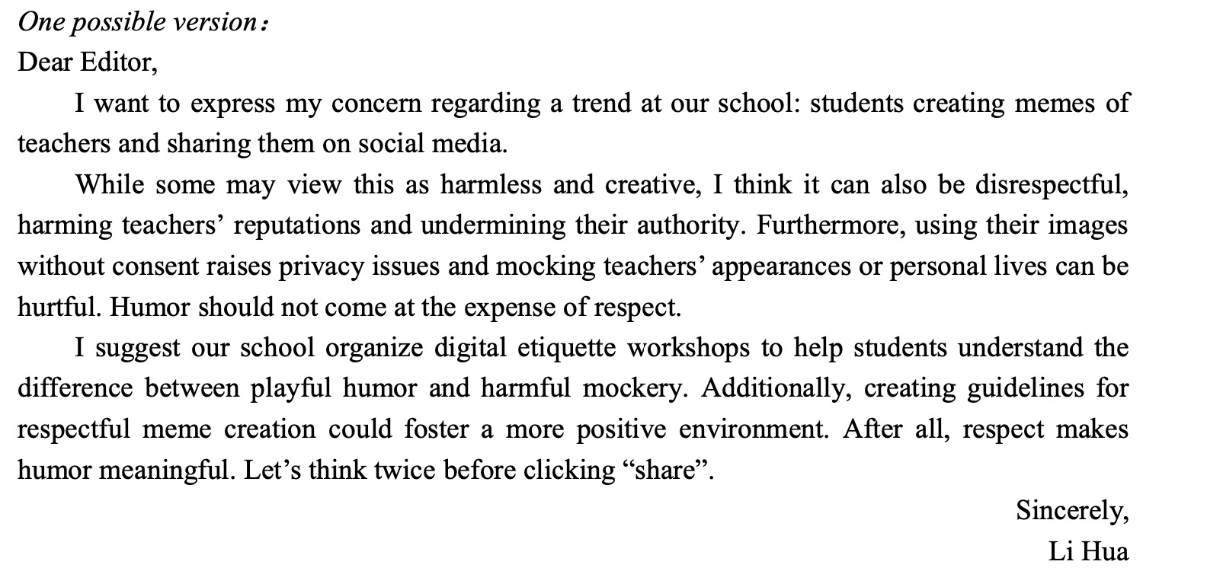
应用文

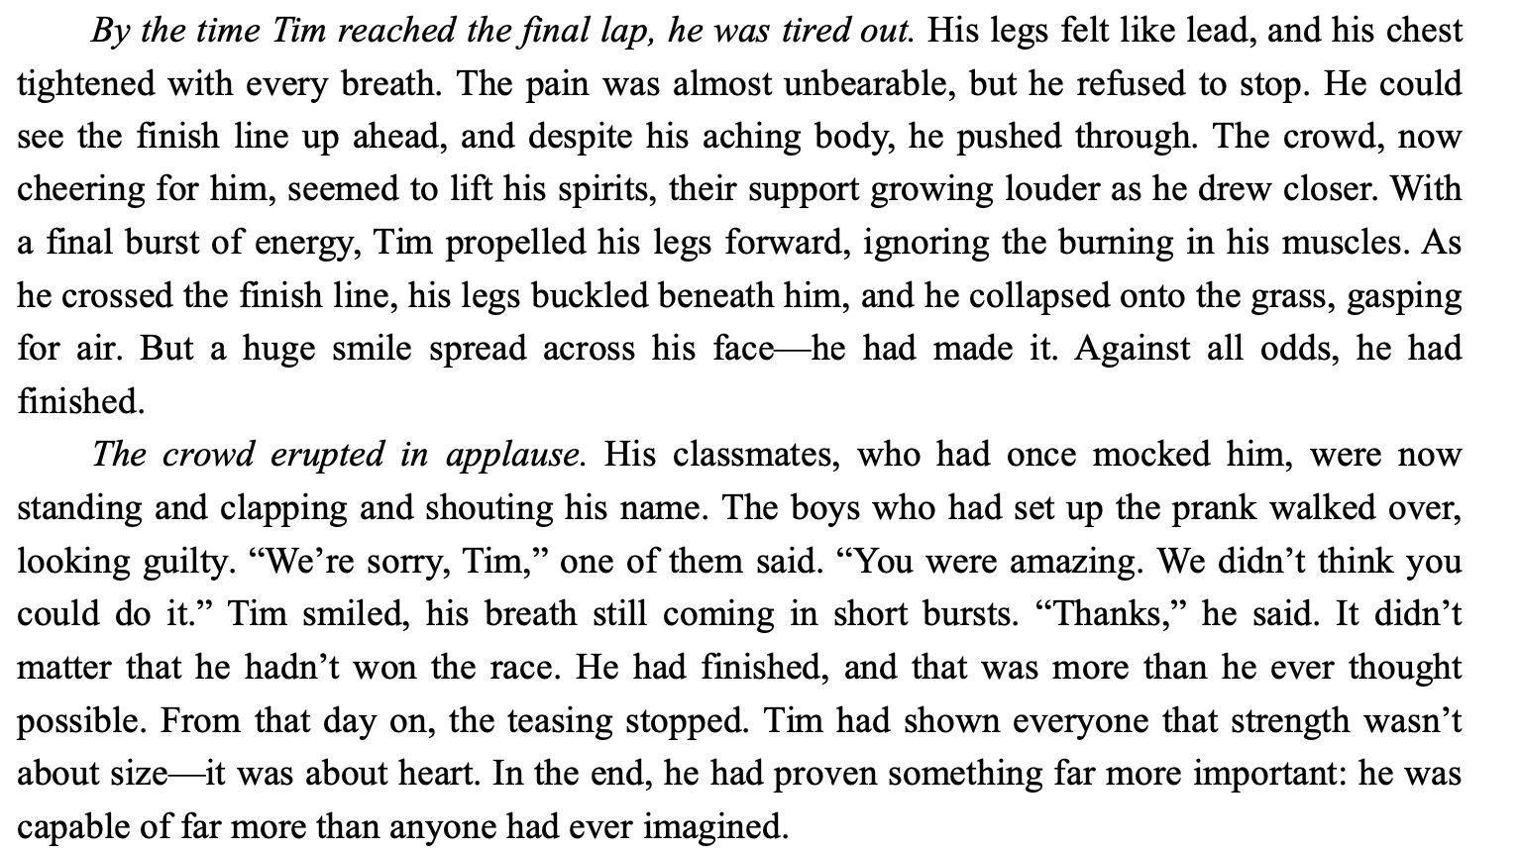
读后续写

