**M3U3 The Value Of Money**

**The Million Pound Bank Note**

**Teaching Objectives：**

At the end of the class, students will be able to

1. master the following new words and phrases: narrator, scene, servant, make a bet, by accident, as a matter of fact…

2. get the main idea of Act1, Scene3 in the play of *The Million Pound Bank Note*

3. master the elements of a play and know their functions in a play

4. infer the hidden information like the characters’ characteristics, background through the elements of a play

**Teaching Important and Difficult Points：**

1. How to make students infer the hidden information in the play successfully.
2. How to make students appreciate the charm of the play.

**Teaching Procedures:**

**hundred**

**thousand**

**million**

**____________关于**

**Step 1: Lead-in——Watch and retell the scene in the video**

Students will be asked to enjoy the beginning of the play——*The Million Pound Bank Note* and retell the scene with the help of the pictures:

Q1: What happened in the video? Can you retell it with your own words?

Q2: Where did the clip come from?

Q3: Who were these men?

Q4: Why did the wealthy men invite the young man to their house? And what happened in the house?

(通过看到说，能帮助学生梳理情节，同时锻炼学生说的能力；其次，基础学生的说提出相关问题能激活学生相关的知识背景，激发他们对于后续情节的好奇，为接下来的教学活动做铺垫)

**Step 2: Prediction**

Students will be asked to look at the title and the organization of the passage to predict the writing style and learn the characteristics of it:

**Q1. What writing style is it?**

A. a narration

B. an exposition

C. an argumentation

D. a play

**Q2: How do you know? And what elements did a play contain?**

(title of play, narration, dialogue, character, lines, stage direction)

(通过观察此次文本与以往不同的文本，观察发现戏剧类文本的结构特征——以对话、台词为主。)

**Step 3: Read for characters**

**1. Students will be asked to skim the dialogue and find out the basic information of the main characters:**

**Result**

Roderick who _______ the idea.

Oliver who _______ a man could live a month _____ a million pound bank note

Henry, an _________ who _______in Britain ____ accident

**Adding question: How did Henry came to London? Rearrange the timeline of Henry’s experience.**

Now, Henry ________ in London streets.

1. About a month ago Henry Adams was ________ out of the bay.

___________he found himself carried out to sea by a strong wind.

The ship brought him England. Then he went to the American consulate __________help, but got nothing.

_____________________he was ________ by a ship.

1. **What’s the relationship between them?**
2. **Why could Henry be chosen for their bet?**
3. **How did Henry’s feeling change in the play?**

**Step 4: Read for reasons and feelings**

Reading tip1: Get the hidden message and the emotions of the characters from their lines.

**Example:**

**Narrator: Two rich brothers, Roderick and Olive have made a bet. Oliver believes that with a million-pound bank note a man could live a month in London. His brother Roderick doubts it. They see a *poor* *young* man walking outside their house. It is Henry Adams.**

**Roderick: Young man, would you step inside a moment, please?**

**Henry: Who? Me, sir?**

**Roderick: Yes, you.**

**Hidden message:**

When the wealthy brother were making a bet, Henry happened to pass by in front of their house. Then he was chosen.

——right moment

**Hidden emotion:** strange, surprised and confused

**1. Then students will be asked to listen to the radio while reading the play, and infer the reasons and feelings of Henry.**

**Reasons:**

a. a right moment,

b. Henry’s personal background (foreigner, young, in a poor situation, without aim, without help, without job, hardworking, without money)

**Feelings:**

surprised——confused——desired——annoyed（climax）——confused——unwilling——determined

**2. Students will be asked to work out more hidden message and feelings in the play.**

**Can you work out the hidden message and feelings of the following sentences?**

1. And ***it was*** the ship ***that*** brought you to England.
2. You mustn’t worry about that. It’s an advantage.
3. What luck! Brother, what luck!
4. I don’t want your charity. I just want a job that earns an honest income.
5. Oh, this is silly.

(此环节通过读、听、一起分析、独立分析、讨论等活动训练学生根据戏剧文本的文体特征推测暗藏信息和任务性格特点的能力，并通过后续再进一步的独立分析巩固落实学生的推断能力)

**Step 5: Read for personalities**

Students will be asked to read the play again and infer the personality of Henry through his lines, and infer his value of money.

**Reading tip2:** In a play, the lines are usually personalized to show the inner world of the characters

**Step 6: Learn about the writer**

Students will be asked to read a short passage about the background of the writer and fill in the blanks:

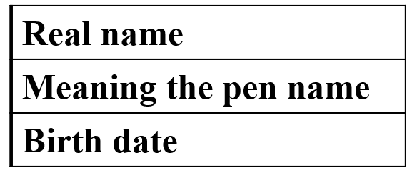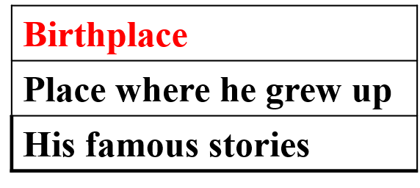

**Step 7: Learn about the million pound bank note**

**Assignment**

**Practice the play and show it in the next lesson**