**M1 Unit5 Languages around the World**

**By Lily**

**Teaching Analysis:**

Unit5 is about languages around the world. And the listening and talking period tries to explore the different kinds of English. And the differences among English is a common situation in English communication so Ss have certain knowledge of these. But they don’t know much about how to explain it when the misunderstanding caused by such differences happened in authentic communication. So, the functional expressions of asking for clarification will be added and practiced in this class. And based on this, the teaching objectives can be as follows.

**Teaching Objectives:**

1. To summarize the differences between AE and BE by listening for the related information.
2. To explore the factors causing the differences by discussing and watching the video.
3. To use expressions of asking for clarifications by applying it into a conversation.

**Teaching Procedures:**

**Step1: Lead-in**

Acitivity1: Watch the video showing different kinds of language.

Think: Why are there so many kinds of English?

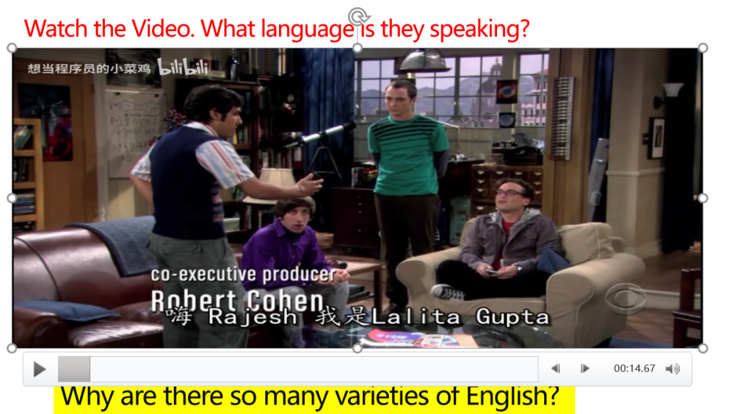

Some basic information about English is reviewed.

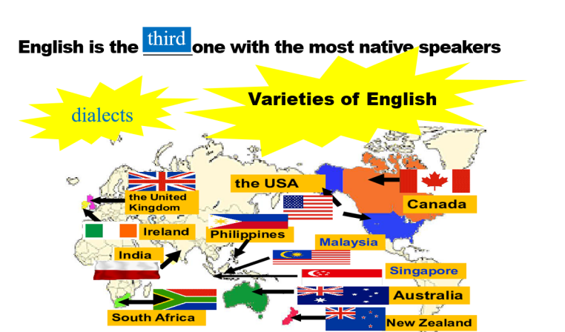

(Aims: to elicit the topic and activate Ss’ previous experience and their interests.)

**Step2: Listening**

Activity1: Listen to the first part and answer the three questions.

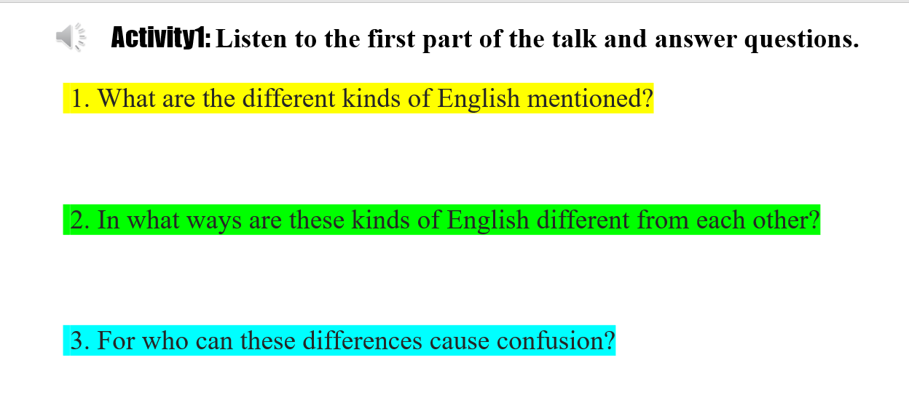

Activity2; listen to a conversation. And tick the pairs of different words that confused the speakers.

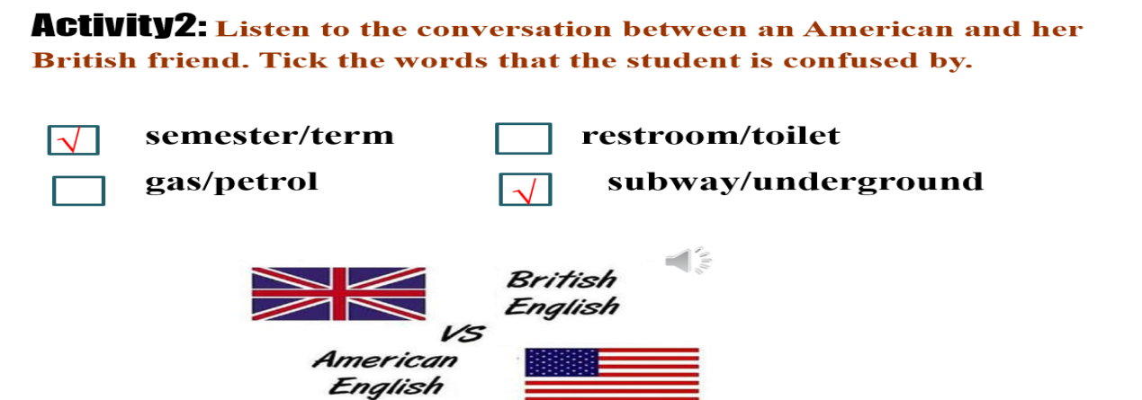

(Aims: Practice listening skills like listening for the main information by quick noting and provide more background information.)

**Step 3: Discussion and Thinking**

Watch a video showing differences of American, British and Australian English.

Discuss the difference of American, British and Australian English.

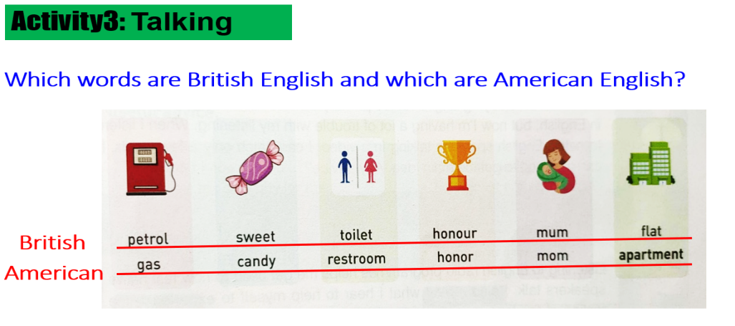

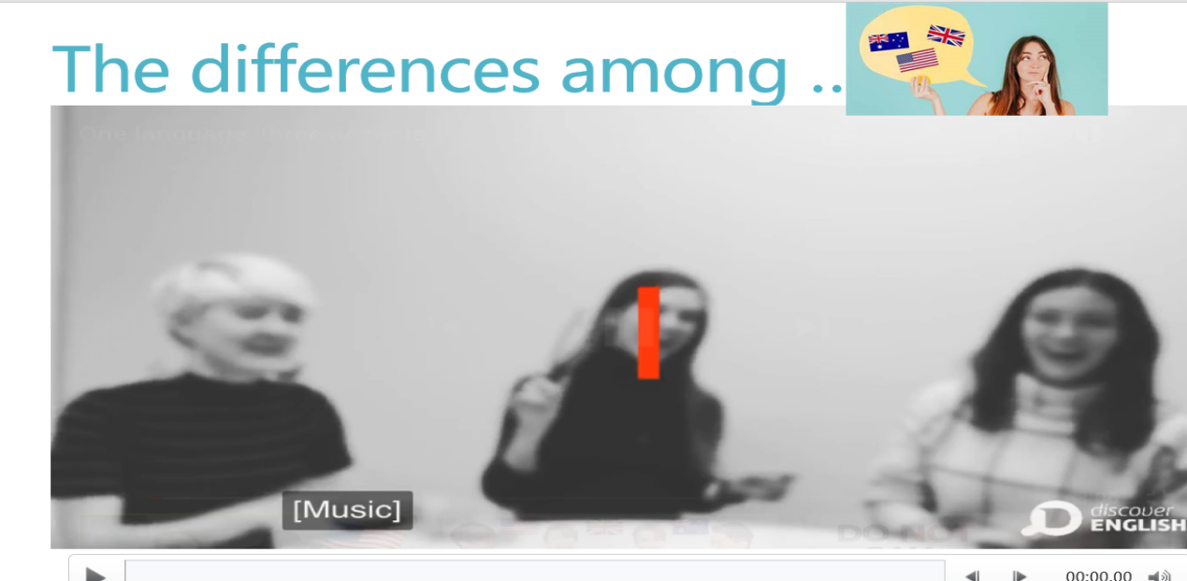

Think: Is such difference a barrier in their communication?

What will caused by such differences?

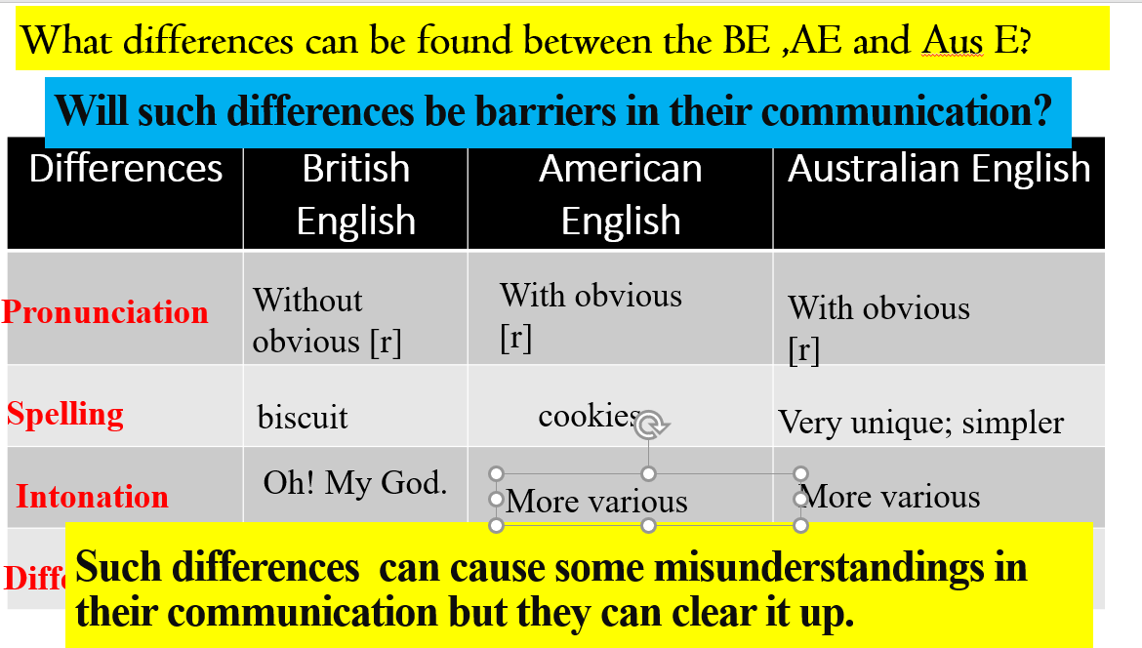

(Aims: to provide more examples of such differences and enable them to feel summarize the differences.)

**Step4: Read the conversation**

Think: What misunderstanding has been caused? Why? How did the speaker clear it up?

(Aims: to taste the differences in real context and find some expression for asking for clarification.)

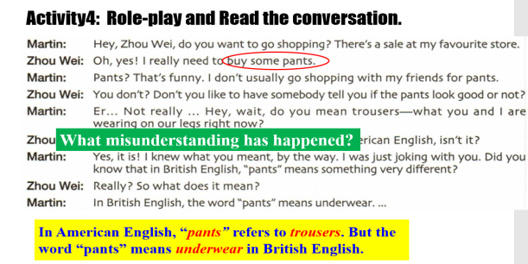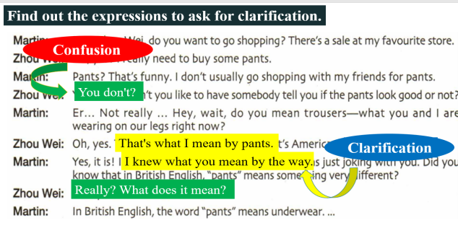

**Step 5: Make a conversation and role-play**

Make a conversation by choosing two pairs of different words as follows.

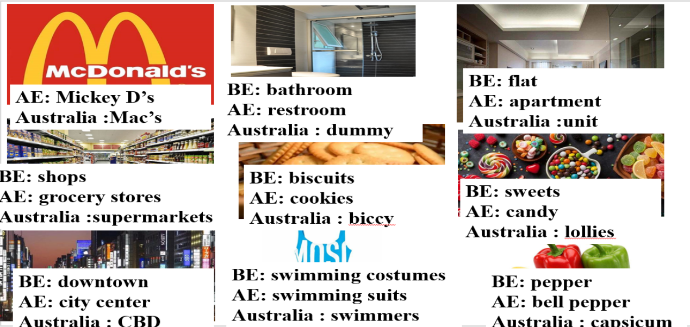

(Aims: to apply the functional items into practice and develop their creative thinking ability by making an authentic conversation.)