**独立主格导学案  
Absolute Construction**

**Ⅰ. Learning Objectives**

At the end of the lesson, we are expected to

1. know the form and function of absolute construction;

2. rewrite sentences with absolute construction;

3. complete sentences with absolute construction;

4. describe photos with absolute construction.

**Ⅱ. Presentation**

**Activity 1 Describe the photo.**

**Activity 2 Compare and summarize.**

1. Looking up at the basket, I aimed the basketball at it.
2. The students staring at me, I aimed the basketball at the basket.

**Activity 3 Observe and summarize** **the form and function of absolute construction.**

1. The players ran on the court, beads of sweat on their faces.
2. The girl made the basket, the opponents wide-eyed.
3. The basketball game over, we settled down to studying.

独立主格 = ______________________________________（在句子中充当_______________）

**Ⅲ. Practice**

**Activity 1 Judge whether the sentences use absolute construction.**

1. One boy was having a rest, one of his legs injured.
2. A basketball in his hands, the player was racing towards the basket.
3. The headteacher gathered them all around, providing strategies for them.
4. The students were seated around the ground, their eyes fixed on the players.
5. The game was going on fiercely, some reporters taking photos of the memorable scenes.
6. A grand basketball game was being held, the sun casting sparkling light everywhere.
7. The moment the headteacher announced there would be a basketball game, the students leaped to their feet with wild joy.
8. The player shot the basket and scored three points. A storm of thunderous applause burst on the playground.

**Activity 2 Rewrite the sentences under the guidance of the teacher**.

**Activity 3 Rewrite the sentences in pairs.**

1. All the players were worn-out. Their faces turned pale.
2. She stood on the ground and a frightened expression was on her face.
3. While the two girls were trying for the ball, their teammates gaped at them.

(4) The girl was surrounded by the opponent. Her teammate tried to catch the ball.

(5) All the students cheered for the player. He gathered all the strength to dribble the ball.

(6) After the final round of the game was over, the champion team was awarded a medal.

(7) The class won the first place, so the headteacher praised them for their team spirit.

(8) If time permits, we shall have another basketball game next year.

**Activity 4 Complete the sentences with absolute construction.**

(1)【2023年宁波联考】I woke up, _______________________________________(我周围的地板上有个坏掉的梯子).

(2)【2023年温州二模】___________________________(疲劳席卷了我的身体), I felt my lungs were bursting.

(3) 【2023新高考I卷续写】_________________________________________(雷鸣般的掌声在礼堂回荡), I could hardly wait to share the honor with my teacher, who assisted me in discovering my potential and passion.

(4)【2023新高考I卷续写】I went to my teacher’ office after the award presentation. As I entered, he looked up from his desk, __________________________________(脸上洋溢着灿烂的笑容), and said, “Congratulations! Your diligence and perseverance paid off.”

5.【2022年1月浙江省高考续写】When I opened the door, he was staring at me peacefully. ___________________(恢复了镇定), I slightly approached him and sat by the bed.

6.【2018年6月浙江省高考续写】________________________________________________________(我的心疯狂地跳动，我的血液在我的血管里涌动), I pulled back the reins(缰绳), distracted the horse and tried every means to stop the horse but in vain.

7.【2017年11月浙江省高考续写】Thinking of the tent, Mom suggested that we go camping in the next village, __________________________(她的眼里闪着兴奋得光芒).

8.【2016年10月浙江省高考续写】She thought of Tom, ____________________(回忆涌起) as she closed her eyes and recalled the kindness of him.

**Ⅳ. Production**

Describe one of the scenes with absolute construction. (场景改编自高考真题)

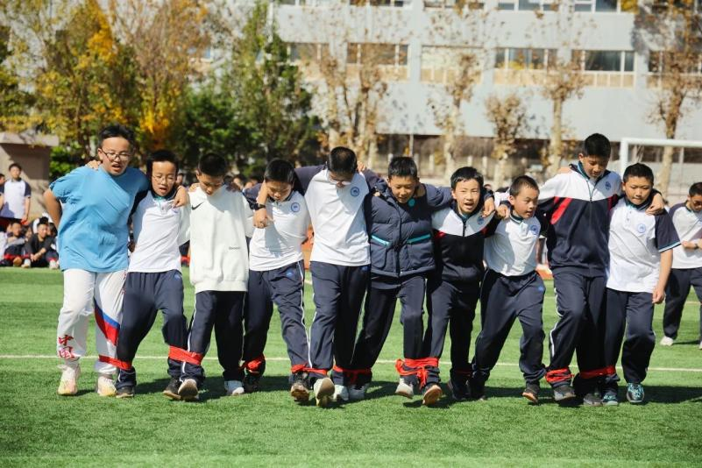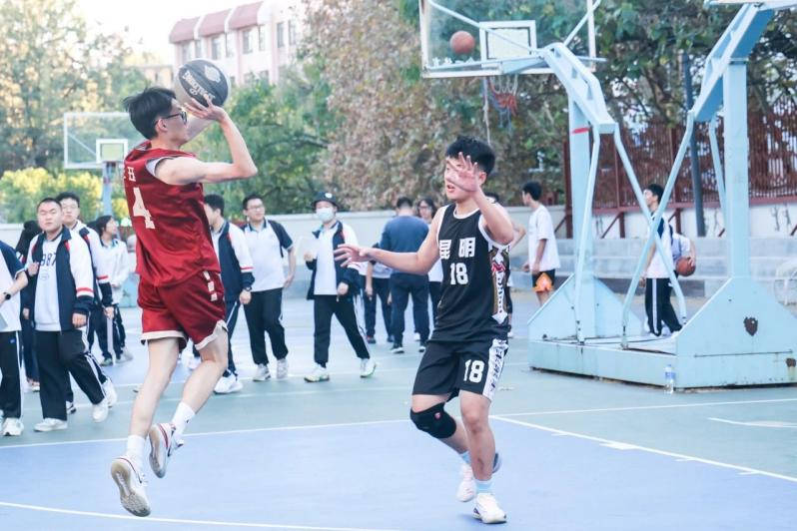___________________________________________________________________________________________________

______________________________________________________________________________________________________________________________________________________________________________________________________

___________________________________________________________________________________________________

**Use the following questions to evaluate the creation.**

1. Is there at least one absolute construction?

2. Does the description make sense?

3. Is there any spelling or grammar mistake?

4. Is the handwriting clear?

**Ⅴ. Self-Assessment**

**Have you achieved the following objectives?**

1. Know the form and function of absolute construction;
2. Rewrite sentences with absolute construction;
3. Complete sentences with absolute construction;
4. Describe pictures with absolute construction.

**Ⅵ. After-Class Assignment**

Describe one of the scenes with absolute construction. (场景改编自高考真题)

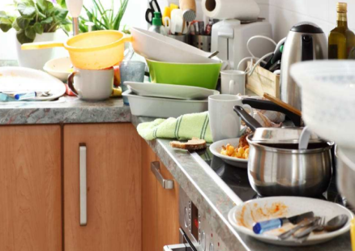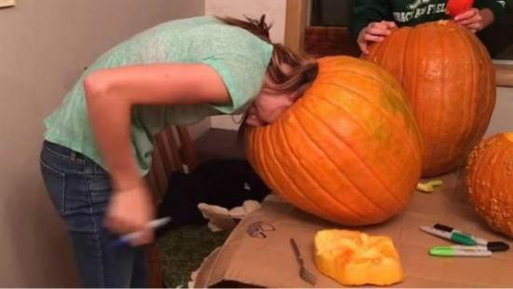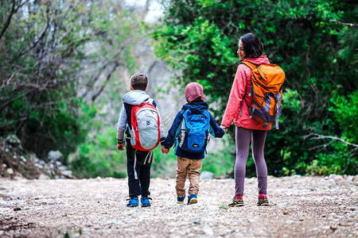

You go to travel with your mother and cannot find a hotel. Your mother suggests putting up a tent.

Your head is stuck in the pumpkin at Halloween and it’s quite hard to get out.

You prepare a gift for your mother on Mother’s Day and make a mess in the kitchen. Then, your father comes in.

**Imagine what would happen to you in the scenes. Choose one to describe.**

* Use at least 80 words.
* Use at least 3 sentences with absolute construction.
* Describe actions, feelings, conversations, or settings.