**Unit 2 Looking into the future**

**The future continuous tense**

**教学设计**

**教学目标：**

1.To identify and analyse the usages of the future progressive tense.

2.To master the usages of the future progressive tense through self-study and practice.

3.To use the future progressive tense to express your ideas.

**教学过程：**

一、Leading-in

Enjoy a short video about smart home in the future and guide the students to pay special attention to the italic and underlined sentences. ---future progressive tense ( future continuous tense )

1. In the not-too-distant future, *we will be living in smart homes* that will lock the door for us when we are away and remember to switch off the TV when we forget.

2. In the future, *we will be using advanced technology every day* for automatic control of just about everything in our home.

**注意：The future progressive tense is used to talk about prediction to the life in the future.**

Enjoy another video and try to feel the future progressive tense in the situation.

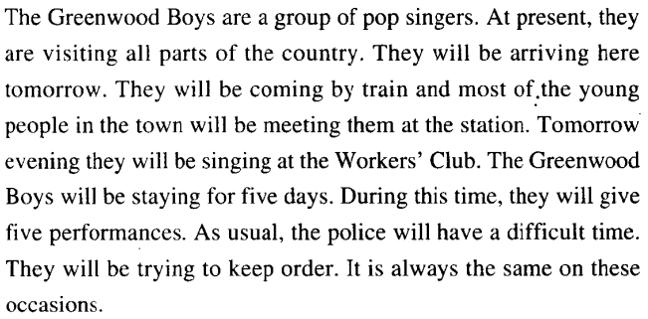

二、While-class

**A.Observe and discover 1 and practice1.**

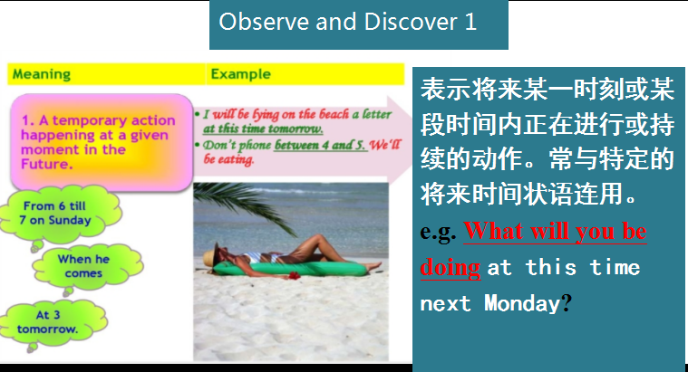

单句语法填空

1.I____________(do) my homework at ten tomorrow evening.

2.We____________(fly) to the United States this time next week.

3.You can call me at 8 in the evening.I____________(not sleep) then.

4.At 5:00 pm,the boys____________(practice) football on the playground.

5.The headmaster____________(meet) some parents at 3:00 this afternoon.

1. **Observe and discover 2 and practice2.**

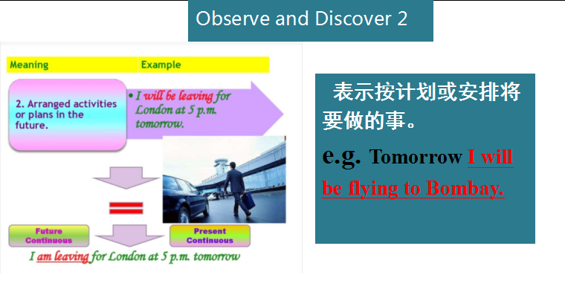

1．我们将在澳大利亚过冬。_____________________________________

2．下两个月玛丽将在这个厂里工作。_____________________________________

3．克雷格教授明晚作关于陶器的讲演。_____________________________________

4．后天这个时候我将飞往纽约。_____________________________________

C. **Observe and discover 3 .**

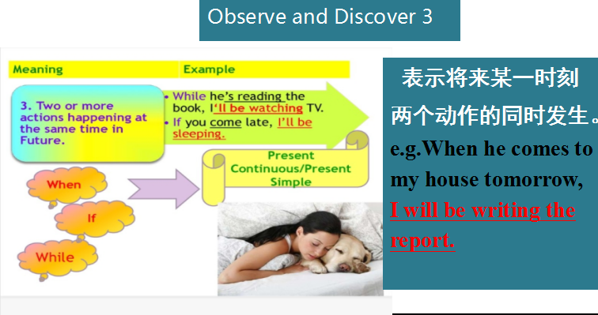

**D.Summary:**

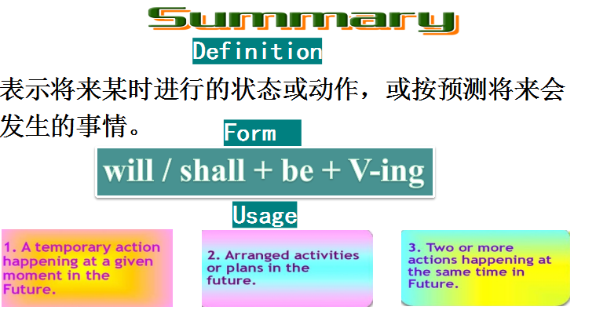

**E.Compare and discover: 一般将来时 VS 将来进行时**

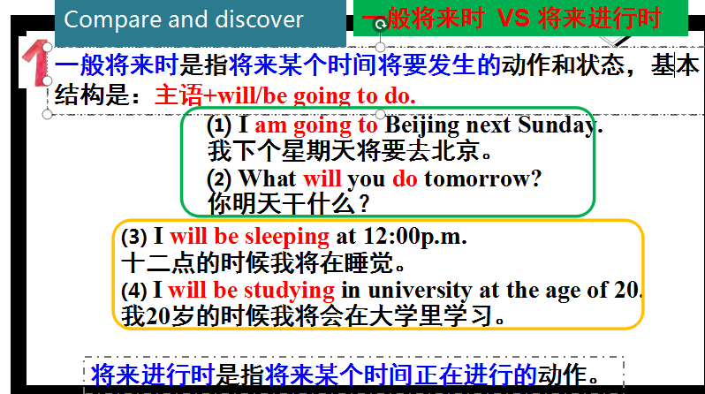

用动词的适当形式填空

Great changes 1.____________(take) place in the future.People 2.____________ (become) richer and richer, life 3.____________(be) more and more convenient.We 4.____________(have) lessons online at home instead of going to school.If we want to do something, the robots 5.____________(perform) all kinds of tasks for us according to our commands.

**F. Pactice and Apply**