**Instructional Design**

Going Positive

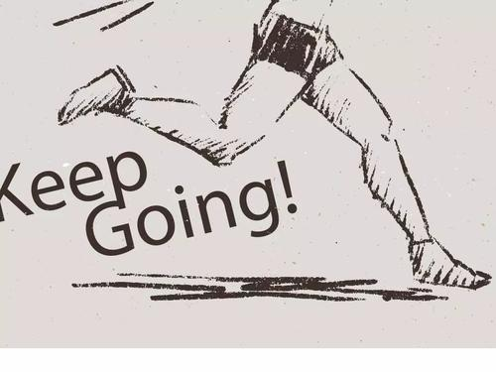

Students: Senior One

Type: Reading for writing

Time: 40mins

Designer: Mao Liqin

|  |  |  |  |
| --- | --- | --- | --- |
| **Teaching objectives** | | | |
| By the end of this lesson, students will be able to:  1). be clear about Kayla’s change and experience.  2). learn the “comparison and contrast” method of writing and write a page for a class wellness book.  3). be inspired to live a healthy life both physically and mentally. | | | |
| **Teaching focus and difficult points** | | | |
| **1. Teaching focus**  1) analyze the organization and language features of the passage.  2) help students form the right recognition of health and fitness .  **2. Teaching difficult points**  Help students grasp the organization and language features of the passage and apply them to writing. | | | |
| **Teaching procedures (40')** | | | |
| **Stage** | **Teacher’s activities** | **The students’ activities** | **Purpose** |
| **Step 1**  **Lead in**  **( 3mins)** | 1. Greeting. 2. Brief self-introduction and lead to the topic of the passage. | Think about what wellness is and get ready to read the passage. | 1. 拉近与学生的距离； 2. 激发学生对文本学习的兴趣，形成阅读期待。 |
| **Step 2**  **Task 1:Reading for information**  **( 7mins)** | Ask the students to read the passage and find the answers to the following questions:  1 What problem did Kayla have in the past?  2 What does the sentence“I almost went bananas” mean?  3 What made her change her thinking?  . | Scan through the passage to find the answer. | 阅读文章，获取信息，了解Kayla健身前存在的问题；借助篇章上下文语境，猜测“I almost went bananas”在文本的意思；了解Kayla开始意识到健身的转折点。 |
| **Step 3**  **Task 2: Reading for further information**  **( 9mins)** | Ask students to find out the required information according to the table. | 1. The students read the whole passage and find information the teacher required. 2. The students will realize the importance of fitness and try to interpret the meaning of the title “Going Positive” by comparison and contrast between the past and the present. | 该表格呈现了文本基本的框架结构，可以帮助学生将阅读到的信息进行结构化和条理化处理，从而形成语篇的结构化知识、加深对文本标题的理解以及形成正确的健康观。 |
| **Step 4**  **Reading for organization**  **( 3mins)** | 1. Ask the students to match the main idea with each paragraph. 2. Ask the students to choose the answer about writing strategy.   How does the author show her positive changes?  A. By giving examples  B. By asking questions.  C. By showing differences.  D. By listing some data. | The students think and answer the questions according to the understanding of the passage. | 帮助学生进一步明确这篇健康随笔的文本结构、写作手法，并形成后续写作的小贴士。 |
| **Step 5**  **Reading for language ( 4 mins)** | 1. Ask the students to underline the words and phrases used in the text to show differences. 2. Express the same meaning with the given words below. | The students read and underline the words and phrases used in the text to show differences and make sentences with these expressions. | 关注和学习表达“不同”的语言，进行语言的输入 |
| **Step6**  **Voice your opinion**  **( 12 min)** | 1. Ask the students to help Cathy go positive in thinking, action and state the possible improvement. 2. Sample study: complete the passage with the words and phrases. | 1. Four students in a group, brainstorm positive attitude, reasonable actions and possible improvement, then the group leader give a report with the help of the given words. 2. The students complete the passage with the words and phrases. | 1. 这是基于文本又超越文本的问题，让学生针对Cathy存在的问题，通过思考和讨论给出相关的改进措施和可能的结果，培养关注健康意识，形成正确的健康观。这属于高级的批判性思维活动，不仅能够帮助学生加深和拓展对文本信息的理解，还能提高学生的思维品质和文化品格。 2. 范本的学习进一步帮助未能很好完成任务的学生去关注内容与语言的结合。 |
| **Step7**  **Assignment**  **( 2 min)** | Ask students to use what they have learnt to write a page in a wellness book. | Choose one topic and write a page in a wellness book. | 进行语言的输出。 |
| **板书设计** | | | |