**Mosquito Bites**

**——语篇知识在科普说明文阅读中的应用**

**学 案**

黄新 云南民大附中

* **The theme context (主题语境)**

|  |
| --- |
| What’s the theme context (主题语境)?  A. People and self B. Human and society C. Human and nature |

* **The Main idea (段落大意、文章大意)**

|  |  |
| --- | --- |
| What’s the main idea of Para.1? | Getting and mosquito bites can be uncomfortable, but can be simple. Luckily, mosquito bites can be . |

* **The structure (语篇结构)**

|  |  |  |  |
| --- | --- | --- | --- |
| Para. 2 | Mosquitoes are **attracted** to sweat... |  | Part 1  behind MB |
| Para. 3 | Mosquitoes are **also** attracted to dark colors. |
| Para. 4 | **Additionally**, there is ... blood type as a factor... |
| Para. 5 | What’s **the best way** to deal with the discomfort...? | Part 2  to deal with MB |
| Para. 6 | **But**, if..., you **can** apply a cold compress... |
| Para. 7 | “Using insect repellent can be pretty **helpful**,”... | Part 3  Ways to MB |

* **Finish the mind map (完成思维导图)**

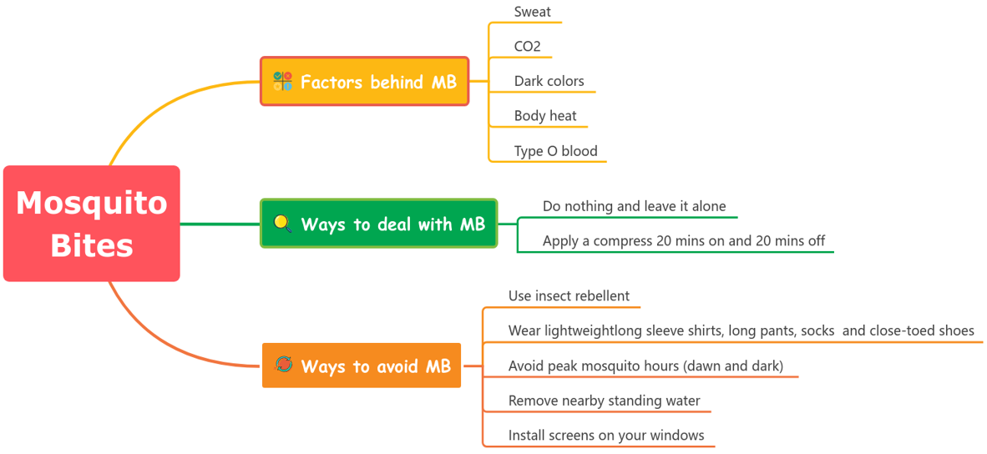

* **The writing type (体裁)**

What’s the writing type of the passage?

A. Narration B. Argumentative essay C. Expository writing D. Practical writing

* **Methods of explanation (说明方法)**

|  |  |  |
| --- | --- | --- |
| **本文用了**  **打钩** | **Methods of explanation**  **(说明方法)** | **Signposts (语言标志词)** |
|  | Definition (定义法) | 定义是（is defined as）、意味着（means）、即（namely） |
|  | Example (举例说明法) | 例如（for example）、比如（such as）、具体而言（specifically） |
|  | Comparison and Contrast  (比较说明法) | 与……相比（compared to/with）、相似地（similarly）、  然而（however）、尽管如此（nevertheless）、  另一方面（on the other hand）、相比之下（in contrast） |
|  | Cause and Effect  (因果说明法) | 因为（because）、由于（due to）、结果是（as a result）、  导致（lead to）、造成（cause） |
|  | Quotation  (引用说明法) | 某某说（sb says/said）、研究确定（a study determined）、  据（according to）、在……看来（in the view of） |

* **Word meaning guessing (词义猜测)**
* attract attracted, attractive Guess by word root (借助词根猜词义)

Practice: un**comfort**able, dis**comfort**

“un**comfort**able” means:

“dis**comfort**” means:

* Mosquitoes are **attracted** to sweat. They’re also **drawn** to when we breathe out CO2.

Guess by signposts (借助语言标志词猜词义)

Practice: ... they might be more drawn to you than say if you were wearing white or **cream**.

“cream” means:

* ... it’s important that you avoid **peak** mosquito hours (dawn and dusk),...

Guess by common knowledge (借助常识猜词义)

Practice: ... it’s important that you avoid **peak** mosquito hours (dawn and dusk), remove nearby **standing** water,... “standing” means:

* **Self-reflection (自我反馈)**

**课堂学习反思评价表(Tick √)**

|  |  |  |  |
| --- | --- | --- | --- |
| **Items For Reflection** | **Agree** | **Partly Agree** | **Disagree** |
| I’ve known three theme contexts. |  |  |  |
| I’ve known how to quickly predict the main idea of an expository writing. |  |  |  |
| I can find some important nouns and verbs to help me get the main idea. |  |  |  |
| I can use a mind map to layout the structure. |  |  |  |
| I can find some signposts that imply the logic. |  |  |  |
| I know five common explanation method. |  |  |  |
| I know and I can use three word meaning guessing methods. |  |  |  |
| I was active in class. |  |  |  |
| I have tried to work with my partner. |  |  |  |
| What do I still need to practice in the future? |  | | |

* **Assignment(s)（课后任务）**

选择作业1或作业1和2作为对课堂所学的巩固和拓展。

Option 1: Design a mind map for the given passage.

Option 2: Raise 2 to 4 questions for the given passage with reference to the follow questions.

|  |  |
| --- | --- |
| Questions | Question types |
| 1. Which of the following is most attractive for a mosquito? | 理解性问题 |
| 2. What does Cotter think of dealing with mosquito bites? | 分析性问题 |
| 3. What is the authors purpose of writing the text? | 评价性问题 |
| 4. Which can be the ending of the passage? | 创作性问题 |