**同文异构 融会贯通**

以讲述人物故事为引 梳理复习类似话题应用文

**StepⅠlead-in**

1. Watch the video of the theme song in the movie of Mu lan: Enjoy a song before the class—I’ll make a man out of you. Students will be aware of what is going to be showed and stimulate their enthusiasm for the figure.
2. Play the game of vocabulary train: according to the order of 26 letters, let the student speak out an adj of describing a person in turn. Then choose some of them to describe Mulan.

**StepⅡstory adaptation**

1. Watch the video and fill the blanks: The video is consistent with the text content. Let students watch the video while paying more attention to the subtitles. Do the following exercise immediately after viewing.

Mulan is a 1___________(legend) Chinese who is known for her bravery, 2___________(selfless) and filial piety. Her story 3_______________(tell) for centuries.

In the story, Mulan is a young woman who lives in China 4___________ the Northern Wei Dynasty. The government of the Northern Wei Dynasty required every household to send one man to fight in the war. Mulan's father was old and sick, and her younger brother was too young to fight. So Mulan decided to disguise herself 5________ a man and take her father's place in the army.

Fighting on the border was a difficult task for many men, and it was even 6_____________（ difficult ）for Mulan, who had to hide her identity and fight alongside her comrades. After many years of fighting, Mulan finally returned home 7___________（ victory）. The emperor was so impressed by her bravery that he pardoned her for impersonating a man and offered her a position in the government. 8___________, Mulan declined, 9___________（say） that she needed to return home to care for her 10___________（age） parents.

The story of Mulan is a reminder of the strength and courage of women. It is also a reminder of the importance of family and duty.

1. Check the answers and study the words: check the answers one by one and highlight the usage of some important one if necessary.

Go further reading by choosing the main idea of the story. Then go through the words and expressions quickly to review what has already been learned before.

1. Adapt the passage
2. List the requirement as following.

2023年全国甲

你校举办以英语讲述中国故事为主题的征文活动，请以一位历史人物为题，写一篇短文投稿，内容包括: 1.人物事迹; 2.意义; 3.启示。

1. Analyze and discuss: make sure of what should be written as required and discuss in groups how to shorten the passage of Mulan in order to suit the writing task.

**Tip1**: Keep or choose the most representative events and shortly clarify the ending of the story.

1st version:

*Mulan is a legendary Chinese who is known for her bravery, selflessness and filial piety. Her story has been told for centuries.*

*In the story, When Mulan's father was called up to fight in the army, Mulan decided to disguise herself as a man and take her father's place in the army. Fighting on the border was a difficult task for many men, and it was even more difficult for Mulan, who had to hide her identity and fight alongside her comrades. Mulan returned home victorious. Mu Lan declined the high position in the government and returned home to care for her aging parents.*

*Mulan is a reminder of the strength and courage of women. It is also a reminder of the importance of family and duty.*

2nd version: add some details

*Mulan is a legendary Chinese who is known for her bravery, selflessness and filial piety. Her story has been told for centuries.*

*In the story, When Mulan's father was called up to fight in the army, Mulan decided to disguise herself as a man and take her father's place in the army. Fighting on the border was a difficult task for many men, and it was even more difficult for Mulan, who had to hide her identity and fight alongside her comrades. After many years of fighting, Mulan finally returned home victorious. Moreover, Mu Lan declined the high position in the government and returned home to care for her aging parents.*

*The story of Mulan teaches us courage, loyalty, and perseverance. It shows that women can be just as brave and strong as men. Mulan is a reminder of the strength and courage of women. It is also a reminder of the importance of family and duty.*

**Tip 2:** Make appropriate adjustment depending on different genre.

Final version:

*Mulan is a legendary Chinese who is known for her bravery, selflessness and filial piety. Her story has a profound impact on Chinese people.*

*In the story, When Mulan's father was called up to fight in the army, Mulan decided to disguise herself as a man and take her father's place in the army. After many years of fighting, Mulan finally returned home victorious, never revealing her true identity. Moreover, Mu Lan declined the high position in the government and returned home to care for her aging parents.*

*The story of Mulan teaches us courage, loyalty, and perseverance. It shows that women can be just as brave and strong as men. Mulan is a reminder of the strength and courage of women. It is also a reminder of the importance of family and duty.*

**Step Ⅲ Practice**

1. **Guess and write:** read the writing task and guess the 2nd and 3rd requirements. Then make use of the passage of Mulan to complete the task.

＊假如你是李华，受学生会委托为校宣传栏“英语天地”写一则通知，请大家观看一部英语电影 Mu Lan,内容包括:

1. 电影内容
2. ________
3. ________

＊假定你是李华，打算参加你校即将举办的主题为"用英语讲中国故事"的演讲比赛。请你写一篇演讲稿。内容包括：

1. 介绍你要讲的中国故事；
2. 2．_________________________。
3. **Compare and rethink**

List 4 writing tasks and compare them by different perspectives.

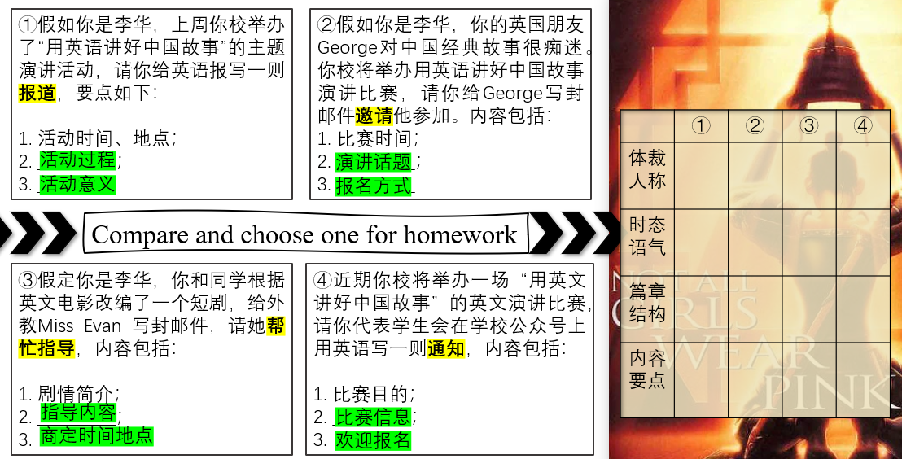

**Step Ⅳ watch and write**

Watch another video of Mulan for the ending of class and choose one writing task for homework.