阅读A篇

One Writer's Beginnings （P29-30）

作者：Eudora Welty

https://books.google.co.jp/books?id=lEM9l_Kka3wC&pg=PA29&lpg=PA29&dq=I+never+knew+anyone+who%27d+grown+up+in+Jackson+without+being+afraid+of+Mrs.+Calloway,+our+librarian.&source=bl&ots=pd7Dmyr2uY&sig=ACfU3U0xIav0cargn7LEY5CW7fdvr0ZmfA&hl=zh-CN&sa=X&ved=2ahUKEwjp5tKq4vPmAhWaxosBHeh5ABYQ6AEwAHoECAcQAQ#v=onepage&q&f=false

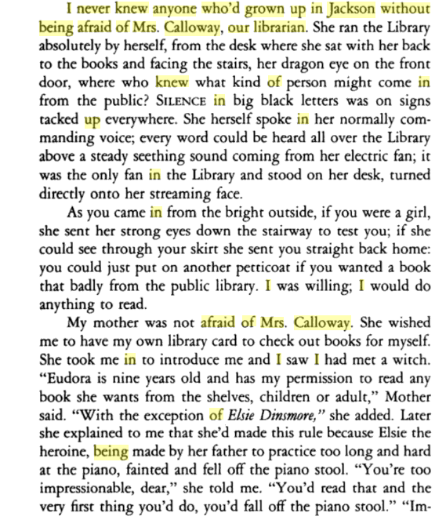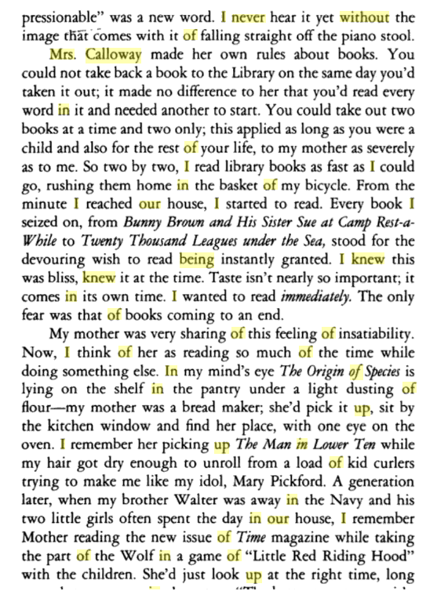

阅读B篇

阅读C篇

Children Tend to Learn Determination From Father

<https://psychcentral.com/news/2012/06/18/children-tend-to-learn-determination-from-father/40301.html>

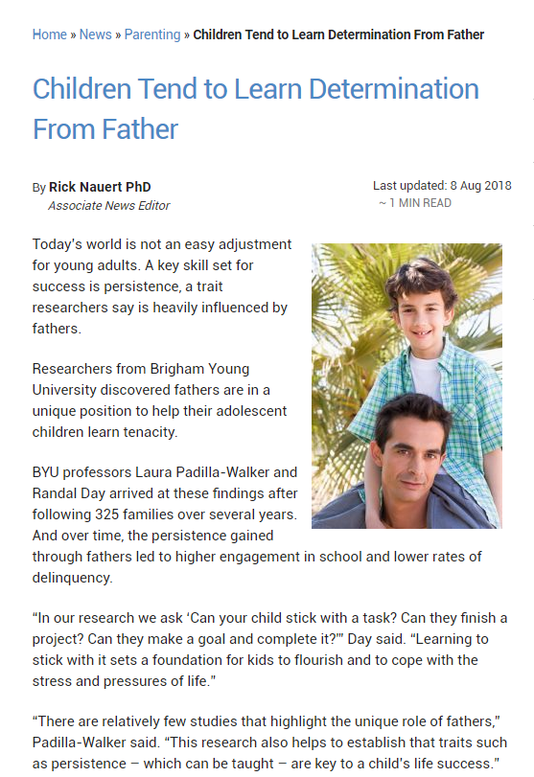

完型

填空

续写

<https://www.readingvine.com/passages/a-puppy-for-poppy>

