思维导图在续写中应用之课例设计
浙江省缙云中学 麻丽佳

- 教学目标
1.借助思维导图梳理故事发展框架，概括故事主要内容。挖掘文本三大写作技巧即通过人物反应和环境描写烘托氛围；人物间的互动推动情节发展；人物的行为语言和心理塑造人物形象，并把提炼出来的三大技巧用于读后续写中。
2.借助思维导图，根据续写段落开头语预测可能的情节发展和结尾，构建符合逻辑的续写故事框架，培养学生的逻辑性和创新性思维能力，根据搭建的故事框架进行书面语言的输出。
3. 丰富学生相关语言储备：关于火灾的环境描写，人物动作反应描写和人物心里反应描写。同时，引导学生关注课文重点句式，学会仿写，灵活运用。
二、教学流程
（一）读前激活思维
步骤1：Lead- in
Q1: If a fire broke out in your flat, what would you do?
Q2: Would you risk your life to take something precious with you?
【设计说明】本环节旨在引入主题，激活学生的背景知识，回顾记叙文的六要素，帮助学生构建一个结构清晰的记叙文理论框架，为接下去的读和写环节做好准备。
（二）读中训练思维
步骤1：Read for information
Q1: Who are the main characters?
Q2: What’s the relationship between them?
Q3: What happened in their flat?
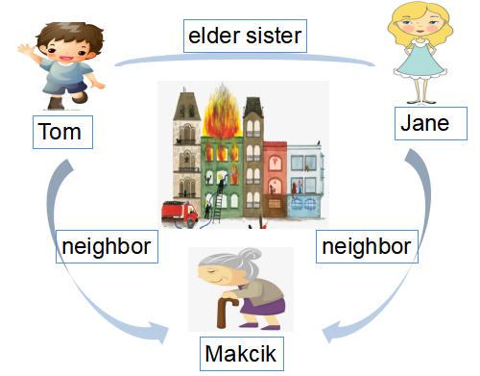
【设计说明】本环节旨在帮助学生理清文本脉络，培养学生提炼信息和概括信息的能力。
步骤2：Read for plot
Q1: How was the fire? Was the fire big and terrifying? Find some evidence.
Q2: What did people say?
(“Quick! Quick! Remove the motorcycles from the shop”someone yelled.)
Q3: What did people do?
(People were running and crying.)
Q4: How was the surroundings?
(Then a thick burning smell filled the air.)
(When Tom opened the front door of their flat to investigate, a thick cloud of smoke greeted him. )
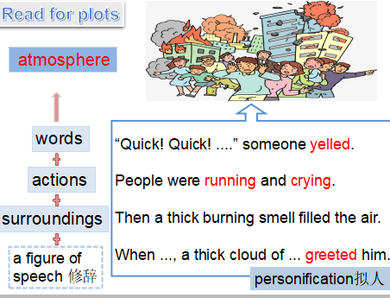
Tip1: Atmosphere= people’s reactions+ surroundings+ a figure of speech
Q5: When Tom and Jane both rushed out and headed towards the stairway, Jane suddenly stopped,she remembered their neighbour Makcik was still sleeping at home. what did they do?
Jane: She stopped and headed back the way they came.
Tom: He had no idea what Jane was doing, but he followed her.
Jane: Jane began banging on Makcik’ s door, but got no answer.
Tom: Tom was feared and cried: “She would have run for safety like everyone else!”
Jane: Jane refused to give up. She pounded against the door.
Q6: From Jane’ s actions, what kind of person is she? How did the author create Jane’ s imagery? How about Tom? How did the author create Tom’ s imagery?
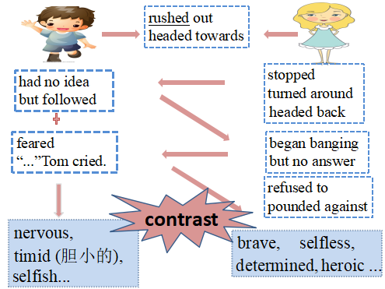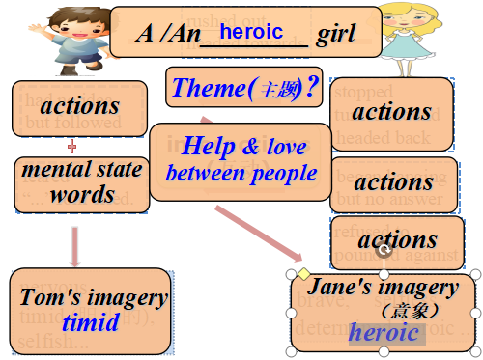

Tip2: Imagery = words+ mental states+ actions
Tip3: Plots are developed by the interactions between the main characters.
Q7: From the contrast, whom did the author really want to praise? Can you give a title?
Q8:What’s the theme of the story?
【设计说明】学生通过寻找动作厘清故事发展线索，再通过Jane一系列动作分析Jane 的人物形象(brave, selfless, heroic)；同样通过Tom的行为，语言和情感提炼Tom 的人物形象(nervous, timid, selfish)。教师顺势归纳可以通过人物语言行为和情感塑造人物形象的技巧。学生通过对两者进行对比突出a heroic girl,以及归纳出本文“help and love between people”这一主题，确定续写部分的主基调。
（三）读后拓展思维
步骤1: Plot deduction (推理)
Para.1:Tom noticed the flame was reaching up.
Para.2:Luckily, some neighbors passing by stopped and offered help.
Q1: According the two given sentences, what can you infer？
（Para1 is about trouble; Para2 is about solution））
Q2: What trouble did they meet ? Please design the trouble.
Q3: What’s the main idea of para2?
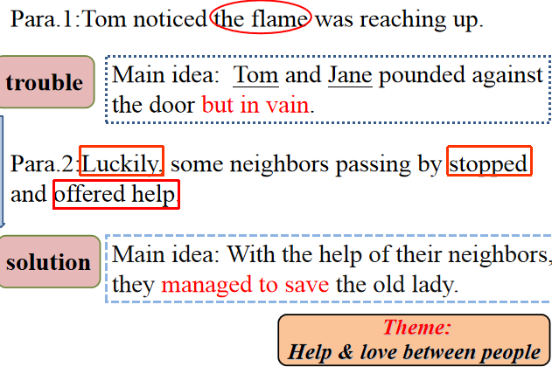
【设计说明】本环节通过对续写部分首句分析，引导学生去深入思考，结合文章主题，通过对全文整体的把握，确定好每段的主题和续写的具体内容。通过思维导图分析，让学生一步步解锁续写内容，帮助学生树立写作信心，克服不知写些什么，无从下手的消极心理。
步骤2: Plot design
Q1: Facing that the flame was reaching up, what would they do? What would they say? What are their feelings?
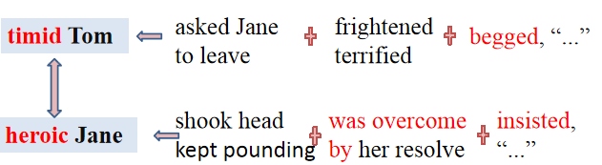
【设计说明】具体情节从人物间的互动展开，包括人物的行为，动作和情感，把阅读过程中提炼的写作技巧用于情节设计中。学生通过发散思维，对两个主人公之间的动作，情感和语言进行设置，丰富情节内容。
步骤3: Language guidance
Q1: Surroundings: Imitate the first sentence and complete the following one to show Tom and Jane’ s situation.
1.The dark, rainy evening, the wind, the thundering clouds held me entirely in their power. — Book1 “Anne’s Best Friend”
The big, terrifying fire，the smoke，the running people held Jane and Tom entirely in their power.
2.There was no stopping the fires. There was no way to organize or communicate. — Book1 “The Story of An Eyewitness”
There was no stopping the fires. There was no way to open the door or awaken the old lady.
Q1: Characters’ reactions: Facing the fire, what are people’s physical and mental reactions?
physical reactions They were coughing.
They were choked to death.
They were sweating at every pore (毛孔).
Their eyes were stinging (刺痛) .
mental reactions Frozen with fear, he stood rooted to the spot.
A burst of horror held him totally in its power, and he was unable to move an inch.
He felt that the blood in his body froze rapidly because of the terrible sight.
Time seemed to stand still.
【设计说明】通过语言指导，鼓励学生有意识地去提升自己的语言表达能力，提高自己的语言表达能力不断努力。
步骤 4: Writing
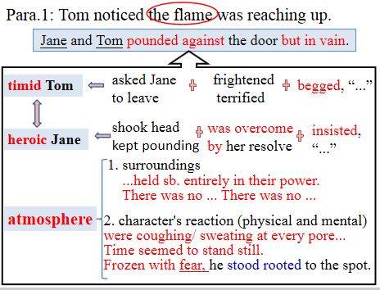
【设计说明】根据思维导图所列的主题、情节、情感、语言等层面的要写，学生通过组织语言，形成语篇。
步骤5: Homework
1. Polish your writing with your partners.
2. Use what we have learned in this class to continue the rest part of the story.
【设计说明】通过设计这一课后作业，旨在让学生在巩固阅读读后续写文本的文章结构，文章内容，人物分析等基础之上，运用所学的思维导图的绘制，进行创造性写作，发展创新思维。

