The World（0916-0930）材料分析和教学目标：

本次选用的材料：①《中国日报》的*Enthralling ceremony opens innovative Games*（杭州亚运会开幕式惊艳世界）、②《新科学家》的*Covid-19 linked to higher risk of type 1 diabetes in children*（Covid-19与儿童患1型糖尿病的风险较高有关）、③《泰晤士报》的*Ticketing nightmare in amphitheatre of dreams*（梦幻圆形剧场的售票噩梦）、④《华盛顿邮报》的*Wildfires eroding decades of air quality progress in U.S.*（美国野火频发致空气污染）和⑤VOA的视频新闻报道。通过语法填空、阅读理解、分析长难句、翻译句子、听力填空和词汇拓展等方式，让学生从多角度提升学习兴趣，提高分析句子、运用词块和听力能力。外媒英语新闻可以让学生体验真实语境下的语言运用，拓展学生的国际视野，了解时事，逐步提升跨文化沟通能力，形成正确的世界观、人生观和价值观。

教学思路：

**Part 1: News Report 1《中国日报》2023年9月25日 1页**

**Enthralling ceremony opens innovative Games 杭州亚运会开幕式惊艳世界**



【设计意图】通过语篇填空的形式帮助学生理解新闻的主要内容，同时训练语言语法的运用能力：在语篇的视角下如何正确使用所给词汇，根据语法规则确定词汇的正确形式，使得文章通顺，激活学生的思维和语言。该新闻主题语境是关于“人与社会”中“社会热点问题”这一子主题，通过学习让学生了解杭州亚运会开幕式的情况。



【设计意图】对文本中的词汇进行解读，并通过翻译句子对其进行巩固。



【设计意图】对文中的两个句子进行翻译练习，对其中单词、词组、句法进行巩固并关注句子结构。

**Part 2: News Report 2《新科学家》 2023年9月16日版 11页**

**Covid-19 linked to higher risk of type 1 diabetes in children**

**Covid-19与儿童患1型糖尿病的风险较高有关**

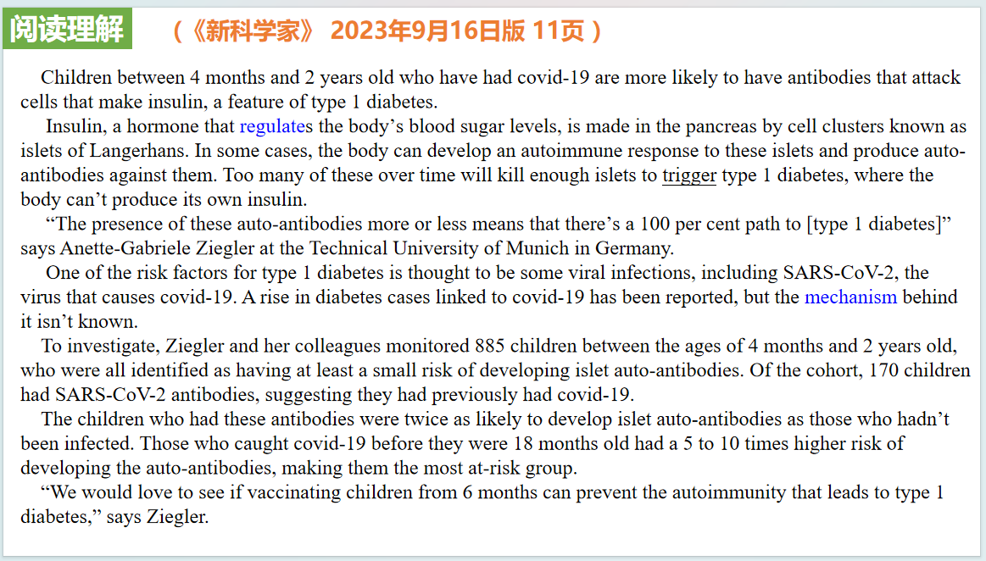

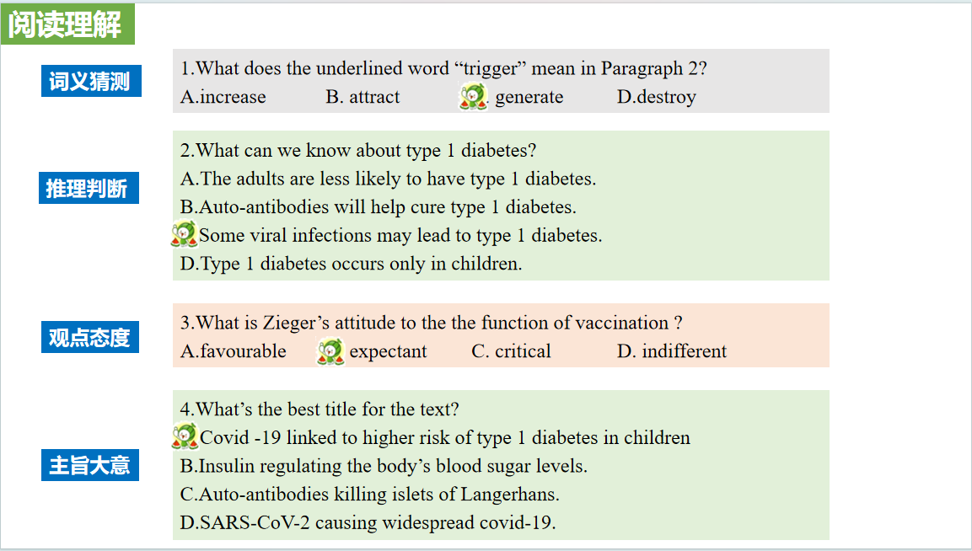

【设计意图】通过阅读理解的形式帮助学生理解新闻的主要内容，同时激活学生的思维和语言。该新闻主题语境是关于“人与社会”中“社会热点问题”这一子主题，通过学习让学生了解Covid-19与儿童患1型糖尿病之间存在的关联。

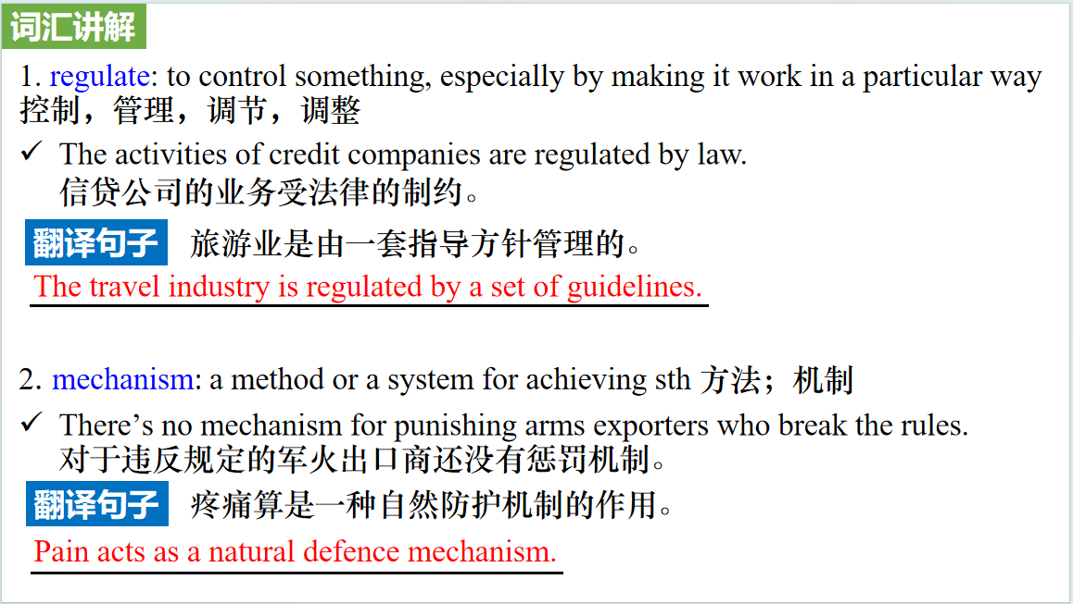

【设计意图】对文本中的词汇进行解读，并通过翻译句子对其进行巩固。

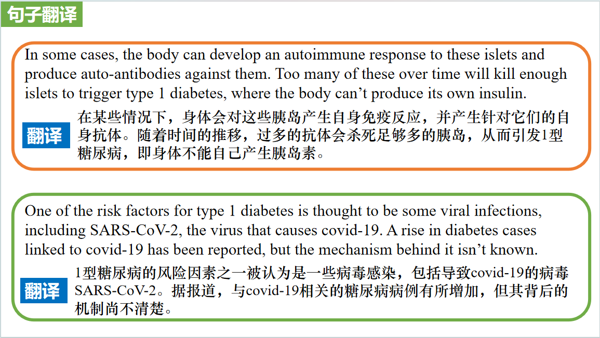

【设计意图】对文中的两个句子进行翻译练习，对其中单词、词组、句法进行巩固并关注句子结构。

**Part 3: News Report 3《泰晤士报》2023年9月18日35页**

**Ticketing nightmare in amphitheatre of dreams** **梦幻圆形剧场的售票噩梦**

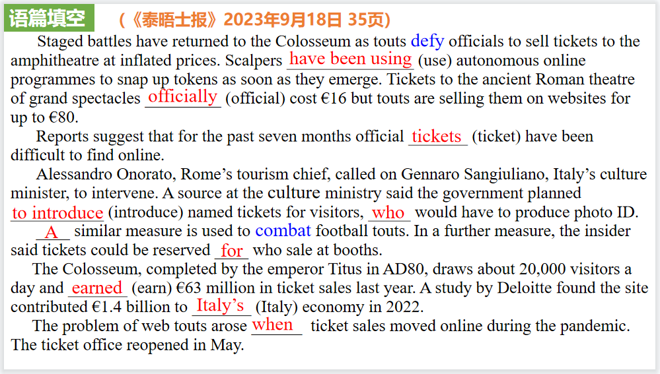

【设计意图】通过语篇填空的形式帮助学生理解新闻的主要内容，同时训练语言语法的运用能力：在语篇的视角下如何正确使用所给词汇，根据语法规则确定词汇的正确形式，使得文章通顺，激活学生的思维和语言。该新闻主题语境是关于“人与社会”中“绘画、建筑等领域的代表性作品和人物”这一子主题，通过学习让学生了解意大利圆形剧场被黄牛高价出售剧场门票及应对措施。

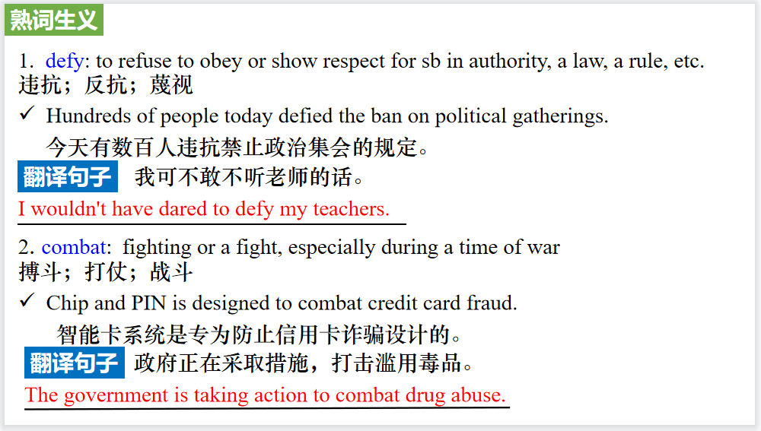

【设计意图】对文本中的词汇进行解读，并通过翻译句子对其进行巩固。

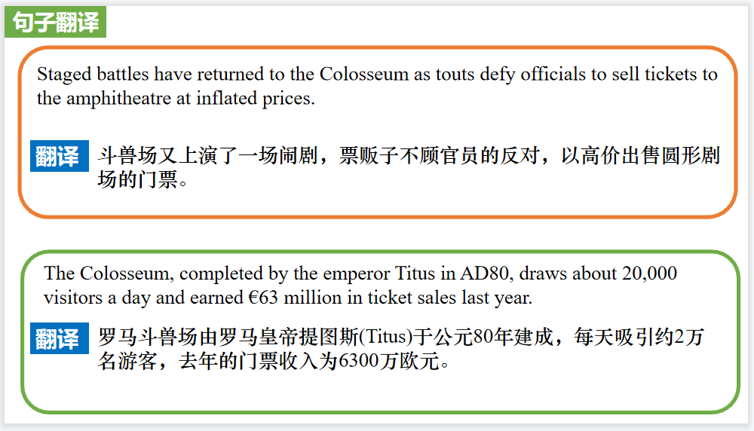

【设计意图】对文中的两个句子进行翻译练习，对其中单词、词组、句法进行巩固并关注句子结构。

**Part 4: News Report 4《华盛顿邮报》2023年9月21日 A3 版面**

**Wildfires eroding decades of air quality progress in U.S.**

**野火频发 美国几十年来的空气质量改善功亏一篑**

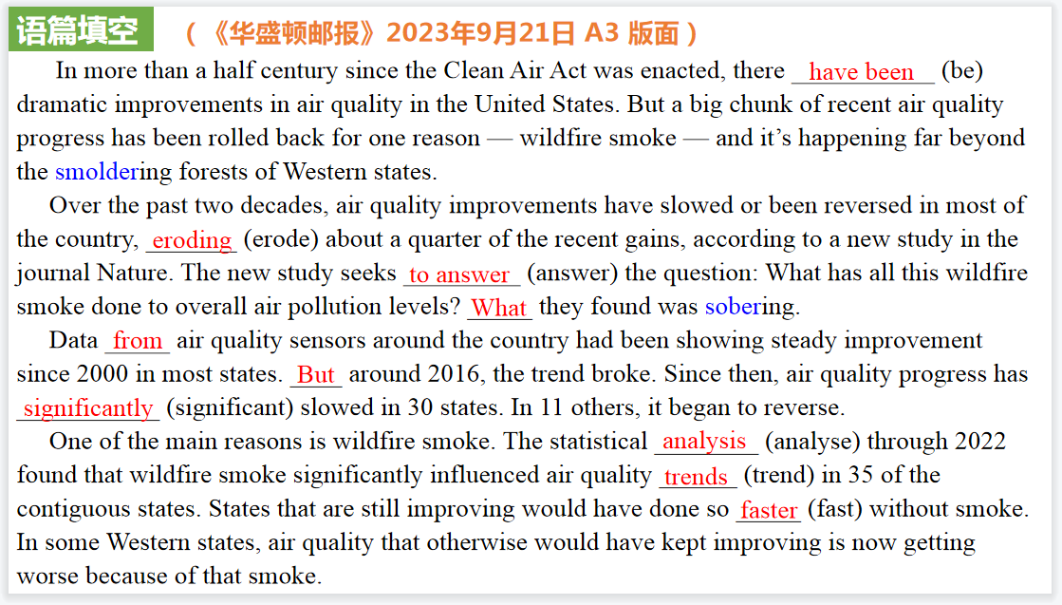

【设计意图】通过语篇填空的形式帮助学生理解新闻的主要内容，同时训练语言语法的运用能力：在语篇的视角下如何正确使用所给词汇，根据语法规则确定词汇的正确形式，使得文章通顺，激活学生的思维和语言。该新闻主题语境是关于“人与自然”中“人与环境”这一子主题，通过学习让学生了解野火频发对于美国空气质量的影响，提高学生的环保意识。

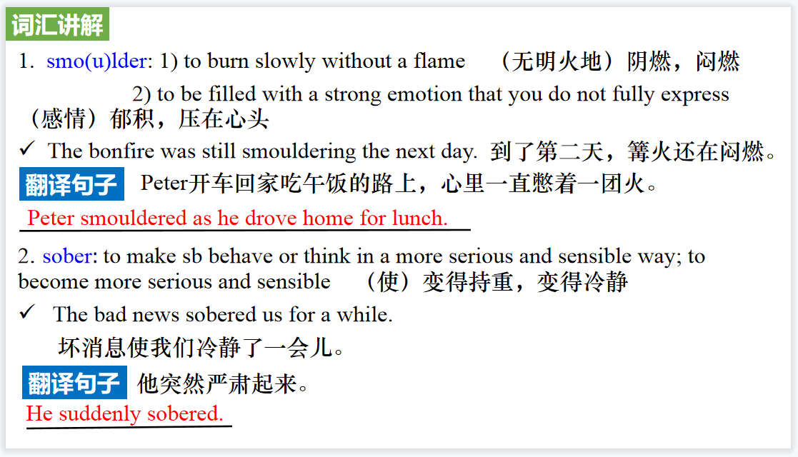

【设计意图】对文本中的词汇进行解读，并通过翻译句子对其进行巩固。

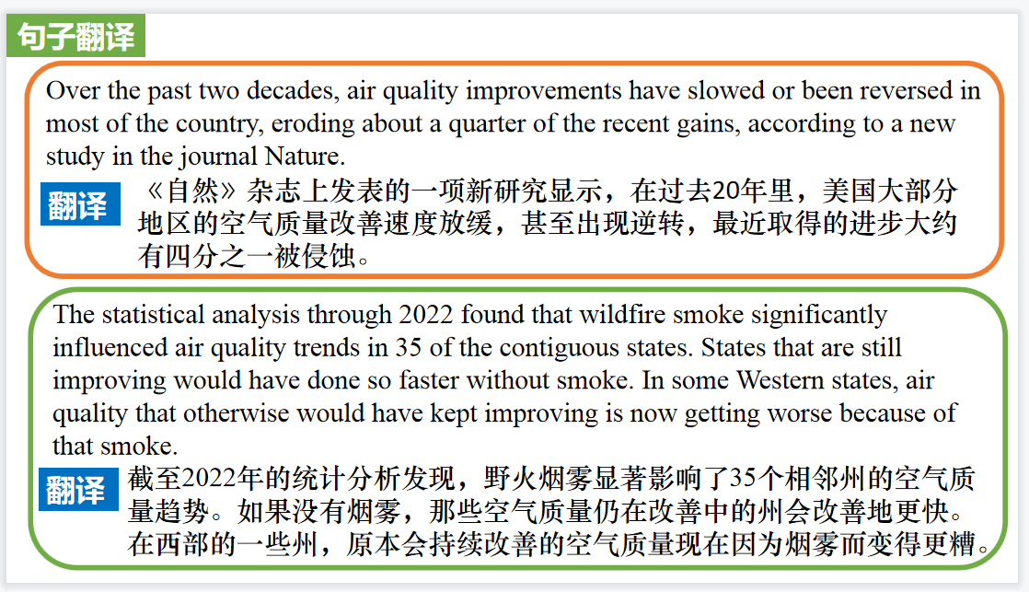

【设计意图】对文中的两个句子进行翻译练习，对其中单词、词组、句法进行巩固并关注句子结构。

**Part 5: VOA 09/26/2023**

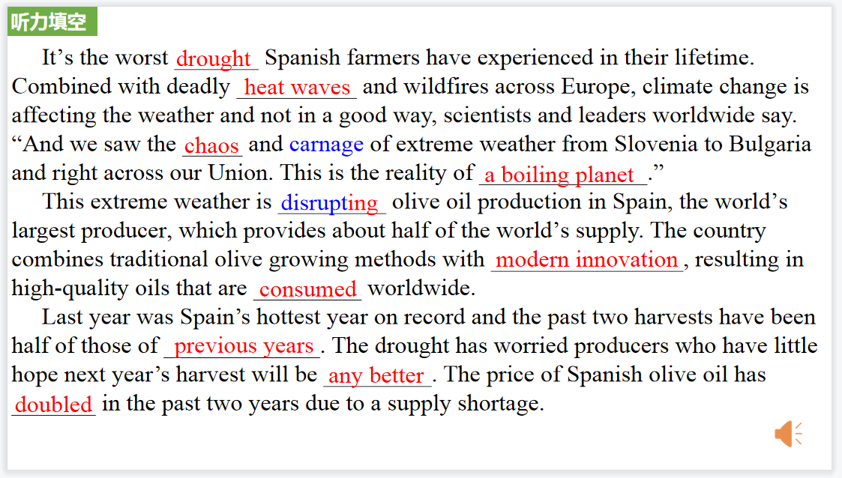

【设计意图】听一则材料，通过听力填空的方式理解文本，考察听力辨识词汇的能力。

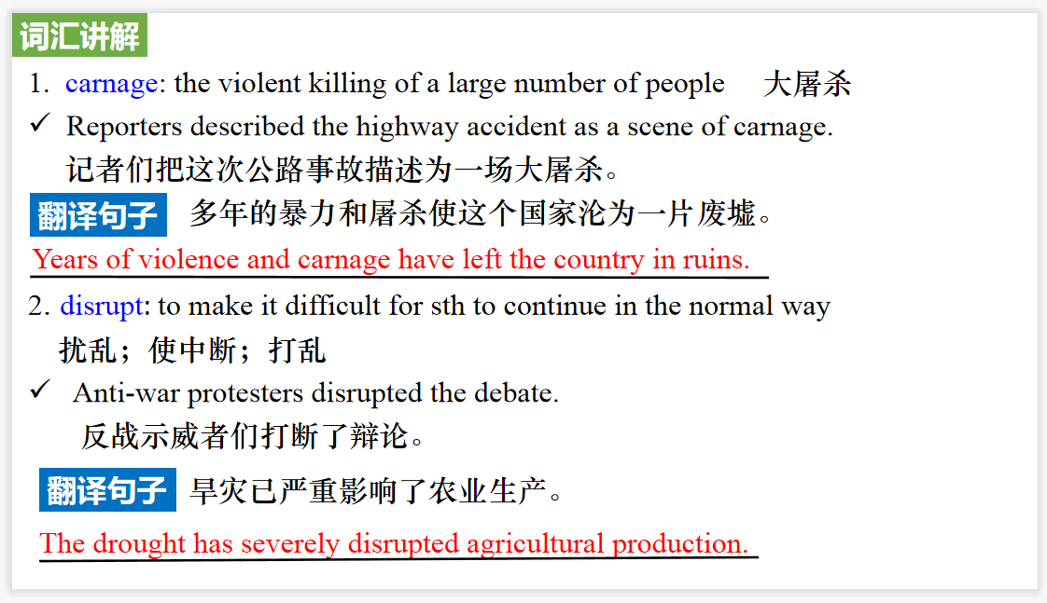

【设计意图】对文本中的词汇进行解读，并通过翻译句子对其进行巩固。

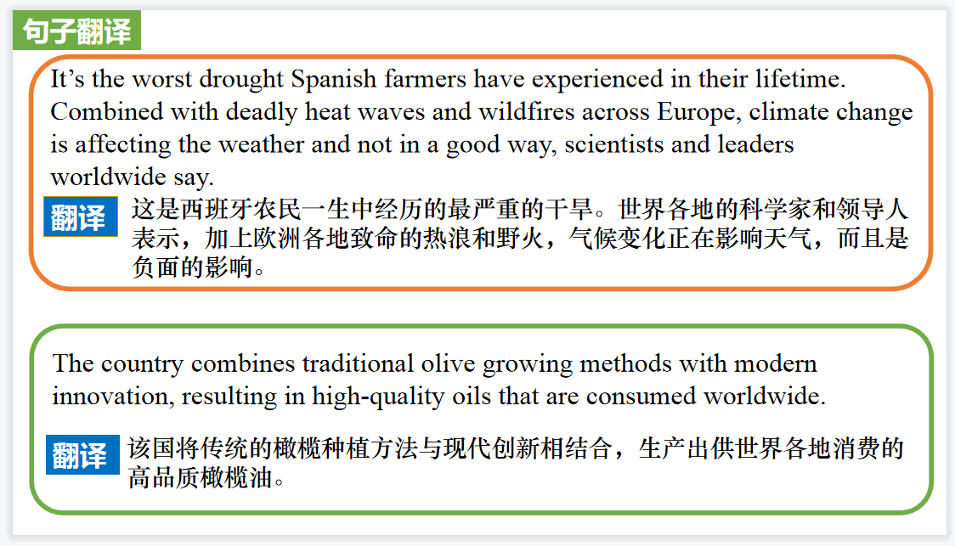

【设计意图】对文中的两个句子进行翻译练习，对其中单词、词组、句法进行巩固并关注句子结构。

附：外刊原文

**Part 1: News Report 1《中国日报》2023年9月25日 1页**

**Enthralling ceremony opens innovative Games**

**杭州亚运会开幕式惊艳世界**

The spectacular opening ceremony of the 19th Asian Games on Saturday in Hangzhou, Zhejiang province, left the world marveling at the stunning combination of China's rich cultural heritage and its remarkable technological advancements.

The two-hour show, themed “Tides Surging in Asia” was a seamless integration of glasses-free 3Dtechnology, augmented reality and artificial intelligence with the real world, which impressed not only athletes, officials and the 50,000 spectators at the Hangzhou Olympic Sports Centre Stadium, but also billions of viewers across the globe.

Raja Randhir Singh,acting president of the Olympic Council of Asia, was among the first to praise China and the Hangzhou Asian Games Organizing Committee for the breathtaking presentation

“We would like to congratulate the organizing committee and the government of China for the wonderful opening ceremony, Singh said on Sunday at a news conference.” It was a spectacular ceremony, and we have been to many. This was one of the fine stand the most beautiful opening ceremonies we have seen.”

As the athletes from 45 countries and regions stepped into the venue amid the roll of drums and melodious Chinese folk music, the packed stadium burst into wild celebration, cheering for every team. With the interplay of Chinese and Asian cultures, the parade highlighted the vision of building a community with a shared future.

Singh, whose daughter Rajesh-wari Kumari is competing in trapshooting for India, said the athletes would remember the Hangzhou Games for years to come. “They were very happy with the opening ceremony. It was perfectly done”

The lighting of the cauldron, which displayed the integration of the virtual and real worlds for the first time at an international sporting event, was undoubtedly the most glorious moment of the opening ceremony.

Scores of people in Asia and beyond watched with fascination as over 100 million sparks, each representing a participant in the digital torch relay, converged over the Qiantang River to form a “digital torchbearer”.

The digital torchbearer then ran toward the stadium to light the cauldron along with Olympic swimming champion Wang Shun, a Zhejiang native and final bearer of the physical torch.

According to the organizers, the opening ceremony used green,zero-carbon methanol for the first time to light the cauldron, helping create the first carbon-neutral Asian Games.

The use of a high-definition screen, which was the size of nine IMAX screens, helped put on a dazzling digital fireworks show, which organizers adopted as an eco-friendly alternative to the smoky display of traditional fireworks.

The vibe was celebratory and exciting, but in a more sustainable way, according to the ceremony’s creative team. Sha Xiaolan, chief director and chief producer of the ceremony, said the event surpassed the team’s own expectations. “What we did was more than what we had planned to do.... Technology allowed us to be more expressive. It was probably the greatest integration of technologies, such as augmented reality, in any international event of this stature,” Sha said.

Geoff Berkelev, chief senior reporter at insidethegames.diz, called the ceremony phenomenal. “It was a real spectacle, he said. “It was a digital art show and absolutely fantastic.”

For Malaysian photographer Luqmanul Arif Abdul Karim, the ceremony was a feast for the eyes. “It was so cool, so great. I loved the digital show, very futuristic. I loved the traditional cultural performances too,” he said.

Raed Abdeldayem, a reporter with Jordan’s Olympic committee, said that China never disappoints when it comes to opening ceremonies. “China gives us something new every time. It was even more amazing tonight.”

**Part 2: News Report 2《新科学家》 2023年9月16日版 11页**

**Covid-19 linked to higher risk of type1 diabetes in children**

**Covid-19与儿童患1型糖尿病的风险较高有关**

Children between 4 months and 2 years old who have had covid-19 are more likely to have antibodies that attack cells that make insulin, a feature of type 1 diabetes.

Insulin, a hormone that regulates the body’s blood sugar levels, is made in the pancreas by cell clusters known as islets of Langerhans. In some cases, the body can develop an autoimmune response to these islets and produce auto-antibodies against them. Too many of these over time will kill enough islets to trigger type 1 diabetes, where the body can’t produce its own insulin.

“The presence of these auto-antibodies more or less means that there’s a 100 per cent path to [type 1 diabetes]” says Anette-Gabriele Ziegler at the Technical University of Munich in Germany.

One of the risk factors for type 1 diabetes is thought to be some viral infections, including SARS-CoV-2, the virus that causes covid-19. A rise in diabetes cases linked to covid-19 has been reported, but the mechanism behind it isn’t known.

To investigate, Ziegler and her colleagues monitored 885 children between the ages of 4 months and 2 years old, who were all identified as having at least a small risk of developing islet auto-antibodies. Of the cohort, 170 children had SARS-CoV-2 antibodies, suggesting they had previously had covid-19.

The children who had these antibodies were twice as likely to develop islet auto-antibodies as those who hadn’t been infected. Those who caught covid-19 before they were 18 months old had a 5 to 10 times higher risk of developing the auto-antibodies, making them the most at-risk group.

“We would love to see if vaccinating children from 6 months can prevent the autoimmunity that leads to type 1 diabetes,” says Ziegler.

**Part 3: News Report 3《泰晤士报》2023年9月18日35页**

**Ticketing nightmare in amphitheatre of dreams**

**梦幻圆形剧场的售票噩梦**

Staged battles have returned to the Colosseum as touts defy officials to sell tickets to the amphitheatre at inflated prices. Scalpers have been using autonomous online programmes to snap up tokens as soon as they emerge. Tickets to the ancient Roman theatre of grand spectacles officially cost €16 but touts are selling them on websites for up to €80.

Reports suggest that for the past seven months official tickets have been difficult to find online.

Alessandro Onorato, Rome’s tourism chief, called on Gennaro Sangiuliano, Italy’s culture minister, to intervene. A source at the culture ministry said the government planned to introduce named tickets for visitors, who would have to produce photo ID.

A similar measure is used to combat football touts. In a further measure, the insider said tickets could be reserved for sale at booths.

The Colosseum, completed by the emperor Titus in AD80, draws about 20,000 visitors a day and earned €63 million in ticket sales last year. A study by Deloitte found the site contributed €1.4 billion to Italy’s economy in 2022.

The problem of web touts arose when ticket sales moved online during the pandemic. The ticket office reopened in May.

**Part 4: News Report 4《华盛顿邮报》2023年9月21日 A3 版面**

**Wildfires eroding decades of air quality progress in U.S.**

**野火频发 美国几十年来的空气质量改善功亏一篑**

Study finds pollution from smoke has undone a quarter of recent gains

BY JOSHUA PARTLOW

In more than a half century since the Clean Air Act was enacted, there have been dramatic improvements in air quality in the United States, as regulations

demanding less-polluting cars and factories helped lift cities from clouds of dirty smog.

But a big chunk of recent air quality progress has been rolled back for one reason — wildfire smoke — and it’s happening far beyond the smoldering forests of Western states.

Over the past two decades, air quality improvements have slowed or been reversed in most of the country, eroding about a quarter of the recent gains, according to a new study in the journal Nature. Some states — Colorado, Montana, New Mexico, Washington and Wyoming — have rolled back 50 percent or more of their progress since 2000. In Oregon and Nevada, wildfire smoke has completely erased their gains.

“We had had so much success, and wildfires, just in five to six years, are really unraveling a lot of this progress,” said Marshall Burke, the paper’s lead author and a professor of Earth system science at Stanford University. “And that’s unfortunate.”

The study builds on previous work by Burke and his colleagues, who had created a detailed map of how much wildfire smoke there has been in the country over the past two decades. That effort relied on melding data from air quality sensors, satellite images of smoke plumes, and computer models that could estimate smoke levels in remote areas without sensors.

The new paper seeks to answer the question: What has all this wildfire smoke done to overall air pollution levels?

What they found was sobering.

Data from air quality sensors around the country had been showing steady improvement since 2000 in most states. But around 2016 — and earlier in some Western states — the trend broke. Since then, air quality progress has significantly slowed in 30 states. In 11 others, it began to reverse.

One of the main reasons is wildfire smoke.

The statistical analysis by Burke and his colleagues through 2022 found that wildfire smoke significantly influenced air quality trends in 35 of the contiguous

states. States that are still improving would have done so faster without smoke, they found. In some Western states, air quality that otherwise would have kept

improving is now getting worse because of that smoke.

“To me it was really a surprising number of states that were being affected,” said Marissa Childs, a co-author and a postdoctoral fellow at the Harvard University Center for the Environment. “We’re really starting to see that impact over the entire country.”

Wildfire smoke is not directly regulated by the Clean Air Act and is often harder to manage than other types of air pollution. Fires are irregular in duration and intensity. Smoke can travel huge distances, affecting places far from the source. The Biden administration is pushing to expand prescribed burns and treethinning projects — to keep fires smaller and less destructive —

while encouraging protections against exposure to smoke.

“This isn’t a traditional source of air pollution where you can put a scrubber on a smokestack or something like that,” said Jason Sacks, a research epidemiologist with the Environmental Protection Agency. “It’s going to be more

of community and personal preparedness and trying to figure out what can I do to protect myself and reduce my exposures.”

This year has been particularly bad for smoke. Over the summer, hundreds of wildfires burning across Canada poured smoke across the border into the Northeast and other parts of the country less accustomed to orange skies and choking air. There were days in June when New York City had some of the worst air quality of any major city in the world.

Childs said if their study had been redone with 2023 data, “the results we’d find would only be stronger.”

The consequences of more smoky days and deteriorating air quality could have profound impacts on Americans’ health. Across the country, researchers are trying to unravel what those effects may be.

Many studies have documented how smoky days can send patients into emergency rooms in greater numbers with respiratory, cardiovascular and other problems. Burke, Childs and other researchers published a second study this week in Proceedings of the National Academy of Sciences that found that visits to California emergency rooms between 2006 and 2017 for asthma, chronic obstructive pulmonary disease (COPD) and other respiratory symptoms rose more than 30 percent in the week after an extreme smoke day, relative to a day without smoke.

They also found a slight rise in all emergency visits after low or moderate smoke days but a decline in total visits on extreme smoke days, suggesting people may change their behavior under those conditions, possibly staying home and avoiding other potential injuries and accidents that might normally send them to a hospital.

In small towns and rural areas, wildfire smoke can quickly strain hospitals. The influx of respiratory patients can force others to miss out on care they might otherwise get, said Kyle Chapman, an associate professor at the Oregon Institute of Technology.

Chapman’s research found that a single day of unhealthy smoke — in the “red” level on the federal government’s color-coded scale — gave the hospitals he was studying in central Oregon a 41 percent chance of exceeding their capacity.

“What we’re finding is that there is a significant burden that is placed on hospital systems,” Chapman said.

The longer-term health consequences of wildfire smoke remain a murkier question.

Few studies have followed people over a multiyear period to document how wildfire smoke has affected their health. One study that did looked at residents from the small town of Seeley Lake, Mont., who lived through an extraordinary run of heavy smoke in 2017, as the Rice Ridge Fire led to weeks of smoky days at

“very unhealthy” and “hazardous” levels.

University of Montana toxicologist Christopher Migliaccio tracked residents who lived through that smoke and found they showed significant decreased lung function one and two years afterward, although some of these changes were subtle, he said.

“The lung function was decreased, clinically significant, more than what would be expected in the normal population,” he said. “But it’s not like suddenly they can’t walk out to the car because they’re going to lose their breath.”

He said more research is needed following people over a longer period, as well as looking into the potential cumulative effects from repeated exposure to heavy smoke.

“Especially like Montana, where almost every other year we’re getting smoke events — there’s got to be something there,” he said.

The work of Burke, Childs and others to quantify how much wildfire smoke there is separate from other sources of air pollution is a first step in trying to understand how harmful all this smoke may be.

Some research has already suggested that wildfire smoke can be worse than other sources of air pollution. In studying hospital admissions in Southern California, Tarik Benmarhnia, an environmental epidemiologist at the University of California at San Diego, and others found that smoke from wildfires can be up to 10 times more harmful to human health than other pollution particles.

“That’s also something that is not considered at all by regulations right now,” Benmarhnia said.

But with climate models predicting that warmer and drier conditions in the West will worsen, researchers say the onslaught of wildfire smoke isn’t going away anytime soon. Smoke was compromising air quality in northern California on Wednesday.

“This problem, if we don’t do something about it,” Childs said, “is only going to get worse.”