**M3U4 Space Exploration**

**Period 1 Listening and Speaking**

**Teaching Objectives：**

By the end of the class, students will be able to

1. be familiar with the development of the world’s space exploration.

2. know how to choose suitable answers to the missing one in a passage

3. train their ability of summarizing the main ideas of each para.

4. understand the importance and benefits of space exploration, forming correct views on it.

**Teaching Important and Difficult Points：**

How to make students work out the skills to choose suitable answers to the missing one in a passage .

How to guide students to summarize the main idea efficiently.

**Teaching Procedures:**

**hundred**

**thousand**

**million**

**____________关于**

**Step 1: Lead-in——Free talk**

Students will be asked to discuss the following two questions at the beginning:

Q1: What achievements has the world made in space exploration so far?

Q2: What benefits has the exploration brought to us?

(此环节目的一方面在于帮助学生激活有关人类在宇宙探索方面取得的成就的相关背景知识，另一方面在于帮助学生通过讨论了解宇宙探索给人类带来的好处，如促进科技发展等，明白宇宙探索的重要性）

**Step 2: Prediction**

Students will be asked to read the title and the first paragraph to know the type of the passage:

1. Where can we find the passage?

A. magazine B. travel journal C. news report D. science book

2. What’s the feature of a popular science article?

(此环节目的在于训练学生通过标题、手段阅读、图片等推测本文题材的能力，并由此了解科普文的一些行文特征。）

**Step 3: Reading**

**Activity1：Read for skills of Gap-filling**

1. Students will be asked read the missing sentences altogether and revise the steps to this exercise.

Step1: 读选项——找关键词，并进行大致分类

T: What do “key words” refer to here?

(主语、宾语；代词（this，they，them等）；逻辑连接词（although，also，because等）；逻辑顺序词（first，then，besides等）；复现词（近义词，反义词，同义词等：）

Step2：细读首段——掌握话题

Step3：上下文联系（逻辑，复现词）——关注挖空位置；遇难则跳

Step4：带入文本检查

1. Students will be asked to underline the key words in the sentences, and categorize the sentences.
2. Students will be asked to choose the answer to the first gap altogether. And tell the reason why.

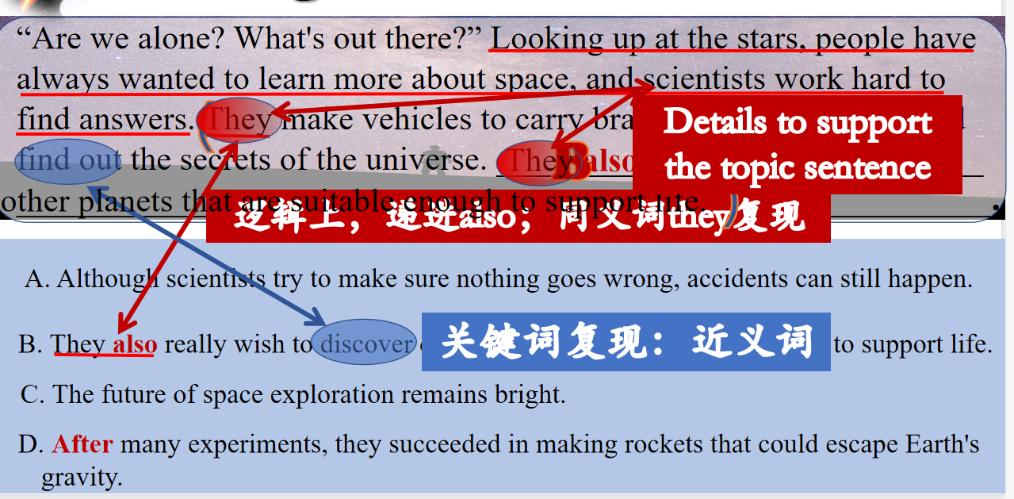

1. Students will be asked to read the first para again and try to summarize the main idea with their own words.

Main idea= topic sentence+supporting details

People are ____________the space and make ________ to ________ the universe, like making _________.

**Activity2：Read for main ideas**

1. Students will be asked to read the following paras to finish the gap-filling and try their best to summarize the main idea.

Tip: When there is no topic sentence, you should pay attention to the key words and logical development of the writer to get the main idea.

1. Check the answers

**Para2:**

1. adding question to understand the para.——rearrange

( ) many goals were achieved.

( a ) Sputnik 1 satellite was launched and successfully orbited around Earth.

( ) American astronaut Neil stepped onto the moon in 1969.

( ) America’s NASA space agency launched Voyager 1, which still transmits data today.

( ) USSR focused on sending people into space, like Yuri Gagarin.

1. Adding question to admire the astronauts

To the achievements, are you desired to say something to the scientists in your nation?

**Para3: Adding questions to admire the astronauts and appreciate their spirits**

What do you want to say to those astronauts in the space at this moment?

Why were people so determined to explore the universe?

**Para4:**

**Which statement of China’s achievements is not true?**

1. **China was *the third country to* explore the universe independently.**
2. **After Jade Rabbit was sent to moon, one Chinese spacewalked on the moon.**
3. **The docking of Tianzhou 1 with Tiangong 2 space lab signalled one step further in China’s plan to establish a space station.**
4. **The most recent achievement China has made was the launch of Chang’e 4 to explore the surface of the far side of the moon.**

**Adding questions to infer the writer’s attitude to China’s achievement**

What was writer’s comment on China’s achievements of space exploration?

1. surprised B. admired C. passive D. both A and B

**Step 4: Further Thinking**

1. Where was the title “Space:The Final Frontier” adapted from?
2. What does the title mean to you?

**Step 5: Revision**

What’s the main idea of each para? How to get the main idea?

What is the main idea of the whole passage?

Can you divide the passage into several parts according to the main ideas?

How to choose proper answers of the missing sentences in a passage?