基于“主题主线逻辑建构”的读后续写讲评
常山一中 吴俊峰 春晖中学 宣晔霏

2022年4月稽阳联谊学校高三联考 读后续写
①The paper on my desk was yellow, with straight blue lines stretching across it. The lines repeated themselves all the way down the page. I counted them. Twenty-six straight lines ran across the paper. The yellow color reminded me of sunshine. In summer the sun is bright yellow like that, and the sky is blue like those lines. I loved blue — blue is for getting lost in...
②“You haven’t written a word yet, have you?” Miss Perry had found me out. I hung my head, as in past years, and gave her the lines I’d given previous teachers.
③“I don’t feel like it.”
④The truth was that I wanted to write about something different. “Write about Your Best Friend,” demanded the assignment on the board. I didn’t have a best friend. I had a few friends, but I didn’t want to claim any of them as my “best” because I was afraid they might pick someone else. What if I picked a “best” friend and then someone different, who thought I was their best friend, heard my paragraph read aloud and then never spoke to me again? It was a stupid topic. I was disappointed in Miss Perry for choosing it.
⑤I knew Miss Perry must have heard about me from my other teachers. I had already prepared myself for another year of listening to teachers scold me. I was only nine years old, but my ears had been dull to the voices of my elders. My teachers, my parents, and the school principal had all given me the “What are we supposed to do with you?” speech. That was probably what Miss Perry was about to say, too.
Paragraph 1:
However, there was something different about Miss Perry. __________________________

Paragraph 2:
I bet I was touched. ________________________________________________________ _

1.Focus on the expressions
get lost in:
the lines:
assignment:
dull:
speech：
- Read and analyze according to narrative elements and structure

故事背景  setting | When and Where
 | Who
 | What
Reflect on  our writings | 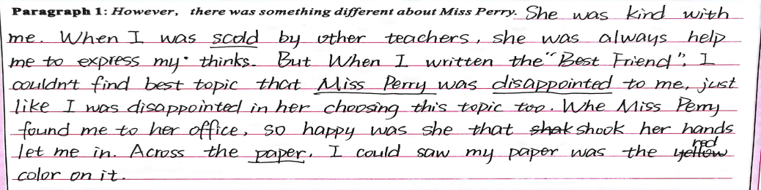
铺垫/伏笔/暗示  foreshadowing | 1.
 | 2.
 | 3.
Appreciation  from  foreshadowing | However, there was something different about Miss Perry. “What do you want to do, then?” she smiled, tenderly staring at me with deep blue watery eyes. What? My previous teachers would scold me or send me to the principal’s office. Miss Perry, however, stood in front of my desk and kept her soft gaze on my face. Without a word, I lowered my head to avoid her eyes. “You just think what it is that you want to write about? Then, come to share with me, and we’ll make some arrangements that you can live with. Fair enough?” She patted me on the back. No teacher had touched me before.  I bet I was touched. Automatically, I raised my head and caught sight of her walking back to her desk. Wondering what to make of her, I received another glance. A sense of something different attacked. I looked out of the window. The trees, the rain, everything was in sight. Inspired, I rose from the seat. “I want to study the weather outside.” “You really like that? But promise to write down what you learn on that blank paper. Deal?” “Deal!” All that afternoon I studied clouds, winds and the rain. Amazingly, a rainbow hung above like an upside-down smile. For the first time in years, I was really concentrating on my school work.
Reflect on our writings | 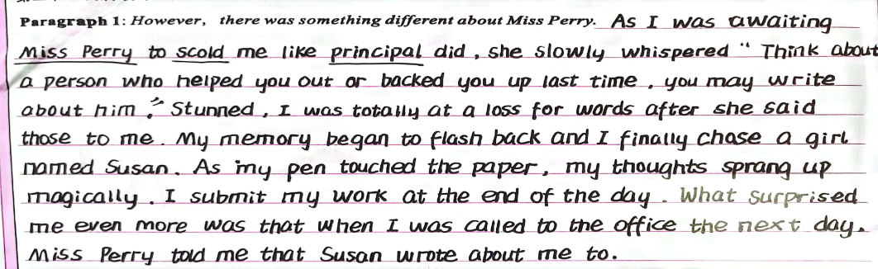
冲突和悬念
conflict
and
suspense
Reflect on our writings | 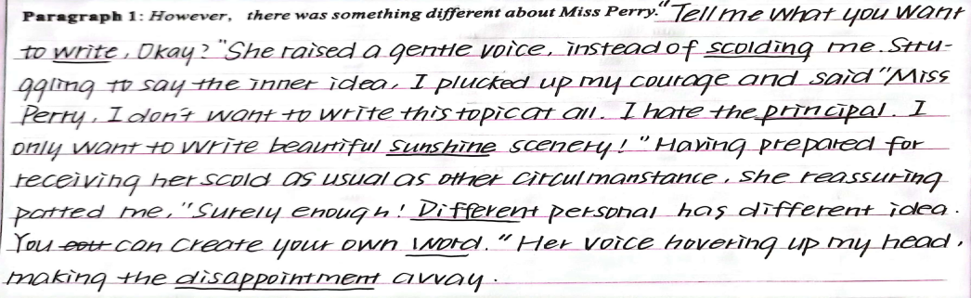
3. 5D to master the main plot and main theme
1).  Character determines fortune  人物性格  决定际遇  2).  Principal contradiction determines main plot  主要矛盾  决定主线 |  |  | 
What was different about Miss Perry?
No

But more

3).  Detail determines inflection point 段首细节  决定拐点  Appreciation  After class  (Detailed descriptions from our writing) | However, there was something different about Miss Perry.  Q1  Q2  Q3
I bet I was touched.
Q1
Q2
Q3
Paragraph 1: However, there was something different about Miss Perry
How to describe Miss Perry?
☞With a faint smile creeping upon her cheeks, Miss Perry stroked my hair and patted my shoulder, uttering some words gently and softly…
☞ with a faint smile dancing around the corner of her moth, Miss perry bent over to hold my hands, genuinely staring at me…
☞ After a seemingly suffocating silence, she knelt down beside me and asked gently.
☞ Instead of bullying my ears with the dull voices just like my previous teachers, she encouraged with sweet and gentle voice as well as a bright smile.
☞ She patted me gently on my shoulder and cast a warm, yet determined look at me, signaling me to follow her to the corridor.
Paragraph 1: However, there was something different about Miss Perry
How to describe my reaction?
● Dumbfounded and stunned, I slowly raised my head, with tears glistering in my eyes. I stammered in a low voice, “I , I …”
● I barely lowered my heard, hoping this action could end the embarrassing , fruitless and nonsense communication.
● A stream of warmth flooding me, my heart melted away.
● With my jaw dropping, I clenched my sleeves tightly, absolutely at a loss what to do.
● I transformed my hard appearance into a softened heart, tears welling up in my eyes.
● I stood there, silent and motionless. … A sudden surge of sorrow mingled with regret enveloped me, tears blurring my vision.
● The initial imagination racing through my mind, I summoned up courage and blurted out_{脱口而出}, “I want to write something different.”
● In her affectionate sight, I poured out my thoughts thoroughly, just like sharing with my best friend.
Paragraph 2: I bet I was touched.
How to describe Miss Perry?
☞ Miss perry approached me, rounded me with her arms and embraced me tightly, form which I sensed her love and warmth.
☞ No scolding, no mocking, she just stared at me gently and asked in a mild voice, “could you please tell me the reason?”
☞ Sensing my frustration and hesitation, she said nothing more but signaling me to go out. Instead of scolding me coldly and bitterly, she bent down, looking into my eyes and whispered.
☞ In her voice was pure sincerity and gentle affection. In her eyes was strong confidence and determination. The ice in my heart seemingly commenced to melt. After this talk, I tried to integrate into every class afterwards.
Paragraph 2: I bet I was touched.
What might happen afterwards?
★ Never had I expected that my “degusting” performance would be greeted by such tolerance!
★ There we stood, outside the classroom, the sunshine brightened the yellow paper.
★ Golden sunshine cast its glow on the yellow paper, witnessing my devotion. My thoughts spilled out（洒出/溢出）and my pen began to dance.
★ Never in my wildest dreamed had I known that such a simple gesture could change my life.
★ The sun shining with bliss, the light clouds crossing the blue sky, I grabbed my pen and gradually filled the lines with my sincere words.
★ When I ultimately wrote the whole lines down, I sent her a wide smile genuinely. Thank you, Miss Perry. Thank you, my best friend.
★ Sunshine filtered through the windows, sending me warmth and happiness.
★ I quickly finished the work and submitted it the next day. Miss Perry seemed quite delighted to witness my growth and I knew it was her generous help and encouragement that really counted.
★ My tears rolling down like a broken string of beads, I held Miss Perry in my embrace, who totally changed my attitude towards life.
★ All the disappointment were melting away. What was deeply rooted in my mind was a total relief, overwhelming exhilaration and most of all, gratitude for Miss Perry’s considerate words.
4).  Coherence determines synergy  语义连贯  决定协同 | I bet I was touched. Automatically, I raised my head and caught sight of her walking back to her desk. Wondering what to make of her, I received another glance. A sense of something different attacked. I looked out of the window. The trees, the rain, everything was in sight. Inspired, I rose from the seat. “I want to study the weather outside.” “You really like that? But promise to write down what you learn on that blank paper. Deal?” “Deal!” All that afternoon I studied clouds, winds and the rain. Amazingly, a rainbow hung above like an upside-down smile. For the first time in years, I was really concentrating on my school work.
 | 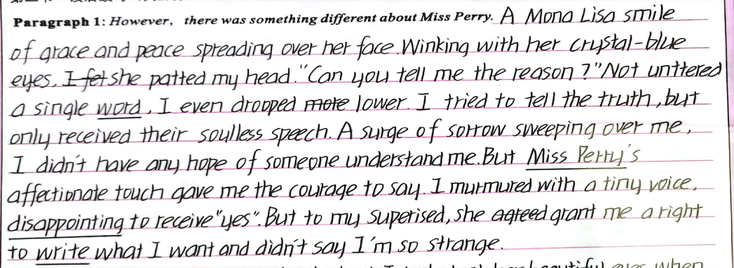
5).  Attitude determines altitude  情感态度  决定主题 | What is the best title of the text?  - My best friend  - My lovely writing  - My favorite teacher  - My first finished assignment  E. You are my sunshine  ...
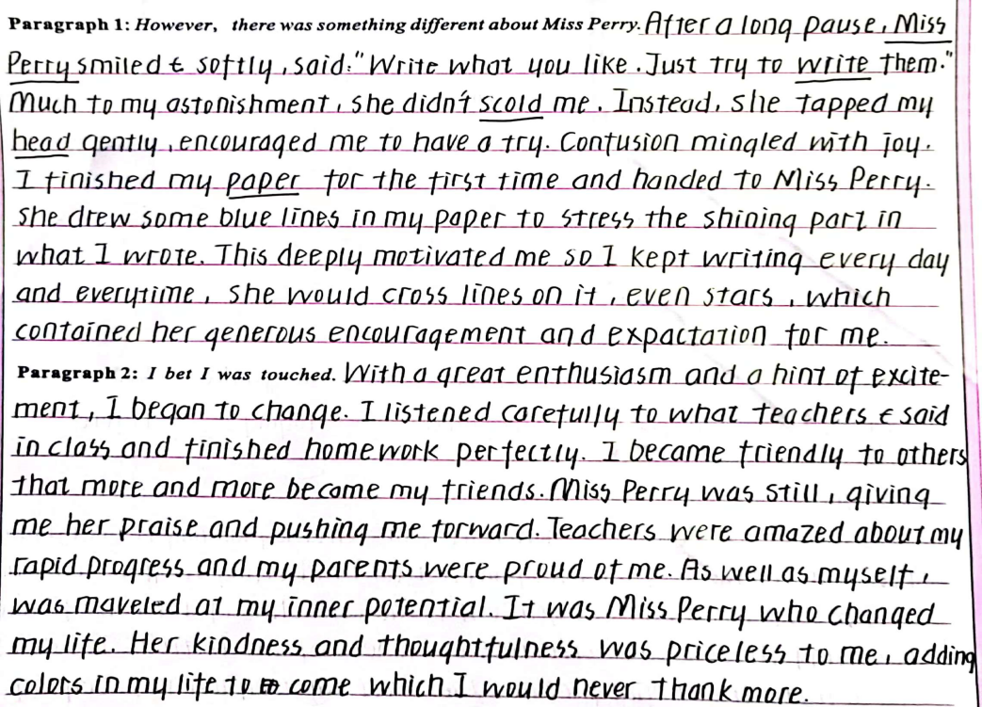
How does a good teacher open a student's inner heart?
Learn to squat down, and talk to a child in an equal, tolerant，silently-waiting and empathetic way.
学会蹲下，用平等、宽容、静待的和同理心的方式与孩子交流。
4. Assignment
1). Appreciation the detailed descriptions from our writing.
2). Carry out self-evaluation and peer-evaluation of your composition.
3). Reflect on 2021.06 and 2022.01 Zhejiang Gaokao continuation writing.
My dad, George, only had an eighth grade education. A quiet man, he didn’t understand my world of school activities. From age 14, he worked. And his dad, Albert, took the money my dad earned and used it to pay family expenses.
I didn’t really understand his world either： He was a livestock trucker, and I thought that I would surpass（超过）anything he had accomplished by the time I walked across the stage at high school graduation.
Summers in the mid-70s were spent at home shooting baskets, hitting a baseball, or throwing a football, preparing for my future as a quarterback on a football team. In poor weather, I read about sports or practiced my trombone（长号）.
The summer before my eighth grade I was one of a group of boys that a neighboring farmer hired to work in his field. He explained our basic task, the tractor fired up and we were off, riding down the field looking for weeds to spray with chemicals. After a short way, the farmer stopped and pointed at a weed which we missed. Then we began again. This happened over and over, but we soon learned to identify different grasses like cockleburs, lamb’s-quarters, foxtails, and the king of weeds, the pretty purple thistle. It was tiring work, but I looked forward to the pay, even though I wasn’t sure how much it would amount to.
At home, my dad said, "A job’s a big step to growing up. I’m glad you will be contributing to the household." My dad’s words made me realize that my earnings might not be mine to do with as I wished.
My labors lasted about two weeks, and the farmer said there might be more work, but I wasn’t interested. I decided it was not fair that I had to contribute my money.
Paragraph 1:
When I brought my paycheck home — it was $119 — my dad wanted to talk to me. ________

Paragraph 2:
I was surprised that my dad allowed me to use the money as I wished. __________________

When Dr. Henderson was assigning(指定) project mates for his psychology class, I secretly hoped he would pair me with my best friend or at least a classmate I could have some fun with. Above all, I hoped he wouldn't assign me to work with the fiercely competitive, extremely serious fellow who always wore dark clothes and apparently had a personality to match. As fate(命运) would have it, Dr. Henderson very deliberately matched everyone in class and announced that I would be working with the one person in class I wanted to avoid.
I went up to my new teammate and introduced myself. He looked at me as though I weren’t there. I felt he treated me as though I would hold him back and probably make him fail to get an “A” in the course. He wasn’t mean or abusive; he just gave me the impression that he could do whatever project we dreamed up better if he did it alone.
Needless to say, I didn't look forward to an entire term of being brushed off, but I tried to make the best of it and didn't say anything for fear that I would make things worse.
The project required each team to develop a hypothesis(假说), set up an experiment to test the hypothesis, do the statistical analysis and present the findings. Whatever grade the team received would be shared by both students.
When my teammate and I met to discuss our project, I was uneasy. Here was this challenging student who had a reputation for single-mindedness and good grades —the exact opposite of me. I actually wanted to drop the class at one point, but stopped short because I didn't want to give him the satisfaction of my chickening out. I decided to stick to it no matter what.
After long discussions, we somehow agreed to do a study on the psychological well-being for teenagers. I wasn't sure what it meant exactly, but at least we had a topic.
Paragraph 1:
We started to meet regularly to draw up our plans.

Paragraph 2:
One day I got word that he was admitted to hospital for a serious disease.

