**M1Unit4 Natural disasters -Listening and Speaking: Report Natural Disasters**

**Teaching Analysis:**

This unit is about natural disasters. In this lesson, ss are going to listen to 4 pieces of news about reporting natural disasters. And although this topic is quite familiar to ss, it’s still hard for them to listen for some detailed information in the news due to the relatively quick speed of news report and its refined language. Thus, it’s necessary for teachers to guide ss to listen for the main structure of the content of news and summarize its language features. Based on the understanding of the features of news, ss are also required to practice the listening skill like how to listen for listening details.

**Teaching Objectives:**

1. To learn some expressions on this topic and the news by listening for the main information.
2. To practice the listening skill by circling the key words in questions and analyzing the key information before listening.
3. To summarize the structure and basic information of news by listening and comparing the four pieces of news.
4. To practice their speaking ability by discussing on the topic and make news reports on their own.

**Teaching Procedures:**

**Step1: Lead in**

Activity: Look and Discuss (CW)

Have ss look at the pic and discuss on the following questions:

Q1: What’s going on in this photo?

Q2: What ideas does this picture want to convey?

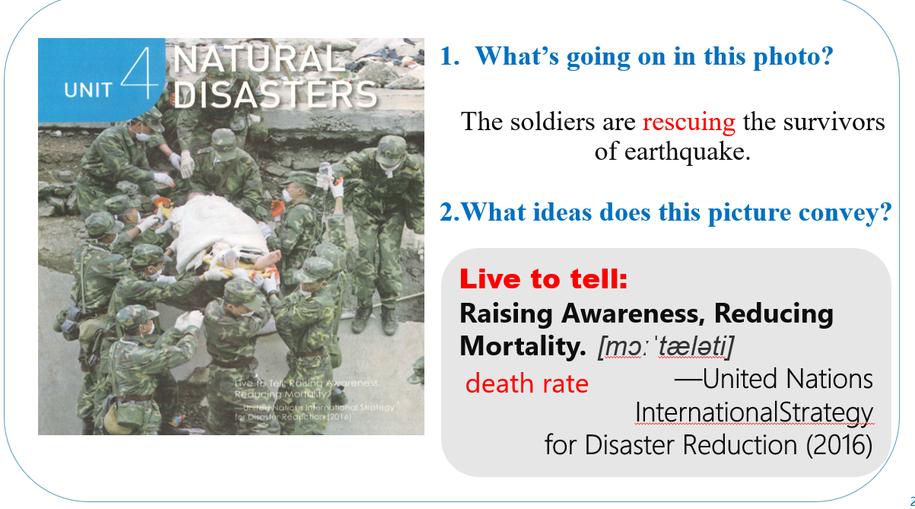

(Aims: To elicit the topic and activate ss’ experience and knowledge before.)

**Step2: Pre-listening**

Ask ss to talk about “What other natural disasters can you think of ?”

“ How do you learn from these disasters? ”

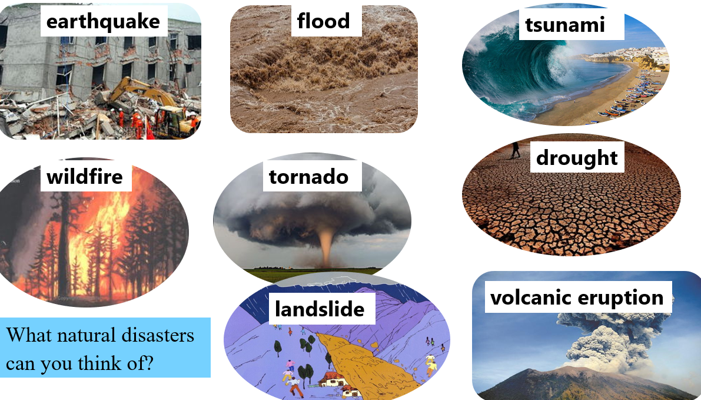

(Aims: to learn some topic-related words on the topic and get ss prepared for listening.)

Step3: While-listening

Activity 1: Listen to the news reports and tick the disasters that you hear.

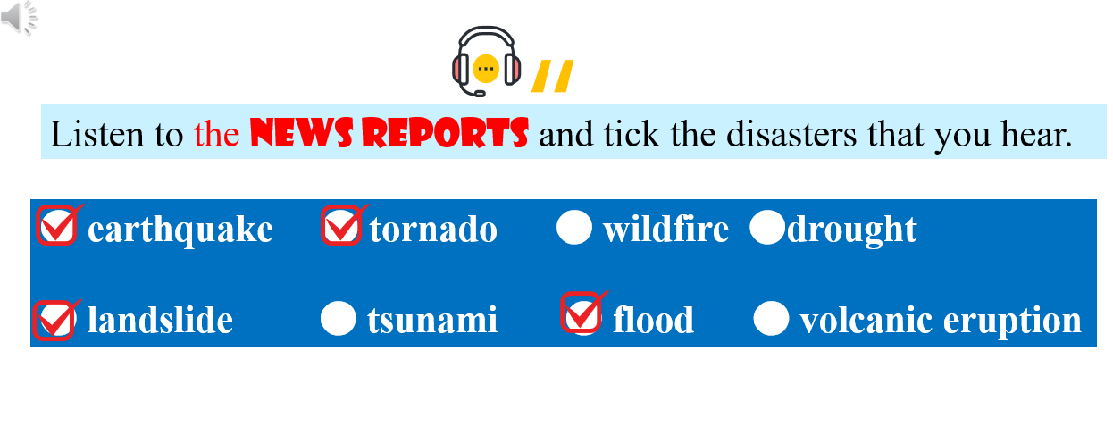

(Aims: Practice the listening skill of listening for the gist.)

Activity2: Listen for some detailed information

1. Ask ss to circle the key words and tell the question is asking for what type of information.
2. Listen for the answers.

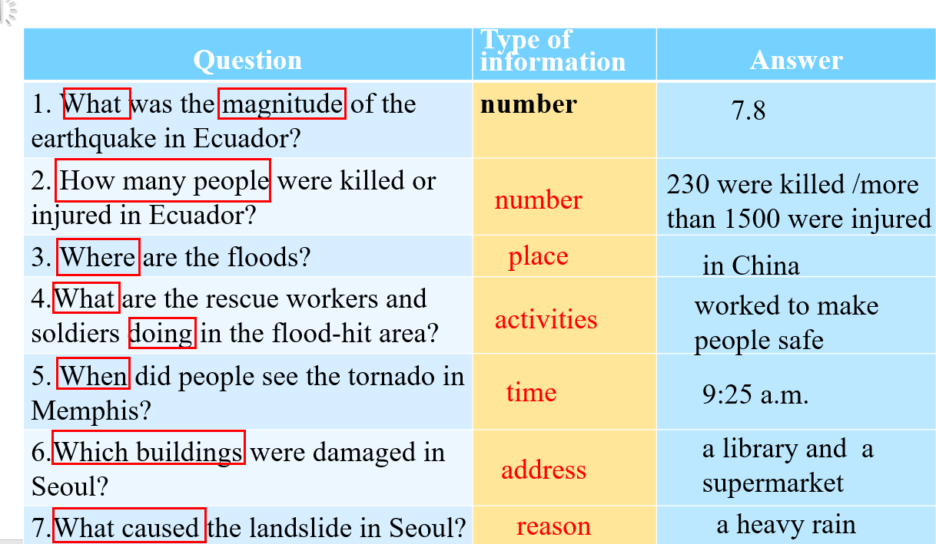

Activity 3: Listen for the language features of the genre.

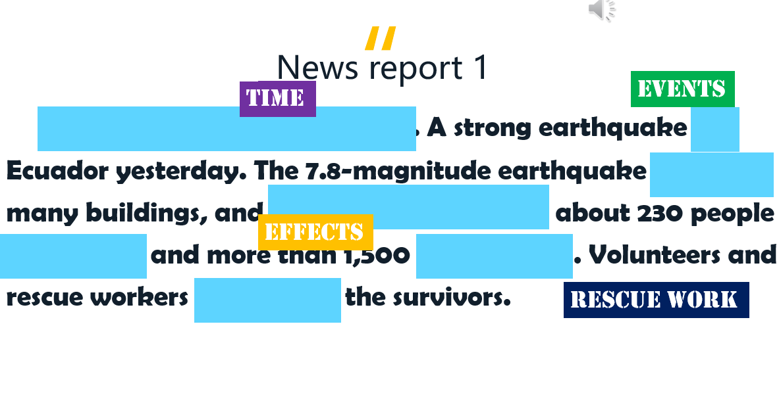

1. Ask ss listen to each piece of news and finish the worksheet.
2. Ask ss to think “what aspects does a piece of news contain?”
3. Ask ss to tell the types of news reports by analyzing its expressions they listened.

(Aims: to guide ss to focus on the non-content words which is easy to ignored but can be essential for getting key information and distinguishing the text features.)

Activity 4: Summarize the features of news reports



(Aims: to learn the features of this genre and develop ss’ thinking ability by summarizing and analyzing.)

**Step3: Post-listening**

Activity: Let’s report news.

Group Work: Choose a piece of news and Report it to your partners.

Sharing: Choose the best one in your group to share your report.

(Aims:)

Step4: Homework

Find the latest news online and make a video of news reports on it.

(Aims: To develop their ability of speaking and searching information and arise their interests in English learning.)