**Unit2 Travelling Around**

**Reading for Writing**

教学目标：

1.to get students to have a good understanding of how to write an impressive travel plan

2.to enable students to use some writing skills flexibly.

3.to develop students’ ability of assessing their own work with the guidance of checklists

4.to increase students cultural confidence

教学重难点:

1.Guide students to write a concise, clear, correct and structured e-mail, introducing their own travel plans

2.Guide students to properly convey emotions using the proper language.

教学过程：

Step 1 lead-in

Introduce Richard to the whole class and show the email from Richard.

Share the traveling brochure of Xi’an from Richard.

Step 2 Fast reading

1. Read for the basic factors of an email and make sure the relationship of Richard and Xiaoli.
2. Read for the format of an email
3. Read for the main idea of each paragraph and raise some questions of each paragraph for details

Step 3 Reading for the organization and language features of each paragraph

1. ●make clear of the structure of paragraph 1:

opening greeting; state plan clearly; the reasons for the plan

●help students build a bridge to express their purpose clearly by analyzing the language features.

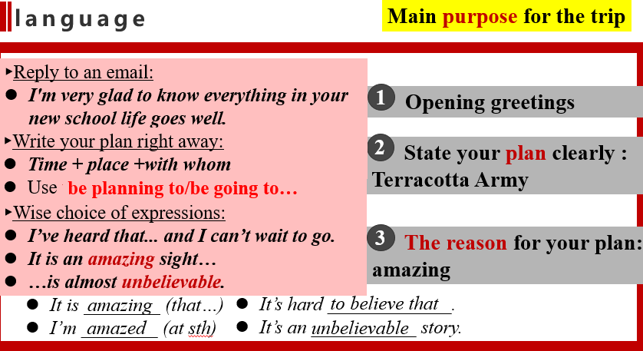

1. ●Find out the structure of paragraph 2: topic sentence + detailed plans/places

●help students collect different expressions of describing the order and the reason.

●pay attention to the present continuous tense.

3. ●consolidate the usage of the present continuous tense: using the present continuous tense to tell about the leaving and arriving time.

●try to arrange your time more specific

4. discuss with the students about how to write the closing paragraph.

Step4 Writing

Choose one place to start writing an email of a travel plan to Richard.

After the passage writing, let students share their works in groups and try to assess the work with the checklists.