Class_________ Name________

读后续写（满分25分） 阅读下面短文，根据所给情节进行续写，使之构成一个完整的故事。

Pumpkin (南瓜) carving at Halloween is a family tradition. We visit a local farm every October. In the pumpkin field, I compete with my three brothers and sister to seek out the biggest pumpkin. My dad has a rule that we have to carry our pumpkins back home, and as the eldest child I have an advantage — I carried an 85-pounder back last year.

This year, it was hard to tell whether my prize or the one chosen by my 14-year-old brother, Jason, was the winner. Unfortunately we forgot to weigh them before taking out their insides, but I was determined to prove my point. All of us were hard at work at the kitchen table, with my mom filming the annual event. I’m unsure now why I thought forcing my head inside the pumpkin would settle the matter, but it seemed to make perfect sense at the time.

With the pumpkin resting on the table, hole uppermost, I bent over and pressed my head against the opening. At first I got jammed just above my eyes and then, as I went on with my task, unwilling to quit, my nose briefly prevented entry. Finally I managed to put my whole head into it, like a cork (软木塞) forced into a bottle. I was able to straighten up with the huge pumpkin resting on my shoulders.

My excitement was short-lived. The pumpkin was heavy. “I’m going to set it down, now,” I said, and with Jason helping to support its weight, I bent back over the table to give it somewhere to rest. It was only when I tried to remove my head that I realized getting out was going to be less straightforward than getting in. When I pulled hard, my nose got in the way. I got into a panic as I pressed firmly against the table and moved my head around trying to find the right angle, but it was no use. “I can’t get it out!” I shouted, my voice sounding unnaturally loud in the enclosed space.

注意： 1. 所续写短文的词数应为150左右；

2. 至少使用5个短文中标有下划线的关键词语；

3. 续写部分分为两段，每段的开头语已为你写好；

4. 续写完成后，请用下划线标出你所使用的关键词语。

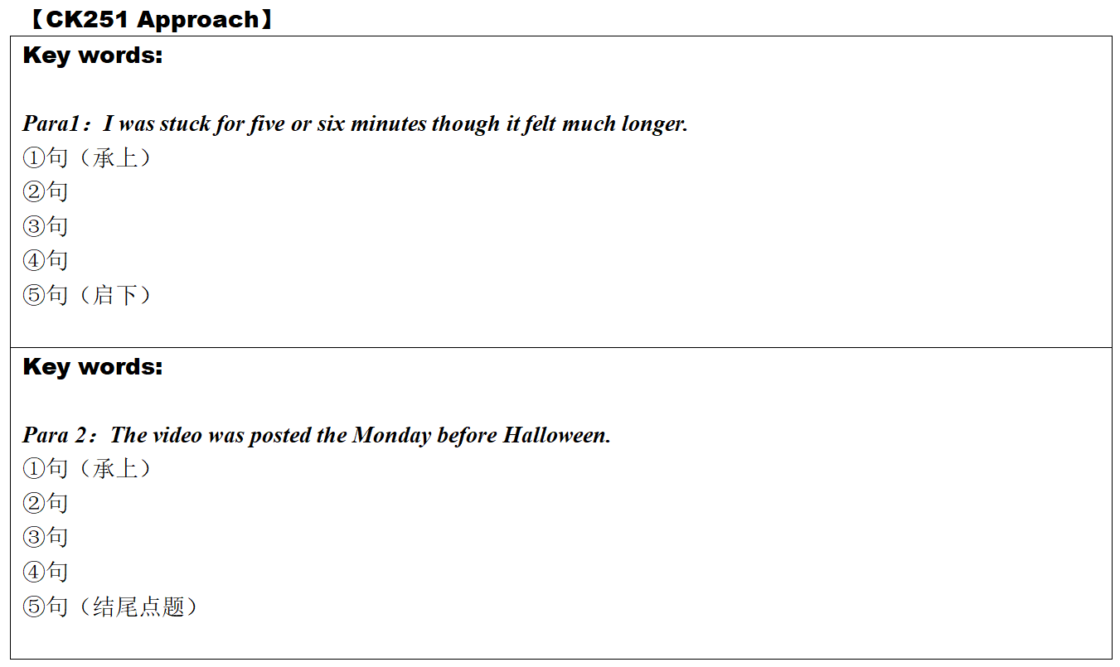

Brainstorm useful expressions

1. **The solutions to Conflict [1] *Who was the winner?*(矛盾一的解决)**

|  |
| --- |
|  |

1. **The solutions to Conflict [2] *I got stuck in the pumkin.Who helps?* (矛盾二的解决：如何把头从南瓜中弄出来)**
2. **我的痛苦感受和徒劳努力：**

***eg1:*** At the thought of being trapped in the pumpkin, I was___________by a strong sense of and my palms were sweating. All efforts to______________my head from the pumpkin were________________, but in vain. As time_______________, I felt _____________// my head was spinning_________________a lack of oxygen and _________________ onto the floor.

1. **家人的帮忙**

|  |
| --- |
|  |

1. **家人想帮又想笑的复杂情绪和行为**

|  |
| --- |
|  |

**III.关于视频拍摄和上传**

|  |
| --- |
| 视频 n. __________________ 拍摄 v.____________________  发送上传 v. _________________ 分享v. _____________________  走红_____________________ 关注v. _________________ 转发v. _____________________  点赞 n. _____________________ 浏览消息 _____________________  评论 n._____________________ / v. _____________________  浏览量 n. _________ / 浏览最多的adj. ______________ 社交工具 _____________________ |

**IV.承上启下句的衔接**

|  |
| --- |
| [第1段启下句]  [第2段承上句] |

**V.我的视频被传到网上的尴尬、懊恼等复杂心情**

|  |
| --- |
|  |

**VI.点题收尾句**

|  |
| --- |
|  |