**My view on technology-supported personalized learning教学设计**

**-----绍兴二模(2025.4.9.)诊断性考试应用文写作讲评**

**绍兴市上虞区丰惠中学 徐玉茹**

**一、文本分析**

本节课选自2025年4月9月绍兴市I模试题应用文写作，原题为“近期，你将参加学校组织的英语主题征文活动。请结合自身经历，就“技术支撑下的个性化学习”的主题写一篇短文，内容包括:1.陈述观点;2.分享体验。本试题特色为结合当今人工智能和新课程理念下学习方式的融合，让考生深刻意识与体会技术支撑为新的学习方式带来的变革、作用及利弊。

1. **命题考查**

考查目的：在陈述现象，表达观点，分享个人体验中体现批判性思维。

**三、课时目标（建议两课时80分钟）**

本节课基于一线考场作文诊断性分析，资料翔实，设计思路清晰，重在写作重难点突破和写作策略指导，尤其是在课堂学生过程性写作中培养学生的逻辑性思维、批判性思维和创造性思维等高阶思维的培养。

**四、课堂构建：“四维六阶”式主题式作文写作**

四维：content,language,thinking + strategy

六阶(教学过程五步法)：lead in, understand,analyse,discover, explore, practise and create.

1. **教学重难点及教学设计定位**

解决考试过程中学生遇到的以下难题：

1.the most challenging difficult points in this Practical Writing.

1.unable to understand well the meaning of the title. (the terms).

2.how to write an English short essay. (structure).

3.how to describe phenomenon. (lead in the topic)

4.how to state opinions on technology-supported personalized learning.

(critical thinking)

5.how to share personal experience.

6. unaware of writing an ending.

...

1. **教学过程（简述）**

**Step1 Lead-in (warming up activity )**

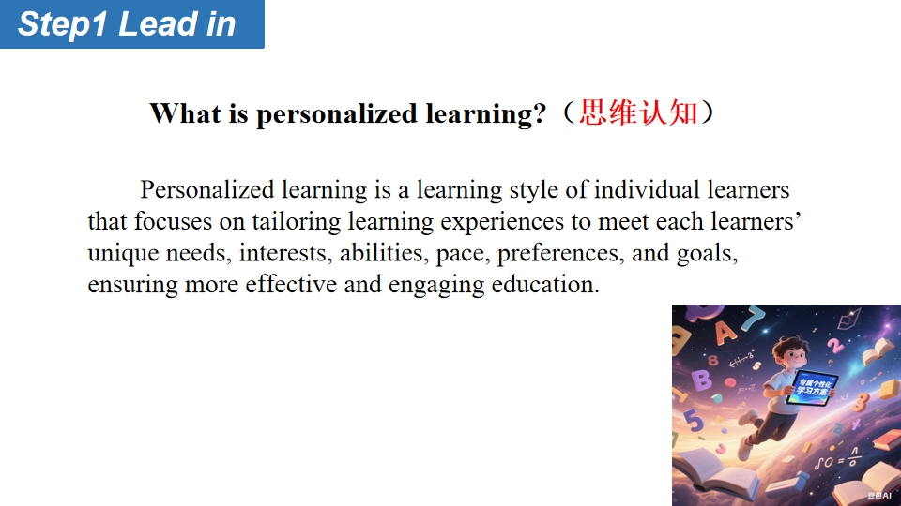

**Step1 Understand**

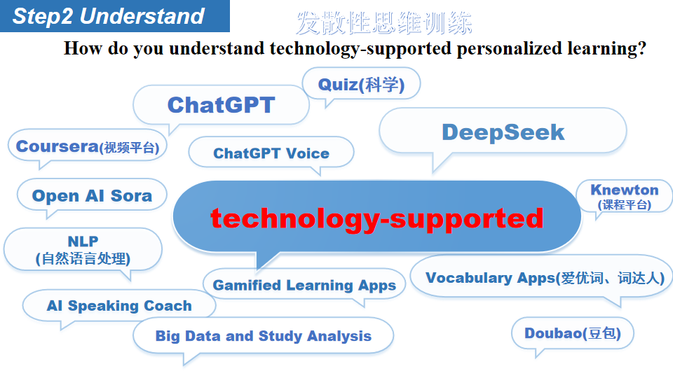

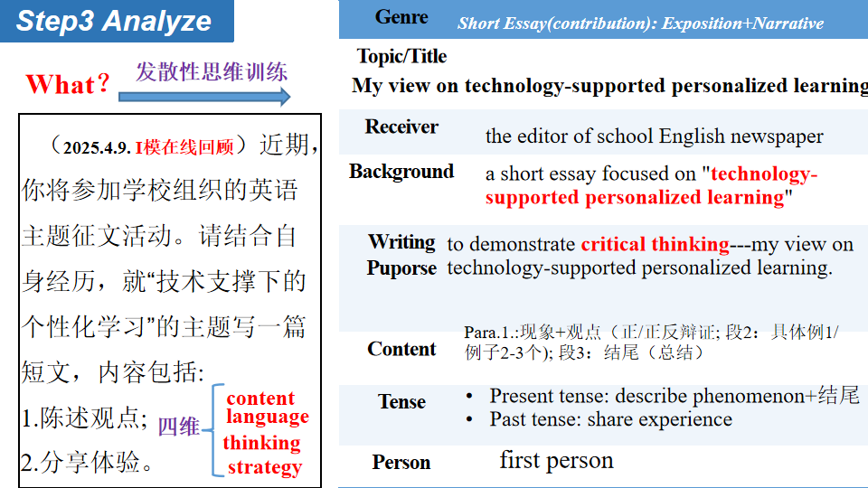

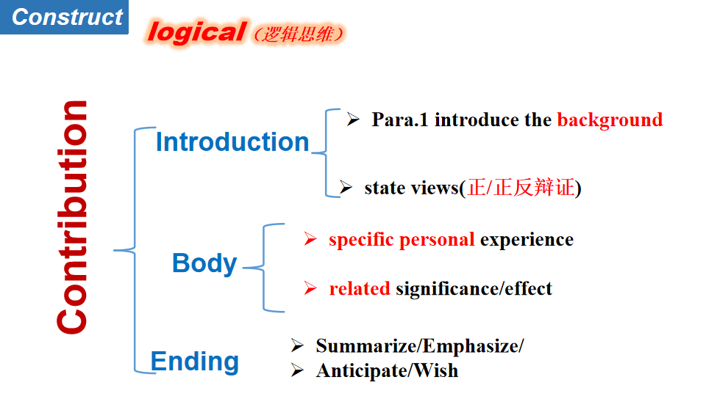

**Step4 Discover**

1. **How to write Para.1.? 2.How to write Para.1.? 3.How to write Para.1.?**

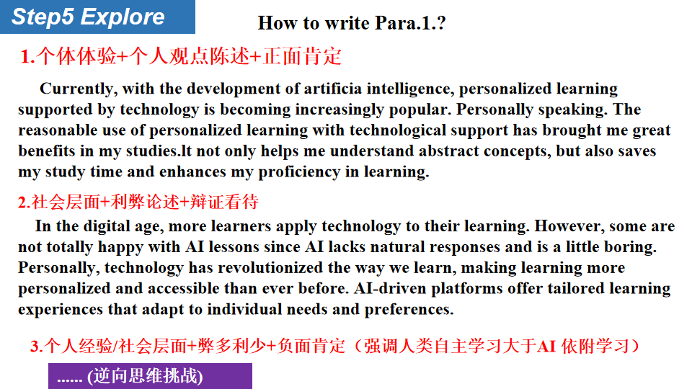

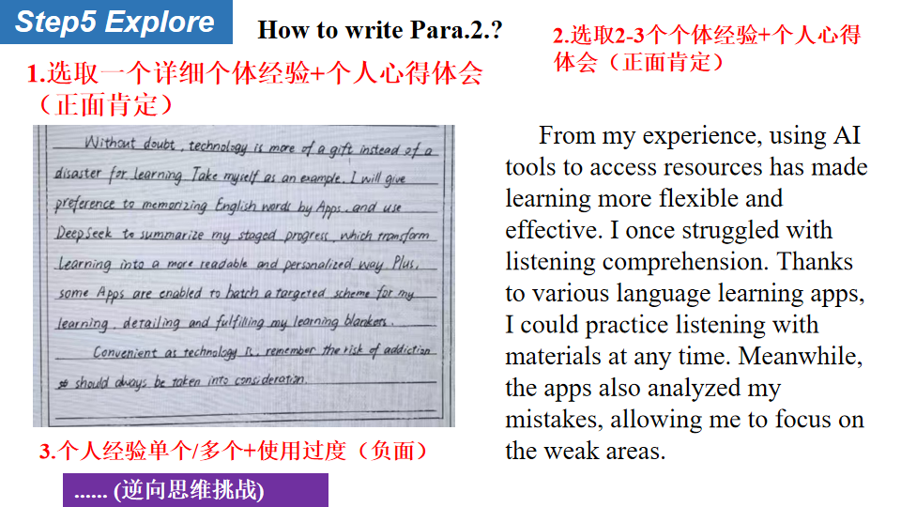

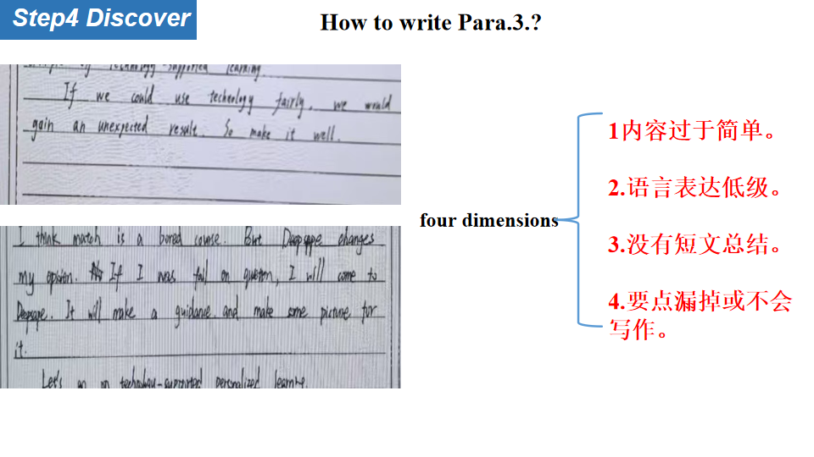

**Step6 Practise and Create**

Ss: Presentation 1（Parar.1）

Ss: Presentation 2 (Para.2)

Ss: Presentation 3(Para.3.)

**参考范文：Mode1 个体经验+个人观点陈述+正面肯定**

**My View on Technology-Supported Personalized Learning**

With the rapid development of cutting-edge technology nowadays, high technology is playing an increasingly crucial role in our learning process. In my opinion, technology-supported personalized learning is indeed beneficial. Nevertheless, we should make good use of it in a prudent manner.

Technology, which is grounded in a vast amount of data, will undoubtedly enhance your learning efficiency by analyzing your personal data. With its help, you can achieve the most significant progress within a limited time frame. Take myself as an example. I once uploaded my test paper to an app, and it provided me with suggestions on where I should exert more effort, specifically in the areas where I was relatively weak. Moreover, it also recommended some learning strategies that were a perfect fit for me.

All in all, although technology-supported personalized learning boasts numerous advantages, we still need to possess the ability to learn independently.

**参考范文：Mode2 社会层面+利弊论述+辩证看待**

**My View on Technology-Supported Personalized Learning**

With the rapid development of cutting-edge technology nowadays, high technology is playing an increasingly crucial role in our learning process. In my opinion,, technology-supported personalized learning is indeed beneficial. Nevertheless, we should make good use of it in a prudent manner.

Technology, which is grounded in a vast amount of data, will undoubtedly enhance your learning efficiency by analyzing your personal data. With its help, you can achieve the most significant progress within a limited time frame. Take myself as an example. I once uploaded my test paper to an app, and it provided me with suggestions on where I should exert more effort, specifically in the areas where I was relatively weak. Moreover, it also recommended some learning strategies that were a perfect fit for me.

All in all, although technology-supported personalized learning boasts numerous advantages, we still need to possess the ability to learn independently.

**参考范文：Mode3个人经验/社会层面+弊多利少+负面影响**

**My View on Technology-Supported Personalized Learning**

In recent years, technology-supported personalized learning has become increasingly popular. While it offers certain conveniences, my personal experience has made me realize the significant negative impacts of over-relying on it.

Last semester, faced with challenging math problems, instead of thinking independently, I immediately turned to a learning app for ready-made solutions. Gradually, I found myself increasingly dependent on this quick-fix approach. During an exam, without the app's assistance, I struggled to solve even moderately difficult questions, as my problem-solving and critical thinking skills had severely deteriorated.

In conclusion, while technology-supported personalized learning can be a useful tool, we must be cautious not to over-rely on it, ensuring we maintain our essential learning and social skills.

**一模参考答案**

**My view on technology-supported personalized learning**

In the digital age, more learners apply technology to their learning. However, some are not totally happy with AI lessons since AI lacks natural responses and is a little boring. Personally, technology has revolutionized the way we learn, making learning more personalized and accessible than ever before. AI-driven platforms offer tailored learning experiences that adapt to individual needs and preferences.

From my experience, using AI tools to access resources has made learning more flexible and effective. I once struggled with listening comprehension. Thanks to various language learning apps, I could practice listening with materials at any time. Meanwhile, the apps also analyzed my mistakes, allowing me to focus on the weak areas.

In conclusion, technology empowers personalized learning. By embracing technology, we can create a more inclusive and dynamic learning environment, empowering every student to reach their full potential.

In conclusion, technology empowers personalize|d learning. By embracing technology, we can create a more inclusive and dynamic learning environment, empowering every student to reach their full potential.



