Period II

教学重点：

1. 学习与厨房餐前活动相关的表达方式，进一步细化学习动作描述和心理描绘。

2. 理解萨曼莎与母亲的关系及他们的互动模式。

3. 推测这两个部分的铺垫对在整篇小说中的作用。

Step 1: Revision

Task 1: Ask 1-2 students in advance to prepare to share their notes and homework assigned last time and their opinion about the first 2 parts as well.

（设计意图： 帮助同学在复习小说开端语言和情节的同时更好的进入下一阶段的阅读。）

step 2: Pre-reading:

Look at the picture on the ppt and ask students what we can describe about preparing food in the kitch?

（设计意图： 导入part 2-3所描述场景， 激活已有语言知识。）

Step 3: While-reading (Part 3)

Task 2: Listen to part 2 with the text on the ppt and try to answer the question “What was she doing here?” After answering the question, try to figure out the heading of this part.

（设计意图：通过多模态输入和问题引领把握文本主题，为进一步文本研读打好基础。）

After getting the heading of this part, read the part and share the understanding of this part together.

Step 4: After-reading: (Part 3)

Task 3: language study:

情境造句。参照文中蓝色字体句子，进行**类似**描述：

小明不但是一个努力的学生，也是一个运动的健将。

Not only is Xiaoming a hardworking student, he is also a talented athlete.

她的父母竭尽全力(去)讨她欢心。

Her parents bend over backwards to please her.

（设计意图：抓取体现萨曼莎内心激烈冲突的表达方式并进行练习，发现可以在这个情景下使用的句型和短语。）

Task 4: Answer the questions to further explore plots and structure of this part:

1. Did Mum think Samantha had problems with her character? Did Thomas agree with Mum?

2. Did Samantha consider herself introverted? What did being an extrovert mean to her?

3. Whose perspective does the story develop from?

（设计意图：在通读文本基础上进一步探索文中主题、文本走向和作者意图）

Step 5: While-reading: (Part 4)

Task 5: Listen to part 3 with the text on the ppt and try to answer the question “What was Samantha doing in this part? (tip: 2 things)” After answering the question, try to figure out the heading of this part.

（设计意图：通过多模态输入和问题引领把握文本主题，为进一步文本研读打好基础。）

After getting the heading of this part, read the part and share the understanding of this part together.

Step 6: After-reading

Task 6: Language study  
Matching:

What do people do to prepare a dinner in the kitchen?

1. Let’s collect expressions of this type in this part.
2. From the expressions, can you figure out which they prepared?

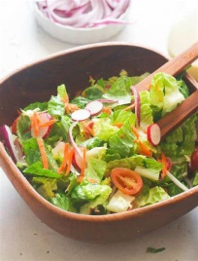 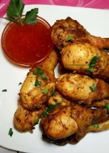 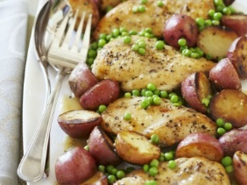 

①put the potatoes into the oven

②fill the kettle with water and then plugged it in

③handed Mum her cup of coffee

④turn the chicken pieces over

⑤drain her cup of coffee

⑥grab … out of the fridge

⑦wash and scrape and peel the vegetables

⑧dice up another radish

（设计意图：归纳这个部分读到的和厨房相关的表达方式）

情境造句。参照以下句子，进行**类似**描述：

Samantha called over her shoulder as she filled the kettle with water and then plugged it in.

Mum laughed, tossing her dark hair back as she spoke.

“…” said Mum, laughing as she diced up another radish. “…”

小明回头答道，一边把书本整理好然后放进书包里。

Xiaoming answered over his shoulder as he put his books away and then put them into the backpack.

（设计意图：在part 1-2 “动词三连”的基础上进行细分，进一步学习分析描述动作过程中可以用到的动词形态并模仿练习）

Task 7: Answer the questions to further explore plots and structure of this part:

1. What were Samantha and Mum talking about in this part?
2. How many dishes did they prepare?
3. Can you figure out Samantha prefer what they prepared in the kitchen?

（设计意图：在通读文本基础上进一步探索文中主题、文本走向和作者意图）

Task 8: Predict what comes next by answer the question:

1. What other expression do you find most impressive? Can you underline it?

2. In the next part what would they talk about over dinner? Does the story miss the point?

（设计意图：培养学生根据已有线索对文本发展进行预测并鼓励有兴趣的同学进行对比写作。）

课件（introduction-水晶3-水晶4）此略