**2025年3月金丽衢十二校应用文写作**

**教学学案**

假如你是李华，你们学校的校报英语论坛（English Forum）正在组织一次讨论活动。主题是“AI And Our Study”。请你写一篇英语文章投稿。  
 内容包括：1. AI用于学习的现状；  
 2. 你的看法或建议。  
 注意： 1. 写作词数应为80个左右；  
 2. 请在答题卡的相应位置作答。

一 审题

文体：________

人称：________

时态：________

要点：________

主题：________

二 结构

Para 1 ___________________________________________________

Para 2 ___________________________________________________

Para 3____________________________________________________

三 语言

Para 1 :

稿件类开头

“开门见山”式：____________________________________________________

回忆性开头：____________________________________________________

疑问性开头：____________________________________________________

倒叙式开头：____________________________________________________

分析类文章开头

背景引入法：With the rapid development of technology, AI has become an important part of our daily lives, especially in education. From personalized learning to instant feedback, AI is changing the way we study.

现象描述法：In recent years, AI-powered tools like smart tutors and learning apps have gained popularity among students. These tools are not only making learning more efficient but also raising questions about their impact on traditional education.

提问引入法：Have you ever wondered how AI is shaping the future of education? As more students turn to AI for help with their studies, it is important to explore both its benefits and challenges.

观点引入法：AI is revolutionizing education, but it is not without its drawbacks. While it offers personalized learning experiences, it may also lead to over-reliance on technology.

Para 2: Body 看法或建议

利弊分析法 On the one hand, AI offers many benefits. It provides personalized learning experiences, helping students focus on their weaknesses. It also saves time by offering instant feedback and access to a wide range of resources. On the other hand, over-reliance on AI may reduce students' critical thinking skills and creativity. For example, some student

举例分析法 AI has been widely used in education. For instance, language learning apps like Oxfordtree use AI to adapt lessons to each student's level, making learning more efficient. Similarly, AI-powered tools like Grammarly help students improve their writing skills. However, these tools can also make students dependent on technology, reducing their ability to think independently.

因果分析法 The use of AI in education has led to significant changes in how students learn. Because AI can analyze data quickly, it provides personalized study plans and instant feedback, which improves learning efficiency. However, this convenience might also lead to laziness, as students may rely too much on AI instead of developing their own problem-solving skills.

对比分析法 Compared to traditional learning methods, AI offers more flexibility and efficiency. For example, while teachers can only address the needs of a group, AI can provide one-on-one support tailored to each student's needs. However, traditional methods encourage face-to-face interaction and teamwork, which are essential for developing social skills. AI, on the other hand, might isolate students and reduce their ability to communicate effectively.

问题解决法 While AI has many advantages, it also brings challenges. One major problem is that students might become too dependent on AI tools, losing the ability to think critically. To address this, schools should teach students how to use AI responsibly. For example, students can use AI for practice and research but should complete assignments and exams without AI assistance.

个人观点法 In my opinion, AI is a powerful tool that can greatly enhance learning, but it should not replace traditional methods. AI can help students understand difficult concepts and save time, but it cannot teach creativity or critical thinking. Therefore, we should use AI as a supplement to traditional learning, not a replacement.

Para 3: Ending 总结

总结观点：In conclusion, AI has both advantages and disadvantages in education. Therefore, we should use AI as a tool to assist, not replace, traditional learning methods.

提出建议;To make the best use of AI, I suggest that students use it as a supplement rather than a complete solution，and schools should also teach students how to use AI responsibly to avoid over-reliance.

展望未来：Looking ahead, AI will likely play an even bigger role in education. However, it is important to ensure that it is used in a way that enhances students' learning. By balancing AI with traditional methods, we can create a more effective and well-rounded education system.

呼吁行动：It is time for us to rethink how we use AI in education. Let us embrace technology wisely and continue to develop our critical thinking and creativity

四 范文

1. 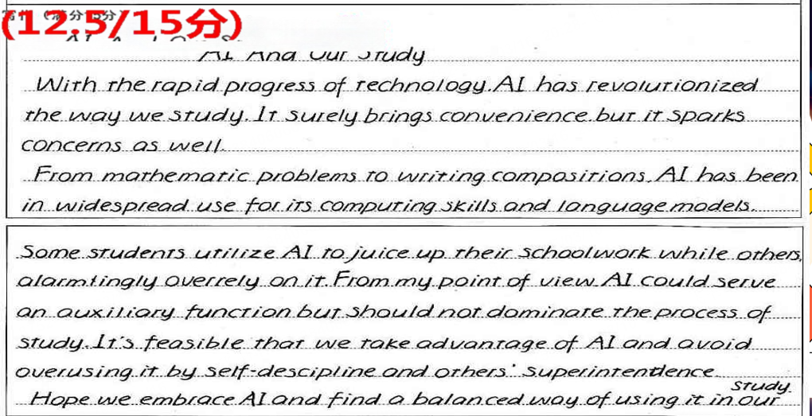

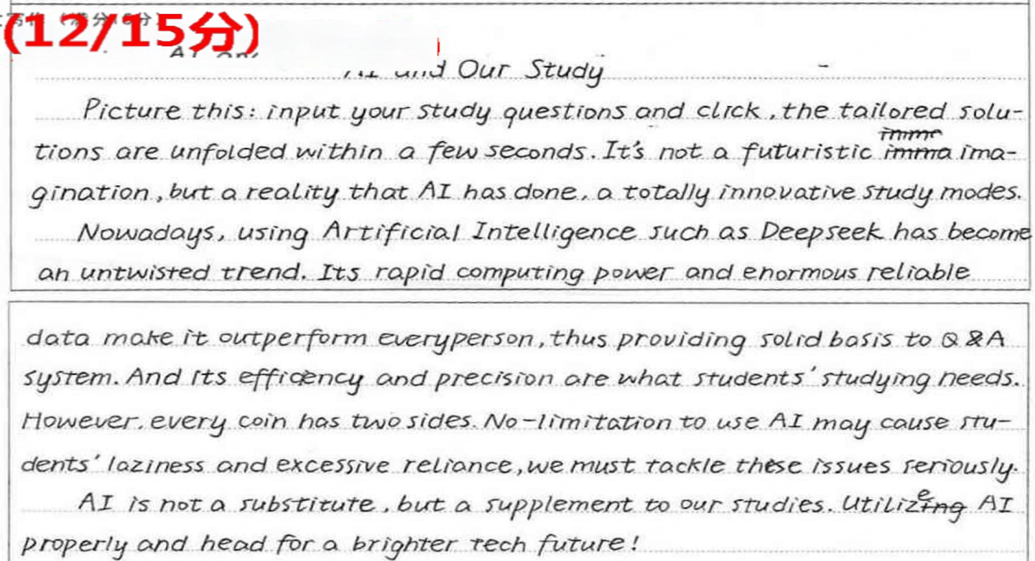

**Version1 分析现状（包括我使用的情况）+我的建议**

**AI and Our Study**

Nowadays, AI has become an inseparable part of study, reshaping how students learn and interact with knowledge. Many students rely on ChatGPT, Deepseek to solve math problems, practice languages, or organize study schedules. However, this convenience comes with challenges, such as over-dependence and ethical concerns about originality in work.

In my daily study routine, I use AI tools wisely. I rely on apps to improve writing accuracy and brainstorm essay ideas. However, I avoid over-dependence by cross-checking AI suggestions with textbooks or teacher feedback. My advice? Embrace AI as a supporter, not a replacement. Balance technology with critical thinking, and always prioritize understanding over shortcuts. AI can lighten the load, but true learning still requires your effort and curiosity.

Only by blending AI’s efficiency with human creativity can we unlock greater academic potential.

**Version2 分析现状（客观环境）+我的观点+建议**

**AI and Our Study**

As a high school student, I have noticed that AI is increasingly being used in our study. Many online learning platforms now incorporate AI to provide personalized study plans and real-time feedback.

In my opinion, the use of AI in study has both advantages and challenges. On one hand, it can adapt to our individual learning styles and paces, making learning more efficient. It can also offer immediate help and explanations when we encounter difficulties. However, there are also concerns. For example, over-reliance on AI might reduce our ability to think independently.

To make the best of AI in our study, we should use it as a tool to assist us, but not rely on it completely. We still need to develop our own critical thinking and problem-solving skills. I believe that with the right approach, AI can greatly enhance our learning experience and help us achieve better academic results.

**Version3 分析现状（大家还不怎么会用）+我的建议**

AI And Our Study

In our school, AI is not yet a part of our daily study. Although it’s widely discussed, most students, including me, haven’t used it in learning, mainly because we lack the know-how.

However, I believe AI can bring huge benefits to our study. For instance, AI-powered language learning apps can offer instant translations and grammar checks, helping us improve language skills. Also, intelligent study planners can arrange personalized study schedules according to our weaknesses.

To make the most of AI, I suggest the school organize training sessions to teach us how to use AI tools safely and effectively. This way, we can leverage AI to enhance our learning efficiency.