A presentation about works of art
structure and main idea | function | signpost markers
选修三Unit1Art Listening and Talking
Talk about works of art
Activity 2 : Listen for signpost markers.
Group Work: Introduce a work of art
Your part of the presentation:

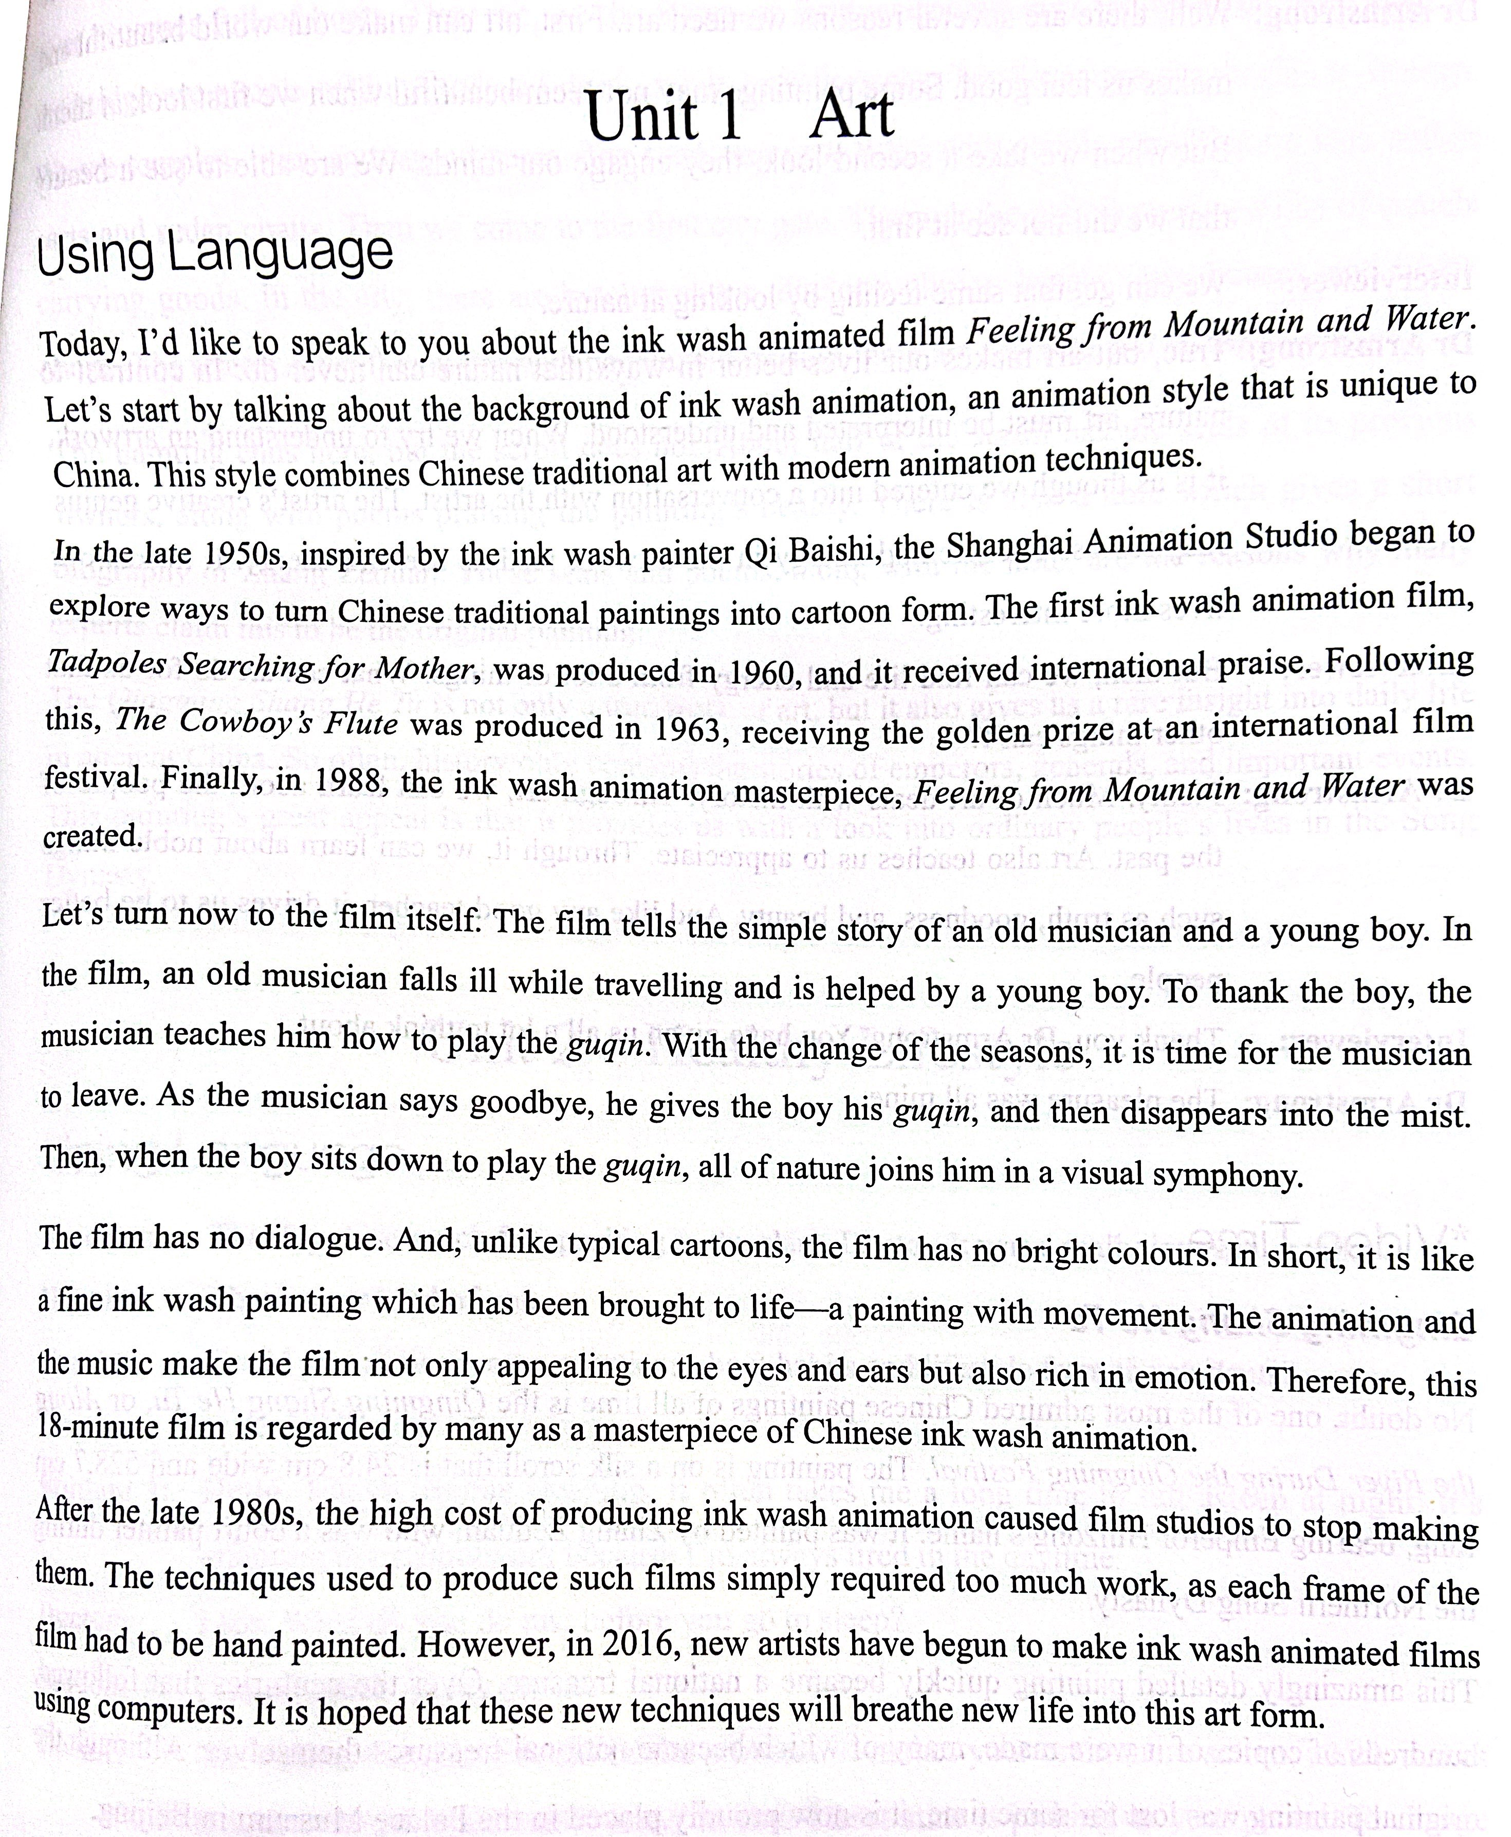

Thinking: How can we know the speaker’s attitude to ink wash painting animation?

