**2023.3福州二检读后续写讲评The Little Astronomer, Catalina**

1. 主题：人与自我、人与社会
2. 原文

阅读下面材料, 根据其内容和所给段落开头语续写两段, 使之构成一篇完整的短文。

Every night as the whole family fell asleep, Catalina would slide from home to the Cerro Tololo observatory （天文台）. Papa was the mechanic （修理工）of the observatory, but during the day Papa would not allow her to get closer to the telescopes there. Only at night, Catalina was allowed in with the permission of the night staff.

Catalina loved helping to service the grand telescopes, the eyes that looked out into the universe. She wanted badly to be an astronomer someday. Adults never took her dream seriously. Even her father laughed, “Maybe you'll be hired to clean the offices. ”

One day in the library, Catalina was reading a plant journal when she stopped at the picture of an unusual white flower. “It's called wild carrot. " A Spanish astronomer, who she saw several times in the observatory, stood behind her. “Pretty, isn't it? I’ve always liked that flower, because it looks like a galaxy. ”

“A spiral galaxy （漩涡星系）, ”she whispered. Blond eyebrows climbed the scientist＇s forehead. “Indeed. And what is your name, young lady?” he asked.

"I'm Catalina Solis. ”

“Eduardo Solis's daughter? The mechanic?”

Yes. ”She

gave a look at him. “I want to be an astronomer when I grow up. "

He laughed kindly, no longer meeting her eyes, and patted her on the shoulder. “Yes, of course, my dear. Work hard in school, and it could happen. ”

One evening, Catalina eyescanned the top of the observatory as usual. Suddenly she noticed the angle of the one-meter telescope was unusual. The telescope was pointed down, lower than she had ever seen it. Catalina learned from1 Papa how dangerous it would be. If left like it was, the telescope would move past its limit and be damaged. So without hesitation, she got inside the observatory.

注意：

1. 续写词数应为150左右；

2. 请按如下格式在答题卡的相应位置作答词

She saw the Spanish scientist buried in work there.

The scientist's words meant a lot to her.

1. 文本解读

读基本信息

Who are the main characters?

What happened (the conflict)?

When did the story happen?

Where did the story happen?

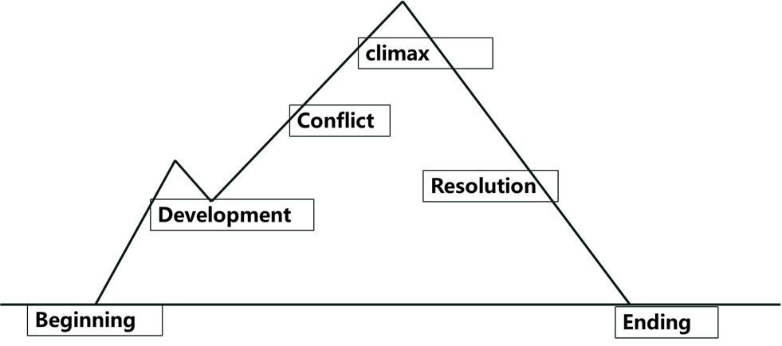读情节线-情感线-时空线

1. 续写思考

Para 1: ① What would she deal with it?

② What would the scientist do? What words did the scientist say?

③ How will her feelings change?

Para 2: ① What would she think after listening to the scientist’s words?

② What would she do in the future?

③ What was the result?

1. 写好四句话

What is the theme of the story? 第二段最后一句（点题）

___________________________________________________________

第一段第一句（衔接）

___________________________________________________________

第一段最后一句（衔接第二段第一句）

___________________________________________________________

第二段第一句（衔接）

___________________________________________________________