**Unit 2 Book 1 学案**

1. castle [ˈkɑ:sl] n._________,__________

破拆法：cast(抛掷)+le(了) 助记：抛掷了的武器都被________挡了下来。

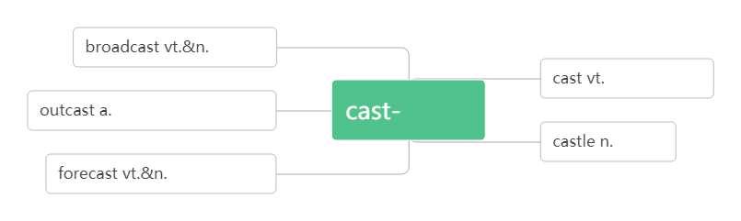

1. apply [əˈplaɪ] vi._________vt. _________；__________

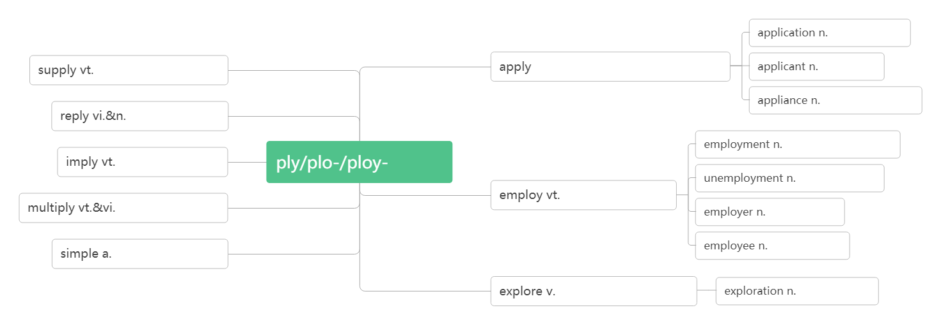

apply ____ sb._______ sth. 向某人申请某物

apply sth ____ sth 把某物应用于/涂抹在...上

application [æplɪˈkeɪʃn]n.__________;__________,__________

applicant [ˈæplɪkənt]n.____________,_____________

1. visa [ˈvi:zə] n________

词根词缀：vis-(看)+a(去)：去给别人看的东西——__________

1. rent [ rent] vt__________;__________vi._________n._________
2. pack [pæk]vi. & vt._________;_________ n.__________;__________

______________________ 将(东西)装箱打包

_______________ 一包；一盒；一群；一堆

1. amaze [ əˈme ɪz ]vt._________,__________

amazing [əˈme ɪzɪŋ ] adj.__________;__________ (现在分词表示_______内涵，意为“______________”)

amazed [əˈme ɪzd ] adj.__________;___________(过去分词表示________内涵，意为 “________________”)

____________________________对……感到惊叹

1. arrange [əˈre ɪnd ʒ ]vt._________;_________

词根词缀：ar(去)+range(排列):去排列好——_________

arrange _________ 安排

arrangement [əˈreɪndʒmənt]n._________;__________

1. extreme [ɪkˈstri:m]adj.___________;___________

破拆法：extre-(extra格外的)+me(我) 助记：一个格外自我的人是比较_________。

extremely [ ɪkˈstri:mli ] adv.__________

1. source[sɔ:s]n._________,__________,_________

拆破法：s(水)+our(我们的)+ce(测) 助记：我们要测出我们河水的源头。

1. narrow [ˈnærəʊ]adj.狭窄的vi.& vt._____________

拆破法：n(门)+arrow(箭)：谁能把箭射入窄门内？

1. flat [ flæ t ]adj. __________;__________ n._________;_________
2. power[pa ʊə]n._________;__________;__________;_________;__________

come to/into power____________

beyond one’s power _________________

nuclear/wind/solar power ________/ _________/ __________

power _______/____________ 断电/ 停电

powerful [ˈpaʊəfl ]adj. ___________;__________;__________

1. empire[ˈempa ɪə(r)]n._________

emperor[ˈempərə(r)]n.__________

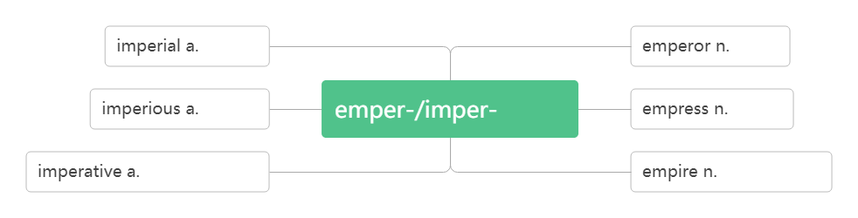

1. site [saɪt ]n.________,_________;_________

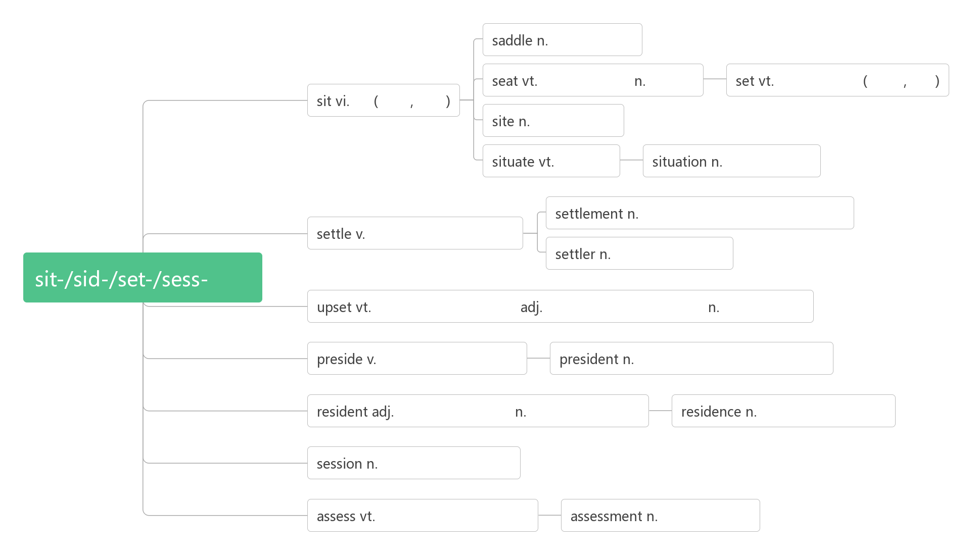

1. control [kən'trəʊl]vt.& n.________;________;________

词根词缀：contr(相反)+rol(滚轮)：让……反着滚——_________;__________

take control of __________;__________

1. official [ə'fɪʃl] adj. ________;_________;__________ n. _____________

____________ adv. 官方地；正式地

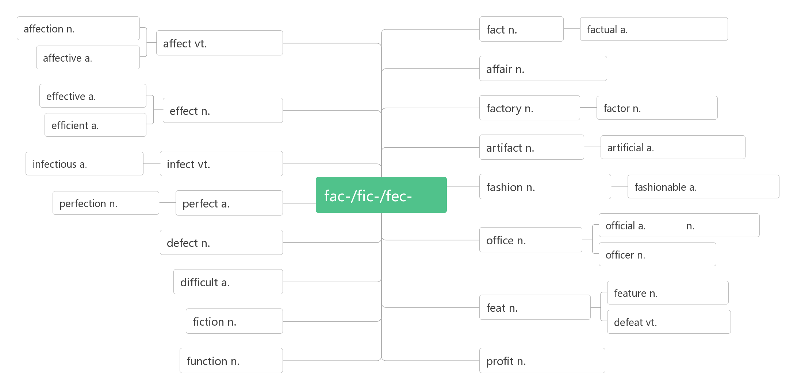

1. recognise[ ˈrekəgnaɪz] vt.___________;_________,_________ (*NAmE*-ize)
2. 词根词缀：re-(再次)+co-(都)+gn-(知)+-ise(动词后缀)：再次都知道——认出；承认

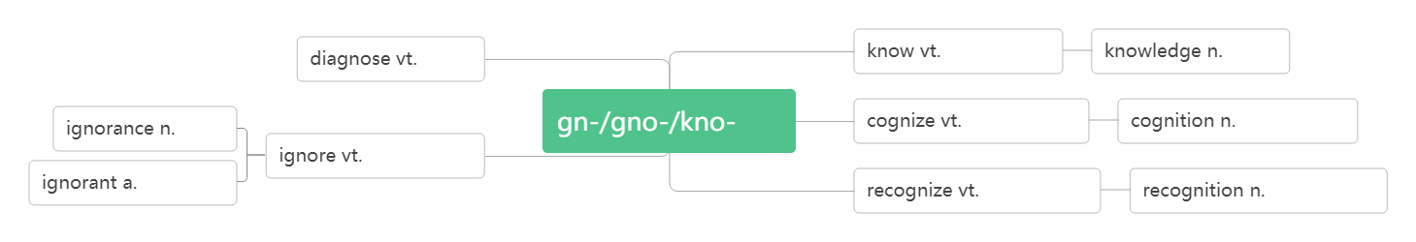

recognise …________/________ 把……当做；承认…… 为

recognition[rekəgˈnɪʃn] n. ________;__________;__________

1. type [taɪp]n._________;__________ vi. & vt._________

__________n.打字员

1. flight [flaɪt]n.________;_________
2. accommodation[əˌkɒməˈdeɪʃn] n._________,__________;___________

词根词缀：ac(去)+com(共同)+mod(模式)+ation(名词后缀)：去用共同的模式吃住——_________

accommodate[əˈkɒmədeɪt] vt.&vi.________;________,___________

__________________________ 适应

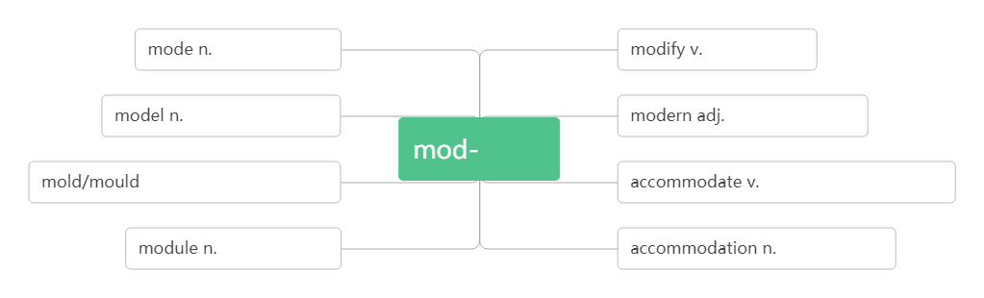

1. unique [juˈni:k]adj.________,__________,___________

unique _____ sb /sp. 是某人/ 某地特有的

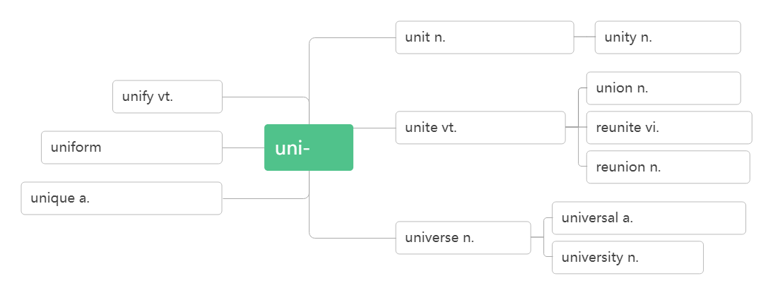

1. path [pɑ:θ ] n.________,__________,_________
2. destination[destɪˈne ɪʃn] n.____________:_________

词根词缀：de(下)+stin(站=stand)+ation(名词后缀):下一个要站的地方——____________

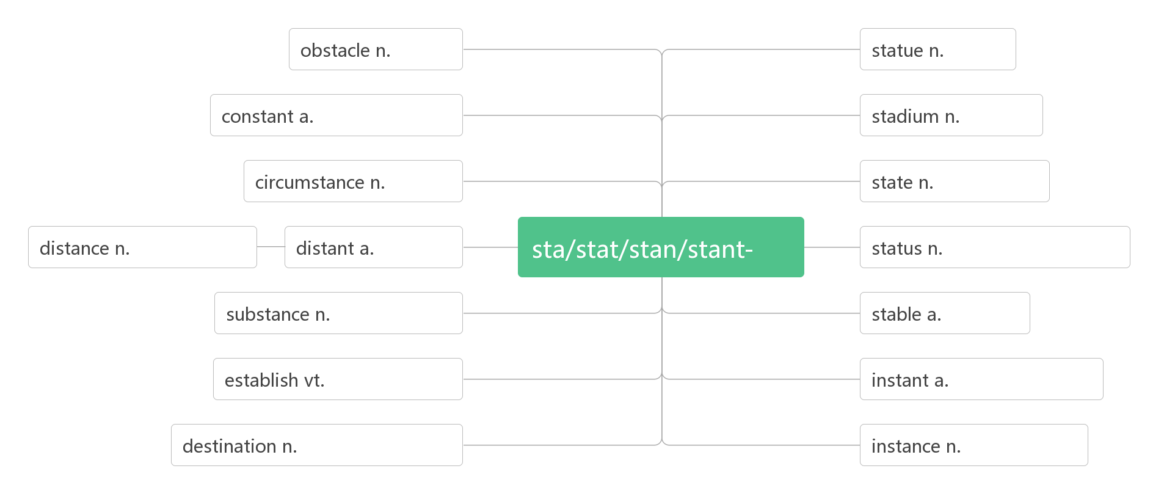

1. other than _____________
2. admire [ədˈmaɪə(r)]vt. __________,__________;_________

音意互通：我的妈呀 助记：我的妈呀，你做的事太让人_______了。

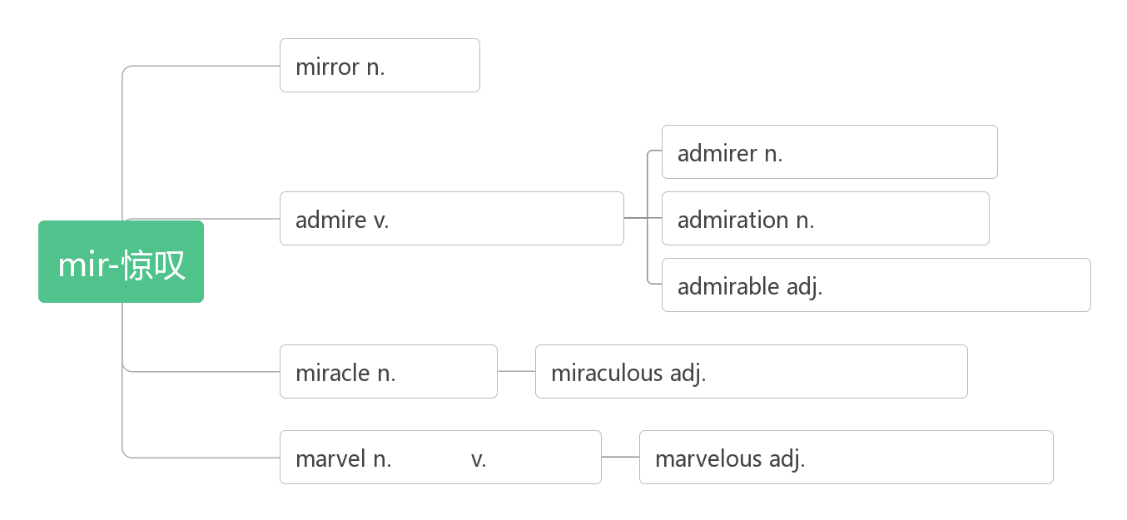

admire sb __________________ sth. 因(做)某事而钦佩/ 羡慕某人

admiring [əd'ma ɪərɪŋ] adj.__________;___________

admirable[ ˈædmərəbl] adj._____________;_____________

admiration / ˌædməˈreɪʃ n] _________;__________;__________

do sth._________________ 钦佩地做某事

1. architect [ˈɑ:kɪtekt ] n__________,______________

词根词缀：archi(拱形)+tect(铸造，织造)：建造拱形建筑的人——__________

architecture [ˈɑ:kɪtekt ʃə(r) ]n. ___________,__________

1. brochure [ˈbrəʊʃə(r)] n. ____________

音意相通：布鲁塞尔 助记：在布鲁塞尔旅游，你需要一本旅行______。

____________________ 旅游手册

1. package[ˈpækɪdʒ]n. ________;___________ vt._____________

词根词缀：pack(包装)+age(名词后缀)：_________

____________________ 包价旅游

_________________ 一包/盒/袋

1. contact [ˈkɒntæ kt ]vt._________,__________n._________,__________

词根词缀：con(一起)+tact(接触)：接触到一起——__________。

1. transport [ˈtræ nspɔ:t]n.__________;_________vt. [trænˈspɔ :t]_________;__________

词根词缀：trans-(转)+port-(运)：转运——________;_________

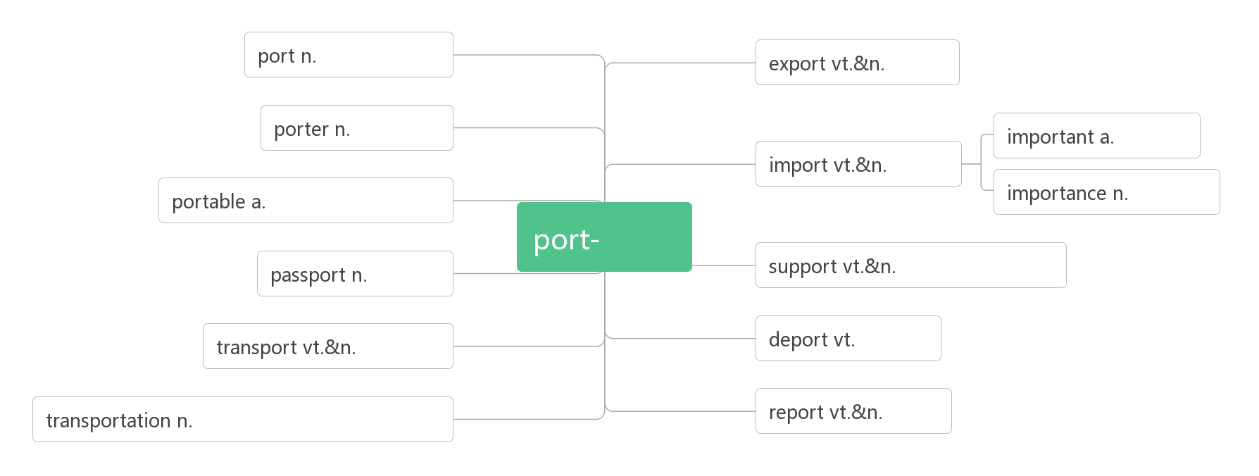

________/_____________________ 空运/路运

_______________________ 公共交通；公交车辆

1. hike [haɪk ]vi.&n.________,___________

__________________ 去远足；去徒步旅行

___________ [ˈhaɪkə(r) ] n.远足者；徒步旅行者

1. make up_______,________,________,_________,_________

__________________ 由……组成/ 构成

make up for ________

1. soldier /ˈsəʊldʒə (r)/ n.________,_________

破拆法：sold(sold)+-ier(人) 助记：_________就是把自己出售给国家的人

1. economy[ ɪˈkɒnəmi] n._________;____________

词根词缀：eco-(家)+nom-(管理)+-y(名词后缀)：对家的管理——________

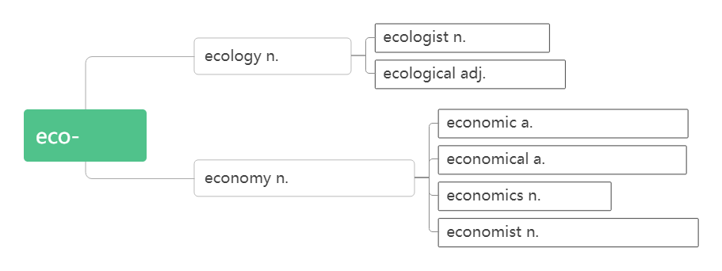

a market economy ______________

economy class _______________

1. credit [ˈkredɪt] n.________；_________；__________；___________

词根词缀：cred(相信)+it(去)：去信任——_________

助记：有了_______才能________上学，要获得老师的________就要拿到_________。

__________________ 值得称赞的是

_______________ 信用卡

___________________ 用信用卡支付

1. detail [ˈdi:te ɪl ] n.________,_________,____________ vt._________

破拆法：de(下)+tail(尾巴)：秋毫之末——________

____________ 详细地

1. check in (在旅馆、机场等) __________

check out（在旅馆等）_____________

1. request[r ɪ'kwest]n.&vt.(正式或礼貌的)_________;__________

词根词缀：re-(强调)+quest(寻求):寻求许可——_______,________

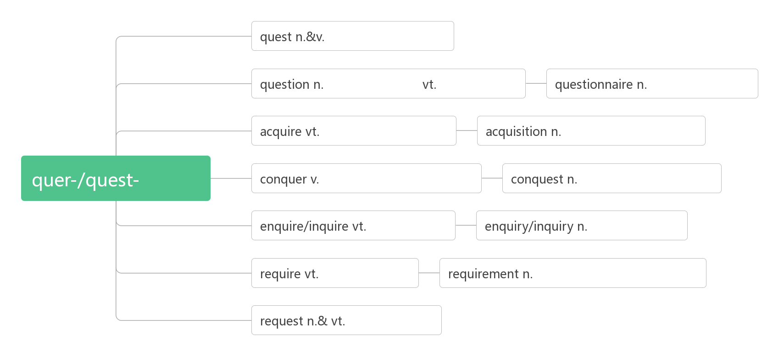

_________________请求做某事

_________________________请求某人做某事

______________________________________ (request跟宾语从句的搭配)

_______________________应某人的请求

1. view [vju:]n.________;_________;_________ vt.______;__________

___________________在某人看来

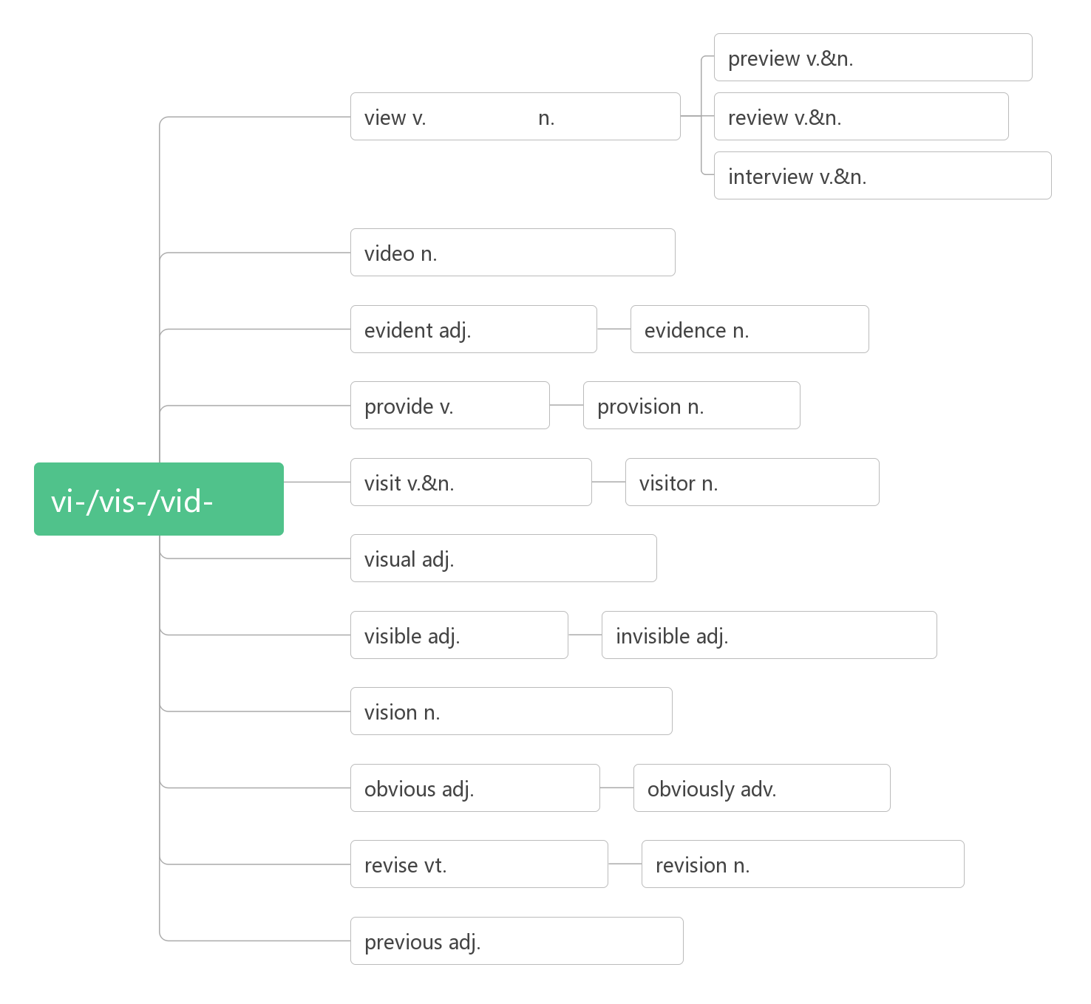

1. sight /saɪt/ n. ________;_________;__________

in sight ___________________ out of sight __________________ catch sight of ________ lose sight of ___________________

at the sight of ______________________ at first sight _______________________

1. statue[ ˈstæ tʃu:] n._________,__________
2. tomb [tu:m ] n.________

音意相通：________

1. unearth [ʌnˈɜ:θ] vt._________,_________

词根词缀：un(不)+earth(土壤)：不留在土壤中——_________。

1. comment / ˈkɒ ment /n.vi.& vt._________

词根词缀：com(一起)+ment(mind)：把想法拿到一起——__________

______________/__________________/_______________ 对表达意见；作出评论

____________________无可奉告