Book1 unit2 expanding your world 教学设计

**Learning Objectives**

**By the end of the lesson, students will be able to:**

1. Understand the descriptive features of the passage about Pisa.
2. Identify key details about the Leaning Tower, Italian architecture, and cultural figures.
3. Infer author's tone and purpose.
4. Appreciate Italian cultural elements like poetry and improvisation.
5. Write a short descriptive paragraph using the same writing techniques.

**Teaching Focus and Difficulties**

**Key Points:**

* Extracting detailed information from a non-fiction passage.
* Understanding descriptive language and its effects.

**Difficult Points:**

* Understanding historical and cultural references (e.g., Improvisatori).
* Applying descriptive techniques in their own writing.

**Teaching Procedure**

**Activity1: Lead in**

* What do you think of your hometown?
* What is the landmark(地标性建筑) of your hometown?
* What do you think the people in your hometown?

**Activity2: Prediction**

What do you expect to know from the text?

raise questions with “wh-”

**Activity3：Explore the text**

* **General impression:**
* ***What’s his first impression of Pisa?***
* ***Where did he visit?***
* ***Who did he meet?***
* ***Why is it a fine city?***
* **Why does the author use so many “well-”adjectives?**
* **What rhetorical device (修辞手法) is used?**
* ***Tip1: use descriptive words (描述性语言) and repetition to paint a vivid(生动的） picture.***
* ***Landmark:***
* **Which sentence does the writer use to show how “*leaning*” the tower is?**
* **Why is it *beautiful*?**
* **Why are the people *interesting*?**
* **Why does the author use *figures* to describe leaning tower?**
* ***Tip2: use figures(数字) to make the description easy to understand and more convincing.***

**People:**

***Tip3：reflect regional(区域) culture when introducing people.***

**Activity3: Form mind-map**

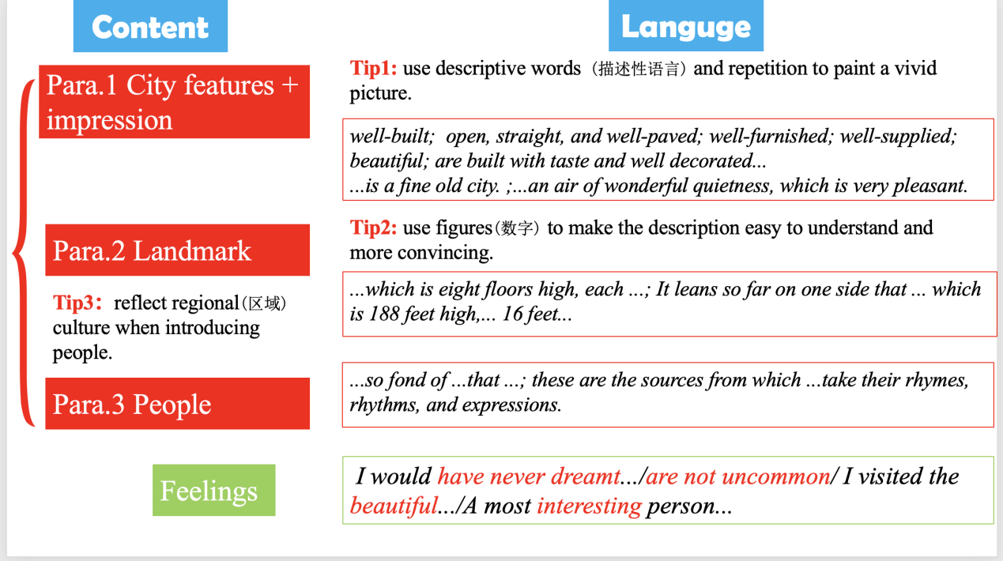

**Activity4: Post-reading**

**Imagine that Tobias Smollet came to your hometown. Try to describe experience visiting your hometown.**

**Content:**

* **The beautiful scenery of ...**
* **Landmarks ...**
* **People ...**