2020年新高考卷I Continuation Writing（读后续写）教学设计
Teaching Aims:（教学目标）
After learning this lesson, students will be able to:
- Understand the plot through analyzing and discussing the structure of the passage;
- Know how to predict and design plots by combing main context and the two first given sentences;
- Summarize the main steps and methods to write a continuing writing;
- Develop a reasonable and positive ending to a story by referring to the content of the text;
Key and difficult points：（教学重难点）
Enable students to master how to read a story, find its plots and characters’ feelings ,and then predict and design a continuing story with a positive ending.
Teaching procedures:（教学流程）
- Presenting the text in the exam.(真题再现）
- The Requirements:

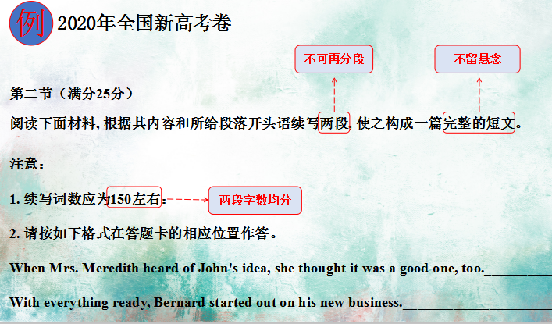
3.Writing steps:
Step1: Reading(读取信息)
1）Read for 4W and 1T(when, where, who, what,(4W and 1Theme)
2）Read and fill the blanks
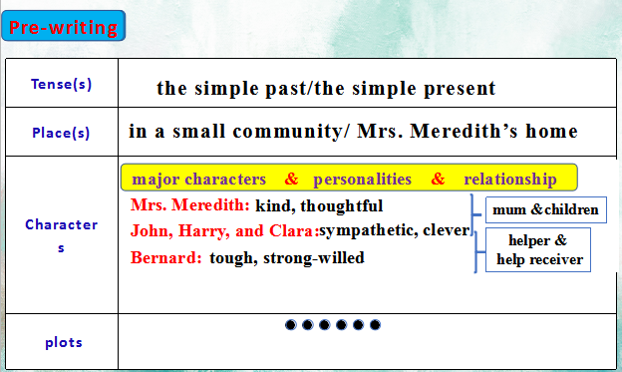
- Read for plots and feelings.
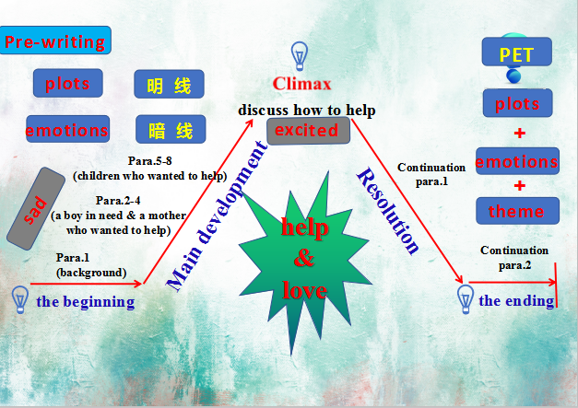
Step2: Thinking(构思）
Predict the plot according to the given sentences:
Analyze the first given sentence of each paragraph and make some guessing based on the given information. Then have a discussion in groups of four, choose one spokesperson to present the ideas on what would happen next to make an outline.
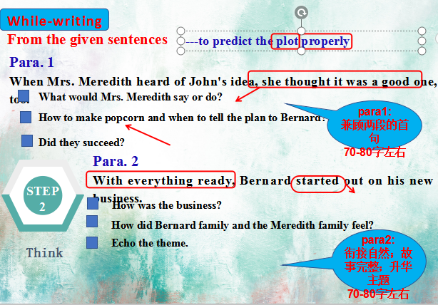
Constructing the plot further
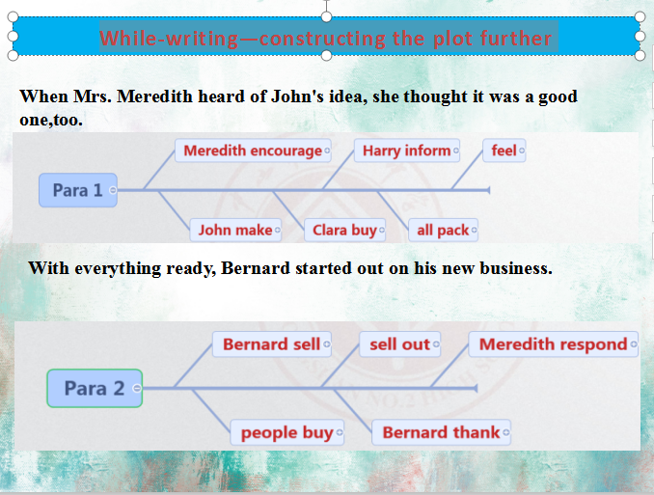

Step3: Drafting and writing（续写打草稿）
Tips: 5-7 details（sentences） in each paragraph covering the plots(actions &surroundings) and feelings
Step4: Polishing（润色定稿）
1)change simple words to advanced expressions
2)use some sentence patterns
3) pay attention to the linking words
4) copy carefully
Step 5：Summary
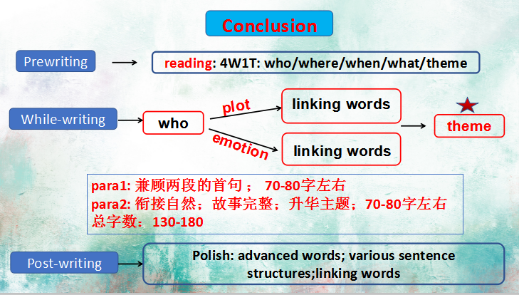
Step6: Show and comment (展示和点评)
- 优秀书写范例展评
- 学生佳作展示
- 品评范文
- 范文挖掘积累
Step7：Homework

