教学设计
课程基本信息
学科 | 英语 | 年级 | 高一 | 学期 | 春季
课题 | B2U2 Reading and Thinking A DAY IN THE CLOUDS
教科书 | 书 名：普通高中教科书英语必修第二册  出版社：人民教育出版社 出版日期：2019年6月
教学目标
1.语言能力：掌握重要的词语和表达，如濒危动物、野生动物保护、关注人与动物关系等， 如die out, mass extinction, live a harmony with nature等表达。
2.学习能力：提高阅读能力，强化训练跳读、查读阅读技巧，提炼文段中关键信息并进行整合，加深对教材文本的理解。
3.文化品格：拓宽野生动物保护视野，着眼于国内外野生动物的保护，培养博爱情怀。
4.思维品质: 基于自主学习和小组合作探究，熟练运用思维导图，利用思维导图复述文章，在探讨中创新性多角度提出保护野生动物的举措。
教学内容
教学重点：
1.保护野生动物相关短语的学习
2.思维导图的运用
3.学会并行结构下抽取文章的中心思想。
教学难点：
1. 如何运用思维导图找到文章的线索，理解全文
2.如何利用思维导图抽取全文的中心思想
3.如何利用思维导图复述文章。
教学过程
Teaching steps
【Step 1】Lead-in
Task: Watch a video clip by the use of google map and show students the vivid environment of antelopes
Aim: To motivate students to learn more about antelope’s protection.
【Step 2】fast reading: skimming (para.1~para.3)
Task: Students compete the basic structure of the text by drawing a mind map. (Where .Who)
Aim: To help students establish the basic understanding of text.
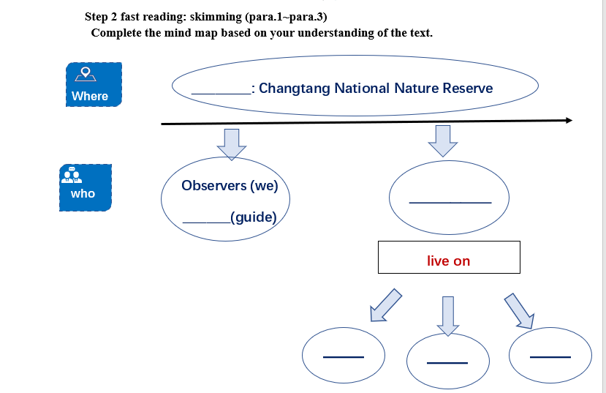
【Step 3】detailed reading: scanning
Task: Students looks for further information about the story of antelopes by reading para.4-6 (What)
Questions(para 4.) :
1. How to describe the time between 1980s-1990s for antelopes?
2. What’s the cause and results of the decreasing number of antelopes？
Question2(para 5-6.) 1. What measures have been taken to save antelopes after 1990s ?
(add more details to the mind map )
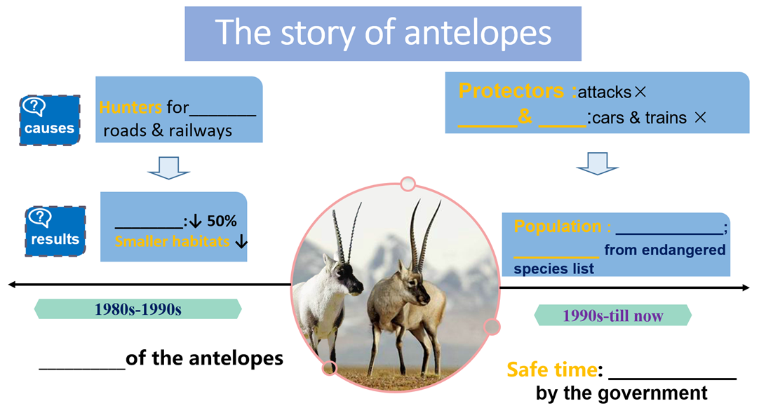
【Step 4】creative and critical thinking
Task: The threats to the Tibetan antelopes have not yet disappeared. Students reflects on antelope’s protection and give a speech calling for wildlife protection from different aspects.
Aim: To help students build up the awareness of wildlife protection in creative and critical way.
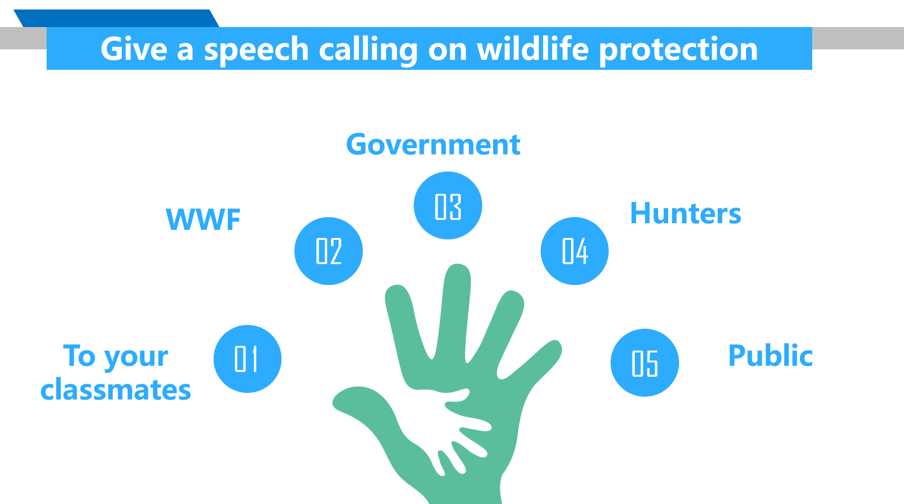

Sample( A speech for classmates)

Dear classmates,

The beauty of world is largely because of its rich biodiversity.However, due to the deep influence of humans, some species disappeared in the world, which will lead to various chain reactions, affecting the survival of other species, including us humans.

Hence, it is necessary for us to protect wildlife. We can start from small things, for example, improving our awareness of for biodiversity and wildlife protection.

Only when we learn to exist in harmony with nature can we stop being a threat to wildlife and to our planet.Caring for animals, caring for the community, caring for the world, makes our only planet earth a better place.
【Step 5】Homework
Task:Students have to design a poster concerning wildlife protection.
Aim: To arise students’ awareness of wildlife protection in a creative way.

Samples
