**M3U2 Morals And Virtues**

**Period 1 Listening and Speaking**

**Teaching Objectives：**

By the end of the class, students will be able to

1. master some phrases that describe the traditional virtues:

2. learn how to identify the attitudes of speakers while listening

3. can express their opinions on the moral dilemmas, and form the right values and behaviors

**Teaching Important and Difficult Points：**

How to make students work out the listening tip of guessing the attitudes of the speakers.

How to make students express their opinions on the moral dilemmas fluently.

**Teaching Procedures:**

**hundred**

**thousand**

**million**

**____________关于**

**Step 1: Lead-in**

**Activity 1: Look and say**

Students will be asked to look at a picture and answer the following questions:

Q1: What problem is the boy faced with in the picture?

T: We can say that the boy is faced with a moral dilemma.

Q2: What is “moral dilemma”?

Q3: If you were the boy in the picture, what would you do?

Sentence pattern: If I were the boy faced with such a moral dilemma, I would choose to help her/continue my way. This is because_____________________________________

Teacher express her opinion on the moral dilemma the boy faced with.

(此环节目的一方面在于帮助学生理解什么叫做“道德困境”，另一方面在于锻炼学生看图说话，以及表达个人观点的能力。教师总结、表达自己的观点并衔接至下一活动。）

**Activity 2: Know more traditional virtues**

Student will be asked to say more traditional virtues they know:

1. What other traditional virtues do you know?
2. What do you think of these traditional virtues?

T: It’s our responsibility to spread Chinese traditional virtues. Do you agree? But to practice, there are many moral dilemmas in our life, just as the dilemma in the picture. So what should we choose to do? Let’s listen to another moral dilemma, and see what will others do.

(此环节目的在于激活学生已有关于中国传统美德的印象，知道美德传承在现代社会遭遇的困境，引导学生树立正确的价值观。）

**Step 2: Listening**

**Activity1: listen and fill in blanks**

Students will be asked to listen and fill in the blanks about the background of the conversation, what choices could the girl make, and the possible result of her choice:

1. Before listening, what can we do to simplify the listening material we are going to listen?

**Listening tip:** Before listening, you can make a prediction according to the key words in the questions

1. Listen and fill in blanks.

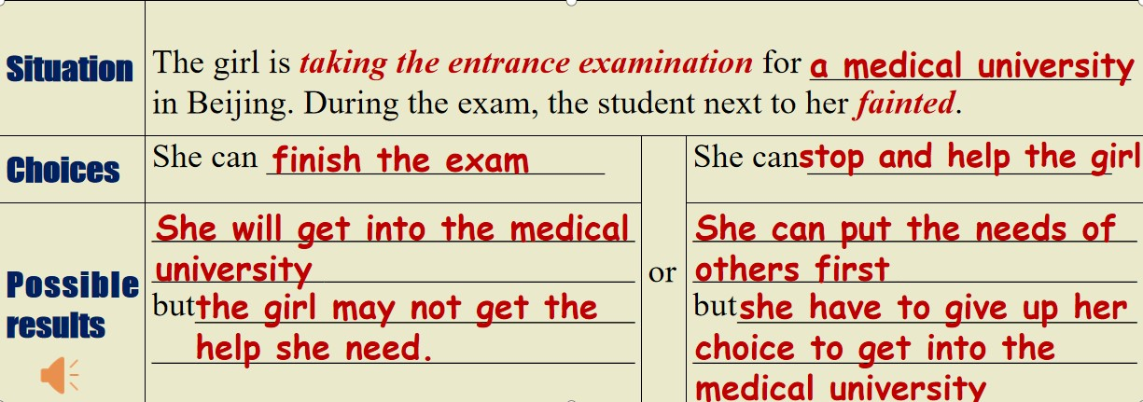

**Activity2: Listen and decide**

Students will be asked to look at the following five sentences and answer the questions:

a. Jane is eager to share the magazine article with Luck.

b. Luck doubts that young people face moral dilemmas all the time.

c. Jane admires what the girl in the story did.

d. Luck doesn’t believe anybody would do what the girl in the story did.

e. Jane wonders how the girl became a doctor later.

1. What do the red words have in common?

2. How to identify the attitudes of the speakers?

**Listening tip:** 1.pay attention to the words speakers use (passive or positive or objective)

2. pay attention to HOW the speakers is talking

**Activity3: Listen and choose**

Students will be asked to listen one more time to know more details of the girl in the story.

1. The girl did all the following to help the student, except for?

A. carried her to a safe place B. went to the hospital C. called the teacher

2. What was the girl’s name? And what was she famous for?

A. Lin Qiaozhi, she always put the needs of the others first.

B. Lin Zhiqiao, her life was full of hard choice, but she always take care of others.

C. Lin Qiaozhi, she cared for tens of thousands of women and babies.

3. What kind of person is the girl can you infer from Jane’s words?

A. kind and devoted B. kind and modest C. devoted and modest

Students will be asked to read the last sentences and translate the sentences.

**Step 3: Post-listening**

1. Students will be asked to have a debate on whether to help or not when faced with a moral dilemma.
2. Students will be asked to express in this way——opinion+reason(s)

Sample

As for me/In my opinion/As far as I’m concerned, if we meet such a moral dilemma, we should choose to help/ ignore. The reason why I make such a choice is that...

(此环节目的在于锻炼学生说的能力，同时通过辩论的形式明白生活中出现道德困境的一些原因，以及当我们遇到道德困境的时候我们到底该如何做——做出积极的行动，同时保留证据。）