巧借思维导图，提升续写能力

—2024 学年浙南名校联盟第一次联考读后续写

陕西省咸阳市礼泉县教研室 高小聪

Contents：

**一.《高考评价体系》命题指导**

**二. 全国I卷读后续写对比分析**

**三. 思维导图链接读后续写**

**四. 思维导图在读后续写中的应用**

**一.中国高考评价体系（英语命题指导）**

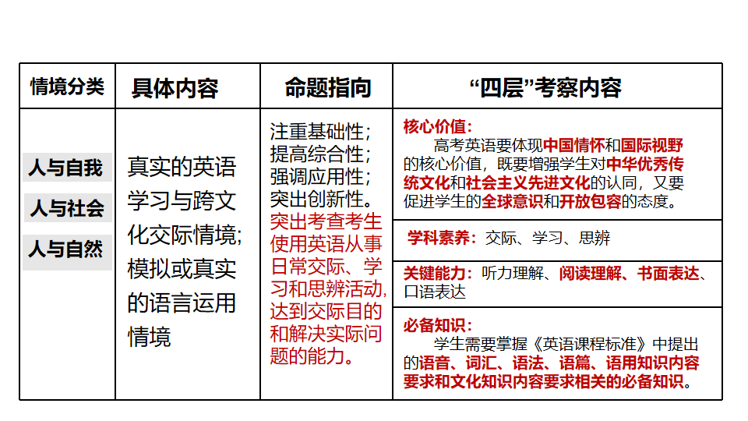 **二.全国I卷读后续写对比分析**

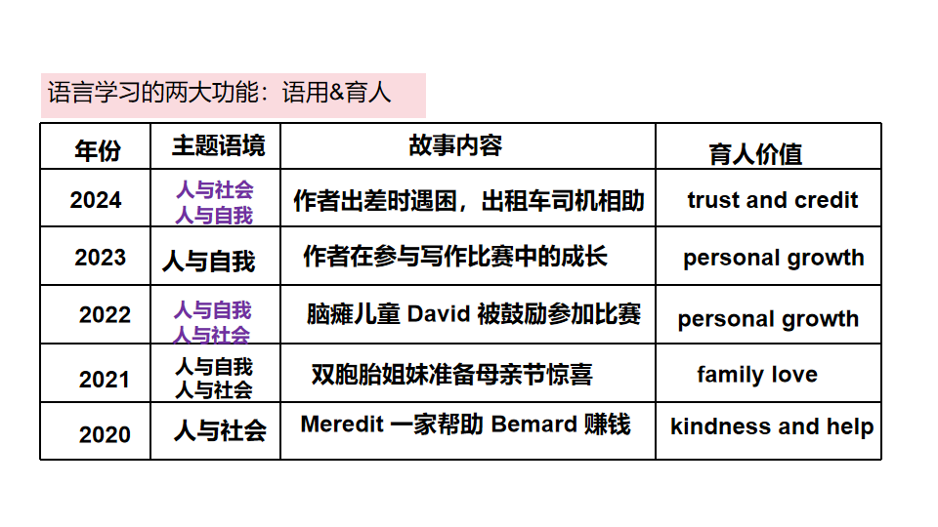

**三.思维导图与链接读后续写**

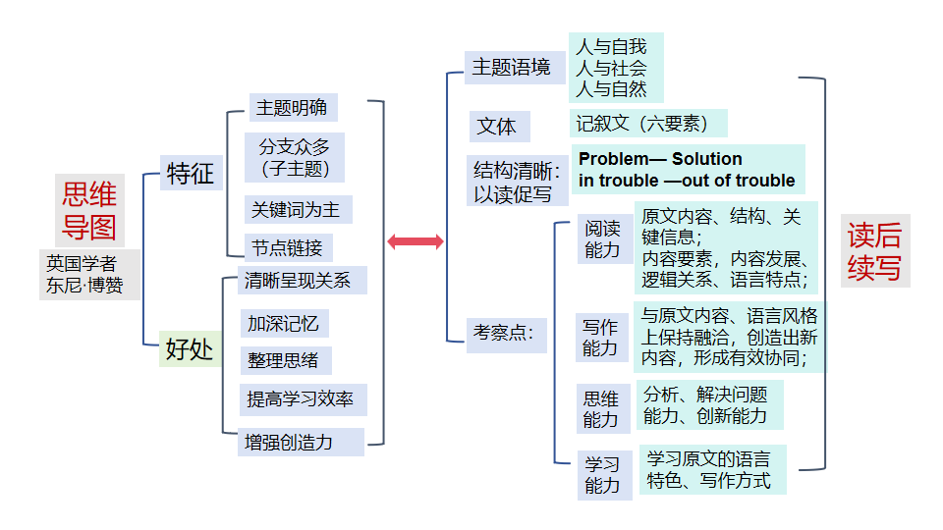

**四.思维导图在读后续写中的应用**

第二节 (满分25分)

阅读下面材料, 根据其内容和所给段落开头语续写两段, 使之构成一篇完整的短文。

Ava, a fifth-grader, longed for a cell phone like her peers but had to wait until she was thirteen. To persuade her parents, she penned an essay, demonstrating she was mature enough for a cell phone. Her parents, impressed, gave her an old phone.

“Ava,” her dad said seriously, “a cell phone isn’t just for fun and games. It’s a significant responsibility. You must keep your phone secure. You must silence it in public spaces. You must...” He listed all of the ways that she had to be responsible with her phone. But Ava, too busy with choosing the perfect wallpaper, downloading apps, and chatting with her best friend Sarah, only half-listened.

Over the weekend, Sarah’s mom took the girls to a movie. Normally Ava avoided horror films, but Sarah’s pleading words with funny memes (表情包) had somehow convinced Ava that the movie might actually be enjoyable. Before the movie started, Sarah’s mom instructed the girls to silence their phones out of respect for others. As the movie’s tension built, Ava found herself growing increasingly uncomfortable. “I need to go to the bathroom,” Ava whispered to Sarah.

After the movie, while waiting for Sarah’s mom to fetch the car, Ava felt a sinking feeling. “I can’t find my phone!” she shrieked, patting down all of her pockets. Panic-stricken, Ava searched her bag, yet her phone seemed to have vanished. Ava got into the car, her stomach in knots.

“Are you going to tell your parents?” Sarah whispered to Ava on their ride back. Ava was silent, her mind racing with the consequences. She could envision her parents’ disappointed faces and harsh words. She feared that this incident might lead to her parents taking away the privilege of having a phone altogether.

As they arrived, Ava climbed out of the car and trudged home, her heart heavy with what had happened.

注意:

1. 续写词数应为150 个左右;

2. 请按如下格式在答题卡的相应位置作答。

Paragraph 1: The moment Ava walked in, her parents greeted her with a smile.

_________________________________________________________________________

Paragraph 2: Then her parents drove Ava back to the cinema.

_________________________________________________________________________

**Step1. Read for the background**

Ava; Ava’s parents；Sarah; Sarah’s mom

who

while Ava, Sarah and her mom were watching a horrible movie

when

Ava’s Cellphone

At the cinema

where

Ava lost her cellphone after the movie

what

felt a sinking feeling; shrieked; patting down all of her pockets; Panic-stricken, searched her bag; feared; trudged home, her heart heavy with what had happened.

How

Ava persuaded her parents to owning an old cellphone with a sincere essay.

**Step2. Read for the plot**

Beginning

Busy with playing with the cellphone and chatting with friends, she only half-listened to her father.

Development

At the cinema, she lost her cellphone accidentally, afraid that this incident might lead to her parents taking away the privilege of having a phone altogether. So Ava went home, her heart heavy with her lost cellphone.

Ava’s Cellphone

Climax

Falling action

续写Para1. ... ...

续写Para1. ... ....

Ending

**Step3. Read for the coming plot**

Parents didn’t scold Ava for losing the cellphone. Instead, they helped her to look for the cellphone at the cinema.

所见

Losing the cellphone made Ava in low spirits; Parents’ helping her to look for the cellphone made her relieved and moved; The cellphone’s being recovered strengthened the sense of her responsibility.

所闻

Ava’s Cellphone

Her parents instructed Ava, “ Possessing a cellphone means taking on a responsibility, including its secure, silencing it in public and using it properly.

所感

Ava murmured to her parents, “ My cellphone is gone/ missing at the cinema.” “ Think carefully where you have left it, ” comforted her mother.

所说

They asked the cinema staff for help. It turned out that the cellphone was left in her seat. Ava jumped with delight. Further, she also learned managing her own cellphone is significant.

所做

**Step4. Read for more details**

Ava’s father offered her weighty advice, “It’s important for you to do what you say. You should take care of your cellphone as your essay tells us to. You are mature enough to solve the puzzles in life.”

语言描写

Hurriedly, Ava bent down, put on her slippers and slipped into the bathroom. Ava’s father shook his head, frowning and urging, “ Hurry up to look for the cellphone at the cinema.

动作

描写

Ava’s

Cellphone

环境

描写

A smell of displeasure was rising up through the air.

Tears streamed down her cheeks with guilt and fear. ( Losing the cellphone)

Ava breathed deeply, trying to calm her nervousness.

Ava took her mom and dad by the hands, her eyes shining with gratitude. (Helping her look for the cellphone)

The cellphone was recovered, her heart bursting with joy.

She understands that possessing a cellphone means taking on a responsibility. (Finding the cellphone)

心理

情感

描写

**Step5. Read for writing**

The moment Ava walked in, her parents greeted her with a smile. Butterflies in her stomach, she 1_________ (force) a smile, saying, “ What a bit scary tonight’s film!” 2__________ (hurry), Ava bent down, put on her 3_________(slip) and slipped into the bathroom. After a second thought, she stumped out of the bathroom, 4___________(murmur) to her parents, “ Mum and Dad, I lost my cellphone accidentally.” “ How could it happen? Think carefully 5_______ you left it?” asked her Mum in a mild tone. “ Watching the film, the cellphone was in ... my pocket. But... leaving for our home, I found it ...missing” , 6___________ (stumble) Ava. Her parents decided to help their daughter look for the cellphone.

Then her parents drove Ava back to the cinema. With the cinema staff’s help, they searched Ava’s seat for the cellphone in vain, so they went to the bathroom together, Ava trying 7________ (dial) her phone number. 8_________ her expectation, her cellphone rang. Ava felt relieved, her heart 9_________(burst) with joy. On the way home, watching Ava holding the cellphone tightly, her dad offered her 10________ (weigh) advice, “Honey, be sure to take care of your things in the future! 11___________ (mature) means a responsibility.” This time so carefully did Ava listen that she nodded, putting it into her pocket quietly. Her parents smiled a 12________ (heart) smile.

**We should move faster to establish our own discourse and narrative. We will better tell China’s stories, make China’s voice heard, and present a China that is credible, appealing and respectable.**

**要加快构建中国话语和中国叙事体系,讲好中国故事、传播好中国声音，展现可信、可爱、可敬地中国形象。**

**— 习近平在中国共产党第十二次全国代表大会上的讲话**

**（2022年10月16日）**