溯恩英语 语法填空满分计划系列课程-2 导学案
名词复数意识好，词性转换要记牢
Ⅰ-1.请完成2018年6月浙江英语卷-语法填空的答题和语篇分析。
Few people I know seem to have much desire or time to cook. Making Chinese
56 (dish) is seen as especially troublesome. Many westerners 57 come to China cook much less than in their own countries once they realize how cheap 58 can be to eat out. I still remember 59 (visit) a friend who’d lived here for five years and I 60 (shock) when I learnt she hadn’t cooked once in all that time.
While regularly eating out seems to 61 (become) common for many young people in recent years, it’s not without a cost. The obvious one is money; eating out once or twice a week may be 62 (afford) but doing this most days adds up. There could be an even 63 (high) cost on your health. Researchers have found that there is a direct link between the increase in food eaten outside the home and the rise in 64 (weigh) problems.
If you are not going to suffer this problem, then I suggest that the next time you go to your mum’s home 65 dinner, get a few cooking tips from her. Cooking food can be fun. You might also begin to notice the effects not only on your health but in your pocket.
1）请书写你的答案在指定答题区域内

56. 57. 58.
59. 60. 61.
62. 63. 64.
65.

2）请快速分析文章的文体，结构以及行文逻辑。

Ⅰ-2.专项训练（浙江新高考 7次语法填空题）
1. I absent-mindedly turned the 56 (page) of the phone book and came across a city map. （2016年10月浙江卷）
2. Lena Pahlsson pulled out a handful of small 56 (carrot) and was about to throw them away. （2017年6月浙江卷）
3. You wouldn’t think that a few 58 (month) of exercise in your teens would be enough for the rest of your life.（2017年11月浙江卷）
4. Making Chinese 56 (dish) is seen as especially troublesome. （2018年6月浙江卷）
5. One study showed that 64_______(woman) who drank a lot of coffee, like eight or
more cups per day.（2018年11月浙江卷）
6. For Japan, the 58 (number) are more striking - 22 in 1950, 46 today and 53 in 2050.（2020年1月浙江卷）
7. I looked 59 (quick) at the clock.（2016年10月浙江卷）
8. Magically, that show remains the Great Jason’s best 65 (perform) to this day.（2016年10月浙江卷）
9. But something made her look closer, and she noticed a 57 (shine) object.（2017年6月浙江卷）
10.“She thought I had hurt 59 (I),”says Pahlsson.（2017年6月浙江卷）
11. Sixteen years 60 (early), Pahlsson had removed the diamond ring to cook a meal. （2017年6月浙江卷）
12. One of the 60 (effect) ways to build vocabulary is to read good books. （2017年11月浙江卷）
13. You need to 61 (real) read at least one good book a week, preferably a classic.（2017年11月浙江卷）
14. Another nice thing is that you learn both new words and 64 (they) use unconsciously.（2017年11月浙江卷）
15. The obvious one is money; eating out once or twice a week may be 62 (afford) but doing this most days adds up.（2018年6月浙江卷）
16. There could be an even 63 (high) cost on your health. （2018年6月浙江卷）
17. Researchers have found that there is a direct link between the increase in food eaten outside the home and the rise in 64 (weigh) problems.（2018年6月浙江卷）
18. 58_______(recent), caffeine has found its way into orange, apple, and other flavored drinks.（2018年11月浙江卷）
19. One cup of coffee in the late afternoon or evening will cause 61_______(they) to stay awake almost all night.（2018年11月浙江卷） them
20. car drivers can 60 (easy) see them.（2019年6月浙江卷）
21. Other American studies showed no 64 (connect) between uniforms and school performance.（2019年6月浙江卷）
22. School uniforms are 65 (tradition) in Britain.（2019年6月浙江卷）
23. and so, on average, the population becomes 61 (old) than before. （2020年1月浙江卷）
24. This is 62 (particular) true in the US. （2020年1月浙江卷）

Ⅱ. 语法填空的常见词形变换练习
2-1.写出名词的复数形式：
1. bus; quiz; fox; match; flash; toothbrush

2. candy; fairy; strawberry

3. tomato; potato; piano; photo

4. knife life; leaf; scarf; roof; belief

5. child; man; woman; ox; foot; goose; mouse; tooth; analysis; basis; medium; phenomenon;

- 核查Ⅰ-2.专项训练的第1-6题答案；思考“名词复数”的做题技巧。

2-2.写出下列形容词或副词比较级和最高级
1. large; nice

2. heavy; easy; happy; healthy

3. big; hot; fat; thin; slim; fit; wet; sad

4. slowly; beautiful; different; easily

5. good/ well; bad /ill; old; little; far; many/much; badly-off/well-off

- 核查Ⅰ-2.专项训练的第11，16，23题答案；思考“形容词或副词比较等级”的做题技巧。

2-3. 完成人称代词表格
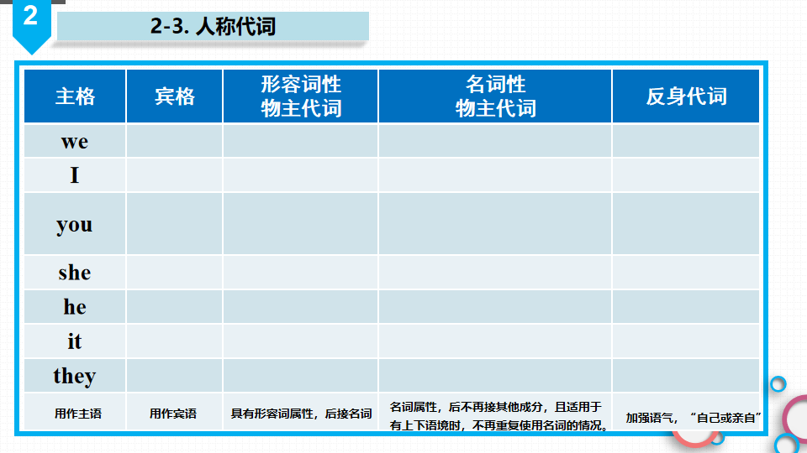

核查Ⅰ-2.专项训练的第10, 14, 19题答案；思考“人称代词”的做题技巧。

2-4. 基数词变序数词
基数词 | 序数词 | 基数词 | 序数词 | 基数词 | 序数词
one |  | eleven |  | twenty-one
two |  | twelve |  | twenty-two
three |  | thirteen |  | thirty
four |  | fourteen |  | forty
five |  | fifteen |  | fifty
six |  | sixteen |  | sixty
seven |  | seventeen |  | seventy
eight |  | eighteen |  | eighty
nine |  | nineteen |  | ninety
ten |  | twenty |  | hundred

Ⅲ. 语法填空的常见词性转换练习
3-1.写出下列形容词的副词形式
1. polite; wide; wise; rude; nice

2. simple; terrible; gentle; possible; comfortable;considerable; probable; incredible

3. true;
4. happy; heavy; angry; busy; shy

5. economic; basic; scientific; public; automatic; energetic

6. dull; shrill

7. 核查Ⅰ-2.专项训练的第7，13，18, 20，24题答案；思考“词性转换为副词”的做题技巧。

3-2.写出下列单词的名词形式
1. ① pronounce; explain; describe; acquire; recognize; compete

② consider; recommend; expect; relax; invite; prepare; explore; admire; observe; organize; combine; occupy

③suggest; connect; attract; pollute; educate; contribute; concentrate; donate; introduce; intend

2.① discuss; express; impress

② conclude; decide; extend; expand; explode

③ permit; admit; emit; transmit

3.① assist; attend; appear; accept; acquaint; perform

② exist; differ; prefer; confer

③ insure; guide; endure
④ relevant; significant; important; ignorant; absent; patient; fluent; confident;
different; independent; convenient

4. qualify; satisfy; clarify; modify; apply

5. achieve; advertise; amaze; amuse; argue; develop; equip; astonish; disappoint;
embarrass

6. survive; arrive; approve

7. marry; short

8. believe; relieve; grieve

9. fail; press; depart; expose; please; mix; sign

10. ① honest; difficult; modest; discover; recover; deliver

② injure; enquire/ inquire; unite

③ real; similar; familiar; popular; equal; personal; national;punctual

④ active; creative; diverse; secure; pure

⑤ cruel; safe; certain

⑥ able; possible; responsible; flexible

⑦ anxious; various; curious; generous; necessary
11. warm; strong; dead; deep; wide; long; true; young; grow

12. wise; free; bore

13. accurate; fluent; frequent

14. aware; cold; weak; bright; kind; empty; happy

15. high; weigh; laugh- laughter
16.加后缀变成“...人”的名词
①engine; employer; interviewer; wait; law

②beg; lie

③direct; instructor; conduct; sailor; visit; translate; edit; operate; invent; govern; act

④art; novel; special; tour; piano; science; violin

⑤account; assist; serve; apply

⑥music; magic; politic; physic

核查Ⅰ-2.专项训练的第8，17，21题答案；思考“词性转换为名词”的做题技巧。

3-3.写出下列单词的形容词形式
1.culture; nature; center; person; education; profession; tradition; addition; origin; globe; benefit; finance, face

2. economy; electricity; history; chemistry; physics; politics; practice; classic; medicine

3. harm; help; color; doubt; peace; hope; use; power; meaning; respect; stress; success; skill

4. access; horror; terror; sense; response

5. dirt; luck; health; wealth; greed; cloud; storm; risk; thirst; shine; noise; scare; fun; sun; fog; hunger; anger

6. hero; enthusiasm; energy;fantasy; tragedy; science

7. friend; love; week; month; year

8. anxiety; adventure; ambition; continue; caution; curiosity; danger; fame; humor; poison; mountain; mystery; variety

9. child; fool; self

10. importance; distance; absence; convenience; evidence; violence; fluency; urgency

11. avoid; afford; accept; comfort; suit; reason; notice; change; believe; cure; value; rely

12.act; attract; effect; impress; instruct; expense; sense; create;

13. consider, fortune; passion

14. care; count; end; fear; harm; help; hope; home; meaning; speech

核查Ⅰ-2.专项训练的第9，12，15, 22题答案；思考“词性转换为形容词”的做题技巧。

3-4.写出下列单词的动词形式
1.apology, memory, modern, social, special; popular

2. class; identity; beauty; simple; pure

3. broad, fast, sharp, strength, dark, deep, hard, length; weak, wide, worse

词性转换解题方法归纳：

