**The World**（**0101-0115**）材料分析和教学目标：

本次选用的材料：①*The Times*的*UK* *ca**ncer rates among worst of wealthy countries* （英国癌症发病率在富裕国家中情况堪忧）、②*The Wall Street Journal*的*Siberia’s ice is melting, revealing its past and endangering its future* （融化的西伯利亚，暴露了它的过去，也危及了它的未来）、③*Choice*的*Ticketek spam tactics prove costly* （Ticketek垃圾邮件策略代价高昂）、④*National Geographic*的*On the Coat Tales* （没有斑点的长颈鹿）和⑤BBC的新闻报道。通过语法填空、阅读理解、分析长难句、翻译句子、听力填空和词汇拓展等方式，让学生从多角度提升学习兴趣，提高分析句子、运用词块和听力能力。外媒英语新闻可以让学生体验真实语境下的语言运用，拓展学生的国际视野，了解时事，逐步提升跨文化沟通能力，形成正确的世界观、人生观和价值观。

**教学思路：**

**Part 1: News Report 1 *The Times (4th January 2024 P4 )***

**UK cancer rates among worst of wealthy countries**

**英国癌症发病率在富裕国家中情况堪忧**

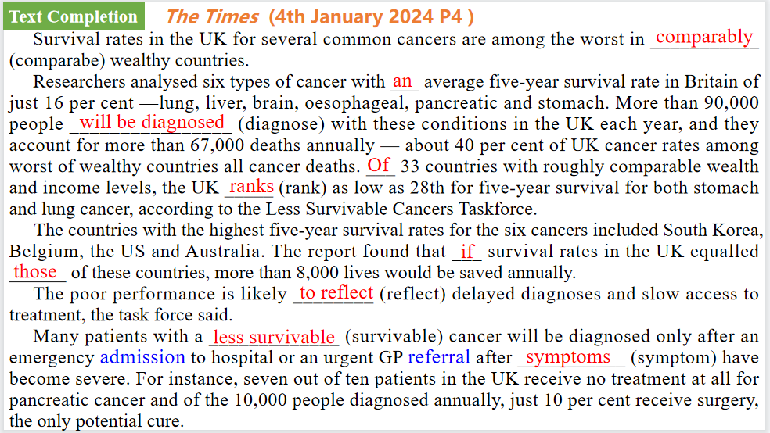

【设计意图】通过语篇填空的形式帮助学生理解新闻的主要内容，同时训练语言语法的运用能力：在语篇的视角下如何正确使用所给词汇，根据语法规则确定词汇的正确形式，使得文章通顺，激活学生的思维和语言。该新闻主题语境是关于关于“人与社会”中“社会热点问题”这一子主题，通过学习让学生了解英国癌症发病率现状：在富裕国家中情况堪忧。



【设计意图】对文本中的词汇进行解读，并通过翻译句子对其进行巩固。

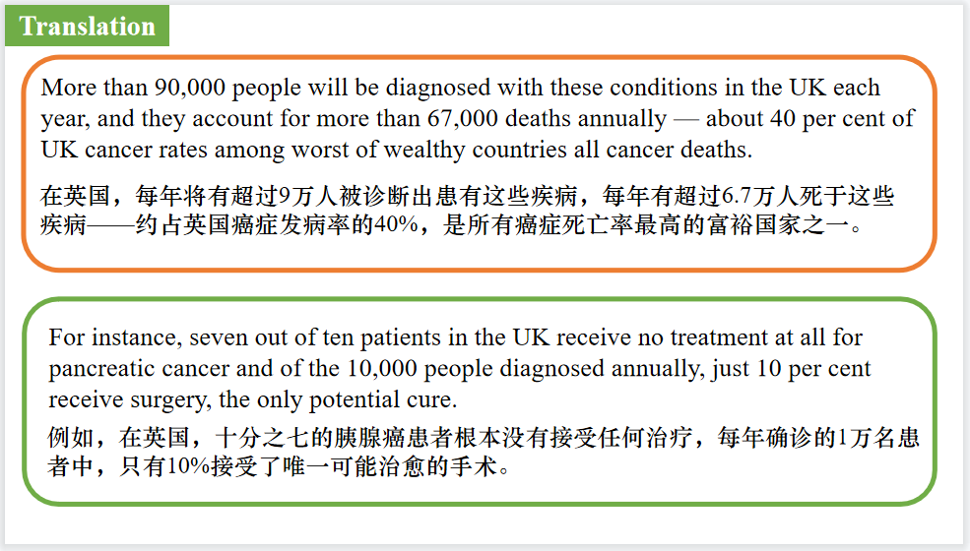

【设计意图】对文中的两个句子进行翻译练习，对其中单词、词组、句法进行巩固并关注句子结构。

**Part 2: News Report 2 *The Wall Street Journal (4th January 2024 A8 )***

**Siberia’s ice is melting, revealing its past and endangering its future**

**融化的西伯利亚，暴露了它的过去，也危及了它的未来**

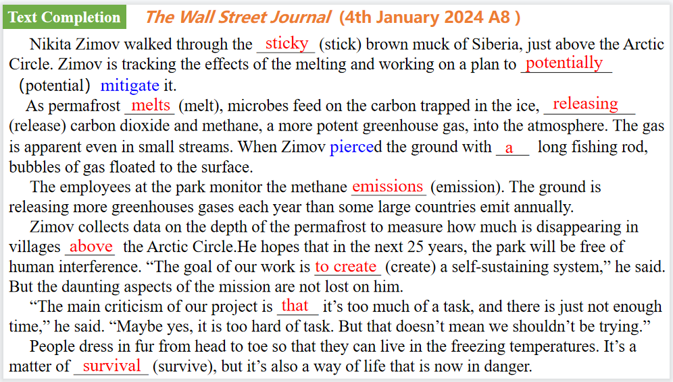

【设计意图】通过语篇填空的形式帮助学生理解新闻的主要内容，同时训练语言语法的运用能力：在语篇的视角下如何正确使用所给词汇，根据语法规则确定词汇的正确形式，使得文章通顺，激活学生的思维和语言。该新闻主题语境是“人与自然”中“人类生存、社会发展与环境的关系”这一子主题，通过学习让学生了解西伯利亚的冰融化会暴露其过去，也可能危及它的未来。

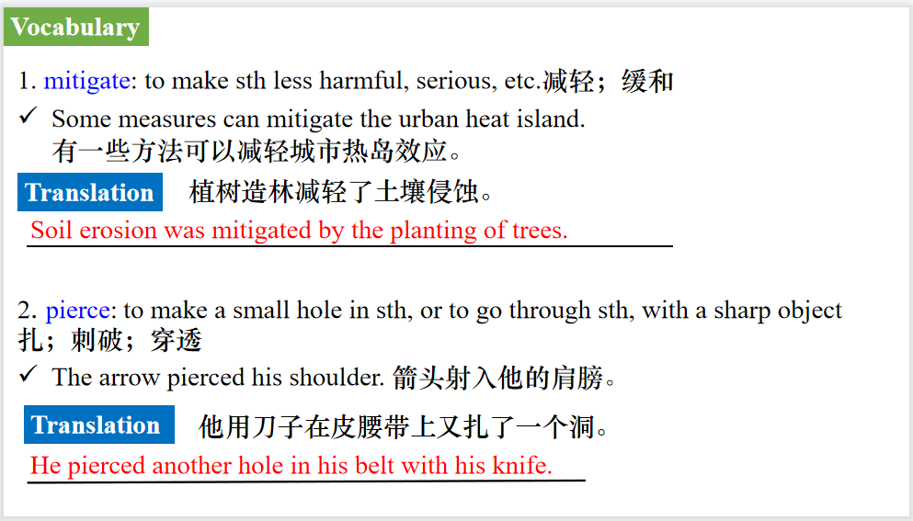

【设计意图】对文本中的词汇进行解读，并通过翻译句子对其进行巩固。

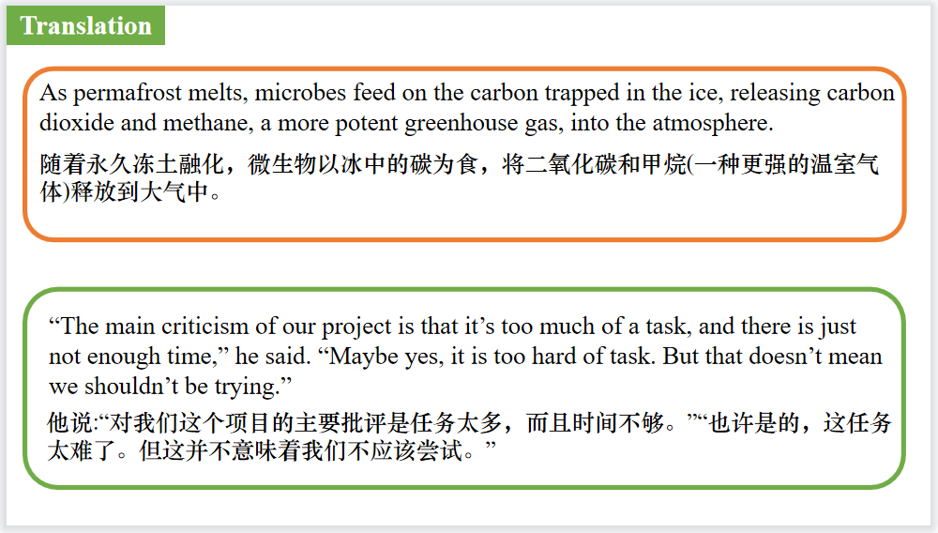

【设计意图】对文中的两个句子进行翻译练习，对其中单词、词组、句法进行巩固并关注句子结构。

**Part 3: News Report 3 *Choice ( December 2023–January 2024 Page 6)***

**Ticketek spam tactics prove costly**

**Ticketek垃圾邮件策略代价高昂**



【设计意图】通过语篇填空的形式帮助学生理解新闻的主要内容，同时训练语言语法的运用能力：在语篇的视角下如何正确使用所给词汇，根据语法规则确定词汇的正确形式，使得文章通顺，激活学生的思维和语言。该新闻主题语境是关于“人与社会”中“社会热点问题”这一子主题，通过学习让学生了解Ticketek为垃圾邮件策略付出了昂贵的代价。

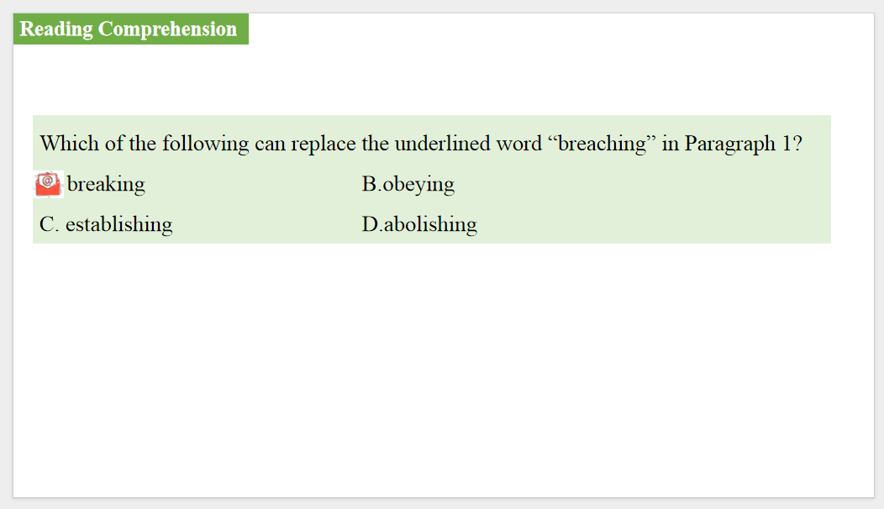

【设计意图】通过阅读理解的形式帮助学生理解新闻的主要内容。



【设计意图】对文本中的词汇进行解读，并通过翻译句子对其进行巩固。



【设计意图】对文中的两个句子进行翻译练习，对其中单词、词组、句法进行巩固并关注句子结构。

**Part 4: News Report 4 *National Geographic* (January 2024 BREAKTHROUGHS)**

**On the Coat Tales 没有斑点的长颈鹿**

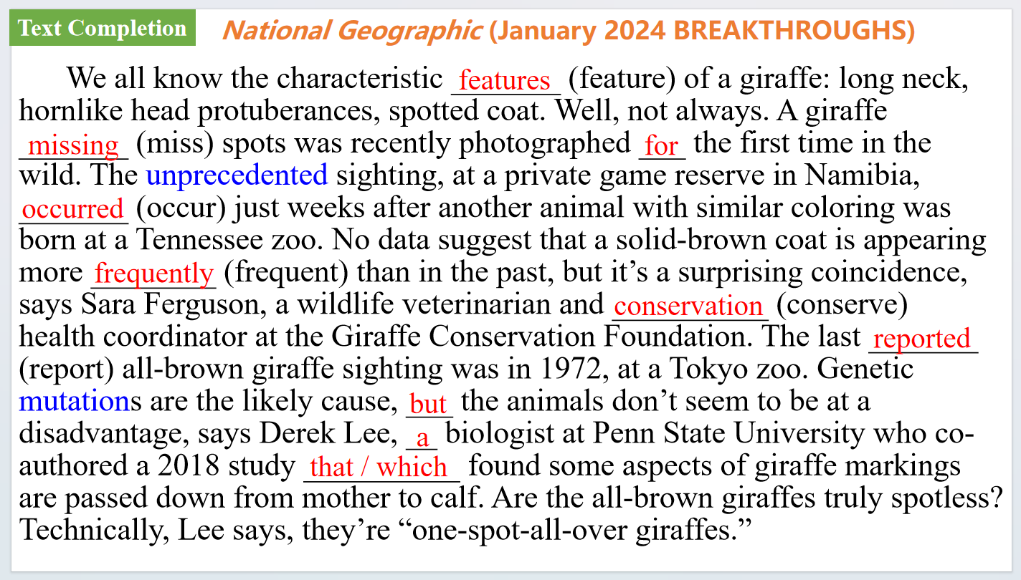

【设计意图】通过语篇填空的形式帮助学生理解新闻的主要内容，同时训练语言语法的运用能力：在语篇的视角下如何正确使用所给词汇，根据语法规则确定词汇的正确形式，使得文章通顺，激活学生的思维和语言。该新闻主题语境是关于“人与自然”中“自然科学研究成果”这一子主题，通过学习让学生了解最新发现的身上没有长斑点的长颈鹿。

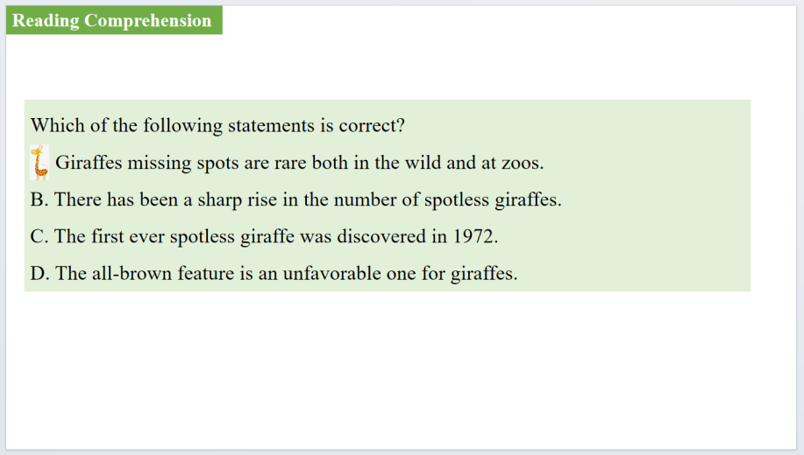

【设计意图】通过阅读理解的形式帮助学生理解新闻的主要内容。

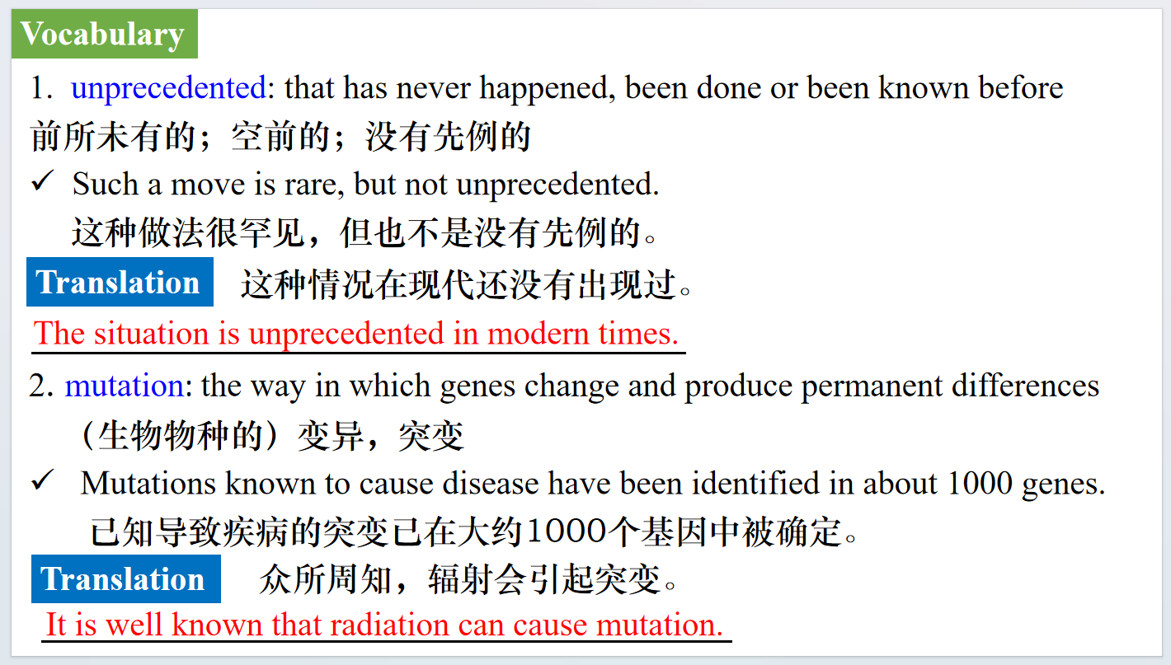

【设计意图】对文本中的词汇进行解读，并通过翻译句子对其进行巩固。

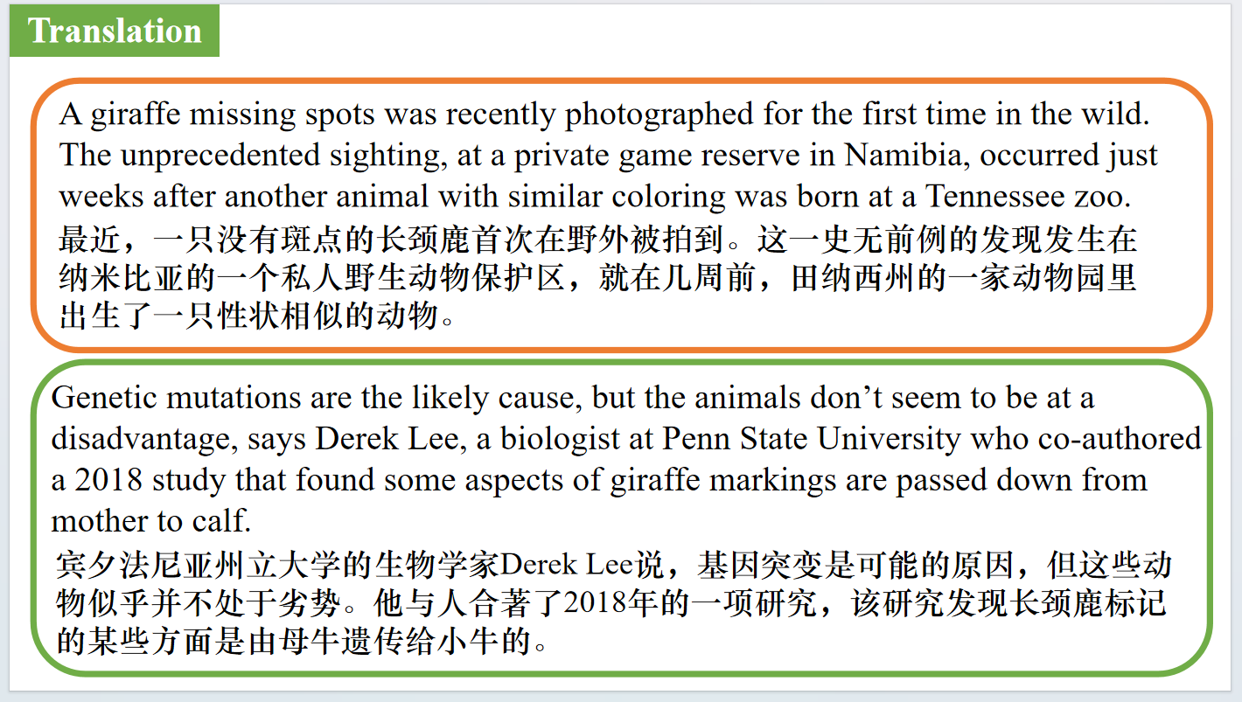

【设计意图】对文中的两个句子进行翻译练习，对其中单词、词组、句法进行巩固并关注句子结构。

**Part 5: BBC News 01/04/2024**

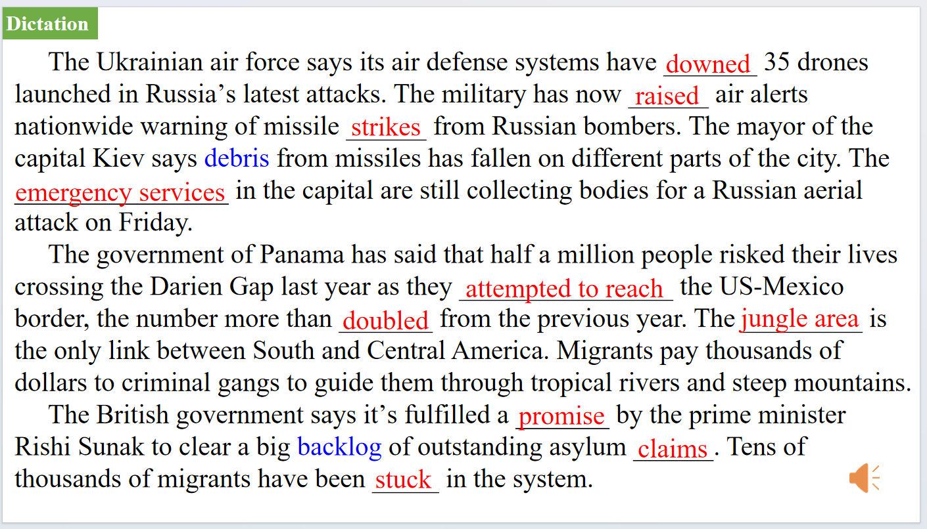

【设计意图】听一则材料，通过听力填空的方式理解文本，考察听力辨识词汇的能力。



【设计意图】对文本中的词汇进行解读，并通过翻译句子对其进行巩固。

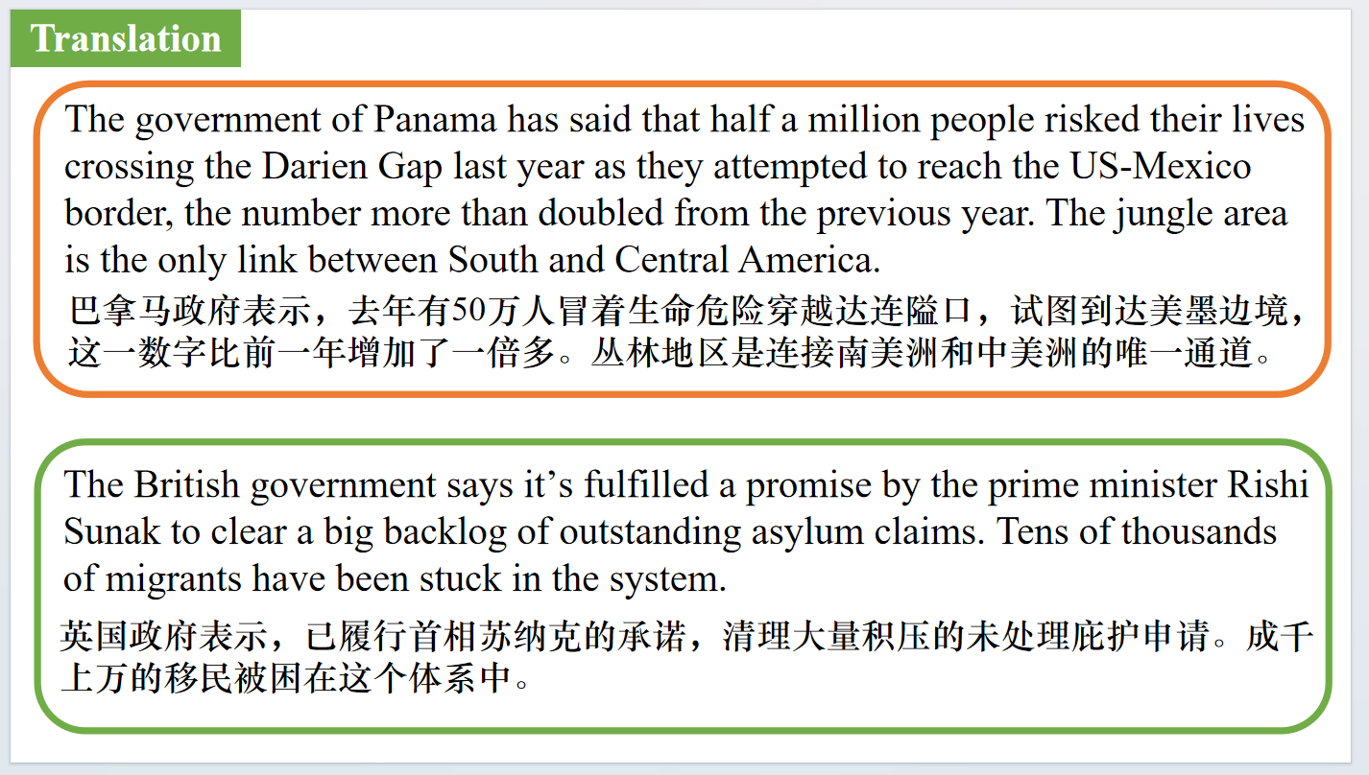

【设计意图】对文中的两个句子进行翻译练习，对其中单词、词组、句法进行巩固并关注句子结构。

附：外刊原文

**Part 1: News Report 1 *The Times (4th January 2024 P4 )***

**UK cancer rates among worst of wealthy countries**

**英国癌症发病率在富裕国家中情况堪忧**

UK cancer rates among worst of wealthy countries

Rhys Blakely Science Correspondent

Survival rates in the UK for several common cancers are among the worst in comparably wealthy countries.

Researchers analysed six types of cancer with an average five-year survival rate in Britain of just 16 per cent —lung, liver, brain, oesophageal, pancreatic and stomach. More than 90,000people will be diagnosed with these conditions in the UK each year, and they account for more than 67,000 deaths annually — about 40 per cent of UK cancer rates among worst of wealthy countries all cancer deaths. Of 33 countries with roughly comparable wealth and income levels, the UK ranks as low as 28th for five-year survival for both stomach and lung cancer, according to the Less Survivable Cancers Taskforce.

For pancreatic cancer, Britain was in 26th place, while for brain, liver and oesophageal cancers, it was ranked 25, 21 and 16, respectively.

The countries with the highest five-year survival rates for the six cancers included South Korea, Belgium, the US and Australia. The report found that if survival rates in the UK equalled those of these countries, more than 8,000 lives would be saved annually.

The poor performance is likely to reflect delayed diagnoses and slow access to treatment, the task force said.

Many patients with a less survivable cancer will be diagnosed only after an emergency admission to hospital or an urgent GP referral after symptoms have become severe. For instance, seven out of ten patients in the UK receive no treatment at all for pancreatic cancer and of the 10,000 people diagnosed annually, just 10 per cent receive surgery, the only potential cure.

Elliot Colburn, chairman of the allparty parliamentary group on cancer, said: “Less survivable cancers deserve particular and urgent attention due to the very severe outcomes often faced by people diagnosed with them.

“If we’re going to deliver world-class care to cancer patients in the UK, then we must bring ourselves on a level with other countries when it comes to diagnosis and treatment of less survivable

**Part 2: News Report 2 *The Wall Street Journal (4th January 2024 A8 )***

**Siberia’s ice is melting, revealing its past and endangering its future**

**融化的西伯利亚，暴露了它的过去，也危及了它的未来**

BY RUBY MELLEN

AND NATALYA SAPRUNOVA

Nikita Zimov walked through the sticky brown muck of Siberia, just above the Arctic Circle. The sun radiated over the Russian republic of Sakha, also known as Yakutia, on a nearly 70 degree day. It was August 2022, but in many ways the young scientist had traveled back in time thousands of years.

Layers of thawing ground towered dozens of feet above Zimov, the manager of Pleistocene Park and head of the Northeast Science Station in Yakutia. They contained leaves, roots and the remains of animals that died millennia ago, during the Pleistocene period, known as the planet’s most recent ice age.

Siberia is heating up almost twice as quickly as other parts of the world. The rapid change is causing the ice known as permafrost that coats about two-thirds of Russia to thaw for the first time in ages.

Its brittle underbrush has fueled vicious forest fires. The melting ice is releasing greenhouse gases. Sheets of the softening land have emerged for the first time in hundreds of thousands of years, revealing skeletons, disease and awakening life.

In July, scientists were able to revive a 46,000-year-old worm that was trapped in the permafrost. European researchers have warned that as the ground continues to thaw, ancient viruses may emerge.

Zimov is tracking the effects of the melting and working on a plan to potentially mitigate it.

As permafrost melts, microbes feed on the carbon trapped in the ice, releasing carbon dioxide and methane, a more potent greenhouse gas, into the atmosphere. The gas is apparent even in small streams. When Zimov pierced the ground with a long fishing rod, bubbles of gas floated to the surface.

The employees at the park monitor the methane emissions. The ground is releasing more greenhouses gases each year than some large countries emit annually.

Zimov lives 26 miles from the park in a remote location with his wife and three daughters.

“It has tons of mosquitoes in the summer, and it’s super dark and cold in the winter,” he said. “But home is home.”

Zimov grew up on the research station, where his father, Sergei, was a scientist. In 2006, Sergei and Alaskan ecologist Katey Walter Anthony published research in Nature detailing how the permafrost’s thaw was adding to climate change. The Zimovs decided to address the problem by “re-wilding” the arctic tundra. Their small patch of land is inhabited by cold-weather grazers such as bison and camels, which they hope can flatten and spread out the insulating snow during the winter, allowing the ground to refreeze before the summer months.

Time is running out. The melting ground is changing daily life in these remote locations. Infrastructure is collapsing. Homes are crumbling. Graveyards are flooding.

In the northern village of Srednekolymsk, graves have been displaced as the ice melts.

A building that once housed a sewage treatment facility in Yakutia has fallen apart.

Zimov collects data on the depth of the permafrost to measure how much is disappearing in villages above the Arctic Circle.

He hopes that in the next 25 years, the park will be free of human interference. “The goal of our work is to create a self-sustaining system,” he said. But the daunting aspects of the mission are not lost on him.

“The main criticism of our project is that it’s too much of a task, and there is just not enough time,” he said. “Maybe yes, it is too hard of task. But that doesn’t mean we shouldn’t be trying.”

Those who live in Siberia’s extreme conditions draw from centuries-old customs crafted for honoring and surviving the cold. Pipes are built above ground. Cars are left running all winter because if they are turned off, they immediately freeze and cannot be restarted.

People dress in fur from head to toe so that they can live in the freezing temperatures. It’s a matter of survival, but it’s also a way of life that is now in danger.

**Part 3: News Report 3 *Choice* ( December 2023–January 2024 Page 6)**

**Ticketek spam tactics prove costly**

**Ticketek垃圾邮件策略代价高昂**

In 2019, the ACMA issued a formal warning to Ticketek to cease and desist breaching the Spam Act. But it seems the market-dominating ticketing business didn’t take the warning to heart. In October this year, Ticketek paid a $515,040 fine to the ACMA after the regulator found it had sent around 41,000 marketing texts and emails without the consent of recipients, and around 57,000 texts and emails to people who had previously unsubscribed.

Ticketek claimed that some of the emails were exempt from the Spam Act because they contained event information for ticket holders, but the ACMA’s investigation found they also contained advertising and promotional material for upcoming events, meaning the Spam Act applied.

“Australians are fed up with these types of intrusions on their privacy and Ticketek has no excuses given it was on notice after our previous action,” says the ACMA Chair Nerida O’Loughlin. “It is also incredibly frustrating for people to take the time to unsubscribe only for those requests to not be actioned. Businesses must have working systems in place to comply with consumer choice and consent.”

**Part 4: News Report 4 *National Geographic* (January 2024 BREAKTHROUGHS)**

**On the Coat Tales 没有斑点的长颈鹿**

We all know the characteristic features of a giraffe: long neck, hornlike head protuberances, spotted coat. Well, not always. A giraffe missing spots was recently photographed for the first time in the wild. The unprecedented sighting, at a private game reserve in Namibia, occurred just weeks after another animal with similar coloring was born at a Tennessee zoo. No data suggest that a solid-brown coat is appearing more frequently than in the past, but it’s a surprising coincidence, says Sara Ferguson, a wildlife veterinarian and conservation health coordinator at the Giraffe Conservation Foundation. The last reported all-brown giraffe sighting was in 1972, at a Tokyo zoo. Genetic mutations are the likely cause, but the animals don’t seem to be at a disadvantage, says Derek Lee, a biologist at Penn State University who co-authored a 2018 study that found some aspects of giraffe markings are passed down from mother to calf. Are the all-brown giraffes truly spotless? Technically, Lee says, they’re “one-spot-all-over giraffes.”